PORTFOLIO · 2025
Bashayer Alhawsawi
Mobile Developer · Android & Cross-Platform
I build mobile apps that people actually use — native Android with Kotlin and cross-platform with Flutter, engineered to feel effortless. Based in Saudi Arabia.
⬩ 4+ Years Experience ⬩ 5 Shipped Projects ⬩ 3 Apps on Google Play
Email: bashayer.eh.19@gmail.com | WhatsApp: +966 54 483 0939 | LinkedIn: linkedin.com/in/bashayereh | GitHub: github.com/BashayerH | X: x.com/fo0oshaty
01 ABOUT — HOW I BECAME A MOBILE DEVELOPER

My journey began at the Tuwaiq Academy bootcamp, where I built my first complete application and truly understood the fundamentals of programming.
After graduating, I worked on small projects that strengthened my skills and gave me real experience solving practical problems through code.
My first professional role introduced me to Flutter, where I spent a year and a half building cross-platform mobile applications.
Later, I returned to my foundation: Kotlin. Since then I've been continuously refining my Android expertise, improving my architecture skills, and building applications that are reliable, scalable, and designed to last.
02 TOOLS I TRUST

- Kotlin — Coroutines, Flow, Jetpack Compose, MVVM, Room, Retrofit — native Android from architecture to animation.
- Flutter — Cross-platform UI at speed. Bloc/Provider state management, custom animations, native feel on both platforms.
- Clean Architecture — Domain, Data and Presentation layers. Testable, maintainable, built to survive the next developer.
- Maps SDK — Live tracking, geofencing, route calculation, custom overlays — real-time location at production scale.
03 SELECTED WORK — MY PROJECTS

Ma'an Initiative 01 / Web
WEB PLATFORM · HEALTHCARE EDUCATION
Under the Ma'an Initiative, I built a web platform serving the healthcare education sector — a responsive, accessible site delivering educational content to its audience.
★ Live platform · Healthcare education sector
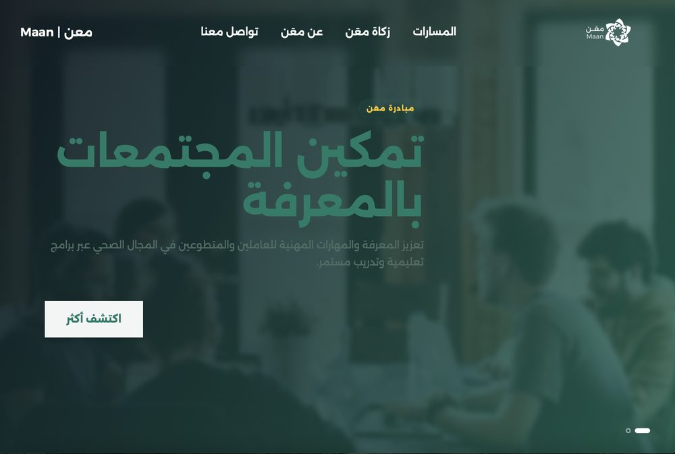 | 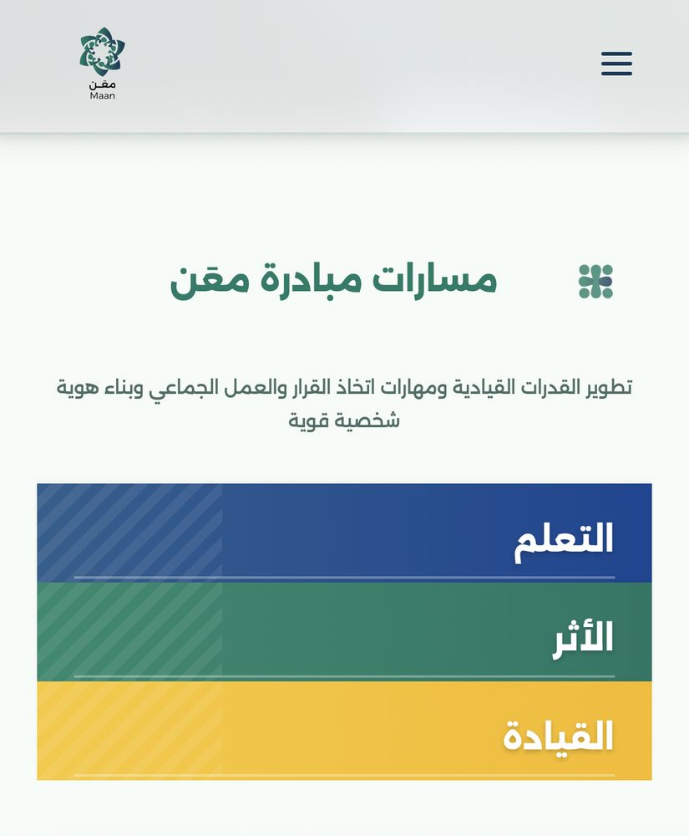 | 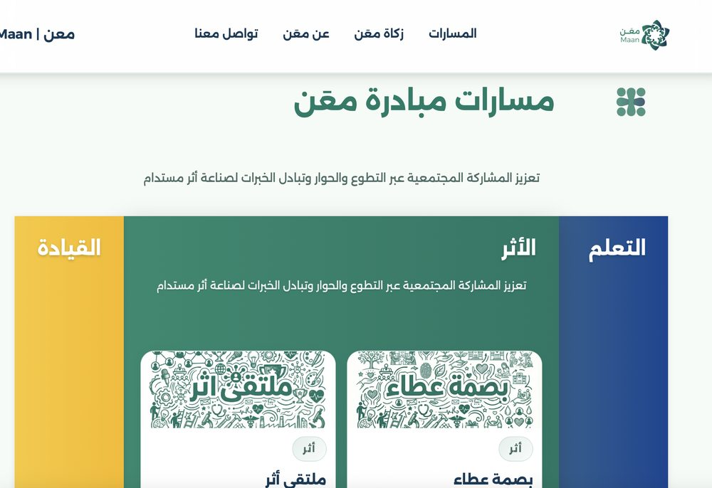

Tech: HTML5 · CSS3 · JavaScript · Responsive
Links: Visit Website
Minute — Driver App 02 / Mobile
REAL-TIME RIDE-HAILING
Drivers needed real-time reliability. I built a production-grade app with Google Maps, live ride handling, and earnings tracking — performance-first, always.
★ Live on Google Play · Real-time ride-hailing
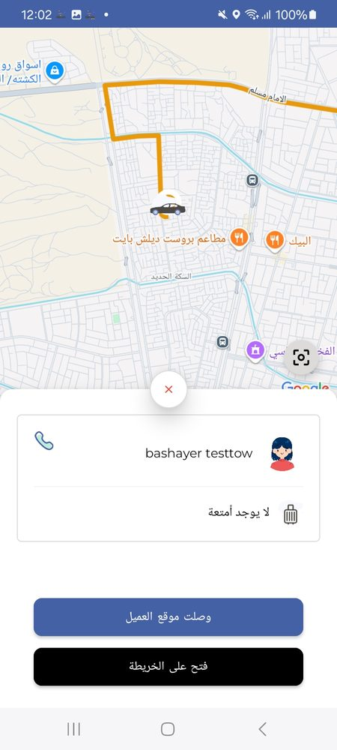 | 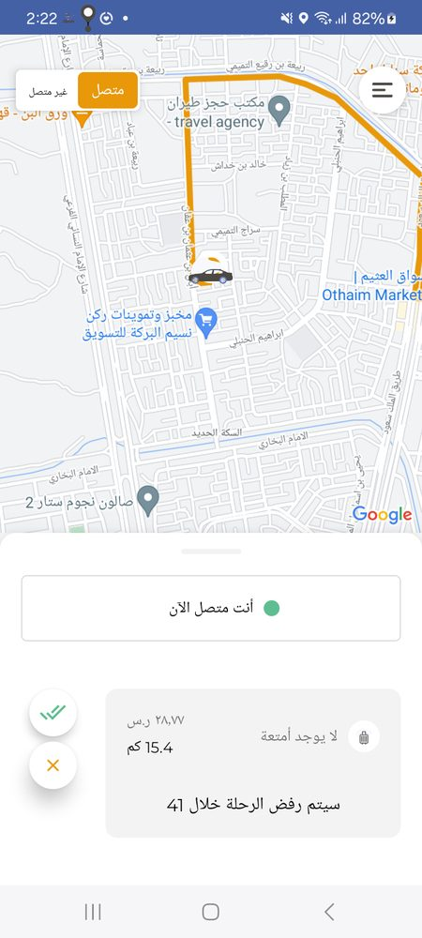 | 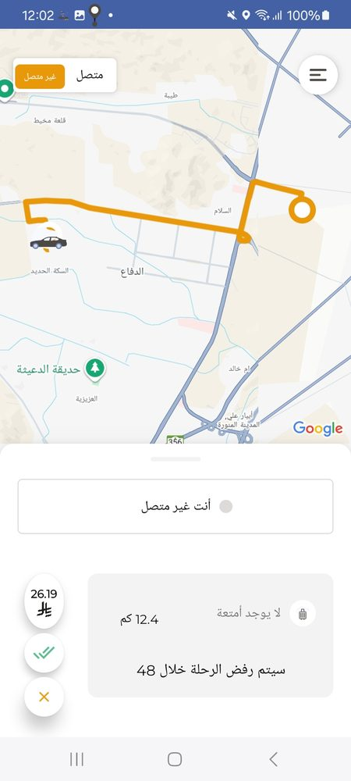

Tech: Flutter · Kotlin · Firebase · Google Maps
Links: Google Play Demo
Minute — Client App 03 / Mobile
PRODUCTION-READY PASSENGER APP
A ride-hailing app that lets users request trips, track drivers live, and reach destinations safely and quickly — with intuitive booking flows, push notifications, and a UX people trust.
★ Live on Google Play · Production-ready passenger app
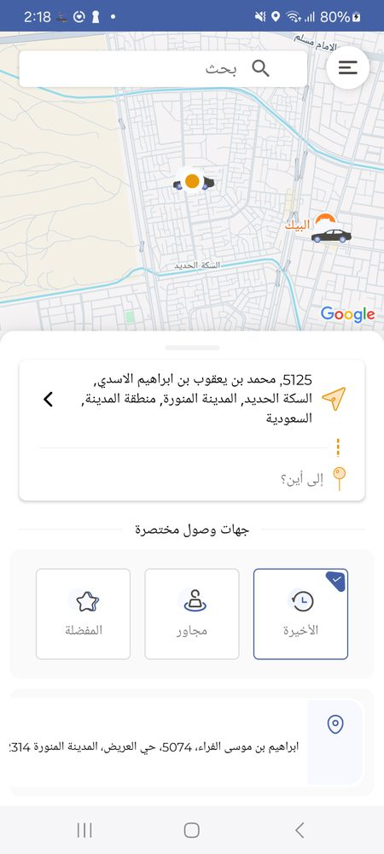 | 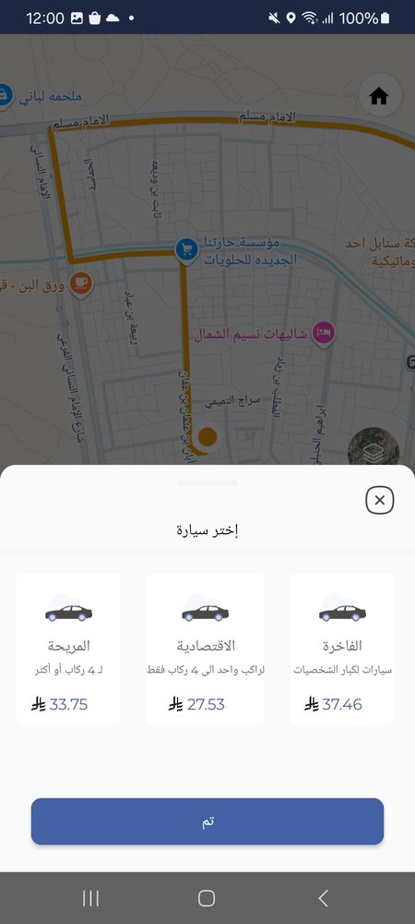 | 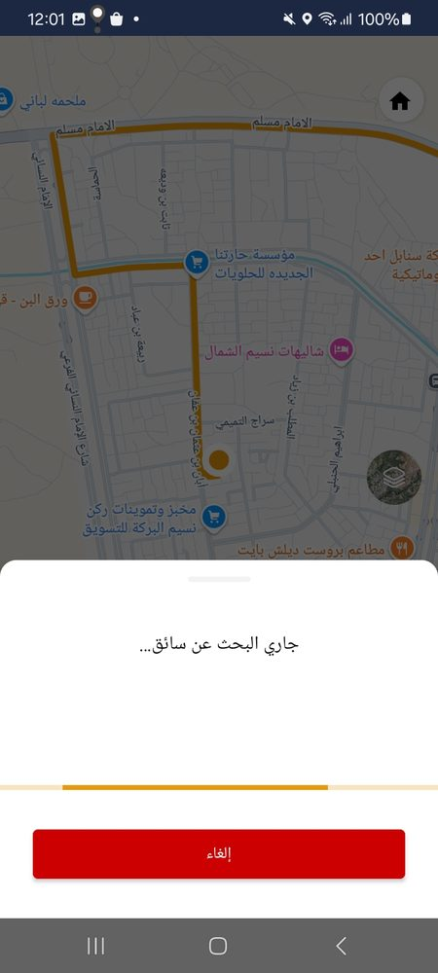

Tech: Kotlin · Flutter · Firebase · Google Maps
Links: Google Play Demo
Minhaj App 04 / Mobile
RELIGIOUS & EDUCATIONAL PLATFORM
An integrated digital platform for religious and educational services, developed under the Elm company as part of the National Skills Development Program.
★ Live on Google Play · National Skills Development Program
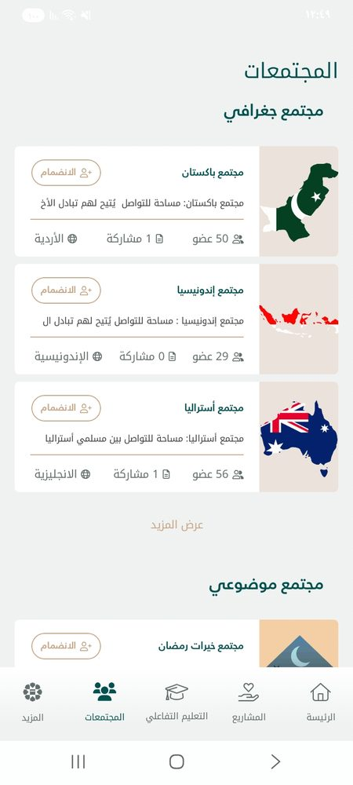 | 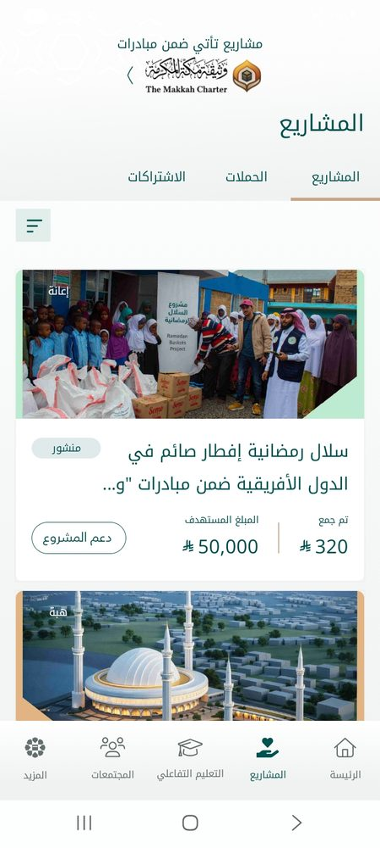 | 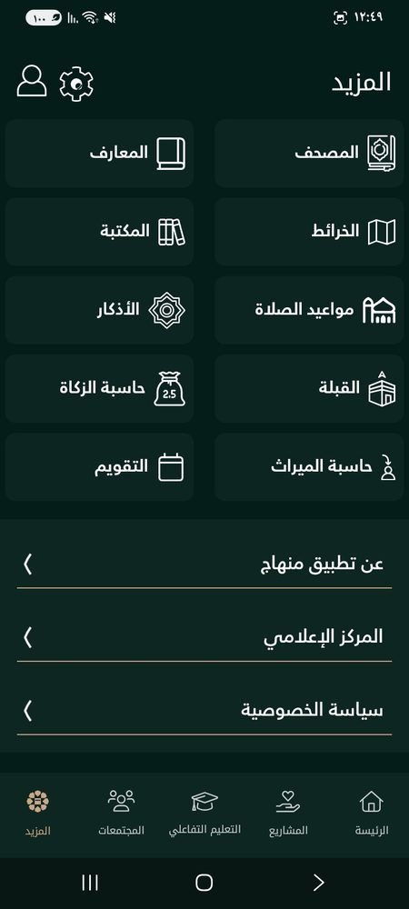

Tech: Kotlin · Android · Firebase · MVVM · Jetpack Compose
Links: Google Play
Meme Editor 05 / KMP
KOTLIN MULTIPLATFORM · ANDROID · IOS · WEB · DESKTOP
A Kotlin Multiplatform app targeting Android, iOS, Web, and Desktop, letting users create and customize memes with text editing and sharing. Built to explore modern cross-platform development from one codebase.
★ Exploration project · Kotlin Multiplatform
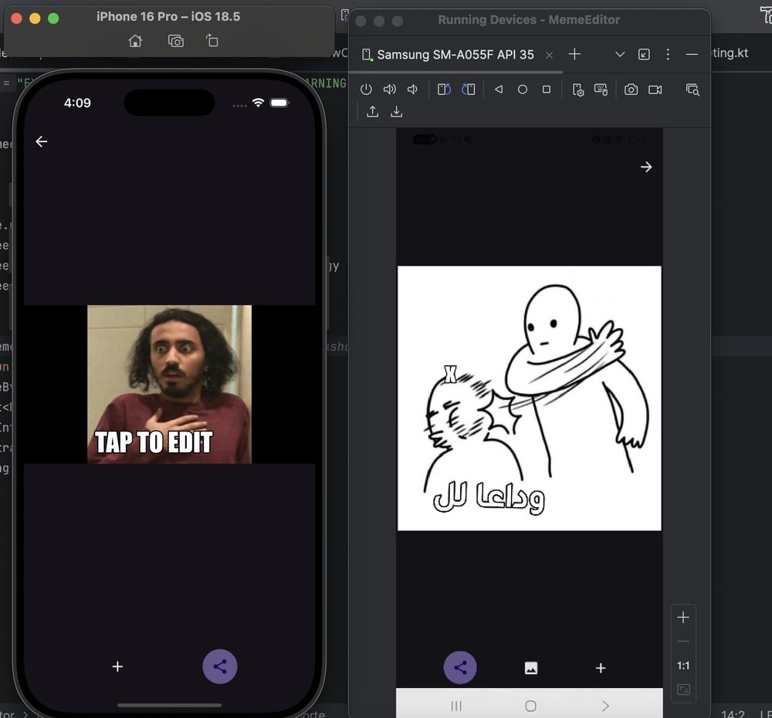 | 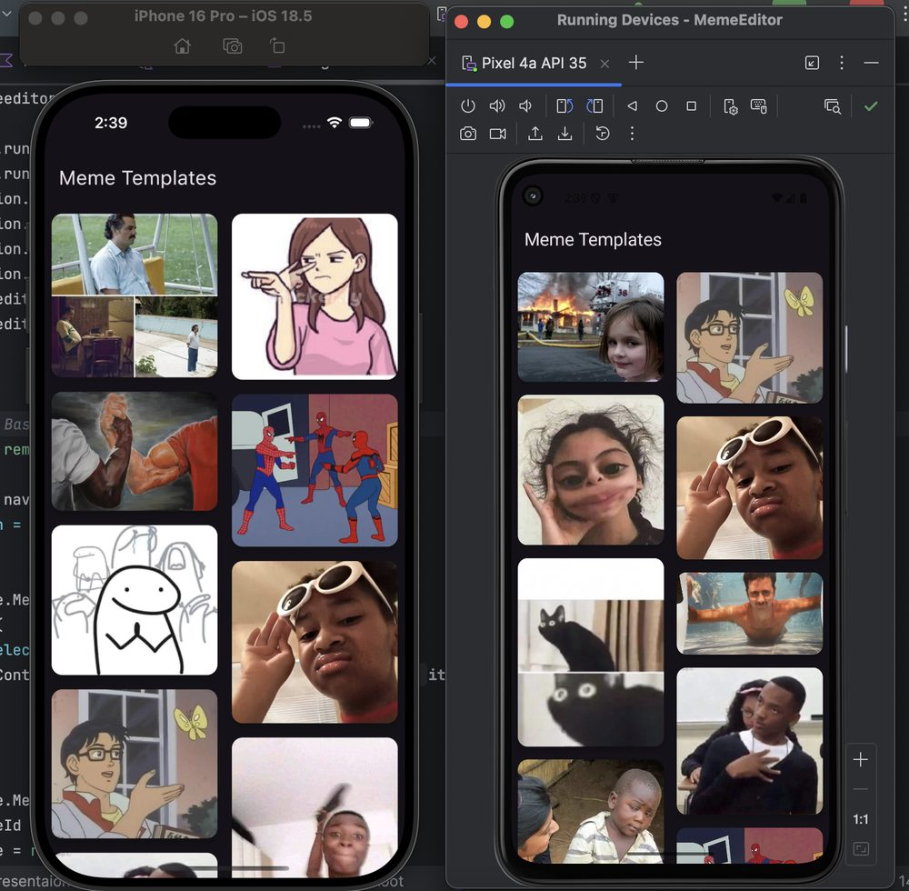

Tech: Kotlin Multiplatform · Compose · Android · iOS · Web · Desktop
Links: GitHub
04 LET'S TALK

If you're building something ambitious, let's talk.
Available for new challenges. I take on selective work, which means what we build gets my full attention. Typically replies within 24 hours — no automated responses.
© 2025 Bashayer Alhawsawi · Built with intention.

