

**Faculty of Engineering and Technology**

**Computer Science Department**

**Friends For Golden Adverts**

**Bashseer Arouri 1201141**

**Ibrahem Abu hijleh 1203065**

**Ahmad Qawareeq 1172871**

**Dr. Samer Zein**

***Introduction:***

Through our understanding of the general description of the company, the following became clear to us, after meeting the team members, on how the company works: This company is called **friends for golden adverts** , and its main function is advertisements in general, through television, radio, social networking sites and billboards in the streets.

This company consists of a number of branches in the following cities: Bethlehem, Hebron, Nablus, and its main headquarters in Ramallah. There are 5 departments in each branch: The business department deals with customers (individually or as a company), and saves their info in excel sheet.

The second dep is adverts in the streets, and it’s task also to maintain the billboards after deploying them to the customers.

Third dep, social media adverts dep and it’s responsible for advertising on Facebook, instagram and so on.

Fourth is TV and Radio and its task is to advertise on TV and radio.

The final dep is management dep, and it’s responsible for all of the financial records in the branch, such as employees records, Billboards records and customer campings.

According to the problems, we recognized some problems in this company such as: saving the data in Excel sheets. The second

Problem is that the company hired a whole team just to troubleshoot the problems of the billboard. The third problem is that the management dep. is responsible for financial records and revenues just from customer campaigns, Billboards, and Employees Info and not for social media and Tv and Radio stations. The last problem is when the customer registered on the website, he wanted the helpness of the business dep. to register the online website.

After we considered the critical problems as mentioned previously, we suggested some solutions for them as the following: we can solve the excel sheet problem with a software program (GUI) and its task is to register on a database. The second solution for the problem is to automate the billboard to be changed by the head of the team. The third problem is solved by giving the authority to the heads of deps. for social media and TV-Radio stations.

***System Features:***

The goal of the new software system is to solve all the problems that the old system was suffering from, and we achieve these important skills by satisfying the functional requirements and non-functional requirements as the following:

1. **We solve the problem of registering phone numbers, mobile numbers, emails, web sites, etc of clients on excel sheet by making a good web application . The web application prompts the special employee in the professional adverts company to enter his password and username. The web application should check if the current client is a golden client or not. The golden client is a client who deals with us for more than 3 years. The golden clients have a discount from the company that reaches up to 30% from his total payment. The special employee can report phone numbers, mobile numbers, emails, web sites, etc of clients. The report of the client should be printed on a diagram (i.e Excel Sheet). The special employee should treat the golden customers in a better way than normal clients.**
2. **We solved the second problem by making electronic billboards. Electronic billboards are billboards that can be controlled remotely (wireless). Each billboard has an id, location, name, and detailed schedule of the adverts controlled by the head of the special team. The head of the special team can enter the billboard by type the id of the billboard. (No two billboards have the same ids). In this way, we can change the advert remotely, thus, we don't want a large number of employees to exist for maintainability of the billboards. The head of the maintenance team can view reports of billboards id, name, location. The last thing is that the head of the maintenance team should calculate the expenses of billboards monthly.**
3. **The third problem is solved by giving the authority to the heads of deps. for social media and TV-Radio stations to the financial records which are connected directly to our system which deals with the management dep. Thus, they can view their financial records and revenue.**
4. **We solved the last problem of the usability of the system by making the system easier to learn and do not want any helpness of the business department. *easier to learn means* that we used AI & Machine learning for learning the customer to deal with the website. The technique of AI & Machine learning is useful by the following : The user asks the AI model for a question about the website, and the AI model will respond to him by useful videos and textual adverts. Thus, the customer does not want any help from any employee in the business department. except for the emergency cases.**

**All of these features, functional and non-functional requirements depend on the *limit of the budget and the time that the customer and the company agreed on.***

***Software development process:***

This scenario of the problem for this company needs a software process with type ***incremental development approach***. The reason for us to choose the incremental approach is that the customer will contact us frequently (usually 2 times in 2 weeks), and this leads to a loss of the ambiguous understanding between the customer and the provider company.

The other important aspect is the testing unit, because in an incremental approach, every sprint (usually two weeks) has unit testing, and this does not lead to testing the whole system as one bulk.

The other thing is that if the customer wants to change something or modify it, we can make it for him, because incremental development always says “welcome to change”.

The last important thing is that we can finish this system in approximately 8 months, and our release is every 2 months, and the release contains a small part of the whole system (subsystem that is ready to use from the customer). And we usually start with the most complex part of the system.

***USE Case Diagram:***

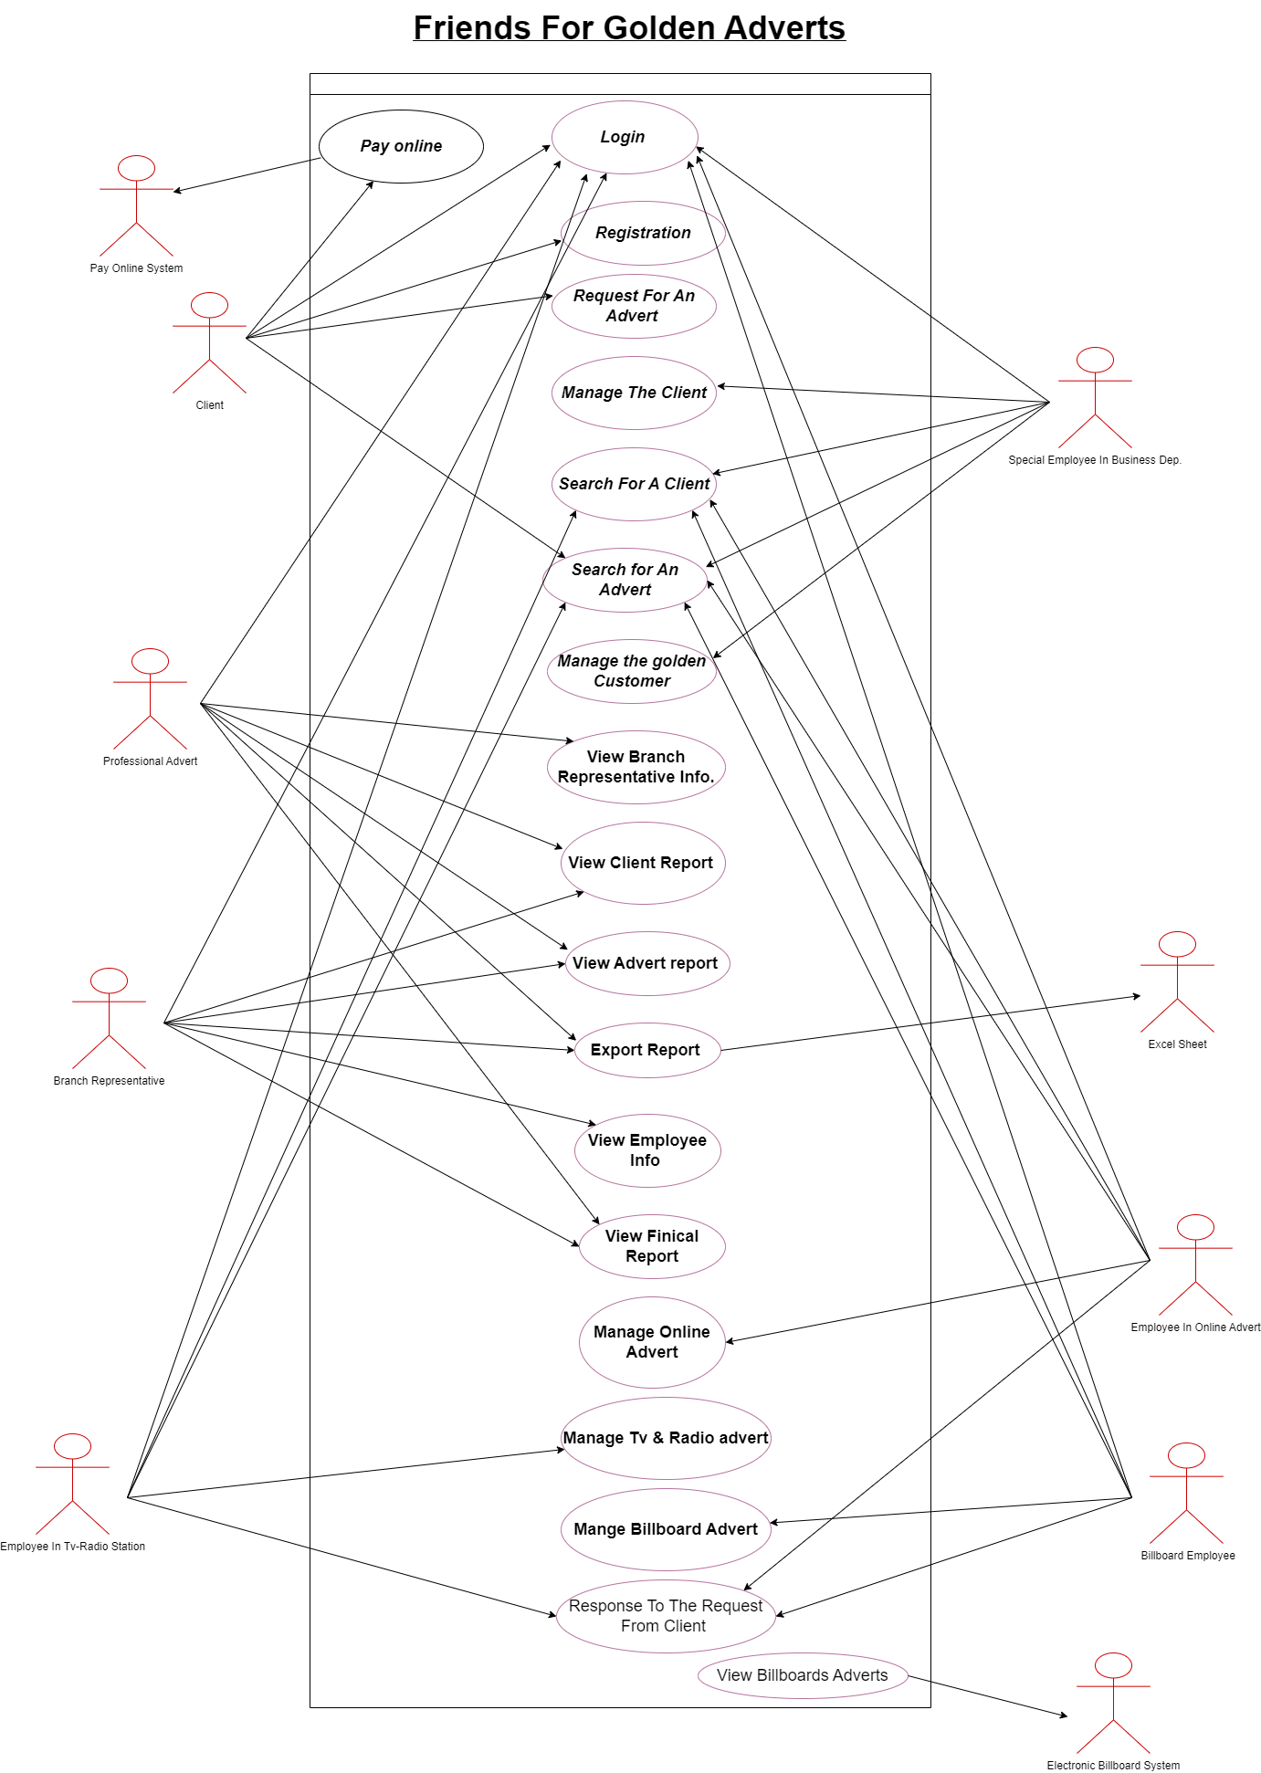

***Explanation for the above use case:***

***Actors*:**

**1- Client : This actor is the main actor in the system, and he wants to request an Advert(s) from the company for him.**

**2- Pay Online System : This System lets the client pay online, and sends a notification to both : client and the main system (Friends For Golden Client).**

**3- Proffential Advert: This is the head of the company, and he manages the whole system.**

**4- Branch Representative: This is the Branch Manager in a specific branch in the city, and he manages his Branch of the whole system.**

**5- Employee in TV-Radio station: This is the person who wants to apply the advert of TV-Radio station for the client.**

**6- Social Employee In Business Department : This is the person who wants to manage the client and especially the golden clients.**

**7- Excel Sheet : This is the program that the Proffential Advert uses to plot the diagram for his advert and client reports on it.**

**8- Employee In Online Advert: This is the person who wants to apply the online advert (i.e Facebook and Instagram) for the client.**

**9 - Electronic Billboard system : This system applies the online billboards in the streets for the clients and are managed by the Billboard Employees (This Electronic system is instead of the manual billboards in the streets).**

**10 - Billboard Employee : This is the person who wants to apply the Billboard advert (Adverts that are put on the street ) for the client .**

***Use Cases:***

**11- Login : A property that lets the client enter the system, by entering his name and password.**

**12- Registration : A property that lets a new client to create an account, by entering the client name, date of birth, phone numbers, mobile numbers and email.**

**13- Request For An Advert: A property that lets the user fill his full request for an advert, and send it to the system by entering the advert properties : own description, start and end date, position, dimensions and name .**

**14- Manage the Client : A property that indicates the special employee should take care of the normal clients.**

**15- Search for a client : A property that searches for a specific client by entering his information (phone numbers, mobile numbers, emails, web sites).**

**16- Search for an Advert: A property that searches for a specific advertisement by entering its information (description, start and end date).**

**17- Manage The Golden Client : A property that distinguishes golden customers, and they are known by being a customer for more than 3 years, and they have a discount for 30% of their total payment, and they have special care from employees.**

**18- View Branch representatives : A property that lets the professional advert see the information of the branch representatives.**

**19- View Client Report : A property that can view information (phones numbers, mobile numbers, emails, web sites) about the current clients in the system in the form of a report.**

**20- View Advert Report: A property that can view information (own description, start-end date and position) about the current adverts in the system in the form of a report.**

**21- Export Report : A property to Issue reports in Excel file format.**

**22- View Employee Info : A property to view employee information(salaries, taxes,name and phone number)from authorized persons(Branch Representative).**

**23- View Financial Report: A property to see the revenues, expenses and profits of the company by authorized persons(Branch Representative and Proffential Advert).**

**24- Manage Tv & Radio Advert: A property that enforces the employee to take care of the Tv & Radio Advert for specific clients.**

**25- Manage Online Advert: A property that enforces the employee to take care of the Online Advert for specific clients.**

**26 -Manage Billboard Advert: A property that enforces the employee to take care of the Billboard Advert for specific clients.**

**27- Response To the Request Client : This important property, and it is for the response for the client request, rejected or approved.**

**28- View Billboard Advert: This property is to transfer the advert to the electronic billboard system and view the advert info on it.**

***Basheer Arouri Scenario:***

***Initial Assumption*: A client called Basheer Arouri wants to sign up an account in the company website and wants from the company an advert in the billboards for his new software company.**

***Normal Flow*:**

**1-After Basheer gets the URL for *Friends For Golden Adverts* company , he wants to sign up for an account.**

**2- The system of the company shall ask basheer to enter his full name, date of birth and email.**

**3- After entering the full name, date of birth and the email successfully by Basheer, the system shall navigate Basheer to a new webpage.**

**4- The new webpage shall contain all of the advert types : Social media adverts, Billboards adverts and TV-Radio adverts.**

**5 - After Basheer presses on the Billboards adverts button, the system shall also navigate him to a new web page which contains all the billboards properties such as : its own description, start and end date, position, dimensions and name, and all of these properties shall Basheer fill them by free text.**

**6- After that , the system shall tell Basheer that it will send him an email within 2 days if the company can support his request or not.**

**7- After that the system shall send to the billboard department at the city depending on Basheer’s request position a message that contains Basheer’s request.**

**8- After that, when the employee in the billboard department sees Basheer’s request, he should determine if the current request can be done or not.**

**9- The current request can be done ,if the ability of the company can support Basheer’s request.**

**10- After that, the employee shall send Basheer an approval by email of his request and tell him that the company shall start the campaign within 24 hours.**

**11- After that, the employees shall generate (put on them electronically) the electronic billboards to the Basheer’s adverts and set the start-end dates.**

**12- After the end date is finished for Basheer adverts, a notification shall be sent by the electronic billboards to the employees in the billboards department and to Basheer email.**

**13- After the notification is reached to the employees in the billboards department, they shall regenerate the electronic billboards to another client advert.**

***Alternative Flow:***

**6.a : Basheer notes that he does not accept any message from the company within 2 days by email, the system then shall resend a message to Basheer and apologize for him, and he will get a 5% discount from total payment.**

***Alternative Flow:***

**8.a : The system cannot accept Basheer's request & sends Basheer rejected for his adverts, then it should apologize to Basheer and tell him to try again in the coming days.**

***Alternative Flow***

**10.a : The company does not start with Basheer’s request after 48 hours, then the system shall apologize for him, and he will give him a 15% discount from total payment to raise the trustness of the company.**

***Ibrahim Abu Hijleh Scenario***

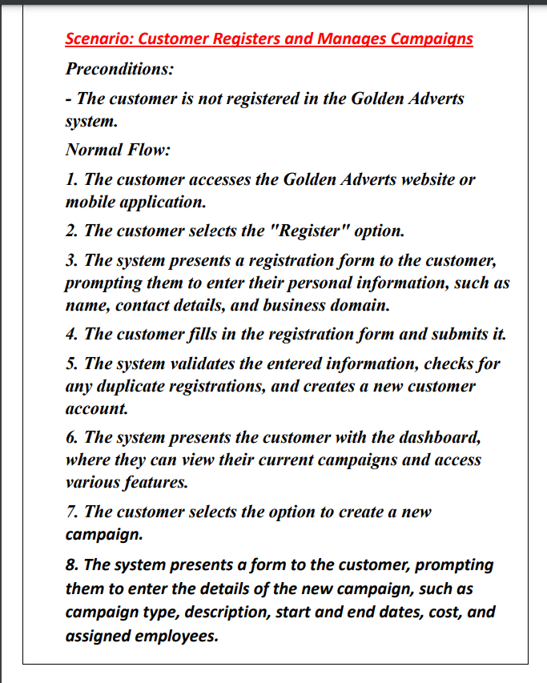

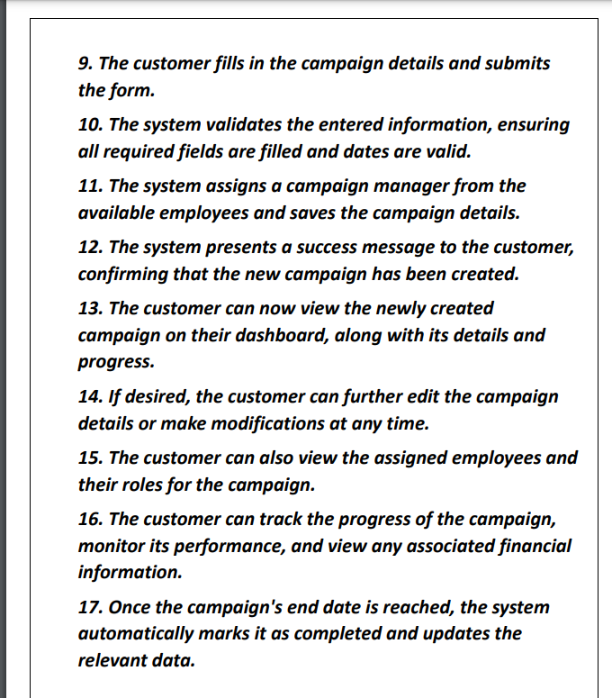

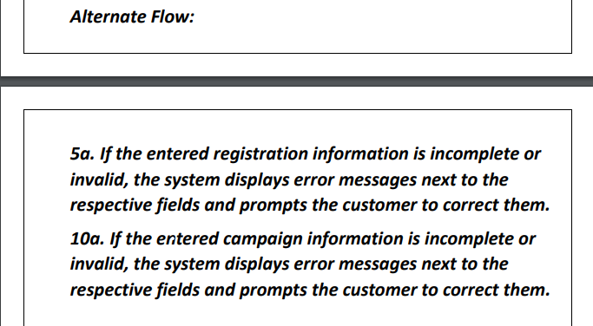

***Ahmad*** *Qawareeq* ***Scenario:***

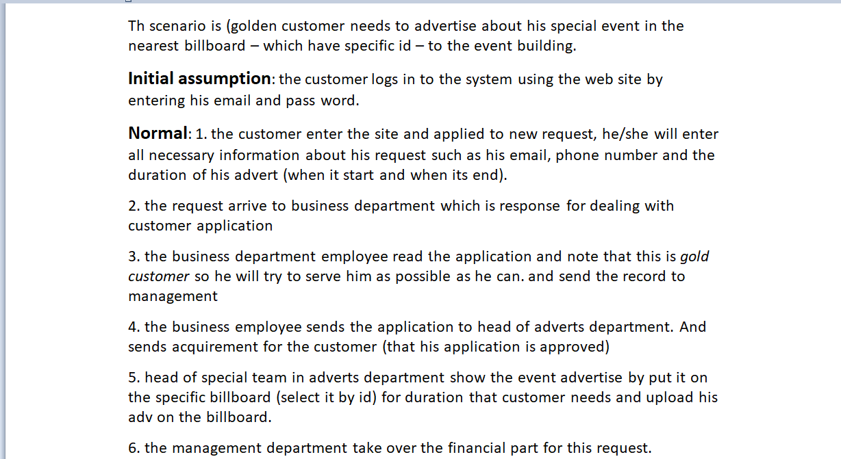

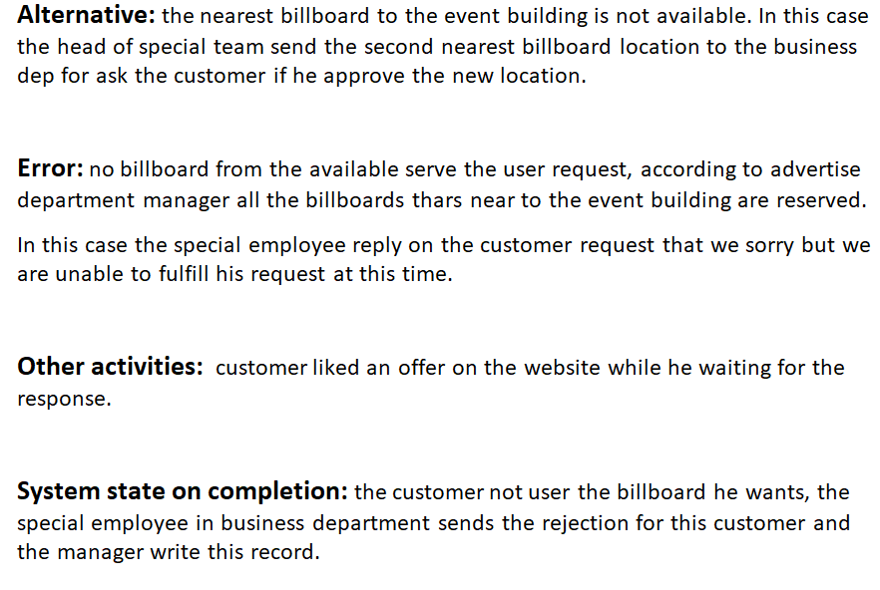

**Non-Functional Requirements:**

1. **Maintenance : The maintenance is very important in our project and that can be seen strictly in all departments and especially the billboards department.**
2. **Usability: The user interface should be intuitive and user-friendly to ensure easy adoption and minimize training requirements for employees and customers.**
3. **Reliability: The system should be reliable and available for use, minimizing downtime and ensuring data integrity.**
4. **Performance: The system should be responsive and capable of handling concurrent user requests without significant delays.**