Supplementary material

Comparative GO BP enrichment in three rat DRG neuropathy models
Selected gene evidence and shared pathway enrichment in oxaliplatin-induced peripheral neuropathy (OIPN), nerve compression (NC) and chronic constriction injury (CCI).
Table S1. Selected genes from the 11 representative GO:BP pathways.
Gene | OIPN  log2FC | OIPN  FDR | NC  log2FC | NC  FDR | CCI  log2FC | CCI  FDR | Physical  support
Bard1 | 1.244 | 1.60E-02 | 2.248 | 8.77E-04 | 1.114 | 1.01E-02 | NC, CCI
Cd14 | 0.587 | 3.10E-02 | 2.816 | 6.76E-11 | 0.031 | 9.97E-01 | NC
Cdk1 | 1.121 | 7.34E-05 | 3.025 | 8.77E-04 | 0.455 | 8.94E-01 | NC
Cdkn1a | 2.366 | 1.35E-34 | 2.356 | 1.79E-18 | 1.253 | 1.17E-03 | NC, CCI
Clspn | 1.229 | 2.21E-02 | 2.479 | 1.60E-05 | 1.321 | 8.63E-01 | NC
Csf1 | 0.503 | 2.66E-03 | 1.192 | 2.43E-05 | 1.430 | 8.54E-07 | NC, CCI
Dtl | 1.408 | 3.07E-03 | 2.579 | 1.39E-02 | 0.426 | 9.63E-01 | NC
Ephb2 | 0.572 | 2.65E-02 | 1.429 | 5.27E-10 | 0.265 | 5.37E-01 | NC
Foxm1 | 0.660 | 7.32E-03 | 1.934 | 6.11E-06 | 0.118 | 9.70E-01 | NC
Gpnmb | 1.307 | 7.06E-13 | 6.323 | 5.02E-37 | 0.201 | 7.70E-01 | NC
Icam1 | 0.823 | 7.19E-04 | 1.312 | 4.25E-07 | 0.253 | 8.10E-01 | NC
Ikbke | 0.760 | 3.13E-03 | 2.236 | 1.10E-11 | 0.243 | 8.58E-01 | NC
Il4r | 0.399 | 3.17E-02 | 1.277 | 2.16E-06 | 0.774 | 6.99E-04 | NC, CCI
Irak3 | 0.632 | 1.56E-03 | 0.878 | 6.58E-05 | 0.245 | 5.22E-01 | NC
Irf1 | 0.550 | 1.17E-02 | 0.942 | 1.40E-04 | 0.068 | 9.73E-01 | NC
Itgal | 0.516 | 4.92E-02 | 3.649 | 1.22E-12 | 0.722 | 8.12E-03 | NC, CCI
Jak3 | 0.427 | 4.14E-02 | 1.879 | 2.06E-05 | 0.235 | 7.41E-01 | NC
Myof | 0.337 | 4.17E-02 | 2.024 | 2.00E-16 | 0.286 | 1.10E-01 | NC
Parp14 | 0.394 | 4.57E-02 | 0.735 | 2.39E-02 | 0.018 | 9.94E-01 | NC
Plk1 | 0.971 | 2.11E-02 | 2.748 | 1.15E-07 | 0.506 | 5.73E-01 | NC
Plk2 | 0.380 | 1.19E-02 | 1.171 | 1.10E-02 | 0.072 | 9.25E-01 | NC
Tln1 | 0.377 | 5.31E-04 | 0.010 | 9.61E-01 | 0.390 | 7.16E-03 | CCI
Amigo1 | -0.283 | 3.04E-02 | -1.900 | 4.63E-10 | -0.281 | 2.51E-01 | NC
Cycs | -0.505 | 9.68E-04 | -0.922 | 1.33E-04 | -0.032 | 9.80E-01 | NC
Dhcr7 | -0.272 | 2.03E-02 | -2.674 | 1.92E-24 | -0.022 | 9.90E-01 | NC
Fxyd7 | -0.361 | 2.03E-04 | -1.187 | 1.58E-05 | -0.325 | 1.28E-01 | NC
Ghitm | -0.266 | 2.78E-02 | -0.607 | 8.99E-03 | -0.183 | 5.23E-01 | NC
Hmgcs1 | -0.416 | 1.97E-02 | -4.538 | 6.87E-46 | -0.157 | 5.45E-01 | NC
Insig1 | -0.380 | 6.98E-03 | -2.748 | 2.47E-21 | -0.213 | 5.42E-01 | NC
Kcna2 | -0.380 | 3.40E-02 | -3.137 | 1.35E-12 | -0.290 | 3.75E-01 | NC
Nefh | -0.745 | 2.29E-05 | -4.041 | 4.18E-05 | -0.548 | 7.62E-06 | NC, CCI
Nrn1 | -0.311 | 3.03E-02 | -2.546 | 4.75E-07 | -0.325 | 1.96E-01 | NC
Pdhb | -0.334 | 2.06E-03 | -0.654 | 3.85E-03 | -0.185 | 5.17E-01 | NC
Sqle | -0.345 | 4.06E-03 | -2.617 | 1.08E-31 | -0.076 | 9.21E-01 | NC
Syt11 | -0.295 | 4.06E-03 | -1.293 | 8.55E-10 | -0.015 | 9.90E-01 | NC
Uqcrc2 | -0.247 | 3.96E-02 | -0.801 | 4.71E-03 | -0.138 | 7.92E-01 | NC
Uqcrfs1 | -0.319 | 1.23E-03 | -0.612 | 1.44E-02 | -0.118 | 7.38E-01 | NC
Selection criterion: the gene has the same nonzero log2FC direction in all three studies and belongs to the same pathway Leading-edge with gene FDR <0.05 in OIPN and at least one of NC or CCI. Physical support identifies the physical study or studies satisfying both Leading-edge membership and gene significance. The remaining physical study need not have significant gene FDR or Leading-edge membership.
Positive log2FC indicates higher expression in neuropathy versus control; negative log2FC indicates lower expression. FDR values retain the original within-study gene-level adjustment; bold FDR values are <0.05. The 37 unique genes are selected from the 11 representative pathways. OIPN: GSE160543; NC: GSE246156; CCI: GSE212311.

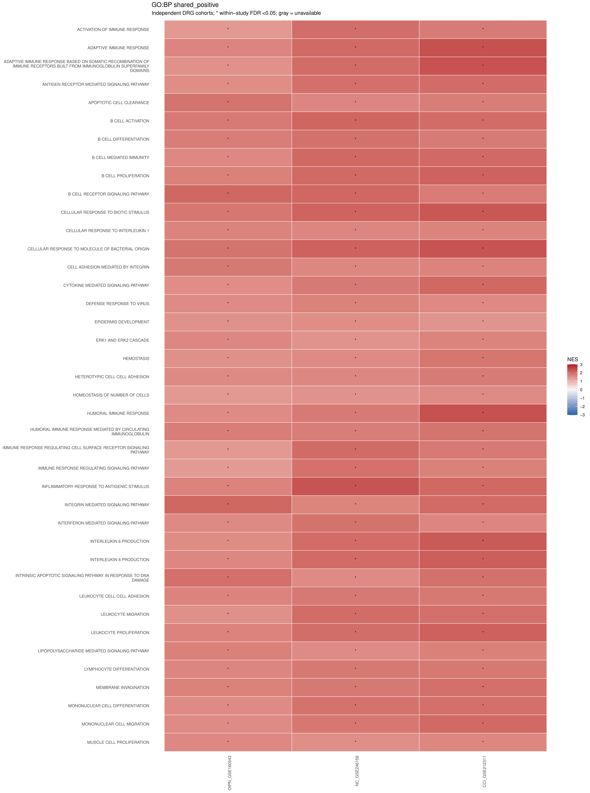
Figure S1. Shared-positive GO:BP pathways (part 1 of 3). All 102 pathways have positive NES and pathway BH FDR <0.05 in OIPN, NC and CCI. Cells show GSEA normalized enrichment scores (NES); red indicates positive and blue negative enrichment. The symmetric scale is shared across studies and pages; rows are not standardized. An asterisk denotes within-study pathway BH FDR <0.05 across the full eligible GO:BP family. OIPN: GSE160543; NC: GSE246156; CCI: GSE212311.

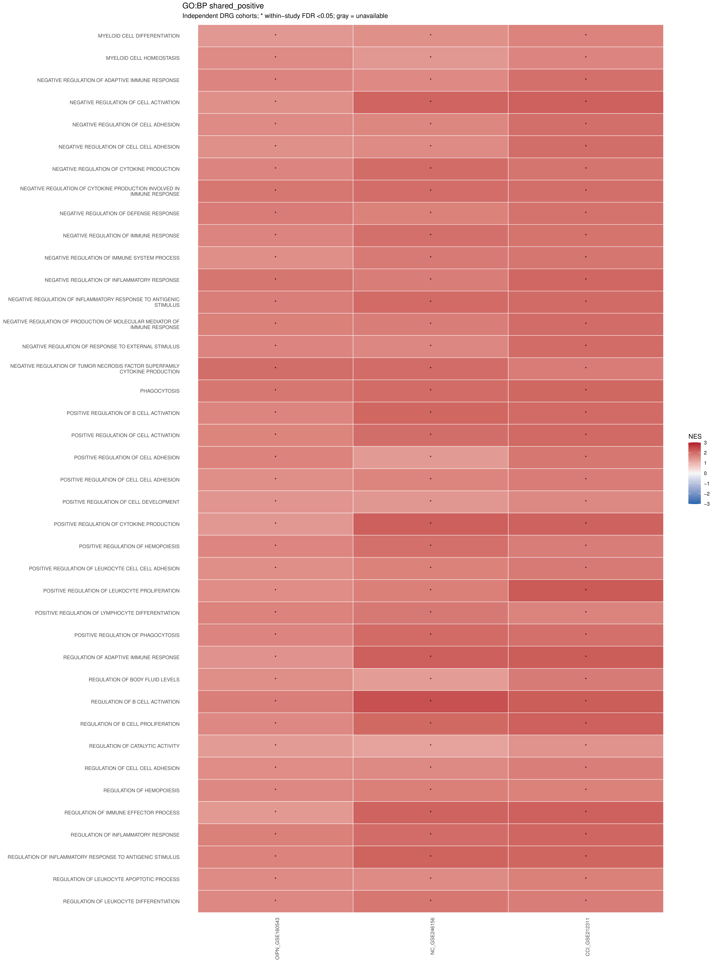
Figure S1. Shared-positive GO:BP pathways (part 2 of 3). All 102 pathways have positive NES and pathway BH FDR <0.05 in OIPN, NC and CCI. Cells show GSEA normalized enrichment scores (NES); red indicates positive and blue negative enrichment. The symmetric scale is shared across studies and pages; rows are not standardized. An asterisk denotes within-study pathway BH FDR <0.05 across the full eligible GO:BP family. OIPN: GSE160543; NC: GSE246156; CCI: GSE212311.

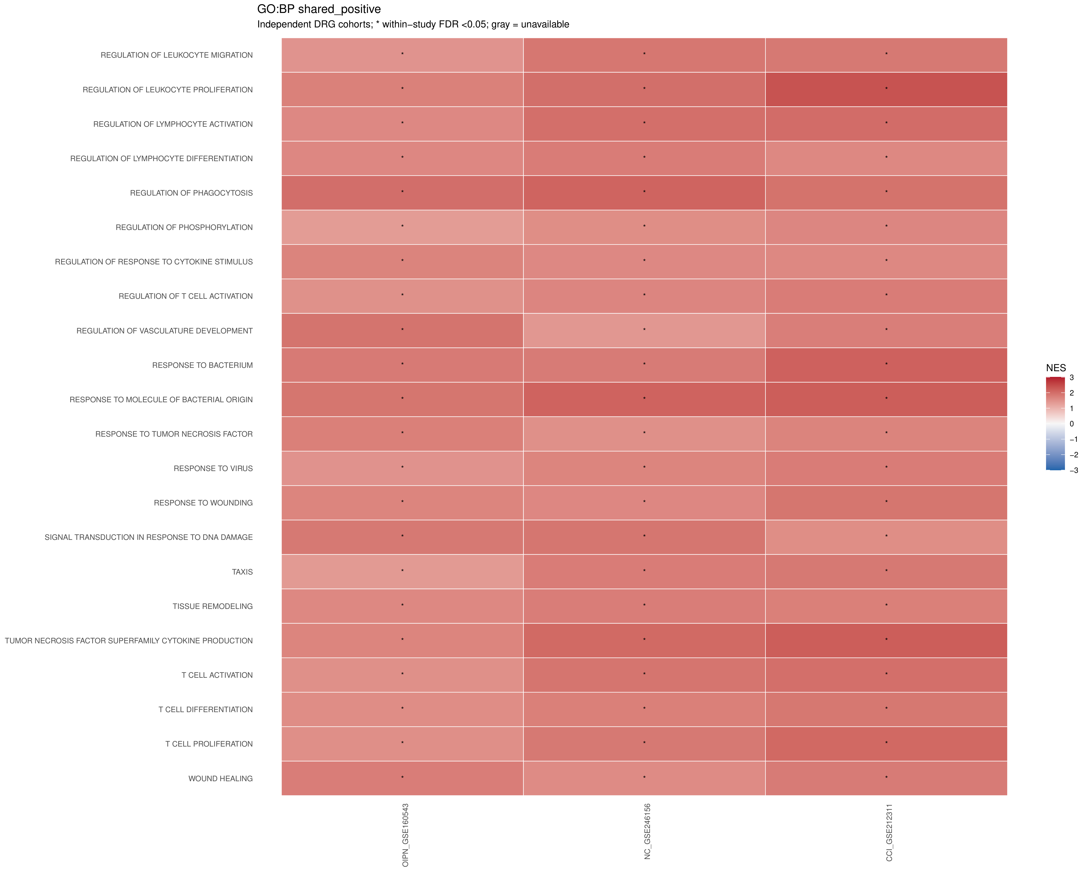
Figure S1. Shared-positive GO:BP pathways (part 3 of 3). All 102 pathways have positive NES and pathway BH FDR <0.05 in OIPN, NC and CCI. Cells show GSEA normalized enrichment scores (NES); red indicates positive and blue negative enrichment. The symmetric scale is shared across studies and pages; rows are not standardized. An asterisk denotes within-study pathway BH FDR <0.05 across the full eligible GO:BP family. OIPN: GSE160543; NC: GSE246156; CCI: GSE212311.

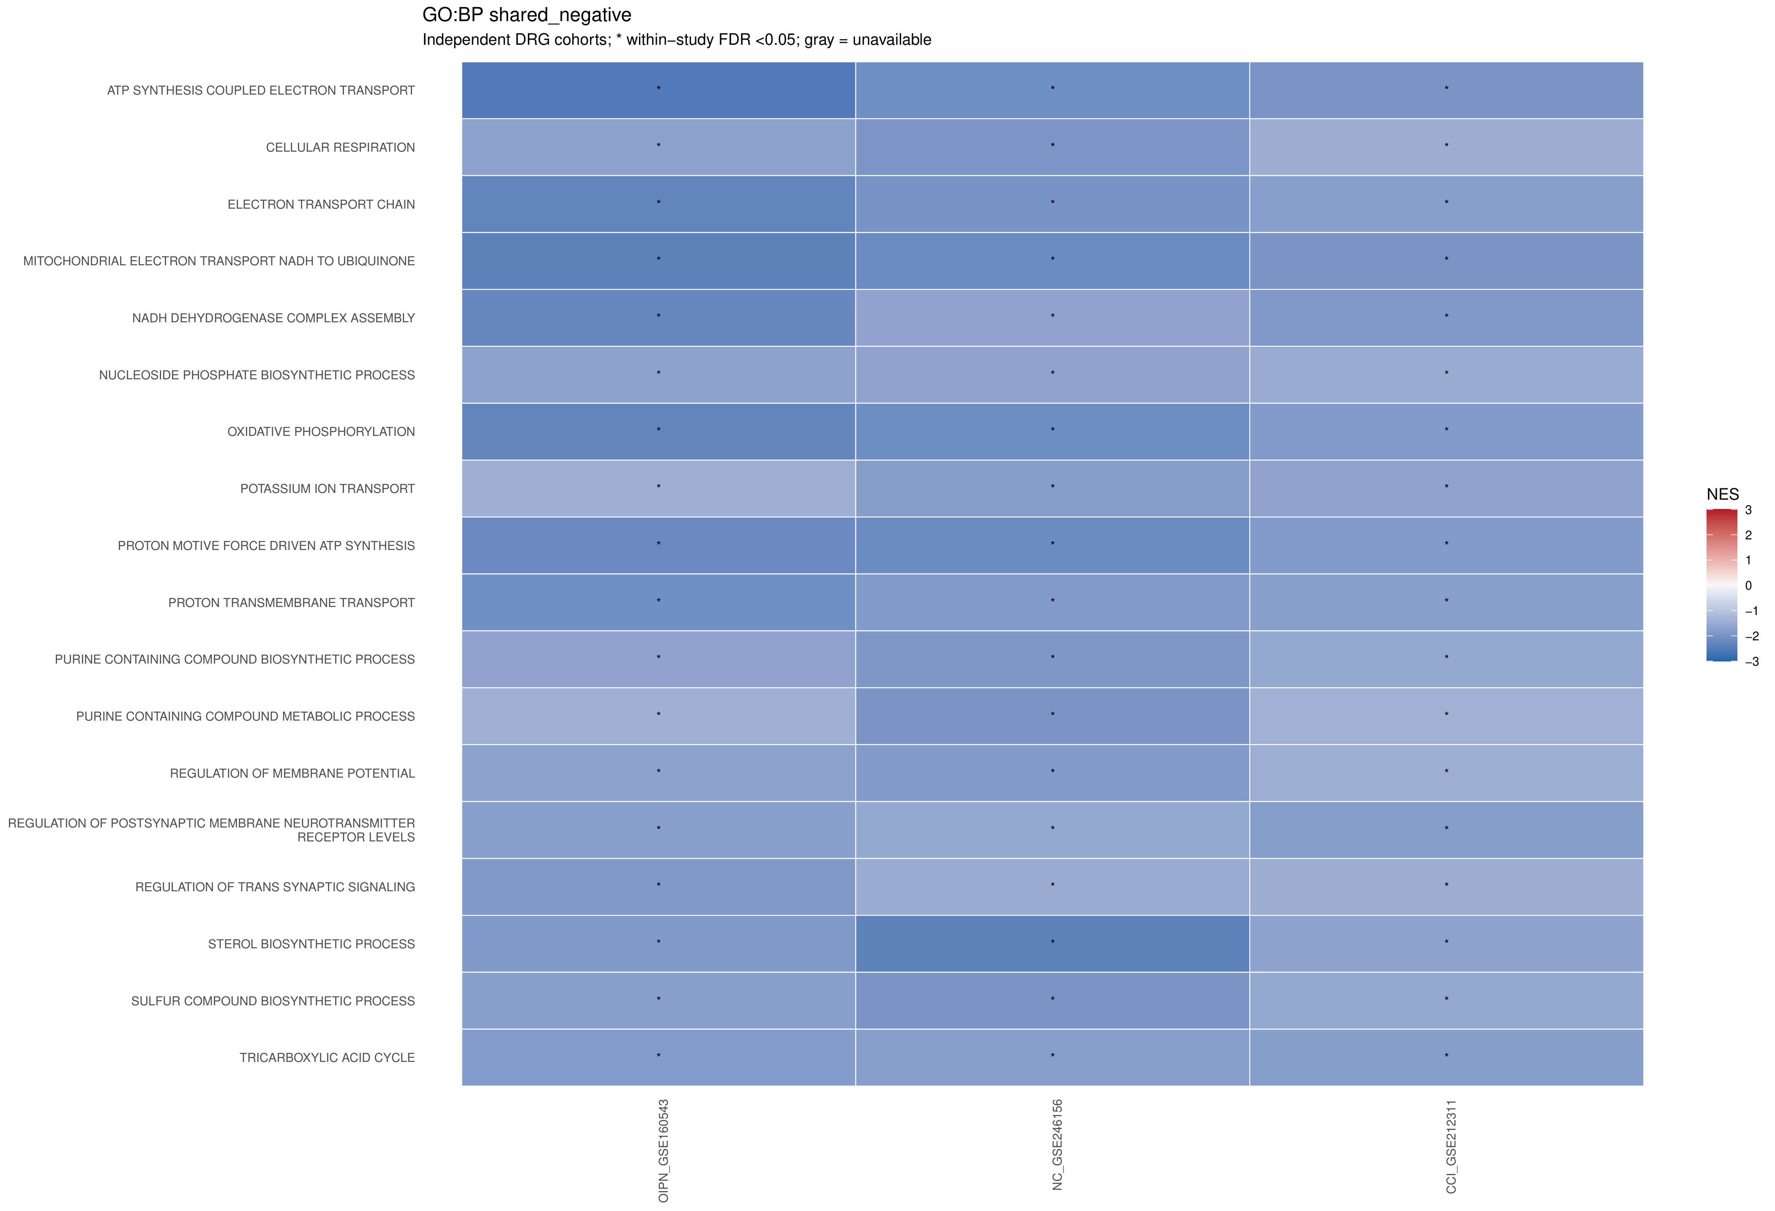
Figure S2. Shared-negative GO:BP pathways. All 18 pathways have negative NES and pathway BH FDR <0.05 in OIPN, NC and CCI. Cells show GSEA normalized enrichment scores (NES); red indicates positive and blue negative enrichment. The symmetric scale is shared across studies and pages; rows are not standardized. An asterisk denotes within-study pathway BH FDR <0.05 across the full eligible GO:BP family. OIPN: GSE160543; NC: GSE246156; CCI: GSE212311.
Gene sets: human MSigDB 2026.1.Hs C5:GO:BP, accessed through msigdbr 26.1.1 and mapped to rat orthologs; overlap size limits 15-500. GO terms overlap. Cross-study enrichment recurrence does not establish cellular origin, functional activation or causality.

Table S2. Genes with opposite expression directions in OIPN and physical injury models.
Gene | OIPN  log2FC | OIPN  FDR | NC  log2FC | NC  FDR | CCI  log2FC | CCI  FDR | Final  selection
Acacb | 0.477 | 3.69E-02 | -2.837 | 3.20E-13 | -0.165 | 8.84E-01 | No
Acsl4 | -0.294 | 1.65E-02 | 0.698 | 1.16E-02 | 0.489 | 1.55E-02 | No
Antxr1 | 0.412 | 1.40E-02 | -0.609 | 3.45E-02 | -0.009 | 9.98E-01 | No
Camk2d | -0.267 | 4.14E-02 | 0.867 | 2.70E-07 | 0.511 | 3.41E-03 | No
Caprin1 | -0.339 | 4.45E-04 | 0.514 | 2.42E-03 | 0.008 | 9.93E-01 | No
Cav1 | 0.407 | 2.53E-02 | -2.502 | 5.24E-26 | -0.093 | 9.74E-01 | Yes
Cd44 | -0.182 | 3.93E-02 | 2.197 | 6.58E-24 | 0.489 | 2.23E-02 | No
Cdc25b | 0.388 | 4.74E-03 | -1.802 | 1.13E-04 | -0.135 | 7.75E-01 | No
Cdh5 | 0.529 | 3.25E-02 | -0.907 | 5.09E-04 | -0.166 | 9.52E-01 | Yes
Col4a2 | 0.332 | 2.21E-02 | -1.539 | 2.55E-18 | -0.098 | 8.88E-01 | Yes
Cxcl12 | 0.417 | 1.49E-02 | -3.082 | 2.04E-34 | -0.038 | 9.90E-01 | No
Disp1 | 0.438 | 8.65E-03 | -2.100 | 2.16E-18 | -0.044 | 9.96E-01 | No
Ehd2 | 0.279 | 3.98E-02 | -1.023 | 1.91E-07 | -0.040 | 9.82E-01 | No
Epb42 | 1.038 | 4.42E-02 | -2.183 | 6.01E-05 | -0.186 | 9.79E-01 | No
Ephx1 | 0.935 | 1.60E-16 | -0.706 | 1.86E-02 | -0.208 | 8.68E-01 | No
Faah | 0.507 | 6.08E-03 | -1.567 | 2.43E-02 | -0.124 | 9.98E-01 | No
Fabp4 | 1.961 | 3.03E-07 | -2.526 | 1.36E-02 | -1.715 | 9.18E-01 | No
Fbxo9 | 0.365 | 1.25E-04 | -0.719 | 1.18E-03 | -0.202 | 4.64E-01 | No
Gadd45a | -0.420 | 9.44E-03 | 2.787 | 1.60E-30 | 1.966 | 5.35E-08 | No
Hopx | -0.420 | 2.77E-03 | 1.070 | 1.21E-02 | 0.526 | 5.42E-05 | No
Il13ra1 | -0.307 | 3.36E-02 | 0.875 | 7.56E-03 | 0.824 | 3.46E-06 | No
Kcnk3 | 1.044 | 4.66E-05 | -2.950 | 2.42E-03 | -0.008 | 9.99E-01 | No
Kel | 2.218 | 4.49E-08 | -2.130 | 2.25E-02 | -0.315 | 9.89E-01 | No
Mapre1 | -0.249 | 4.00E-02 | 1.065 | 1.92E-10 | 0.207 | 2.02E-01 | No
Meox2 | 0.647 | 9.99E-03 | -1.616 | 4.12E-04 | -0.116 | 9.84E-01 | No
Mrap2 | -0.513 | 2.46E-07 | 5.414 | 1.87E-15 | 0.640 | 3.33E-02 | No
Nos3 | 0.692 | 1.26E-02 | -0.687 | 9.49E-03 | -0.084 | 9.86E-01 | No
Pla2g4b | 0.548 | 1.22E-02 | -2.400 | 6.34E-23 | -0.318 | 6.90E-01 | No
Plat | -0.316 | 3.77E-02 | 1.791 | 9.59E-24 | 0.198 | 7.34E-01 | No
Plaur | -0.694 | 1.79E-04 | 4.057 | 8.59E-22 | 0.295 | 6.80E-01 | No
Psmd8 | -0.271 | 3.60E-02 | 0.486 | 2.53E-02 | 0.082 | 9.16E-01 | No
Rsad2 | 1.054 | 3.30E-05 | -1.600 | 8.15E-03 | -1.174 | 7.32E-01 | No
Scrib | 0.298 | 1.05E-02 | -0.786 | 6.79E-05 | -0.061 | 9.65E-01 | No
Slc4a1 | 1.508 | 8.29E-03 | -2.440 | 4.35E-02 | -0.380 | 9.00E-01 | No
Thrsp | 2.850 | 1.19E-04 | -10.026 | 7.25E-05 | -0.489 | 9.29E-01 | No
Tns2 | 0.541 | 1.21E-02 | -1.257 | 2.97E-15 | -0.062 | 9.81E-01 | Yes
Uck2 | -0.441 | 2.28E-02 | 1.360 | 2.72E-07 | 0.225 | 3.74E-01 | No
Vmp1 | -0.302 | 2.49E-02 | 1.548 | 2.54E-23 | 0.093 | 8.72E-01 | No
Wnt6 | 0.404 | 1.84E-02 | -0.637 | 3.93E-02 | -0.053 | 9.88E-01 | Yes
The 39 unique genes were selected across all 457 GO:BP terms with opposite NES signs. The original gene rule requires opposite nonzero log2FC signs in OIPN versus both NC and CCI and original gene FDR <0.05 in OIPN and at least one physical injury study. Genes enter through the union of pathway Leading-edges; this original rule does not require Leading-edge membership and significance in the same pair of studies.
Final selection marks Cav1, Cdh5, Col4a2, Tns2 and Wnt6. These five genes occur within the nine representative pathways from the 24 opposite-direction terms with OIPN pathway FDR <0.05. Each gene matches its pathway NES direction in all three studies and has same-path Leading-edge membership together with gene FDR <0.05 in OIPN and the same NC or CCI study. The other physical study must retain the opposite log2FC sign to OIPN but need not have significant FDR or Leading-edge membership.
Positive log2FC denotes higher expression in neuropathy versus control. FDR values retain the original whole-study gene adjustment; bold values are <0.05. OIPN: GSE160543; NC: GSE246156; CCI: GSE212311. Opposite expression directions do not establish OIPN specificity or a formal interaction between models.

Table S3. Selected evidence sensitivity and GSEA-GSVA concordance.
Counts summarize the locked 37 shared and five opposite-direction genes and 11 shared and nine opposite-direction pathways. OIPN: GSE160543; NC: GSE246156; CCI: GSE212311.
Measure | Category | OIPN | NC | CCI
Genes retaining direction after every omission | Shared | 37/37 | 36/37 | 33/37
Genes retaining direction after every omission | Opposite | 5/5 | 5/5 | 1/5
Pathway GSVA effects retaining direction after every omission | Shared | 11/11 | 10/11 | 11/11
Pathway GSVA effects retaining direction after every omission | Opposite | 9/9 | 4/9 | 1/9
GSEA-GSVA agreement in effect direction | Shared | 11/11 | 11/11 | 11/11
GSEA-GSVA agreement in effect direction | Opposite | 9/9 | 6/9 | 3/9
Pathways with original GSVA FDR below 0.05 | Shared | 0/11 | 7/11 | 0/11
Pathways with original GSVA FDR below 0.05 | Opposite | 0/9 | 2/9 | 0/9
Direction stability is descriptive. For genes, each sample omission retains the strict sign of the neuropathy minus control difference in mean log2(normalized count + 1). For pathways, the corresponding difference uses archived GSVA scores. Normalization and scoring remain fixed; DESeq2 and limma are not refitted, and no new P values or FDR are calculated. Stability is not a significance test.
The direction-sensitive shared genes are Tln1 in NC and Cd14, Parp14, Dhcr7 and Syt11 in CCI. Cdk1 and Cdkn1a retain positive descriptive differences after every omission in all three studies. Tissue remodeling is the direction-sensitive shared pathway in NC.
All five opposite-direction genes retain their descriptive directions in OIPN and NC. In CCI, only Col4a2 remains negative after every omission; Cav1, Cdh5, Tns2 and Wnt6 can change sign. None of these five genes has original gene FDR below 0.05 in CCI.
The sole stable opposite-category GSVA term in CCI is Schwann cell differentiation. Its positive GSVA effect disagrees with its negative GSEA NES. The stability counts refer to each GSVA baseline, not agreement with GSEA. GSEA and GSVA use the same samples and are complementary evidence, not independent validation.

