**Queries:**

1. select * from singer where singer_birthplace ="Hong Kong";

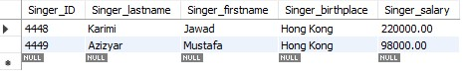

1. select Staff_ID, Staff_lastname, Staff_firstname, period_of_emp, Staff_job from Staff where

Staff_job = "Event Manager" and period_of_emp > 3;



1. select Concert_ID, Concert_name, Concert_location from concert where concert_date between ‘2006-01-01’ AND ‘2006-12-30’;

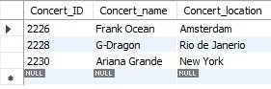

1. select Concert_ID from guest where total_guests > 3;

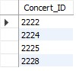

1. select Singer_ID, Singer_lastname, Singer_firstname, Singer_salary from singer where Singer_salary > 150000;

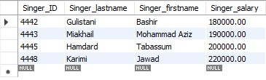

1. select Concert_ID, Concert_name, net_revenue from Concert where net_revenue >= 1;

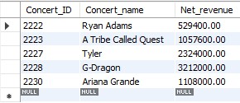

**Additional:**

1: List of concerts that sponsored with at least 10000 or higher;

Select Concert_ID, Concert_name, Spon_amount from Concert where Spon_amount > 10000;

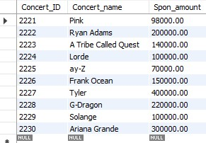

2: List of singers who is from New York or have a salary of 90000 or higher.

Select Singer_ID, Singer_birthplace from singer where Singer_birthplace = ‘New York’ OR Singer_Salary > 90000;

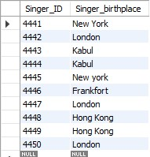

3: List of concerts and guests that were held in New York and Paris and had more than one guest;

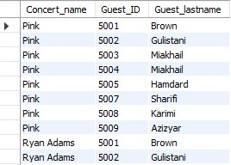Select Concert_name, Guest_ID, Guest_lastname from concert, guest where (Concert_location = 'New York' and Concert_location = 'Paris') OR (total_guests > 1);

4: List of singer and concert whose Performance ID is 8831

Select Singer_lastname, Singer_firstname, Performance_ID, Concert_name from Singer, Performance, Concert where Performance_ID = 8831;

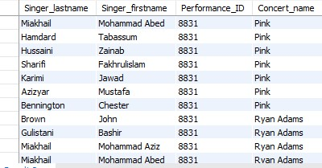

5: List of staff who works as a security guard and their first name starts from N.

Select Staff_ID, Staff_lastname, Staff_firstname, Staff_job from staff where Staff_job = ‘Security Guard’ AND Staff_firstname like ‘N%’;



6: List of Singers that has a salary of at least 100000 and their names are at least 6 characters.

Select Singer_ID, Singer_firstname, Singer_salary from Singer where Singer_salary >= 100000 AND Singer_firstname like ‘%______%’;

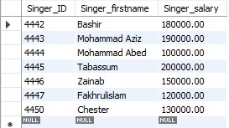

7: List of concerts that located in New York and Paris OR sold less than 3000 tickets

Select Concert_ID, Concert_name, Concert_location, ticket_squantity from concert where (concert_location = ‘New York’ AND concert_location = ‘Paris’) OR ticket_squantity < 3000;

