VitalTrack
Muhammad Otah Bashi

1. Introduction
An Electronic Health Record (EHR) system is often described as a digital version of the paper chart, but the practical aim is broader than digitising documents. An EHR is meant to organise patient information so it can be updated over time and accessed securely by authorised users when clinical decisions are being made. In a typical setting, this includes medical history, diagnoses, medications, treatment plans, immunisation dates, allergies, radiology images, and laboratory results—information that would otherwise be scattered across paper files or separate systems.
EHRs have become a standard part of modern healthcare because they can improve the reliability and availability of patient information. When clinicians can find up-to-date records quickly, they are better positioned to make informed decisions, coordinate care with other providers, and reduce avoidable errors that come from missing details or illegible handwriting. At the same time, real-world EHRs also show that benefits depend on design quality and how well the system supports everyday workflows. For this reason, building even a simplified EHR system requires attention not only to features, but also to usability and access control.
The development of EHRs has a long history, with early hospital computing projects appearing decades ago. However, widespread adoption became more visible in the 2000s, supported by improvements in web technologies, databases, and policy environments that encouraged digitisation. Today, EHR systems are used across most healthcare settings, and they provide a useful reference point for understanding how sensitive data is stored, structured, and accessed in a controlled way.
I developed this EHR information system as a university project to practise building a web-based healthcare application that resembles core EHR functionality. Before implementation, I reviewed examples of existing EHR systems and feature lists to understand what is commonly expected in a basic clinical record platform. That initial research helped shape the scope: doctor registration and login, patient management, appointment scheduling, recording laboratory results, uploading radiology images, and documenting medical history (especially allergies). The system is designed mainly for doctors to manage their own patients’ records within a single application. Building it gave me practical experience with full-stack development, database modelling, and security decisions that are unavoidable when handling health-related information.

2. Website Design and Technical Architecture

2.1 Design Process
Before coding, I planned the system structure and user interface with the assumption that a doctor should be able to navigate quickly and predictably. Rather than designing a complex interface with deep menus, I used a simple layout with a top navigation bar that provides direct access to the main modules. This approach keeps the system understandable as the number of records increases and reduces the effort required to switch between tasks.
The user interface follows a clean, modern style. A purple gradient navigation bar includes the “VT” (VitalTrack) logo and links to key areas: Dashboard, Patients, Appointments, Lab Results, Radiology Imaging, and About Us. The navigation bar also shows the logged-in doctor’s name and specialty, with a dropdown menu for profile settings and logout. Even in a student project, this small detail reinforces that the system is account-based and that access should be controlled by login state.

2.2 Frontend Structure
The frontend is built using HTML, CSS, and Bootstrap. Pages extend from a shared base template (base.html) so that navigation and styling remain consistent throughout the system. This reduces duplicated code and makes it easier to update the interface without changing every page separately.
Technologies used include: HTML5 for structure, CSS3 for custom styling, Bootstrap 4.6.2 for responsive design, and icon libraries (Bootstrap Icons and Font Awesome) for visual cues across modules. Google Fonts (Kavoon and Mogra) provide consistent typography. Custom CSS refines elements such as the navigation bar, cards, buttons, forms, and flash messages. The colour scheme centres on purple gradients for primary elements, chosen to give the system a clear identity while keeping the overall interface professional.

2.3 Backend Structure
The application uses Flask’s application factory pattern, creating the app in app.py through a create_app() function. Routes are organised into blueprint modules, which keeps features separated and improves maintainability. The main blueprints include:
- auth.py — Registration, login, email confirmation, password reset
- main.py — Dashboard and general navigation
- patients.py — Patient management
- appointments.py — Appointment scheduling and editing
- lab_results.py — Laboratory results management
- radiology.py — Radiology imaging management
- medical_history.py — Medical history and allergy tracking
- doctor.py — Doctor profile management
Early in development, routes were placed in a single file, but splitting them into blueprints became necessary as the project grew. This change made the code easier to read and reduced the likelihood of feature interactions being hidden inside a large route file.
Technologies Used:
- Python 3 — Programming language
- Flask 2.3.3 — Web framework
- Flask-SQLAlchemy 3.0.5 — Database ORM (Object-Relational Mapping)
- Flask-Mail 0.9.1— Email functionality
- Werkzeug 2.3.7 — Password hashing and security utilities
- itsdangerous 2.1.2 — Token generation for email confirmation and password reset
- python-dotenv 1.0.0 — Environment variable management
- mysql-connector-python 8.1.0 — MySQL database connector
- Pillow 12.0.0 — Image processing for radiology uploads

2.4 Database Structure
The system uses MySQL, with the schema defined through SQLAlchemy models in models.py. The database is organised into core tables and clinical record tables that reflect the main entities and relationships needed for basic EHR functionality.
Core tables include:
- Doctor — Doctor identity and account data (including hashed password and specialty)
- Specialty — Medical specialty information
- Patient — Patient identifiers and basic details (name, email, phone, age, gender, date of birth)
- DemographicInfo — Additional patient details (address, emergency contact)
- SocialHistory — Patient social history (smoking, alcohol use, drug use, occupation)

Medical record tables include:
- MedicalHistory — Patient history entries linking to allergies/conditions with description and date
- Allergy — Allergy/condition names for reuse and consistency
- LaboratoryResult — Test name, result, unit, reference range, status, date, and notes
- RadiologyImaging — Imaging name/type, date, and uploaded image filename
- Appointment — Patient, doctor, date/time, type, status, and notes
- Prescription — Medication details and date ranges (included in the model for completeness)
Relationships are designed so that a doctor can have many patients, and each patient can have many appointments, lab results, radiology records, and medical history entries. The model also includes a many-to-many relationship between doctors and specialties, although the current user interface supports only one specialty per doctor. This mismatch is noted later as a limitation and potential improvement.

2.5 Data Flow
The system follows a typical web application flow. The user interacts with HTML pages through links and forms, generating HTTP requests that Flask routes handle. Protected routes use a @login_required decorator, which checks session data for a logged-in flag. When the user is authenticated, the route handler performs database operations through SQLAlchemy, validates inputs, and then passes results into Jinja2 templates to render the final HTML response.
A common example is adding a patient: a doctor submits a form via POST, the system validates required fields and basic formatting, creates a new Patient object linked to the logged-in doctor, commits the entry to the database, and then shows a success message before redirecting to the patient list. Similar patterns apply across appointments, lab results, radiology records, and medical history entries.

2.6 Security Features
Because the system deals with sensitive health information, basic security practices were built into the design:
- Password hashing: Passwords are hashed using Werkzeug rather than stored in plaintext. This was implemented after early development, when it became clear that plaintext storage is not acceptable even for a learning project.
- Session management: Authentication state is stored in Flask sessions, including the doctor’s ID and basic profile fields.
- Email confirmation: New registrations require email confirmation before login is allowed, reducing the risk of fake or unreachable accounts.
- Password reset: A “forgot password” flow sends a time-limited token link via email.
- Access control: Doctors can only access records linked to their own account. Queries are filtered by the logged-in doctor’s ID.
- File upload checks: Radiology uploads validate file type and size, and files are stored in patient-specific folders.
- Environment variables: Sensitive configuration (database credentials, secret keys, email settings) is stored in a .env file rather than hard-coded. The .env file is not committed, and a .env.example is provided.
These measures do not cover every requirement of a production healthcare system, but they establish a responsible baseline for a university project and align with common secure development expectations for applications handling private data.
NOTE: For security reasons, the environment file (.env) is not committed to the repository. Instead, an example configuration file (.env.example) is provided.

3. EHR Information System
This section explains how to use the system and what each module supports. The system is intended to be straightforward for doctors, but the step-by-step guide clarifies workflows and helps ensure features are used correctly.

3.1 Registration
To use the system, doctors must first create an account. Figure 1 below shows the registration page.
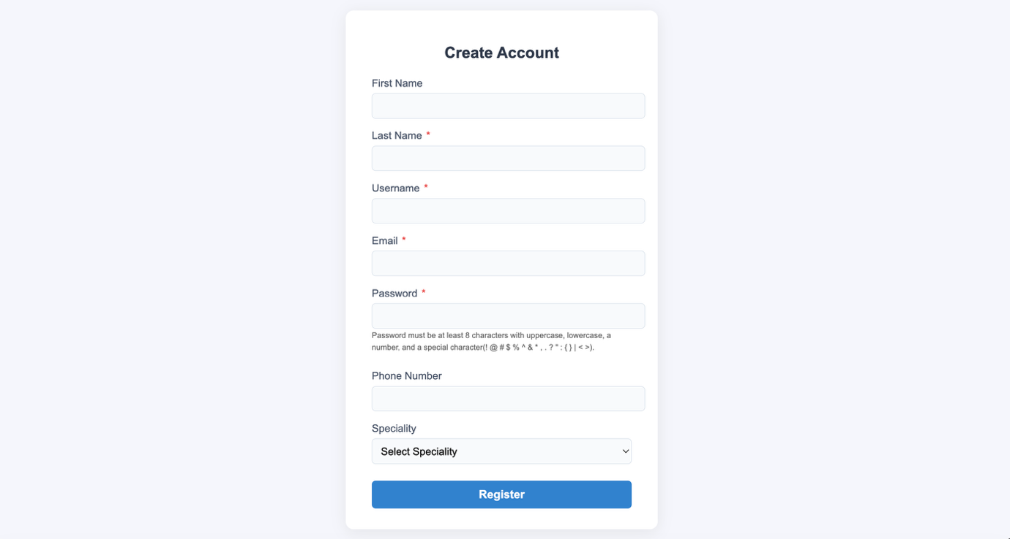
The form collects various data, with required fields marked by an asterisk (*). Although the database supports multiple specialties per doctor, the current interface only allows for the selection of one specialty.
When submitted, the system validates inputs and provides specific error messages if a field fails checks (for example, a duplicate email or weak password). On successful registration, the password is hashed and stored, and an email confirmation link is sent. The doctor must confirm their email before they can log in.
Figure 2 below shows the registration success page.
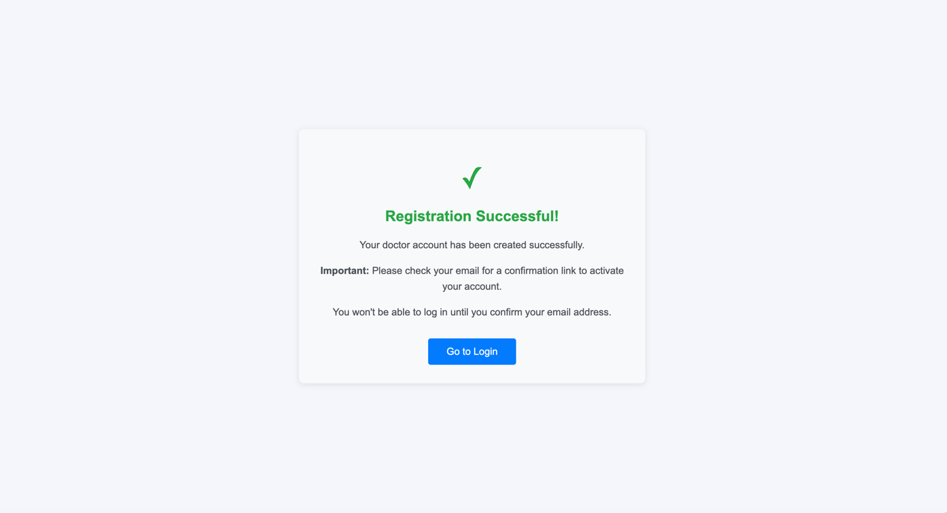

3.2 Login
Figure 3 below shows the login page. Doctors can log in using either their username or email, plus their password.
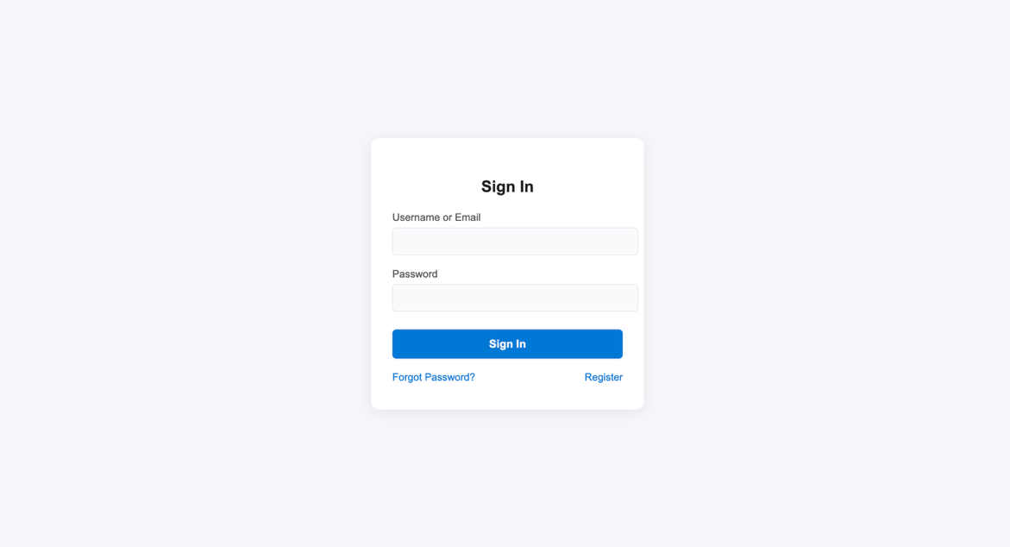
The system looks up the doctor by username/email, checks the password against the stored hash, and blocks login if the email is not confirmed. When authentication succeeds, the system creates a session and redirects the doctor to the dashboard. Session data includes the doctor’s ID, name, specialty (currently treated as a single value), and a logged_in flag.
3.3 Dashboard
Figure 4 below shows the dashboard, which acts as the system’s main hub.
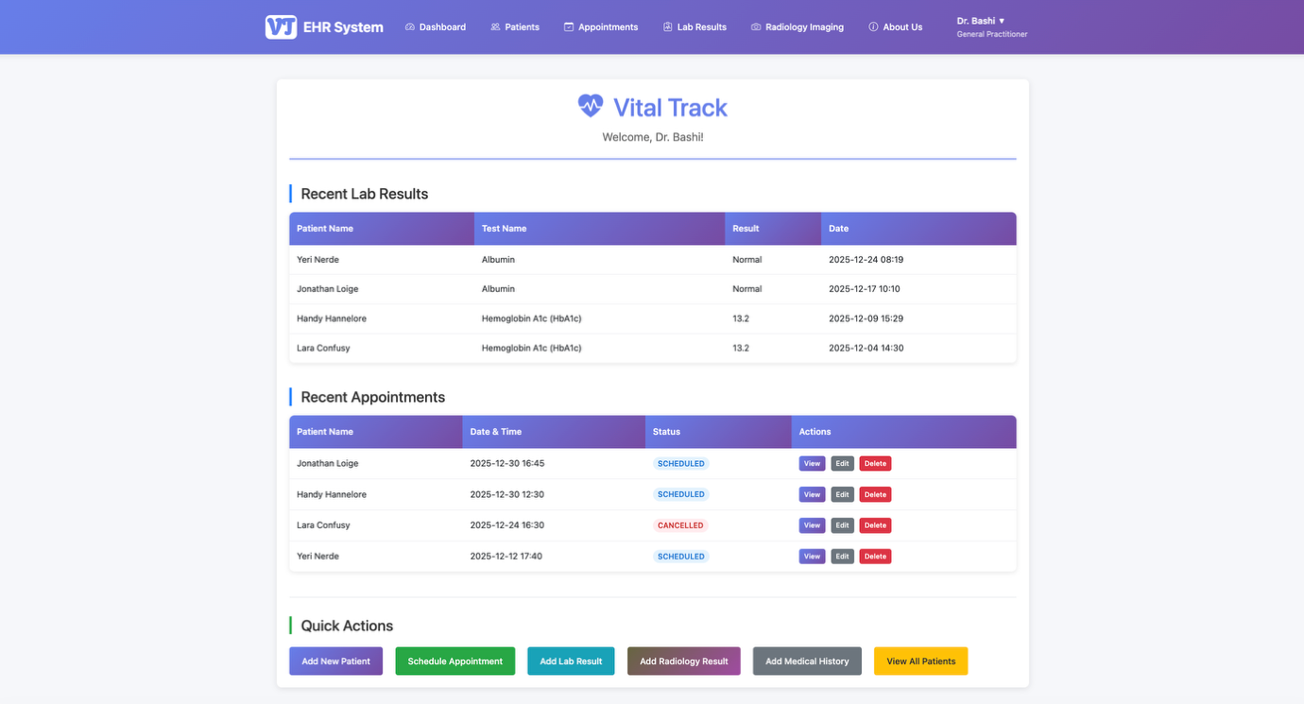
The dashboard displays recent activity across the doctor’s patients: up to 10 recent lab results and up to 10 recent appointments. It also provides quick navigation cards for common tasks such as adding a patient, scheduling an appointment, recording lab results, and uploading radiology images. The goal is to reduce clicks for frequent actions and provide a quick overview of what has changed recently.

3.4 Patient Management

3.4.1 Viewing All Patients

Patients are displayed in a table with basic details (name, email, phone, age, gender). The page also shows counts of related records (appointments, lab results, radiology images, and medical history entries) and a small view of recent medical history entries, especially allergies. A statistics panel summarises totals and distributions (patient count, gender, age groups, and number of patients with medical history). Each patient row includes actions to view, edit, or delete.
Figure 5 shows the patient list page.

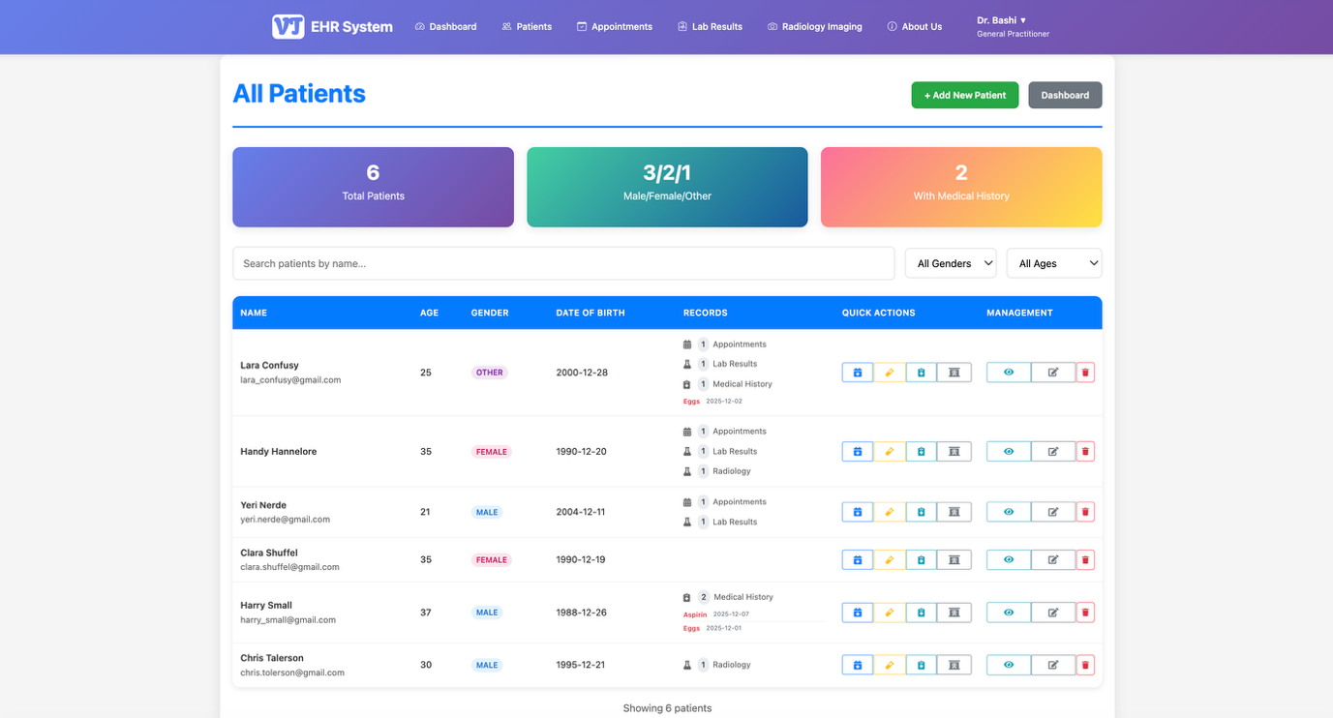

Patients are displayed in a table with basic details. The page also shows counts of related records and a small view of recent medical history entries, especially allergies. A statistics panel summarises totals and distributions. Each patient row includes actions to view, edit, or delete.

3.4.2 Adding a New Patient

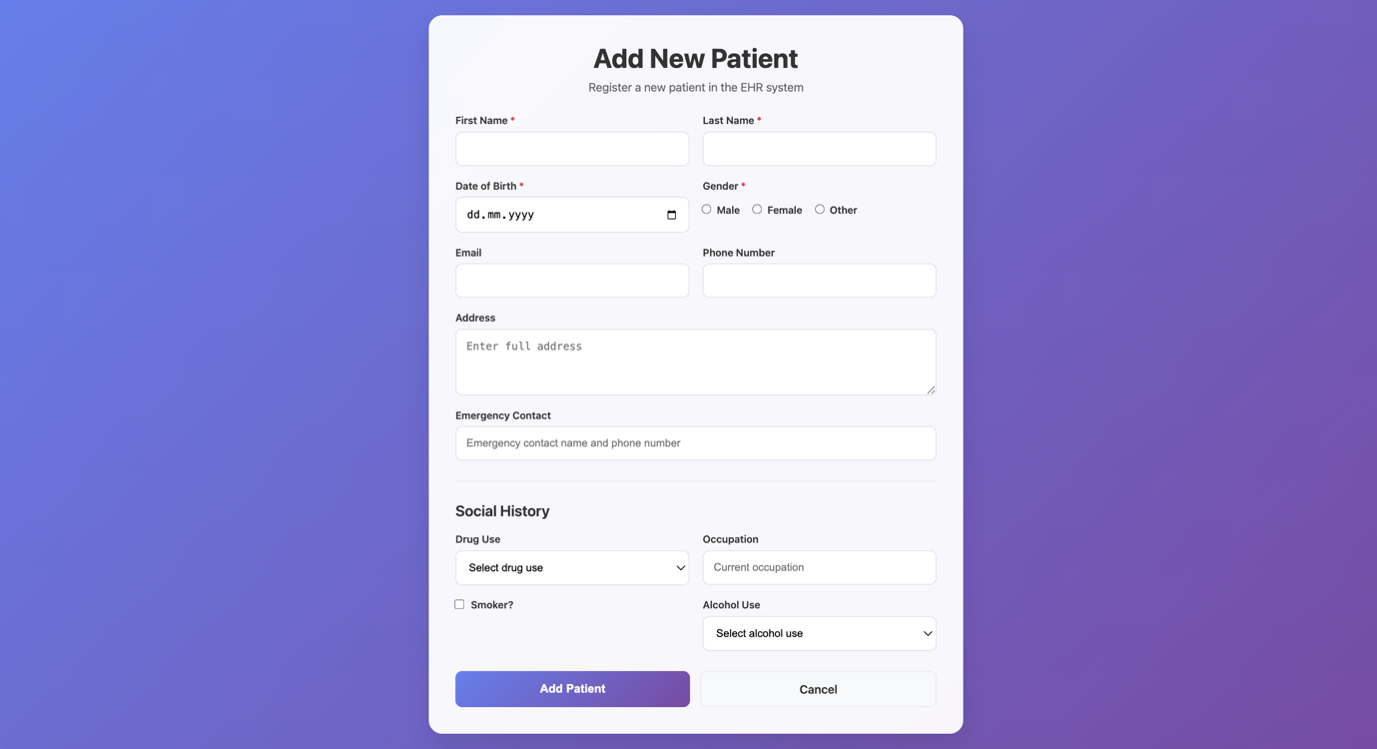

Figure 6 shows the add patient form.

The form collects various data, with required fields marked by an asterisk (*). The system validates required fields and date of birth before creating the patient record linked to the logged-in doctor.

3.4.3 Viewing Patient Details
This page combines: basic patient information, demographic details, social history (if available), and recent clinical records. It shows the last five appointments, lab results, radiology entries, and medical history items. Action buttons allow the doctor to edit patient data and add new records directly from the patient page, which keeps workflow centred on the patient rather than forcing the user to move across modules repeatedly.
Figure 7 shows the patient detail page.
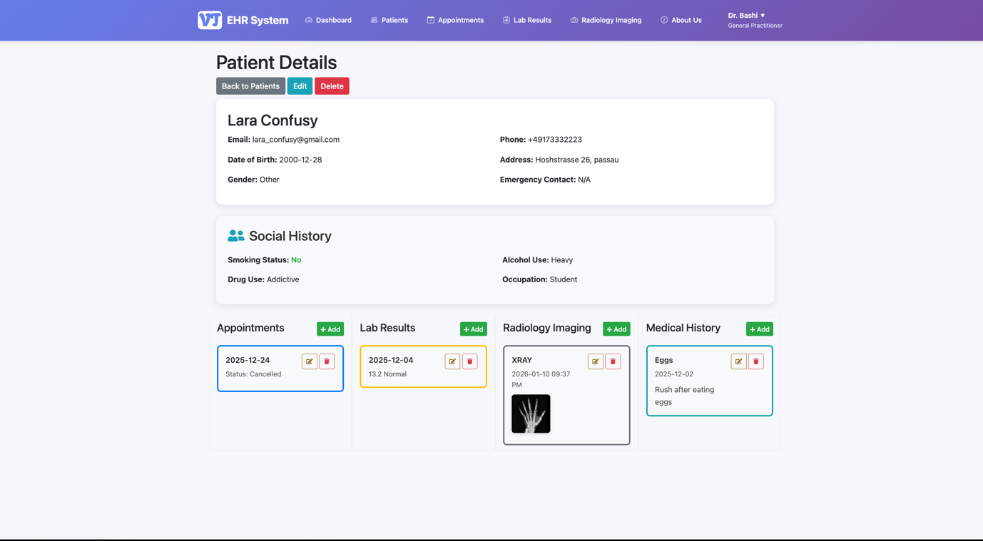

3.4.4 Editing Patient Information
Doctors can update fields and save changes. Validation rules remain the same as when adding a patient, which helps prevent incomplete or inconsistent records.

3.4.5 Deleting Patients
Doctors can delete patient records. When a patient is deleted, related records (appointments, lab results, radiology entries, and medical history) are also removed to maintain database integrity. The system asks for confirmation before deletion.

3.5 Appointment Management

3.5.1 Viewing Appointments

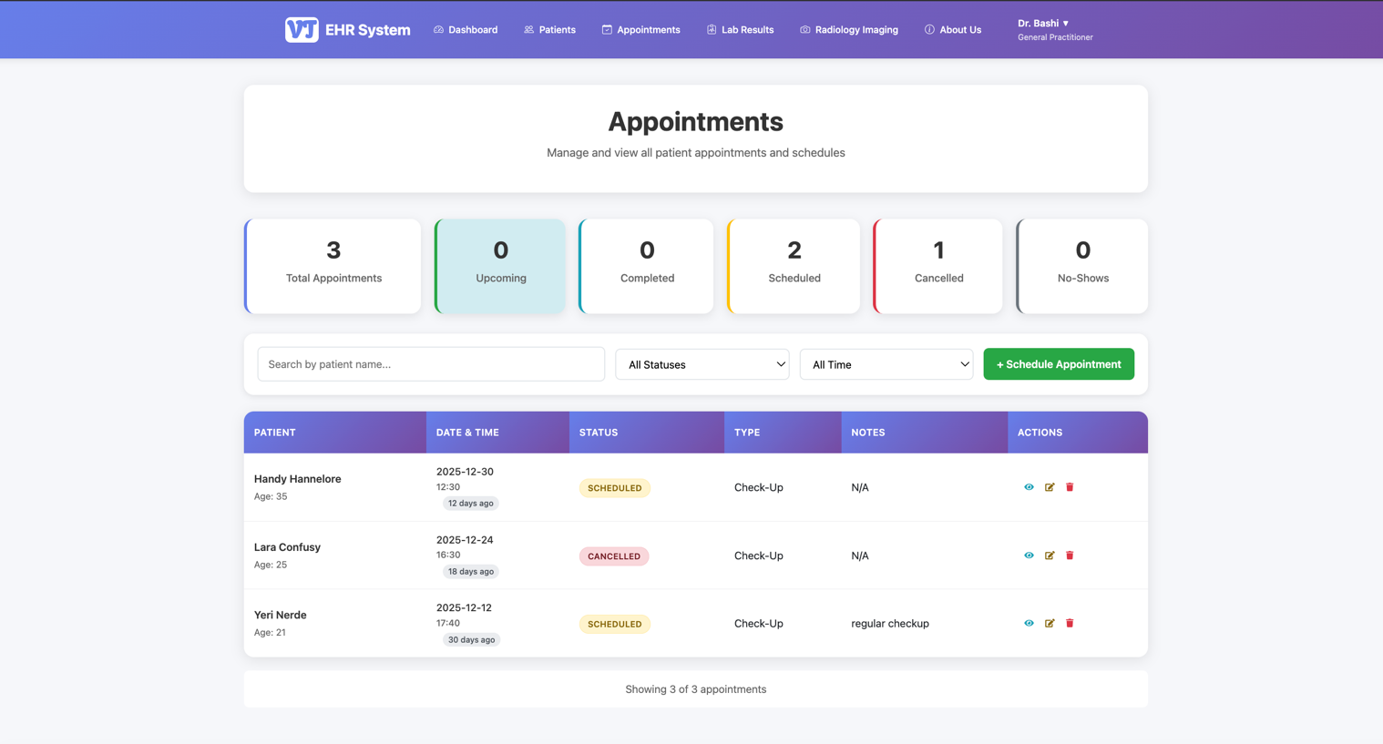
Figure 9 shows the appointments list page.
Appointments display patient name, type, date/time, status, and notes. A statistics area summarises totals and status breakdown (upcoming, completed, cancelled, no-show). Each appointment can be viewed, edited, or deleted.

3.5.2 Scheduling an Appointment
The doctor selects a patient, chooses date/time, optionally selects appointment type, and can add notes. The system validates required fields and checks for scheduling conflicts (another appointment at the same time). After saving, the appointment appears in the list and dashboard.

3.5.3 Viewing and Editing Appointments
Doctors can update time, type, status, and notes. Conflict checks apply during edits to prevent overlapping appointments.

3.6 Laboratory Results Management

3.6.1 Viewing Lab Results

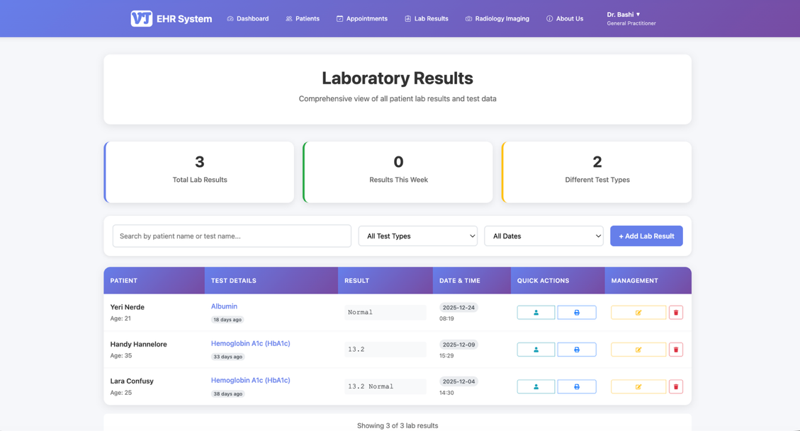
Figure 12 shows the lab results list page.
Each result includes patient name, test name, result value, unit and reference range (if provided), status label, date, and notes. The page summarises totals and recent results and lists the test types stored in the system.

3.6.2 Adding Lab Results

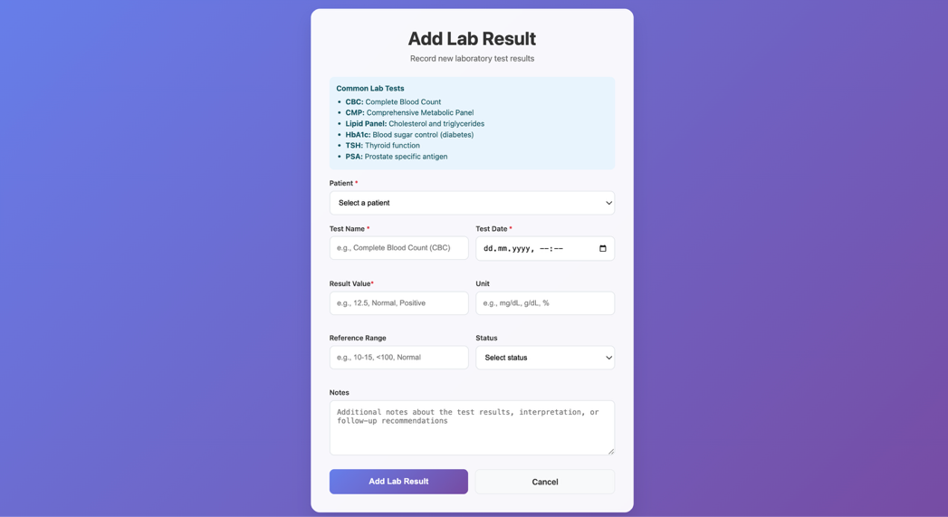
Figure 13 shows the add lab result form.
Doctors select a patient and enter test name, test date, and result value. Unit, reference range, status, and notes are optional but supported. The system validates required fields and ensures the patient belongs to the logged-in doctor. Saved results appear in the patient record and on the dashboard.
3.6.3 Editing and Deleting Lab Results
Doctors can edit lab results using a pre-filled form and can delete results that were entered incorrectly. This keeps records maintainable without requiring database access outside the application.

3.7 Radiology Imaging Management

3.7.1 Viewing Radiology Images
Figure 14 shows the radiology imaging list page.
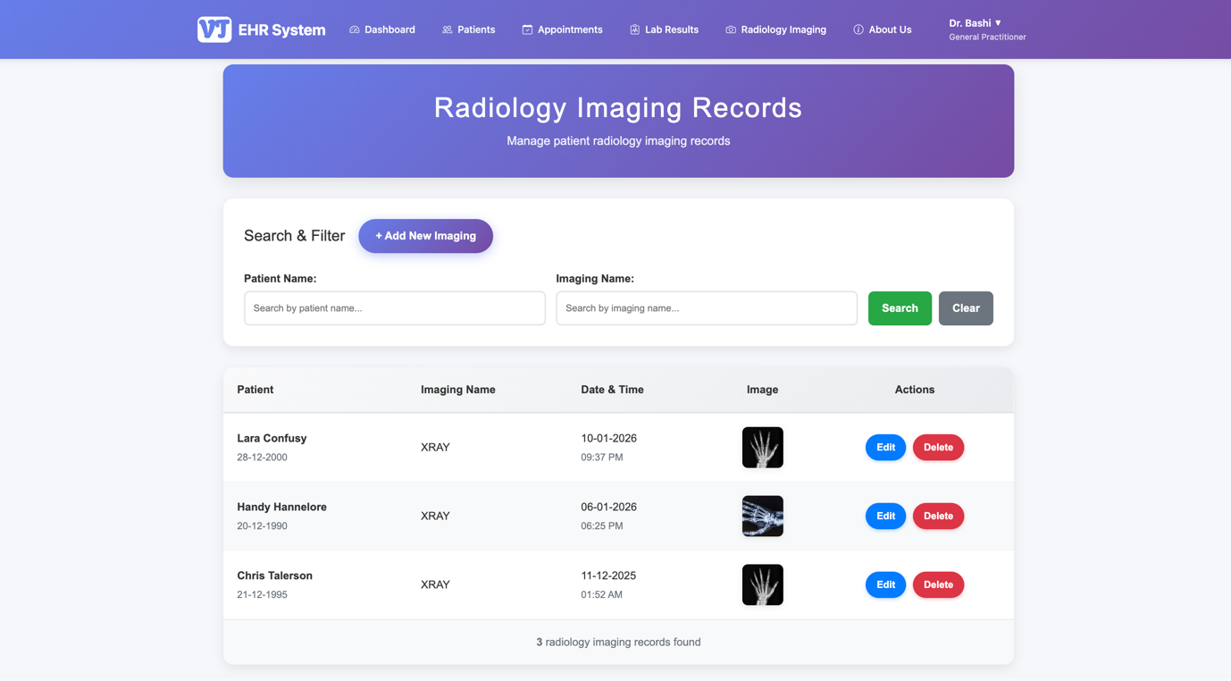
Records display patient name, imaging name/type, date, and a thumbnail preview if an image was uploaded. Search supports filtering by patient name or imaging name.

3.7.2 Adding Radiology Imaging
Doctors select a patient, enter imaging name/type and date, and optionally upload an image file (supported formats include common image types and DICOM-related extensions). The system enforces file type validation and a maximum size of 10MB. Files are stored in static/uploads/radiology/patient_X/, and the filename is saved in the database for retrieval.

3.7.3 Editing and Deleting Radiology Records
Doctors can edit imaging metadata (name/date). When deleting a radiology record, the system also deletes the associated image file to avoid unused storage and leftover data.

3.8 Medical History Management

3.8.1 Adding Medical History
Medical history entries link patients to allergies or conditions. Doctors select a patient, enter or select an allergy/condition name, add a description (reaction details or clinical notes), and provide a date. If the allergy/condition name does not exist, the system creates a new Allergy entry automatically, allowing flexible documentation without losing consistency across patients.

3.8.2 Viewing Medical History
Medical history entries appear in multiple places: the patient detail page, the patient list page (recent entries), and when reviewing an individual patient record. Entries display the allergy/condition name, description, and date.

3.8.3 Editing and Deleting Medical History
Doctors can edit medical history entries to correct details and can delete entries that were added incorrectly.

3.9 Doctor Profile Management
Figure 17 shows the doctor profile page.
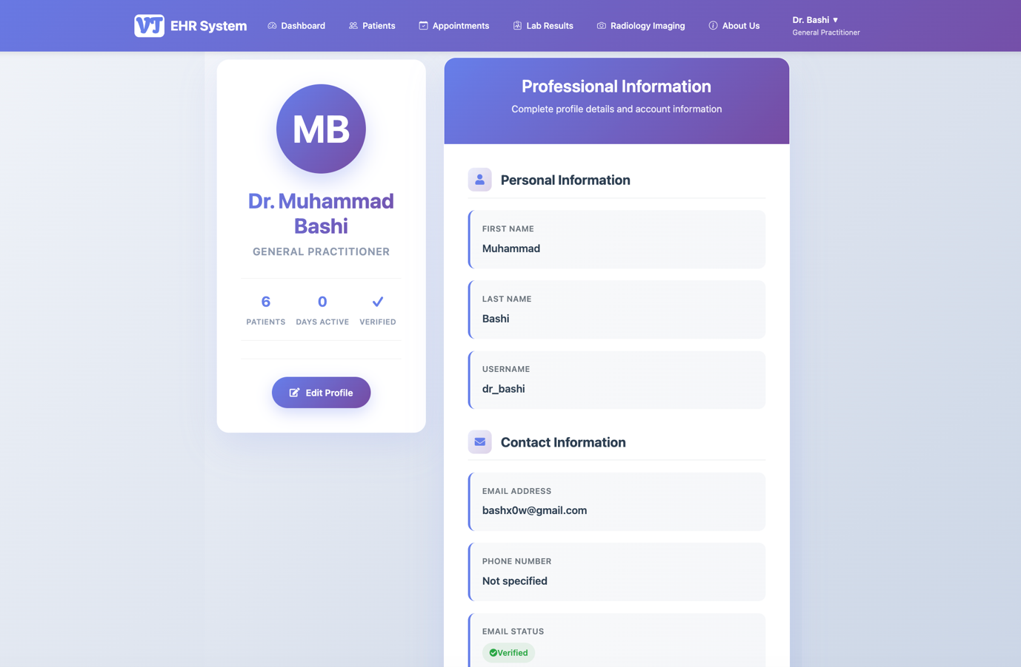
Doctors can view and update first name, last name, email address, and phone number. The system validates updates and ensures email addresses remain unique.

3.10 Password Management

3.10.1 Forgot Password
Figure 18 shows the forgot password form.
Doctors can request a reset by entering their email address. The system sends a reset link containing a secure token that expires after 24 hours.

3.10.2 Reset Password
Figure 19 shows the reset password form.
Doctors enter a new password that must meet the same strength rules as registration. After saving, they can log in with the new password.
3.11 About Us Page
Figure 20 and Figure 21 show the About Us page.
This page provides system-wide statistics: total patients, appointments, lab results, radiology records, and registered doctors. It gives a simple view of system usage and helps demonstrate scale during testing or presentation.
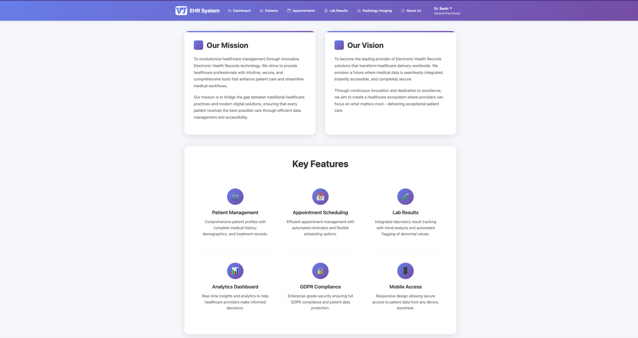

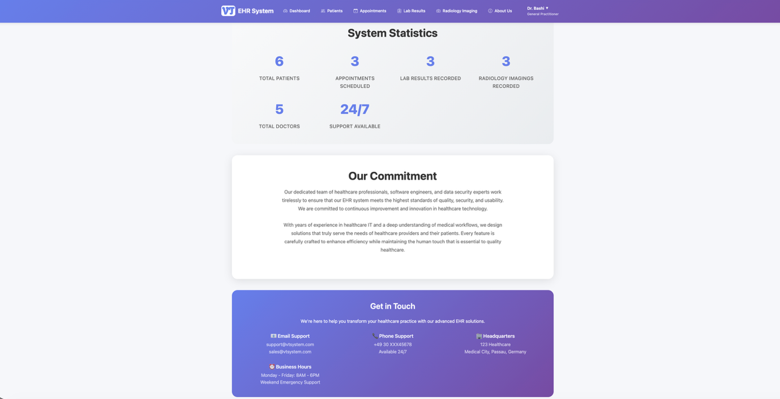

3.12 System Features Summary
The EHR system supports essential record-keeping tasks for a doctor managing their own patients. Patient management includes creating, viewing, editing, and deleting patient profiles with demographic and social history data. Appointment scheduling supports different types and statuses and prevents double booking. Laboratory results and radiology imaging modules store diagnostic information with structured fields and optional notes. Medical history tracking focuses on allergies and conditions, allowing entries to be added, edited, and reviewed within patient context. Security measures—hashed passwords, confirmation and reset workflows, access control by doctor ID, safer configuration management, and file upload checks—support responsible handling of sensitive data within the scope of a university project.

4. Evaluation of the EHR Information System
To evaluate usability, I used the System Usability Scale (SUS), a common questionnaire-based method for measuring perceived usability. SUS provides a single score from 0 to 100 based on responses to ten statements. It is widely used because it is quick to administer and easy to interpret, especially for early-stage systems.

4.1 SUS Methodology
SUS consists of 10 statements rated on a 5-point Likert scale from “Strongly Disagree” (1) to “Strongly Agree” (5). The statements alternate between positive and negative wording. Scoring follows a standard transformation: odd-numbered items are scored as (response − 1), even-numbered items as (5 − response). The adjusted values are summed and multiplied by 2.5 to produce the final SUS score (Brooke, 1996).
The SUS statements used were:
- I think that I would like to use this system frequently.
- I found the system unnecessarily complex.
- I thought the system was easy to use.
- I think that I would need the support of a technical person to be able to use this system.
- I found the various functions in this system were well integrated.
- I thought there was too much inconsistency in this system.
- I would imagine that most people would learn to use this system very quickly.
- I found the system very cumbersome to use.
- I felt very confident using the system.
- I needed to learn a lot of things before I could get going with this system.

4.2 Evaluation Process
For this project, I asked one evaluator (a fellow student) to use the system and complete the SUS questionnaire. Although SUS is often used with multiple participants, using one evaluator allowed me to practise the method carefully and get direct feedback after a first-time use session.
The evaluator was asked to complete key tasks: register a doctor account, log in, add a patient, schedule an appointment, add a lab result, add a radiology imaging record, add medical history, view patient details, and then complete SUS. The evaluator used the system for approximately 15–20 minutes before submitting the questionnaire.

4.3 SUS Score Calculation
The evaluator’s responses were:
- Statement 1: 4
- Statement 2: 2
- Statement 3: 5
- Statement 4: 2
- Statement 5: 4
- Statement 6: 2
- Statement 7: 4
- Statement 8: 2
- Statement 9: 4
- Statement 10: 2
Adjusted scoring:
- Item 1: 4 − 1 = 3
- Item 2: 5 − 2 = 3
- Item 3: 5 − 1 = 4
- Item 4: 5 − 2 = 3
- Item 5: 4 − 1 = 3
- Item 6: 5 − 2 = 3
- Item 7: 4 − 1 = 3
- Item 8: 5 − 2 = 3
- Item 9: 4 − 1 = 3
- Item 10: 5 − 2 = 3
Sum = 31
SUS Score = 31 × 2.5 = 77.5

4.4 SUS Score Interpretation
SUS scores range from 0 to 100. A commonly used benchmark for “average” usability is around 68, and scores above that are typically interpreted as above average. A score of 77.5 suggests the evaluator found the system generally easy to use and learn. Since this was based on a single participant, the score should be treated as an early indicator rather than a final judgement. Additional evaluations with more users would give a more reliable picture of usability strengths and weaknesses (Bangor et al., 2008).

5. Conclusion
This project involved building a web-based Electronic Health Record information system using HTML, CSS, and Python with Flask. The system supports core EHR-style functions for a doctor managing patient records digitally: registration and secure login, patient profile creation and maintenance, appointment scheduling, lab result recording, radiology image uploads, and medical history tracking focused on allergies and conditions.
A key outcome of the project was learning how feature development connects to architectural and security decisions. The system evolved over time: password handling was improved through hashing, route organisation was made more maintainable through blueprints, and configuration secrets were separated into environment variables. File upload handling required practical safeguards, and access control needed to be enforced consistently at the database query level so that doctors only see their own patient data.
The system successfully implements the main functional goals, but it also has clear limitations that point toward future improvements:
Scalability is limited, and the system is best suited to a single doctor or small practice scenario. Data export and interoperability features are not implemented, so patient records cannot be exchanged using standard healthcare formats. Reporting is basic; the system does not generate summaries or trend views (for example, lab result trends over time). Mobile responsiveness relies mainly on Bootstrap defaults and could be improved for routine use on smaller screens. Backup and recovery are not automated, and there is no audit trail of access or changes, which would be important for compliance in real clinical settings. Security could be strengthened through multi-factor authentication, encryption at rest, and more detailed role-based access control. Finally, although the database structure supports multiple specialties per doctor, the interface currently supports only a single specialty selection. Extending this would require changes across registration, profile editing, and display logic to match the underlying model.

Overall, the project provided hands-on experience with full-stack development in a healthcare-style domain. Even at a simplified level, an EHR system requires careful thinking about data structure, workflow, and security. The system demonstrates the core elements needed to manage patient records digitally and provides a foundation for future development if the scope were expanded.

References
Bangor, A., Kortum, P. T., & Miller, J. T. (2008). An empirical evaluation of the System Usability Scale. International Journal of Human–Computer Interaction, 24(6), 574–594. https://doi.org/10.1080/10447310802205776
Brooke, J. (1996). SUS: A “quick and dirty” usability scale. In P. W. Jordan, B. Thomas, B. A. Weerdmeester, & I. L. McClelland (Eds.), Usability evaluation in industry (pp. 189–194). Taylor & Francis.

