**Лабораторна робота №1**

**Тема.** Керуваннявимогами та планування розробки.

**Мета.** Навчитися збирати, аналізувати, валідувати, документувати та погоджувати вимоги до ПЗ; створювати SRS; сформувати Product Backlog і базовий процес виконання (Kanban/Scrum).

**Керування підписками** — агрегація платежів, нагадування, авто-скасування.

**ЗАВДАННЯ**

**ЗАВДАННЯ 1. Discovery Phase**

* сформулювати бачення продукту: цілі бізнесу, межі (**scope/out of scope**), припущення;
* визначити всіх **stakeholders**;
* обрати та обґрунтувати методи елесітації (інтерв’ю, воркшоп, опитування, спостереження, аналіз документів, прототипування, jad тощо);
* скласти список первинних вимог.

**ЗАВДАННЯ 2. Аналіз і декомпозиція вимог**

* класифікувати вимоги;
* нормалізувати вимоги: усунення дублів, атомарність, трасованість, узгодженість термінів (за потреби);
* декомпозувати вимоги **Epic → Feature → User Story**;
* **User Story** у форматі: *as a [persona] i want [goal] so that [value]*;
* скласти каталог вимог з атрибутами;
* для функціональних вимог створіть **Use Case Diagram**.

**ЗАВДАННЯ 3. Валідація та верифікація (V&V)**

* перевірити вимоги за критеріями: повнота, коректність, узгодженість, однозначність, здійсненність, необхідність, тестованість, трасованість;
* для кожної **User Story** сформувати **Acceptance Criteria**.

**ЗАВДАННЯ 4. Approval і документація**

**4.1 Модель SCRUM-команди + RACI-matrix**

Для визначених вимог створіть команду для розробки ПП.

**4.2 Product Backlog**

* створити **Product Backlog** на основі вимог, які були визначенні в попередніх пунктах;
* таблиця (рекомендовано): *id, title, user story, priority (moscow), value (1–5), effort (sp), ac і тд.*

**4.3 Kanban-дошка для Product Backlog**

Колонки (рекомендовано): *Backlog → Ready → In Progress → Review → Testing → Done*.

**4.4 Планування спринтів і дошки**

* оберіть довжину спринту (напр., 2 тижні);
* сплануйте мінімум 3 спринти: визначіть **Sprint Goal**, оберіть необхідні **User Story** з **Product Backlog**;
* для кожного спринту створіть окрему **Kanban-Дошку**;
* створити діаграму **Gannt**.

**4.5 Software Requirements Specification (SRS)**

На основі всіх вище пройденних завдань створіть **SRS** за зразком. Рекомендовано використовувати **Сonfluence**:

**ЗАВДАННЯ 5. Оформити звіт та продемонструвати викладачу.**

Хід роботи:

Завдання 1. Discovery Phase

* 1. **Виявлення цілей.** Із завдання можна визначити такі основні цілі:

1. Створити єдину платформу для додавання, зберігання, видалення підписок, завдяки цьому зменшити грошові врати від забутих підписок.
2. Агрегувати платежі для зручного перегляду користувачами інформації про витрати.
3. Атоматизувати нагадування та видалення підписок для ще більшої зручносі використання програми.

**Межі.** Враховуючи цілі бізнесу було виділено такі межі:

**Scope:**

1. Registration and login,
2. User profile management,
3. Manually adding and editing subscriptions,
4. Cost aggregation,
5. Subscription payment reminder,
6. Automatic and manual deletion of subscriptions,
7. Clear and intuitive interface,
8. Support for different languages ​​and currencies,
9. Integration with subscription cancellation services.

**Out of Scope:**

1. Payment through the program,
2. Integration with banks,
3. Grouping subscriptions with other users.

**Припущення.** Виходячи із цілей та меж, сформовано припущення:

1. Користувачі готові надати свої електронні адреси та дані із сервісів.
2. Сервіси із підписками мають відкриті API або можуть надати доступ для скасування підписок.
3. Користувачі мають потребу в такому застосунку, коли в них є принаймі декілька підписок.

**1.2 Визначення stakeholders.** Стейкхолдерами данного продукту є:

1. End users - для них і розробляється ця програма, вони мають високий вплив та на їхніх відгуках і робиться кінцевий продукт.
2. Developers – реалізують поставлені завдання.
3. Investors – фінансують розробку, тестування, рекламу та все, що потребує певного капіталу.
4. Project manager – забезпечує ефективність роботи команди, визначає терміни, бюджет та ресурс.
5. Product owner – контролює продукт та його успішність на ринку.
6. Support service – взаємодіють із користувачами для виявлення проблем та надання подопомоги.
7. QA – виконують тестування продукту.
8. Marketing – забезпечують донесення інформації про продукт.

**1.3 Методи елісітації.** Було вибрано наступні методи елісітації:

1. Serveys - вибрано з метою виявлення проблеми з яким зустрічаються користувачі підписок, зрозуміти, що найбільше дратує, чого б вони бажали та чого не вистачає, визначити найважливіші функції.
2. Market and competitor research – вибрано з метою того, щоб зрозуміти, що вже запропоновано іншими сервісами, виявлення потенційних конкурентів та визначення альтернатив та відповідей на їхні реалізації.
3. Prototyping – створення інтерактивних макетів для реалізації головних функцій, щоб отримати ранній фідбек та покращти проблемні елементи.
4. JAD – вибраний з причини того, що усі ключові елементи збираються на короткій сесії для уточнення та визначення остаточних вимог та цілей.

**1.4 Список первинних вимог.** Використовуючи методи елісітації та цілі, сформовано настуаний список початкових вимог:

1. The application must be in the AppStore and PlayMarket,
2. The system must run on IOS 18 and Android 15,
3. The user interface should be adapted to different screen sizes,
4. Using PostgeSQL 17,
5. Backend – Node.js 20 LTC with NestJS 11.x,
6. Frontend – React.js 18.x with TypeScript 5.9.x,
7. The system is developed on a microservice architecture,
8. The system must have automated unit tests, integrated and end to end tests,
9. Reduce money lost from forgotten subscriptions,
10. Concentration of subscriptions in one place,
11. Give control over subscriptions,
12. Main menu loading time is less than 3 seconds,
13. The system must be available 99% of the time,
14. Intuitive interface,
15. Availability of foreign languge and , currencies.
16. Integration with services (Netflix, Amazon, YouTube, ect.),
17. Fast integration process with services,
18. Maintaining performance for large subscriptions,
19. The program has the advantage of being easy to maintain and support,
20. Performing actions in a few clicks,
21. Registration by email,
22. Login to the system using social networks,
23. Adding a subscription manually,
24. Adding a subscription using integration with services,
25. Editing and deleting existing subscriptions,
26. Automatic deletion for integrated subscriptions,
27. Widget showing total expenses for the month/year,
28. Push notification about the need for payment,
29. Setting the notification period,
30. View payment history for your current subscription,
31. Subscription categorization,
32. Subscribe sorting and filtering.

Завдання 2. Аналіз і декомпозиція вимог.

**2.1 Класифікація вимог.**

Функціональні вимоги. Цей перелік вимог віднесенно до функціональних тому, що вони показають, що саме повинна робити програма, які функції вона має надати у використання, сюди відносяться:

1. Registration by email
2. Login to the system using social networks,
3. Adding a subscription manually,
4. Adding a subscription using integration with services,
5. Editing and deleting existing subscriptions,
6. Automatic deletion for integrated subscriptions,
7. Widget showing total expenses for the month/year,
8. Push notification about the need for payment,
9. Setting the notification period,
10. View payment history for your current subscription,
11. Subscription categorization.
12. Subscribe sorting and filtering

Нефункціональні вимоги. Цей перелік вимог віднесенно до нефункціональних тому, що вони описують як саме система повинна працювати та що надавати сюди відносяться:

1. Main menu loading time is less than 3 seconds,
2. The system must be available 99% of the time,
3. Intuitive interface,
4. Availability of foreign languge,
5. Integration with services (Netflix, Amazon, YouTube, ect.),
6. Fast integration process with services,
7. Maintaining performance for large subscriptions.
8. The program has the advantage of being easy to maintain and support.,
9. Performing actions in a few clicks,

Технічні вимоги. Цей перелік вимог віднесенно до технічних тому, що вони визначають середовище та технічні умови у яких повинна працювати система, що сюди відносяться:

1. The application must be in the AppStore and PlayMarket,
2. The system must run on IOS 18 and Android 15,
3. The user interface should be adapted to different screen sizes,
4. Using PostgeSQL 17,
5. Backend – Node.js 20 LTC with NestJS 11.x,
6. Frontend – React.js 18.x with TypeScript 5.9.x,
7. The system is developed on a microservice architecture,
8. The system must have automated unit tests, integrated and end to end tests,

Бізнес вимоги. Цей перелік вимог віднесенно до біснес вимог тому, що вони показують що саме повинна надати програма та для чого вона взагалі, сюди відносяться:

1. Reduce money lost due to forgotten subscriptions,
2. Concentration of subscriptions in one place,
3. Give control over subscriptions,

**2.2 Декомпозиція вимог**

Згідно вимог можна виділити наступні epic – feature – user story:

Epic 1. Account Management:

Feature 1.1. User Authentication:

US1 - As a new user, I want to sign up with an email and password so that I can create a secure personal account.

US2 - As an existing user, I want to log in with my email and password so that I can access my data.

US3 - As a registered user, I want to log in using social networks so that it's faster.

Feature 1.2. Profile Management:

US4 - As a user, I want to be able to change my password so that I can keep my account secure

US5 - As a user, I want to be able to turn off notifications so that they don't interfere.

Epic 2. Subscription Management:

Feature 2.1. Manual Addition and Tracking:

US6 - As a user, I want to manually add a new subscription so that I can begin tracking its cost and payment dates.

US7 - As a user, I want to see a list of all my subscriptions on one screen so that I can have a complete overview of my recurring expenses.

US8 - As a user, I want to be able to edit my subscription details, so that I can change something.

US9 - As a user, I want to manual delete a subscription so that it no longer appears in my active expenses and financial forecasts after I've canceled it.

Feature 2.2. Categorization and Search:

US10 - As a user, I want to assign a category to my subscriptions so that I can better organize them.

US11 - As user, I want to be able to search for a subscription by name so that I can quickly find.

Feature 2.3 Sorting and filtering:

US12 - As a user, I want to be able to filter subscriptions by category so that saves time.

US13 - As a user, I want to be able to sort subscriptions by specified parameters so that I can show the information I need.

Epic 3: Financial Analytics:

Feature 3.1. Expense Visualization:

US14 - As a user, I want to see a widget that displays my monthly expenses so that I can monitor my spending.

US15 - As a user, I want to see a widget that displays my yearly expenses so that I can monitor my spending.

Feature 3.2. Charts and graphs:

US16 - As a user, I want to see a pie chart of monthly expenses so that I can better understand.

US17 - As a user, I want to see the payment calendar so that it is a convenient way to submit information.

Feature 3.3. Payment History:

US18 - As a user, I want to be able to view my subscription history so that I can track my subscription costs.

US19 - As a user, I want to receive a statement of expenses to my email address so that I can show others.

Epic 4. Notifications and Reminders:

Feature 4.1. Reminders:

US20 - As a user, I want to set a reminder period so that helps to keep track of time.

US21 - As a user, I want to receive payment notifications so that I don't forget about my subscriptions.

US22 - As a user, I want to be able to choose which services I receive notifications from so that I don't miss any messages.

Epic 5. Automation and integration:

Feature 5.1. Automatic cancellation of subscriptions:

US23 - As a user, I want to set the subscription to auto-unsubscribe so that I no longer need it.

US24 - As a user, I want to add a subscription using integration with services so that it is faster.

**2.3 Каталог вимог із атрибутами.**

Виходячи із наявних вимог, можна скласти таку таблицю вимог із атрибутами (таблиця 1):

Таблиця 1 – Вимоги із атрибутами

|  |  |  |  |  |  |
| --- | --- | --- | --- | --- | --- |
| Epic | Feature | User stiry | Priority | Value | Effort SP |
| Epic 1. Account Management | Feature 1.1. User Authentication: | US1  Email SignUp | Must have | 5 | 3 |
|  |  | US2  Email LogIn | Must have | 5 | 2 |
|  |  | US3  SN LogIn | Should have | 4 | 3 |
|  | Feature 1.2. Profile Management: | US4  Pasword change | Must have | 5 | 2 |
|  |  | US5  Disable notification | Could have | 3 | 1 |
| Epic 2. Subscription Management | Feature 2.1. Manual Addition and Tracking | US6  Manual subscription adding | Must have | 5 | 3 |
|  |  | US7  View Subscription List | Must have | 5 | 4 |
|  |  | US8  Edit Subscription | Must have | 5 | 3 |
|  |  | US9  Manual Subscription deleting | Must have | 5 | 2 |
|  | Feature 2.2. Categorization and Search | US10  Subscription catagorization | Should have | 4 | 2 |
|  |  | US11  Subscription search | Should have | 3 | 2 |
|  |  | US12  Filtering | Could have | 3 | 2 |
|  |  | US13  Sort subscription | Could have | 3 | 1 |
| Epic 3: Financial Analytics | Feature 3.1. Expense Visualization | US14  Monthly expense widget | Must have | 4 | 2 |
|  |  | US15  Yearly expense widget | Must have | 4 | 2 |
|  | Feature 3.2. Charts and graphs | US16  Expance chart | Should have | 4 | 3 |
|  |  | US17  Paymant calendar | Should have | 3 | 4 |
|  | Feature 3.3. Payment History | US18  Payment history | Mast have | 4 | 3 |
|  |  | US19  Export report to email | Could have | 3 | 5 |
| Epic 4. Notifications and Reminders | Feature 4.1. Reminders | US20  Set reminder period | Must have | 5 | 2 |
|  |  | US21  Receive payment notification | Must have | 5 | 4 |
|  |  | US22  Choose notification servise | Won’t have | 3 | 5 |
| Epic 5. Automation and integration | Feature 5.1 | US23  Automatic subscription cancellation | Must have | 5 | 8 |
|  |  | US24  Add subscriotion via integration | Should have | 4 | 13 |

**2.4 Use case diagram.**

Створено use case diagram, яка сформована з функціональних вимог, в цій діаграмі використано чотири основні актори, серед яких три сервіси (Рисунок 1).

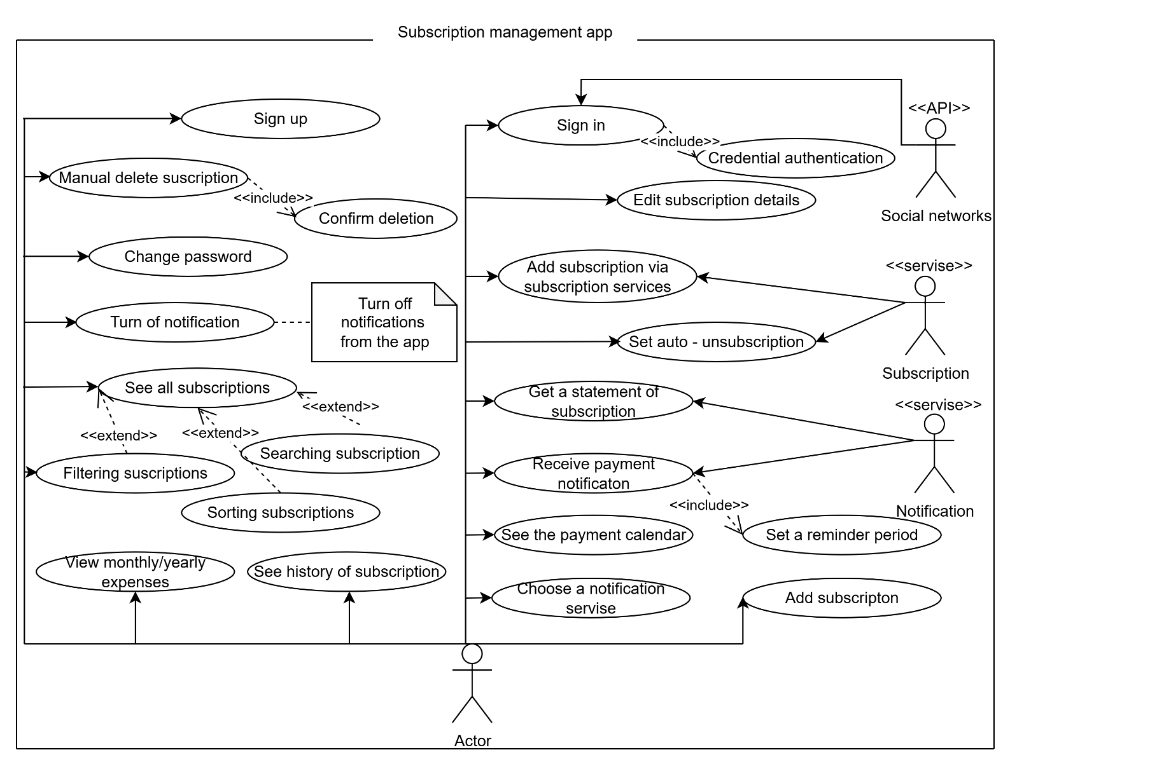

Рисунок 1 – Use Сase Diagram

Завдання 3. Валідація та верифікація (V&V)

**3.1 Перевірити вимоги.** Всі вимоги є чіткими та однозначними, повними, узгодженими з іншими вимогами та тестованими.

**3.2 Acceptance Criteria.** До кожного US створено AC, які визначають, що саме має бути реалізовано та як це має працювати:

US1 - As a new user, I want to sign up with an email and password so that I can create a secure personal account.

AC1 - Given I am on the registration page, when I enter a valid email address and a password that meets the security requirements, then my account is successfully created.

AC2 - Given I try to register with an email address that already exists in the system, when I submit the form, then I see an error message "This email is already in use," and the account is not created.

AC3 - Given I enter a password that does not meet the complexity criteria, when I submit the form, then I see a validation error and the account is not created.

US2 - As an existing user, I want to log in with my email and password so that I can access my data.

AC1 - Given I am a registered user on the login page, when I enter the correct email address and password, then I am successfully authenticated.

AC2 - Given I am on the login page, when I enter an incorrect email or password, then I see an error message "Invalid credentials".

US3 - As a registered user, I want to log in using social networks so that it's faster.

AC1 - Given I am on the login page and social login is available, when I successfully authenticate through that network, then I am logged into the app.

AC2 - Given I am a new user, when I log in via a social network for the first time, then an account is automatically created for me using data from the social network.

AC3 - Given I attempt to log in via a social network, when the authentication with the third-party service fails, then I have an error message.

US4 - As a user, I want to be able to change my password so that I can keep my account secure.

AC1 - Given I am in account settings and chose to change password, when I entered the old password correctly and the new one twice then the password is changed.

AC2 - Given I am trying to change my password, when I enter an incorrect current password, then I see an error message, and the password is not changed.

AC3 - Given I am trying to change my password, when the new password and its confirmation do not match, then I see a error, and the password is not changed.

US5 - As a user, I want to be able to turn off notifications so that they don't interfere.

AC1 - Given I am in the notification settings section, when I turn off the notifications, I no longer receive push notifications.

US6 - As a user, I want to manually add a new subscription so that I can begin tracking its cost and payment dates.

AC1 - Given I am on the "Add New Subscription", when I fill in all required fields and save, then the new subscription appears in my main list.

AC2 - Given I am trying to save a new subscription, when I have not filled in a mandatory field, then I see error next to that field, and the subscription is not created.

US7 - As a user, I want to see a list of all my subscriptions on one screen so that I can have a complete overview of my recurring expenses.

AC1 - Given I have added one or more subscriptions, when I open the main screen, then I see a list of all my active subscriptions.

AC2 - Given I haven't added any subscriptions yet, when I'm on the main screen, I see the message "No active subscriptions"

US8 - As a user, I want to be able to edit my subscription details, so that I can change something.

AC1 - Given I am viewing the details of an existing subscription, when I make changes to the fields and save, then the subscription information is updated.

AC2 - Given I am editing a subscription, when I enter invalid, then I see a error, and the changes are not saved.

US9 - As a user, I want to manual delete a subscription so that it no longer appears in my active expenses and financial forecasts after I've canceled it.

AC1 - Given I am viewing my list of subscriptions, when I select the delete option for a specific subscription and confirm the action, then that subscription is removed from the apps.

US10 - As a user, I want to assign a category to my subscriptions so that I can better organize them.

AC1 - Given I am adding or editing a subscription, when I select a category from the list, then the category is saved with the subscription.

US11 - As user, I want to be able to search for a subscription by name so that I can quickly find.

AC1 - Given I am on the subscription list screen, when I type subscription's name into the search field, then the list show only subscriptions that match the query.

AC2 - Given Search is open, when a non-existent subscription is entered, the message "No such element found" is displayed.

US12 - As a user, I want to be able to filter subscriptions by category so that saves time.

AC1 - Given I have subscriptions in different categories, when I apply a filter for some the category, then only subscriptions assigned to this category are displayed in the list.

AC2 - Given I have subscriptions in different categories, when a category is selected that has no subscriptions then message "No such element found" is displayed.

US13 - As a user, I want to be able to sort subscriptions by specified parameters so that I can show the information I need.

AC1 - Given I have subscriptions when I choose a sort criterion and order then my subscriptions are sorted by the specified conditions

US14 - As a user, I want to see a widget that displays my monthly expenses so that I can monitor my spending.

AC1 - Given I have active subscriptions, when I open the analytics screen, then I see a widget displaying the total subscription expenses for the current month.

AC2 - Given I have no subscriptions and never had any, when I open the analytics screen, then I see widget with empty values.

AC3 - Given I don't have any active subscriptions but there were during this period, when I open the analytics screen, I see widgets with the values ​​of past subscriptions.

US15 - As a user, I want to see a widget that displays my yearly expenses so that I can monitor my spending.

AC1 - Given I have active subscriptions, when I open the analytics screen, then I see a widget displaying the total subscription expenses for the current year.

AC2 - Given I have no subscriptions and never had any, when I open the analytics screen, then I see widget with empty values.

AC3 - Given I don't have any active subscriptions but there were during this period, when I open the analytics screen, I see widgets with the values ​​of past subscriptions.

US16 - As a user, I want to see a pie chart of monthly expenses so that I can better understand.

AC1 - Given I have subscriptions assigned to categories, when I view the analytics screen, then I see a pie chart visualizing the breakdown of my monthly expenses by category.

AC2 - Given I have no information about subscriptions for this month ,when I open the analysis screen, then I see a blank chart

US17 - As a user, I want to see the payment calendar so that it is a convenient.

AC1 - Given I have scheduled subscription payments, when I open the payment calendar, then I see the dates on which payments are scheduled marked on the calendar.

AC2 - Given I am on the payment calendar, when I tap on a marked date, then I see a list of subscriptions due for payment on that day.

AC3 - Given I have no scheduled payments, when I open the payment calendar, then it is empty.

US18 - As a user, I want to be able to view my subscription history so that I can track my subscription costs.

AC1 - Given I have a subscription with past payments, when I open the details of this subscription, then I see a "Payment History" list of past payments.

US19 - As a user, I want to receive a statement of expenses to my email address so that I can show others.

AC1 - Given I am on the analytics screen, when I select the "Export monthly report" option and, then I receive an email with a file containing the expense report.

US20 - As a user, I want to set a reminder period to keep track of time.

AC1 - Given the reminders tab is open and reminders are enabled, when a period is selected from the list and confirmed, then the setting is applied.

US21 - As a user, I want to receive payment notifications so I don't forget about my subscriptions.

AC1 - Given a reminder period set, when the time comes then a notification comes.

AC2 - Given no reminder period set, when the subscription is about to end, then the notification does not arrive.

US22 - As a user, I want to be able to choose which services I receive notifications from so that I don't miss any messages.

AC1- Given the reminder tab is open, when a service for sending messages is selected and saved, then a message will arrive using this service

US23 - As a user, I want to set the subscription to auto-unsubscribe so that I no longer need it.

AC1 - Given the card is integrated with the service, when the automatic subscription cancellation option is selected, then the subscription will be canceled at the end of the subscription period.

AC2 - Given the card is not integrated with the service, when a subscription is opened then there is no automatic cancellation option

US24 - As a user, I want to add a subscription using integration with services so that it is faster.

AC1 - Given I have connected my account , when I initiate a subscription scan, then the app finds my active subscriptions from that service and suggests adding them to my list.

AC2 - Given a subscription was found automatically, when I confirm adding it, then it appears in my list with its pre-filled.

Завдання 4. Approval і документація

**4.1 Модель SCRUM-команди + RACI-matrix.**

Виходячи із спиписку стейкхолдерів можна сфорувати таку SCRUM -команду: PO (1 особа) – Project owner, який визначає вимоги до продукту та його пріорітети, PM (1 особа) – Project manager – керує процесами, строками здачі та ресурсами під проект, Developers (7 осіб) – команда розробників, яка складається з Backend (2 особи) – керують серверною логікою та базаи данних,

Dev.(2 особи) - виконують загальну розробку, Frontend (2 особи) – відповідальний за загальний вигляд програми, QA Engineer (1 особа) – відповідальний за автоматизоване та ручне тестування. Всі вони об’єданні для надання корстувачені готового застосунку, тому звідси можна виділити таку RACI matrix (Таблиц 2):

Легенда:

R – Responsible, A – Accountable, C – Consulted, I – Informed.

Таблиця 2 RACI matrix

|  |  |  |  |  |
| --- | --- | --- | --- | --- |
| **Feature / Action** | **Product Owner (PO)** | **Project Manager (PM)** | **Development Team (Dev Team)** | **QA Engineer** |
| Registration and Authentication | C | A | R | R |
| Profile Management | C | A | R | R |
| Manual adding/editing | I | A | R | R |
| Integration and auto-adding | C | A | R | R |
| Categorization and filtering | I | A | R | R |
| Automatic cancellation | C | A | R | R |
| Expense tracking | C | A | R | R |
| Viewing payment history | I | A | R | R |
| Exporting reports | C | A | R | R |
| Notification settings | C | A | R | R |
| Receiving reminders | C | A | R | R |
| Feature requirements definition | R | A | C | C |
| Deployment and releases | R | R | R | R |
| Testing and quality assurance | I | A | R | R |
| Feedback collection and analysis | R | R | C | I |

**4.2 Product Backlog.** На основі попередніх вимог, user story до них та acceptance criteria можна створити наступний prodycut backlog:

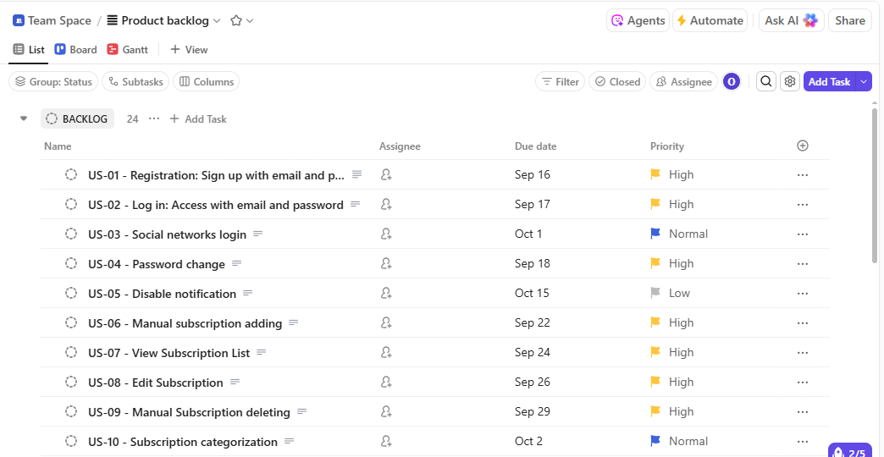

Рисунок 2 – Перша частина PB

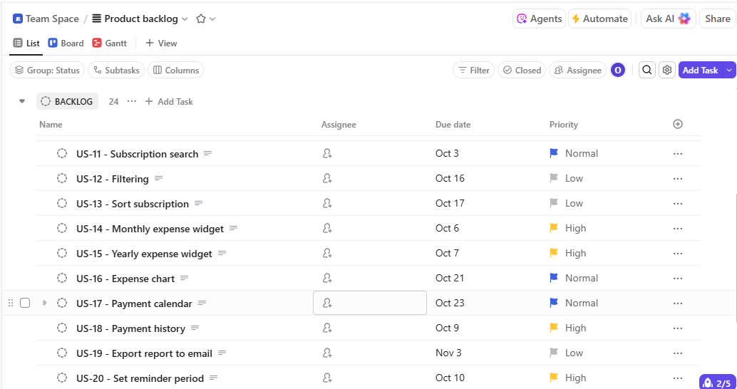

Рисунок 3 – Друга частина PB

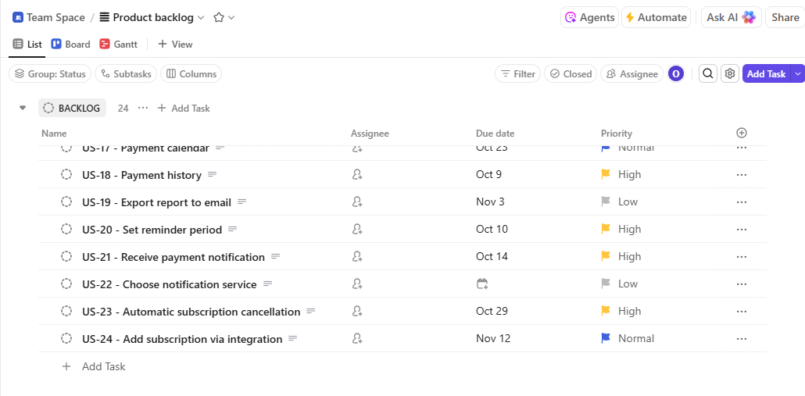

Рисунок 4 – Третя частина PB

**4.3 Kanban-дошка для Product Backlog.**

Згідно із наведеним Product Backlog було створено цю дошку:

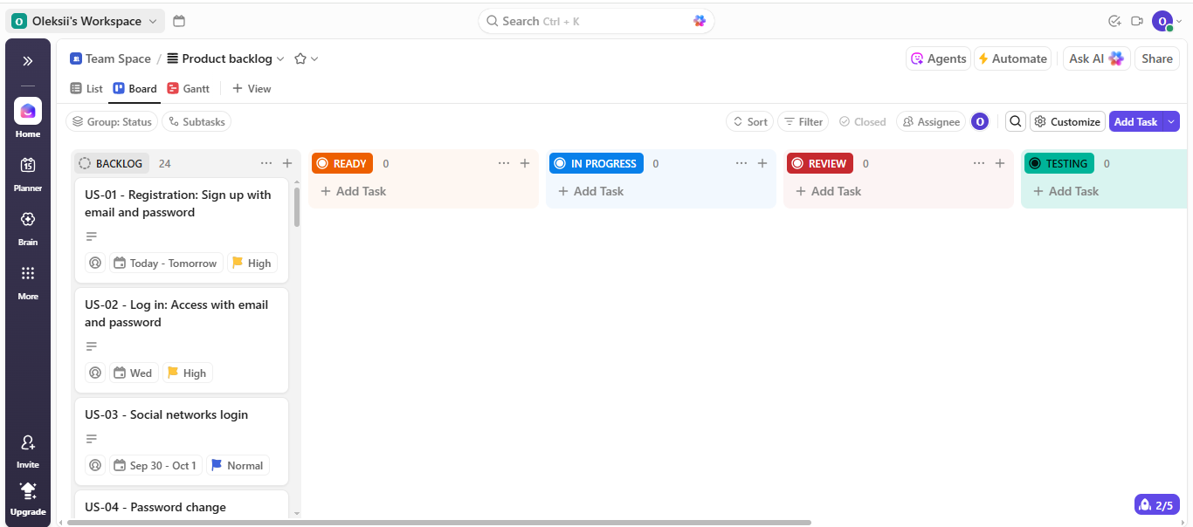

Рисунок 5 – Перша частина дошки

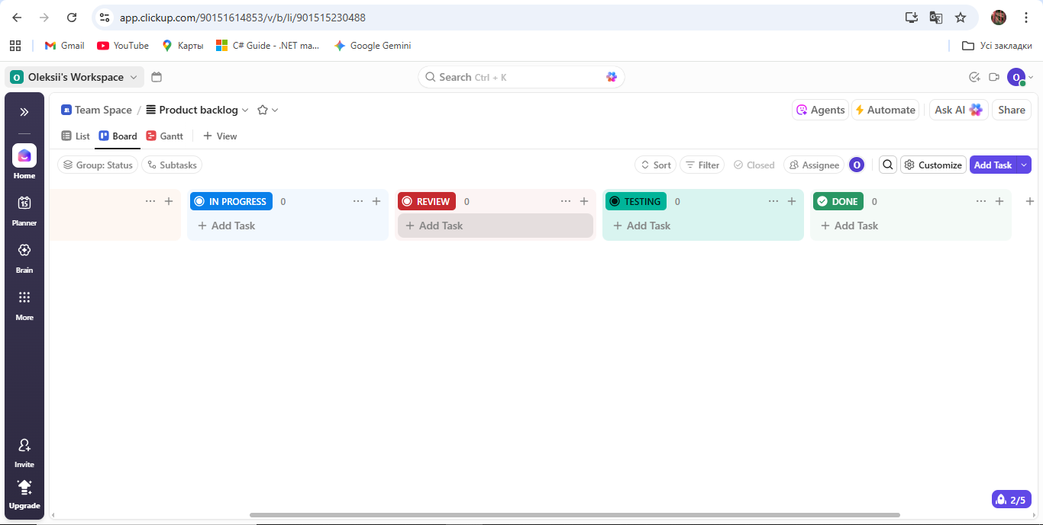

Рисунок 6 – Друга частина дошки

**4.4 Планування спринтів і дошки.** Виходячи із наведеного backlog можна виділити чотири основні спринти:

**Sprint 1 Plan (12 days)**

**Sprint Goal**

Основні фунції та взагалі функціонування, він закладає базове функціонування програми: реєстрація, вхід, створення, видалення та перегляд підписок.

**Scope (User Stories in Sprint 1)**

* **US - 01:** Email SignUp
* **US - 02:** Email LogIn
* **US - 04:** Password change
* **US - 06:** Manual subscription adding
* **US - 07:** View subscriptions list
* **US - 08:** Edit subscriptions
* **US - 09:** Manual subscription deleting

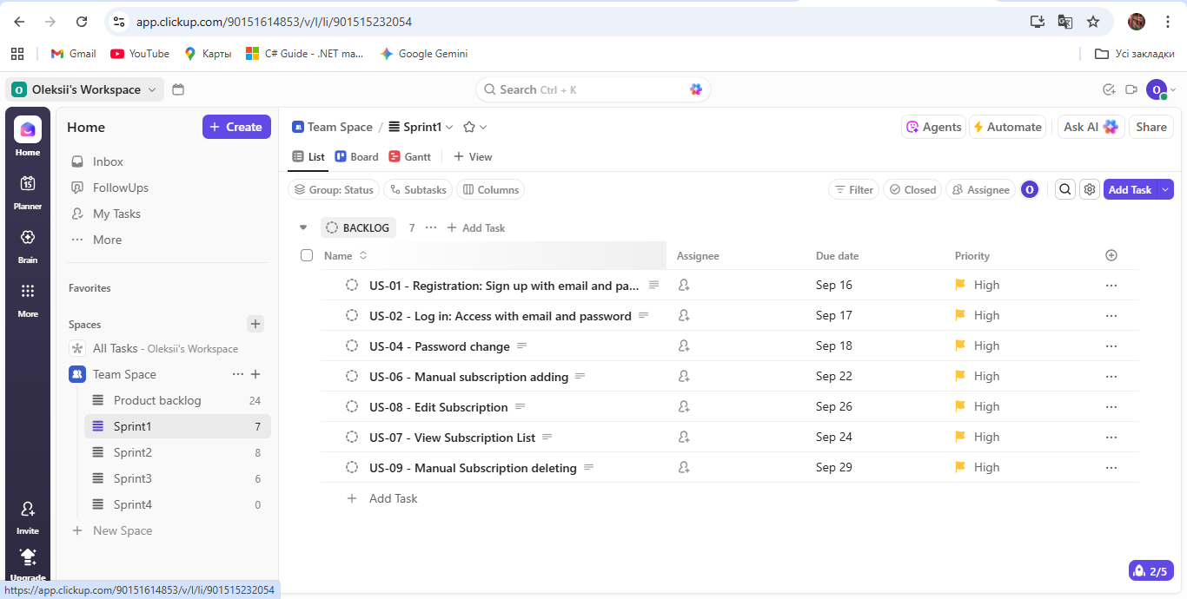

Рисунок 7 – Sprint backlog

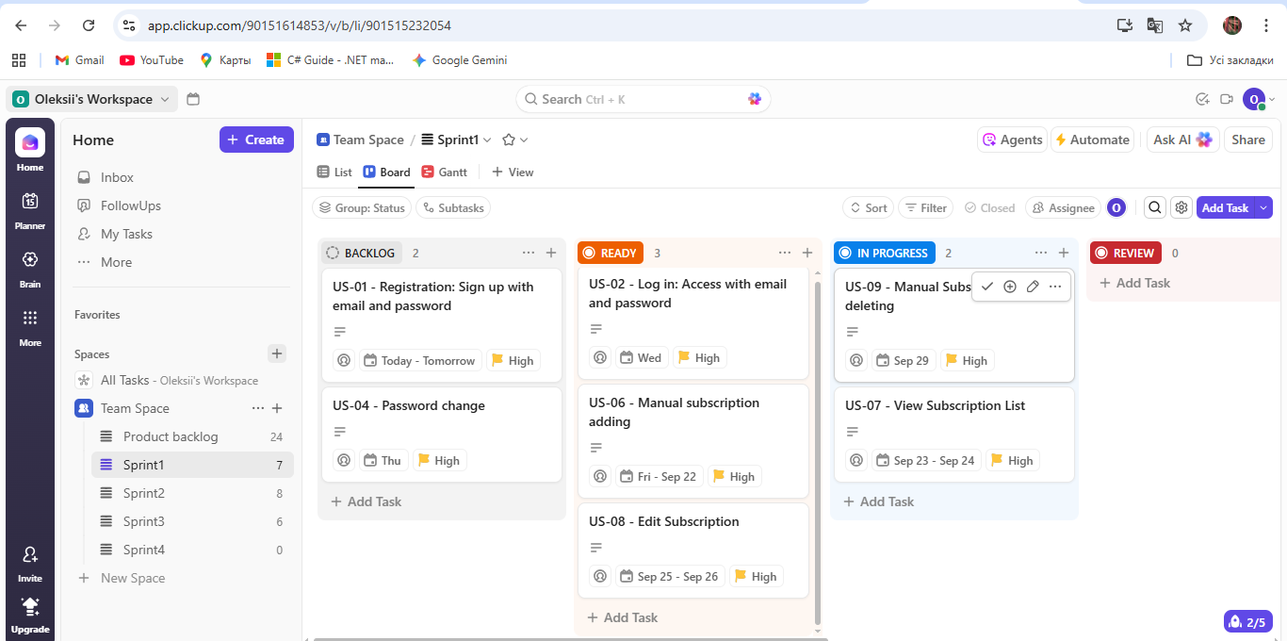

Рисунок 8 – Дошка

**Timeline ( 12 - days Sprint)**

* **Day 1 (15.09):** Sprint Planning, початок розробки ключових завдань: реєстрація (US - 01).
* **Day 2 – 4 (16.09 - 18.09):** Daily Meetings, завершення реєстрації, реалізація входу в систему (US - 02) та зміни пароля (US - 04).
* **Day 5 – 9 (19.09 - 24.09):** Daily Meetings, розробка основних функцій: додавання нової підписки (US-06) та перегляд списку підписок (US - 07).
* **Day 10 – 11 (25.09 - 26.09):** Daily Meetings, завершення можливостей редагування (US - 08) та видалення (US - 09) підписок, проведення тестування та підготовка до демонстрації.
* **End of Day 12 (29.09):** Sprint Review and Retrospective.

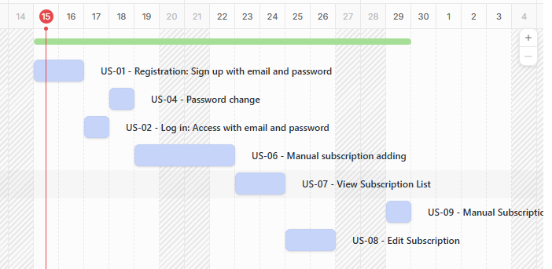

Рисунок 9 – Діаграма Gaant

**Sprint 2 Plan (13 days)**

**Sprint Goal**

Покращення основних функцій, розиширення системи, аналітика, в цьому спринті додано функіональності, що роблять додаток зручнішим.

**Scope (User Stories in Sprint 2)**

* **US - 03:** SN LogIn
* **US - 10:** Subscription categorization
* **US - 11:** Subscription search
* **US - 14:** Monthly expense widget
* **US - 15:** Yearly expense widget
* **US - 18:** Payment history
* **US - 20:** Set reminder period
* **US - 21:** Receive payment notification

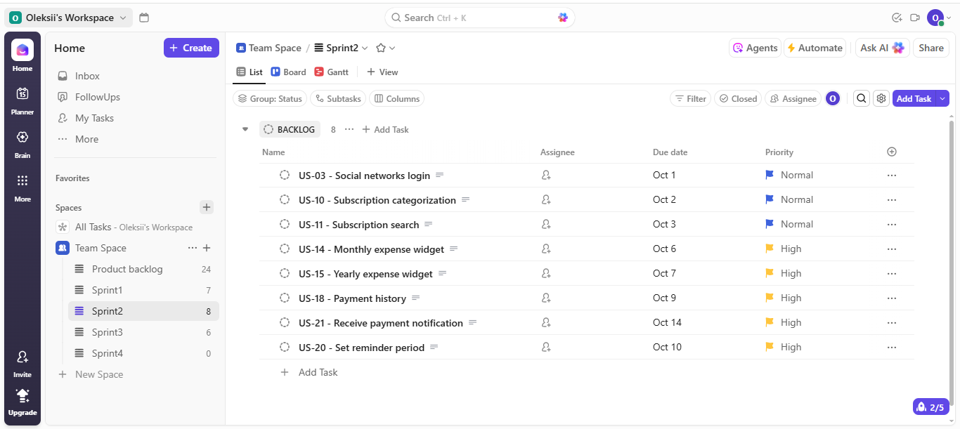

Рисунок 10 – Sprint backlog

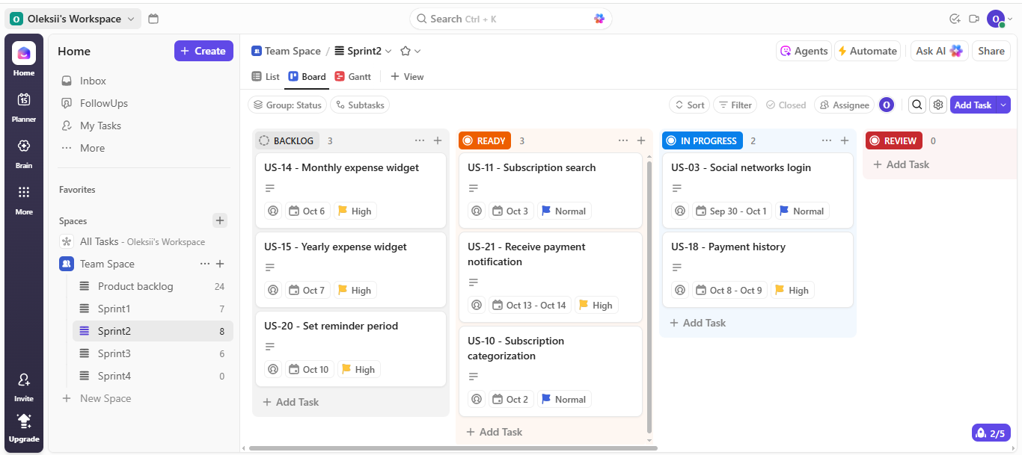

Рисунок 11 - Дошка

**Timeline (13 - days Sprint)**

* **Day 1 (30.09):** Sprint Planning, початок роботи над методом входу через соціальні мережі (US - 03).
* **Day 2 – 5 (30.09 - 03.10):** Daily Meetings, категоризації (US-10) та пошуку по підписках (US-11), початок роботи над аналітикою.
* **Day 6–8 (06.10 - 08.10):** Daily Meetings, створення віджетів для відображення місячних та річних витрат (US - 14, US - 15), а також перегляду історії платежів (US - 18).
* **Day 9 – 10 (09.10 - 10.10):** Daily Meetings, налаштування періоду (US - 20).
* **Day 11 – 12 (13.10 - 14.10):** Daily Meetings, створення отримання сповіщень (US - 21)
* **End of Day 13 (14.10):** Sprint Review and Retrospective.

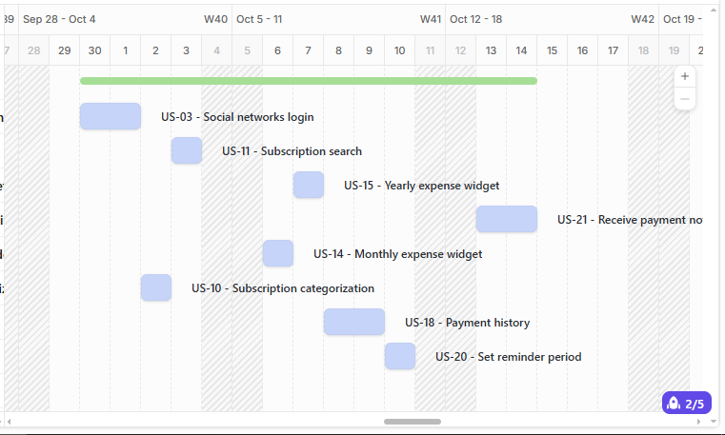

Рисунок 12 – Діаграма Gaant

**Sprint 3 Plan (1,5 weeks)**

**Sprint Goal**

Реалізація складніших функцій, які реалізують більш зручне використання програми.

**Scope (User Stories in Sprint 3)**

* **US - 05:** Disable notification
* **US - 12:** Filtering
* **US - 13:** Sort subscriptions
* **US - 16:** Expense chart
* **US - 17:** Payment calendar
* **US - 23:** Automatic subscription cancellation

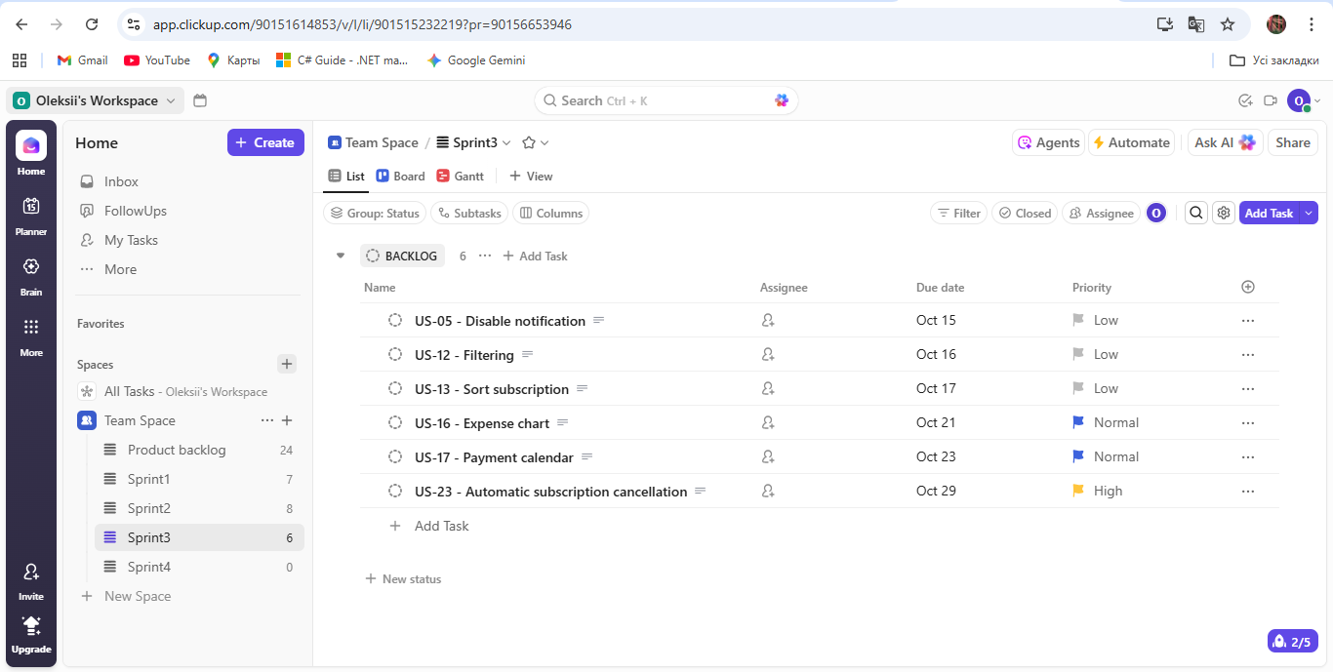

Рисунок 13 - Sprint backlogs

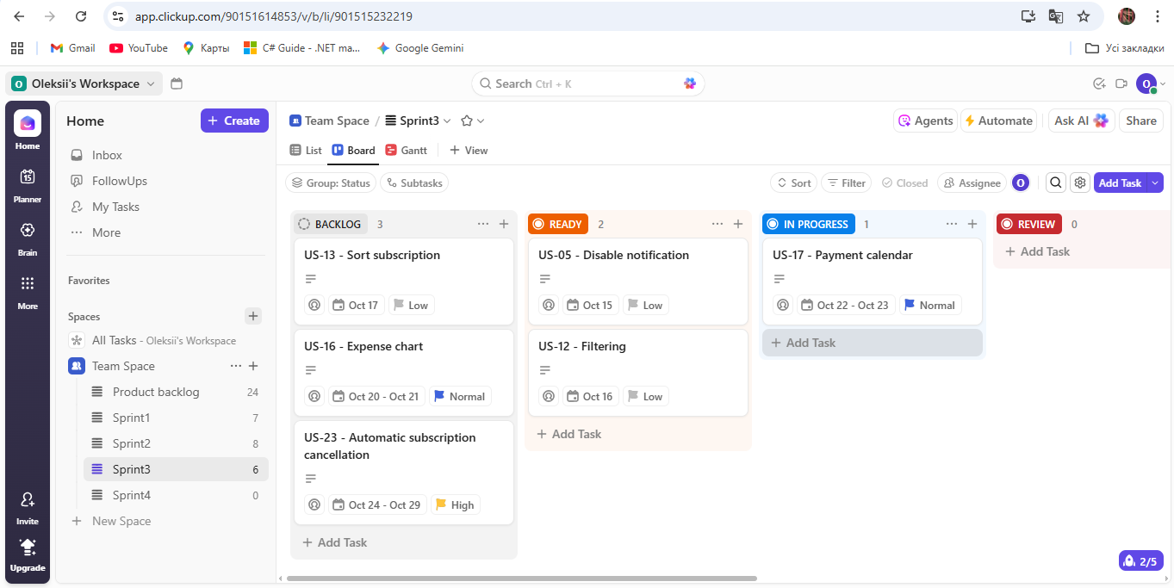

Рисунок 14 - Дошка

**Timeline (13 - days Sprint)**

* **Day 1 (15.10):** Sprint Planning, початок розробки налаштувань для керування сповіщеннями (US-05).
* **Day 2 – 3 (16.10 - 17.10):** Daily Meetings, реалізація фільтрації підписок за категоріями (US - 12) та сортування (US - 13).
* **Day 4 – 5 (20.10-21.10):** Daily Meetings, розробка кругової діаграми (US-16).
* **Day 6 – 7 (22.10-23.10):** Daily Meetings, створення календаря оплат (US - 17),
* **Day 8 - 13 (24.10 - 29.10):** Створення автоматчного видалення підписок (US - 23)
* **End of Day (29.10**) - Sprint Review and Retrospective.

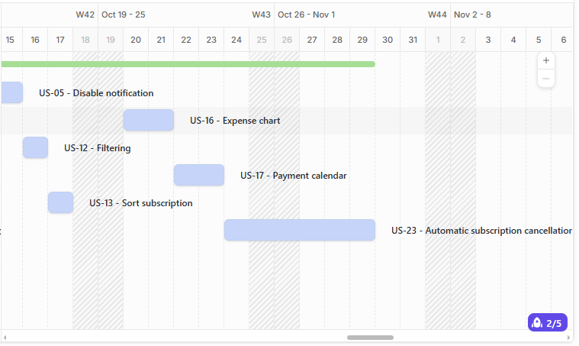

Рисунок 15 – Діаграма Gaant

**Sprint 4 Plan (13 days)**

**Sprint Goal**

Реалізовано найважчі та найзручніші елементи для функціонування програми.

**Scope (User Stories in Sprint 4)**

* **US - 19:** Export reports to email
* **US - 24:** Add subscription via integration

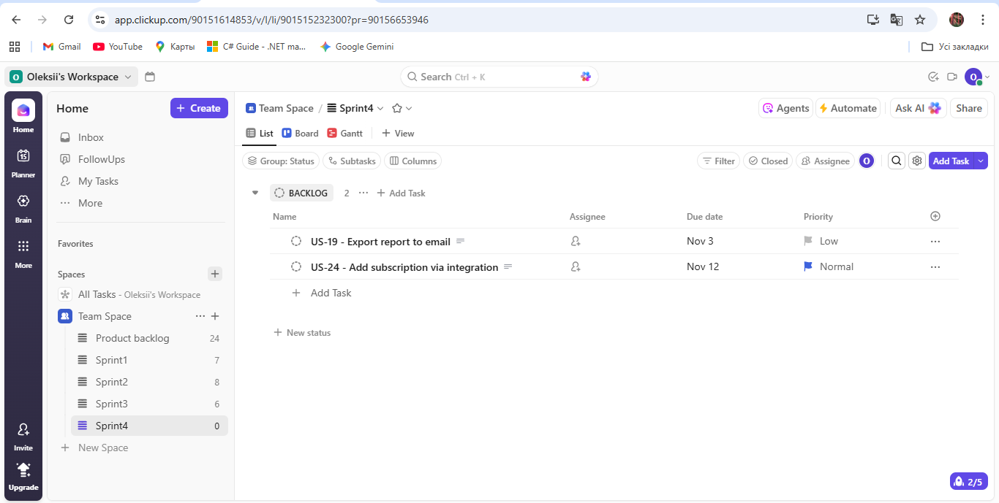

Рисунок 16 – Sprint backlog

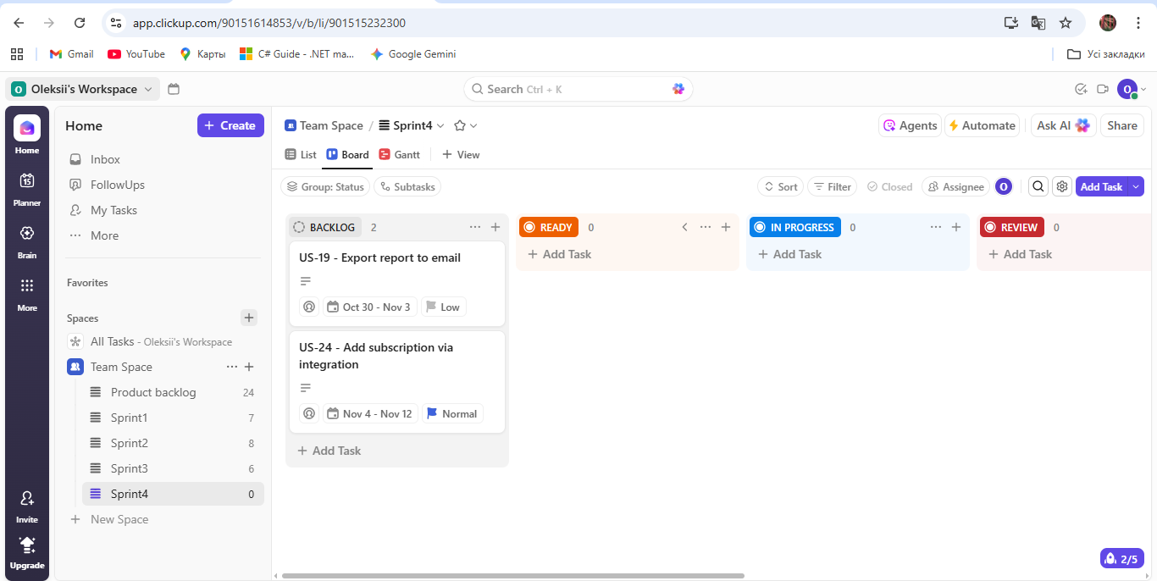

Рисунок 17 – Дошка

**Timeline (13 days Sprint)**

* **Day 1 (30.10):** Sprint Planning, аналіз та початок роботи над функцією експорту звітів на електронну пошту (US - 19).
* **Day 2 – 5 (31.10 - 4.11):** Daily Meetings, продовження роботи над звітом на елемектронну пошту.
* **Day 6 – 10 (4.11 - 08.11):** Daily Meetings, основна фаза розробки та сканування та додавання підписок (US - 24).
* **Day 11 - 13 (09.11 – 12.11):** Daily Meetings, фіналізація інтеграції, завершення тестування всього функціоналу, підготовка до релізу.
* **End of Day (13.11):** Sprint Review and Retrospective.

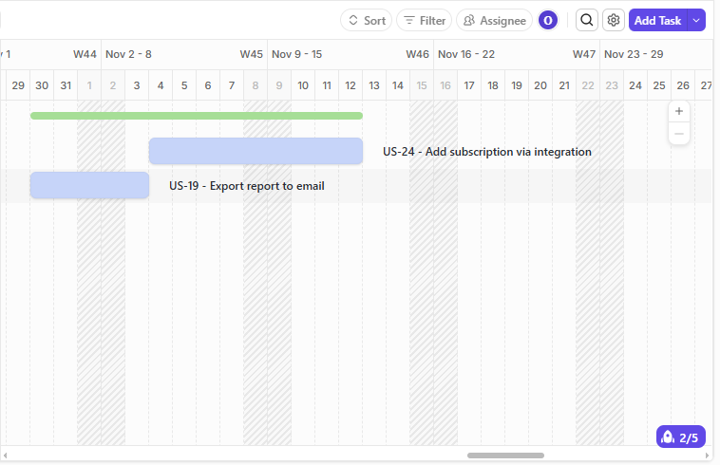

Рисунок 18 – Діаграма Gaant

**4.4 SRS**. На основі всіх етапів збору і аналізу вимог до додатку «Subscriprion managemnt app» було задокументовано вимоги для розробки ПЗ. Документ можна переглянути за дописалння в в додатку А.

**ВИСНОВОК:**

Засвоєно як збирати, аналізувати, валідувати, документувати та погоджувати вимоги до ПЗ, створено SRS та сформовано Product Backlog, засвоєно базові процеси виконання Kanban/Scrum.

**ДОДАТКИ**

Додаток А **-** Software Requirements Specification.

# Subscriptions management app SRS

|  |  |
| --- | --- |
| **Target release** | v1.0.0 (MVP Realese) |
| **Date** | 14 Sep 2025 |
| **Document status** | REVIEW |
| **Document owner** | Business Analyst / Product Manager |
| **Designer** | @ designer |
| **Teach lead** | @ lead |
| **Technical writers** | @ writers |
| **QA** | @ QA |
| **Approved by** | CTO |

### (blue star)**Introduction**

This document describes the requirements for the MVP mobile application Subscriptions management app, which allows users to add and manage subscriptions, use integration with services, and provide data aggregation. The document will be used by development, testing, project management teams, and stakeholders as the primary source of authoritative information during development.

###### Project scope:

The system provides the following key features:

* Registration and login,
* User profile management,
* Manually adding and editing subscriptions,
* Cost aggregation,
* Subscription payment reminder,
* Automatic and manual deletion of subscriptions,
* Clear and intuitive interface,
* Support for different languages ​​and currencies,
* Integration with subscription cancellation services.

###### Out of scope:

* Payment through the program,
* Integration with banks,
* Grouping subscriptions with other users.

###### Definitions, acronyms, abbreviations:

|  |  |  |
| --- | --- | --- |
| **Acronym** | **Full Form** | **Description** |
| SRS | Software Requirements Specification | A document that describes what a software system should do and how it should perform. |
| API | Application Programming Interface | A set of rules and tools that allows different software applications to communicate with each other. |
| Feature | Feature | A specific functional capability of the product that delivers value to the user. |
| User Story (US) | User Story | A short, simple description of a feature told from the perspective of the person who desires the new capability, usually a user or customer of the system. |
| Use Case Diagram | Use Case Diagram | A diagram that visually represents the interaction between users (actors) and the system. |
| Acceptance Criteria (AC) | Acceptance Criteria | The conditions that a software product must meet to be accepted by a user, a customer, or other stakeholders. |
| RACI-matrix | RACI Matrix | A responsibility assignment chart that maps out who is Responsible, Accountable, Consulted, and Informed for tasks and deliverables in a project. |

#### (blue star)General description

Subscription Management App is a B2C platform designed to simplify online subscriptions. Its main goal is to give users control over their spending, gather all subscription information in one place, and reduce unplanned expenses. The app interacts with the backend via REST API and integrates with services to automate processes.

#### Main product feature:

* Registrition via emain and SN
* Manual and auto subscription adding
* Manual and auto subscription deleting
* Subscription sorting, categorixation and filtering
* Subscription data aggregation
* Notification of early payment
* Integration with subscription services

#### User characteristcs:

* Users: phone users who want to keep all their subscriptions in one place and have full control over their subscription costs

#### (blue star)Fuctional Requriments (User Stories + Acceptance Criteria)

**US-01 - Registration**

As a new user, I want to sign up with an email and password so that I can create a secure personal account.

* **AC-01** - Given I am on the registration page, when I enter a valid email address and a password that meets the security requirements, then my account is successfully created.
* **AC-02** - Given I try to register with an email address that already exists in the system, when I submit the form, then I see an error message "This email is already in use," and the account is not created.
* **AC-03** - Given I enter a password that does not meet the complexity criteria, when I submit the form, then I see a validation error and the account is not created.

**US-02 - Log in**

As an existing user, I want to log in with my email and password so that I can access my  data.

* **AC-01** - Given I am a registered user on the login page, when I enter the correct email address and password, then I am successfully authenticated.
* **AC-02** - Given I am on the login page, when I enter an incorrect email or password, then I see an error message "Invalid credentials".

**US-03 - Social networcs login**

As a registered user, I want to log in using social networks so that it's faster.

* **AC-01** - Given I am on the login page and social login is available, when I successfully authenticate through that network, then I am logged into the app.
* **AC-02** - Given I am a new user, when I log in via a social network for the first time, then an account is automatically created for me using data from the social network.
* **AC-03** - Given I attempt to log in via a social network, when the authentication with the third-party service fails, then I have an error message.

**US-04 - Password change**

As a user, I want to be able to change my password so that I can keep my account secure.

* **AC-01** - Given I am in account settings and chose to change password, when I entered the old password correctly and the new one twice then the password is changed.
* **AC-02** - Given I am trying to change my password, when I enter an incorrect current password, then I see an error message, and the password is not changed.
* **AC-03** - Given I am trying to change my password, when the new password and its confirmation do not match, then I see a error, and the password is not changed.

**US-05 - Disable notification**

As a user, I want to be able to turn off notifications so that they don't interfere.

* **AC-01** - Given I am in the notification settings section, when I turn off the notifications, I no longer receive push notifications.

**US-06 - Manual subscription adding**

As a user, I want to manually add a new subscription so that I can begin tracking its cost and payment dates.

* **AC-01** - Given I am on the "Add New Subscription", when I fill in all required fields and save, then the new subscription appears in my main list.
* **AC-02** - Given I am trying to save a new subscription, when I have not filled in a mandatory field, then I see error next to that field, and the subscription is not created.

**US-07 - View Subscription List**

As a user, I want to see a list of all my subscriptions on one screen so that I can have a complete overview of my recurring expenses.

* **AC-01** - Given I have added one or more subscriptions, when I open the main screen, then I see a list of all my active subscriptions.
* **AC-02** - Given I haven't added any subscriptions yet, when I'm on the main screen, I see the message "No active subscriptions"

**US-08 - Edit Subscription**

As a user, I want to be able to edit my subscription details, so that I can change something.

* **AC-01** - Given I am viewing the details of an existing subscription, when I make changes to the fields and save, then the subscription information is updated.
* **AC-02** - Given I am editing a subscription, when I enter invalid, then I see a error, and the changes are not saved.

**US-09 - Manual Subscription deleting**

As a user, I want to manual delete a subscription so that it no longer appears in my active expenses and financial forecasts after I've canceled it.

**AC-01** - Given I am viewing my list of subscriptions, when I select the delete option for a specific subscription and confirm the action, then that subscription is removed from the apps.

**US-10 - Subscription catagorization**

As a user, I want to assign a category to my subscriptions so that I can better organize them.

* **AC-01** - Given I am adding or editing a subscription, when I select a category from the list, then the category is saved with the subscription.

**US-11 - Subscription search**

As user, I want to be able to search for a subscription by name so that I can quickly find.

* **AC-01 -** search field, then the list show only subscriptions that match the query.
* **AC-02** - Given Search is open, when a non-existent subscription is entered, the message "No such element found" is displayed.

**US-12 - Filtering**

As a user, I want to be able to filter subscriptions by category so that saves time.

* **AC-01** - Given I have subscriptions in different categories, when I apply a filter for some the category, then only subscriptions assigned to this category are displayed in the list.
* **AC-02** - Given I have subscriptions in different categories, when a category is selected that has no subscriptions then message "No such element found" is displayed.

**US-13 - Sort subscription**

As a user, I want to be able to sort subscriptions by specified parameters so that I can show the information I need.

* **AC-01** - Given I have subscriptions when I choose a sort criterion and order then my subscriptions are sorted by the specified conditions

**US-14 - Monthly expense widget**

As a user, I want to see a widget that displays my monthly expenses so that I can monitor my spending.

* **AC-01** - Given I have active subscriptions, when I open the analytics screen, then I see a widget displaying the total subscription expenses for the current month.
* **AC-02** - Given I have no subscriptions and never had any, when I open the analytics screen, then I see widget with empty values.
* **AC-03** - Given I don't have any active subscriptions but there were during this period, when I open the analytics screen, I see widgets with the values ​​of past subscriptions.

**US15 - Yearly expense widget**

As a user, I want to see a widget that displays my yearly expenses so that I can monitor my spending.

* **AC-01** - Given I have active subscriptions, when I open the analytics screen, then I see a widget displaying the total subscription expenses for the current year.
* **AC-02** - Given I have no subscriptions and never had any, when I open the analytics screen, then I see widget with empty values.
* **AC-03** - Given I don't have any active subscriptions but there were during this period, when I open the analytics screen, I see widgets with the values ​​of past subscriptions.

**US-16 - Expance chart**

As a user, I want to see a pie chart of monthly expenses so that I can better understand.

* **AC-01** - Given I have subscriptions assigned to categories, when I view the analytics screen, then I see a pie chart visualizing the breakdown of my monthly expenses by category.
* A**C-02** - Given I have no information about subscriptions for this month ,when I open the analysis screen, then I see a blank chart

**US-17 - Paymant calendar**

As a user, I want to see the payment calendar so that it is a convenient.

* **AC-01** - Given I have scheduled subscription payments, when I open the payment calendar, then I see the dates on which payments are scheduled marked on the calendar.
* **AC-02** - Given I am on the payment calendar, when I tap on a marked date, then I see a list of subscriptions due for payment on that day.
* **AC-03** - Given I have no scheduled payments, when I open the payment calendar, then it is empty.

**US-18 - Payment history**

As a user, I want to be able to view my subscription history so that I can track my subscription costs.

* **AC-01** - Given I have a subscription with past payments, when I open the details of this subscription, then I see a "Payment History" list of past payments.

**US-19 - Export report to email**

As a user, I want to receive a statement of expenses to my email address so that I can show others.

* **AC-01** - Given I am on the analytics screen, when I select the "Export monthly report" option and, then I receive an email with a file containing the expense report.

**US-20 - Set reminder period**

As a user, I want to set a reminder period to keep track of time.

* **AC-01** - Given the reminders tab is open and reminders are enabled, when a period is selected from the list and confirmed, then the setting is applied.

**US-21 - Receive payment notification**

As a user, I want to receive payment notifications so I don't forget about my subscriptions.

* **AC-01** - Given a reminder period set, when the time comes then a notification comes.
* **AC-02** - Given no reminder period set, when the subscription is about to end, then the notification does not arrive.

**US-22 - Choose notification servise**

As a user, I want to be able to choose which services I receive notifications from so that I don't miss any messages.

* **AC-01**- Given the reminder tab is open, when a service for sending messages is selected and saved, then a message will arrive using this service

**US-23 - Automatic subscription cancellation**

As a user, I want to set the subscription to auto-unsubscribe so that I no longer need it.

* **AC-01** - Given the card is integrated with the service, when the automatic subscription cancellation option is selected, then  the subscription will be canceled at the end of the subscription period.
* **AC-02** - Given the card is not integrated with the service, when a subscription is opened then there is no automatic cancellation option

**US-24 - Add subscriotion via integration**

As a user, I want to add a subscription using integration with services so that it is faster.

* **AC-01** - Given I have connected my account , when I initiate a subscription scan, then the app finds my active subscriptions from that service and suggests adding them to my list.
* **AC-02** - Given a subscription was found automatically, when I confirm adding it, then it appears in my list with its pre-filled.

###### Use case diagram



**RACI Matrix for Subscriptions management app** major features:

* R – Responsible → the role that actually does the task.
* A – Accountable → the role ultimately answerable for the task.
* C – Consulted → the role(s) providing input.
* I – Informed → the role(s) kept up to date.

|  |  |  |  |  |  |
| --- | --- | --- | --- | --- | --- |
| **Feature / Action** | **End User** | **Product Owner (PO)** | **Project Manager (PM)** | **Development Team (Dev Team)** | **QA Engineer** |
| Registration and Authentication | C | A | R | R | C |
| Profile Management | C | A | R | R | C |
| Manual adding,editing | I | A | R | R | I |
| Integration and auto-adding | C | A | R | R | C |
| Categorization and filtering | I | A | R | R | I |
| Automatic cancellation | C | A | R | R | C |
| Expense tracking | C | A | R | R | C |
| Viewing payment history | I | A | R | R | I |
| Exporting reports | C | A | R | R | C |
| Notification settings | C | A | R | R | C |
| Receiving reminders | C | A | R | R | C |
| Feature requirements definition | R | A | C | C | R |
| Deployment and releases | R | R | R | R | R |
| Testing and quality assurance | I | A | R | R | I |
| Feedback collection and analysis | R | R | C | I | R |

#### (blue star)Non - Function Requirements (NFR)

**Perfomance**

* Main screen loading time must be less three seconds
* The system should be able to support multiple users simultaneously
* Performance degradation with large number of subscriptions
* The program has the advantage of being easy to maintain and support

**Scalability**

* The system must be able to scale to accommodate a large number of users

**Availability and reliability**

* The system must be available 99% of the time
* The system must support a large number of users
* Fast integration process with services

**Usability**

* The interface should be clear and intuitive
* Performing actions in a few clicks

**Security**

* Using avorization
* Data encryption

**Compatibility**

* Android 15 and IOS 18 compatibility

#### (blue star)Interface Requirements

**User Interfaces (UI)**

* Responsiveness: The user interface should adapt to different screen sizes
* Intuitiveness: The interface should be clear and intuitive
* Multilingualism: There should be support for foreign languages ​​and different currencies
* Push notifications: The system should send push notifications about the need for payment

**Softavre Interfaces**

* Distribution platforms: The application must be available in the AppStore and PlayMarket
* Operating systems: The system must run on IOS 18 and Android 15
* Database: The system should use PostgreSQL 17 to store data
* Social authentication: Log in using a social network
* Integration with services: The system should integrate with subscription services to add and automatically cancel subscriptions.

**Communication Interfaces**

* Integration with subscription services and social networks via their APIs, which requires the use of HTTPS and JSON

#### (blue star)Technical Requirements

**Technical stack**

* Backend: Node.js 20 LTC with NestJS 11.x framework
* Frontend: React.js 18.x with TypeScript 5,9.x
* Database: PostgreSQL 17

**Architecture**

* The theme should be developed on a microservices architecture

**Environment Requirements**

* The program must be available in the AppStore and PlayMarket
* The application should be available for Android 15 and IOS 18 versions

**Constraints and risks**

Constraints are conditions that must be followed and cannot be changed during development.

**Budgetary Constraints** - The total development cost shall not exceed the allocated project budget of $X.

**Time Constraints** - The system must be delivered and deployed by [specific deadline].

**Regulatory and legal restrictions -** The system must not violate data protection law, and AppStore and PlayMarket rules

**Resource Constraints** - The development team is limited to 7 full-time engineers and 1 QA specialist.

**Risks**

|  |  |  |  |  |
| --- | --- | --- | --- | --- |
| **Risk ID** | **Description** | **Likelihood** | **Impact** | **Mitigation Strategy** |
| R1 | Problems accessing third-party APIs | Medium | Hight | Implement logic for re-requests and viewing the status of services |
| R2 | Low user attention level | Medium | Hight | Conduct market research, collect feedback and implement unique solutions |
| R3 | Development problems due to difficulty integrating with other services | Medium | Medium | Conduct a detailed assessment and plan for integration with services |
| R4 | Problems with scaling support | Medium | Medium | Strive to work with a scalable microservices architecture |

#### (blue star)Testing

**Test Objectives**

* Verify that all functional requirements are implemented correctly
* Validation of all non-functional requirements
* Early detection of all defects
* Ensure that the system is stable

###### Testing Types

The following types of testing shall be performed:

|  |  |
| --- | --- |
| **Test type** | **Description** |
| Unit testing | Testing individual modules to verify correct operation |
| Integration testing | Checking the interaction between microservices, as well as external services |
| System testing | Testing the entire program |
| Acceptance testing | Testing by the Product Owner to confirm that the system meets user requirements |
| Usability testing | Evaluation of whether the interface is clear and intuitive |

**Test Enviroment**

* All tests shall be performed in a dedicated staging environment that mirrors production.
* Test data shall be anonymized and comply with data privacy regulations.
* The environment shall include all required software, hardware, and network configurations.

**Test Tools:**

* Unit Testing: Jest / JUnit / NUnit
* Integration and System Testing: Postman, Selenium
* CI/CD Integration: GitHub Actions, Jenkins

###### test Plan Overview

|  |  |
| --- | --- |
| **Item** | **Description** |
| Test Scope | All functional and non-functional requirements described in the SRS |
| Test Objectives | Verify compliance with requirements, find defects early, ensure quality |
| Test Schedule | ligned with the development milestones |
| Entry Criteria | All planned features for the sprint are implemented and build is stable |
| Exit Criteria | 100% of test cases executed, 95% passed, 0 critical defects open |
| Responsible Roles | QA Engineers, Developers (for unit tests), Product Owner (for acceptance) |

#### Appendices

|  |  |  |  |  |  |
| --- | --- | --- | --- | --- | --- |
| **Metric** | **Category** | **Description** | **Target Value** | **Measurement Method** | **Responsible** |
| Requirement Coverage | Functional | Percentage of implemented functional requirements | 100% | Requirements Traceability Matrix | Product Owner/QA |
| Defect Rate | Quality | Number of defects at the release stage | <1 | Bug tracking reports | QA |
| Response Time | Productivity | Home screen loading time | 3 seconds | Performance testing tools | QA |
| System Uptime | Productivity | System availability percentage | 99% | Monitoring tools | PM/ dev. team |
| Task Completion Rate | User ecpirience | Percentage of users who completed all tasks | >95% | Usability-test | QA/PO |
| Business Value | Business | Level of achievement of business goals | Max feedback | User survey | PO |

#### (blue star)**Milestones**

|  |  |  |  |
| --- | --- | --- | --- |
| **Milestone** | **Target Date** | **Description** | **Owner** |
| M1 – MVP Release | Q4 2025 | Core Features: Account registration/login, manual addition, viewing, editing, and deletion of subscriptions. This lays the groundwork for the application's basic functionality | Dev. team, QA, PO |
| M2 – Analytics & Notifications | Q4 2025 | Enhancements and Analytics**:** Login via social networks, categorization and search for subscriptions, expense tracking widgets, viewing payment history, and setting up payment reminders | Dev. team, QA, PO |
| M3 – Advanced Features | Q1 2026 | Advanced Functionality: The ability to disable notifications, filter and sort subscriptions, visualize expenses with charts, a payment calendar, and automatic cancellation of integrated subscriptions | Dev. team |
| M4 – Automation and Integration | Q2 2026 | Automation and Integrations**:** Exporting expense reports to email and automatically adding subscriptions through service integration, which are the most complex elements | Dev. team |

###### Open questions

|  |  |  |
| --- | --- | --- |
| **Question** | **Answer** | **Date Answered** |
| **What are the specific password complexity requirements?** | -Pending- | - |
| **What specific languages ​​and currencies will the program have?** | -Pending- | - |
| **What specific networks will be available for login?** | -Pending- | - |
| **What specific services can provide APIs for integration?** | -Pending- | - |
| **In what format will the report be sent?** | -Pending- | - |