**Brute-force Serial implementation block diagram:**

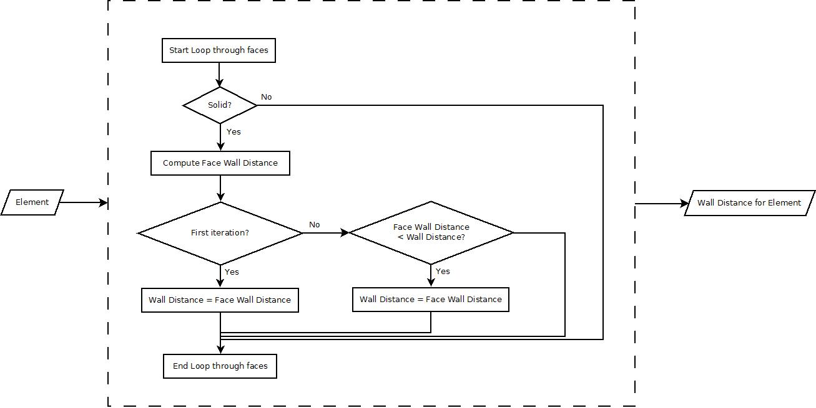

**Brute-force Parallel implementation#1 block diagram:**

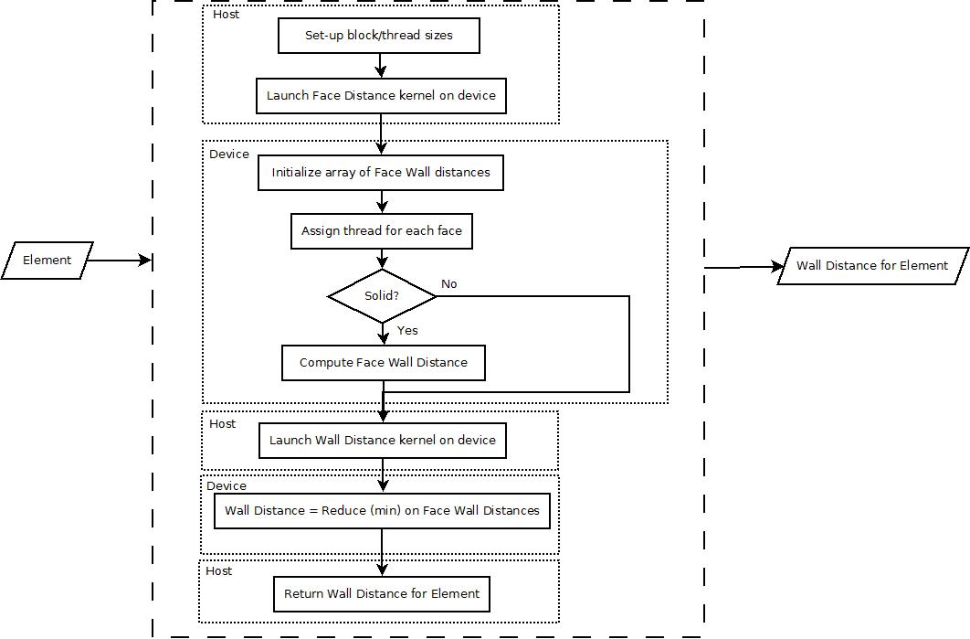

**Brute-force Parallel implementation#2 block diagram:**

