# UMG拖放控制

UMG 中图标拖动需要三步，可以用来实现物品栏，快捷键的设置。

1. 在需要拖动的窗口重载一下函数 On Mouse Button Down：在此时开启拖放检测，拖放检测会在鼠标按下过程中一直持续。

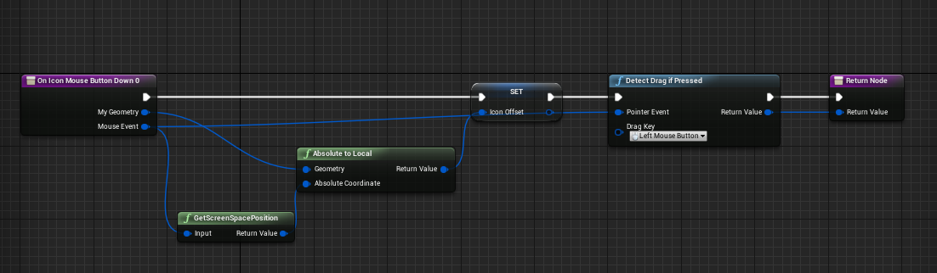

图一：On Mouse Button Down

1. 在允许拖动的窗口重载以下函数 On Drag Detected：当拖动事件被侦测到，创建Drag Drop Operation， 如图二所示：

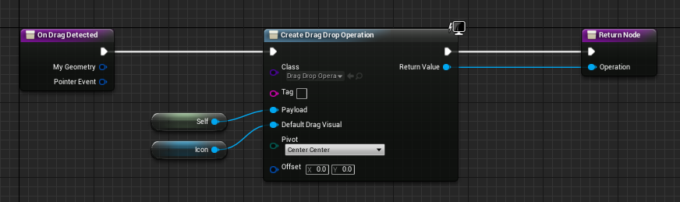

图二：On Drag Detected

Drag Drop Operation 函数如下表所示: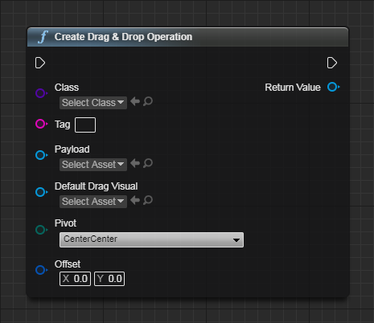

图三：Creates a new drag drop operation

其中各参数如下表所示：

表一：Creates drag drop operation 各参数

|  |  |
| --- | --- |
| Inputs | |
| In  Exec |  |
| Class  Drag Drop Operation Class | Drag Drop Operation Class Class The object class you want to construct |
| Tag  String | A simple string tag you can optionally use to provide extra metadata about the operation. |
| Payload  Object Reference | The payload of the drag operation. This can be any UObject that you want to pass along as dragged data. If you were building an inventory screen this would be the UObject representing the item being moved to another slot. |
| Default Drag Visual  Widget Reference | The Drag Visual is the widget to display when dragging the item. Normally people create a new widget to represent the temporary drag. |
| Pivot  EDragPivot Enum | Controls where the drag widget visual will appear when dragged relative to the pointer performing the drag operation. |
| Offset  Vector 2D Structure | A percentage offset (-1..+1) from the Pivot location, the percentage is of the desired size of the dragged visual. |
| Outputs | |
| Out  Exec |  |
| Return Value  Drag Drop Operation Reference | Drag Drop Operation Reference Return Value The constructed object |

1. 在允许Drop 操作的窗口重载OnDrop函数，实现放下操作：

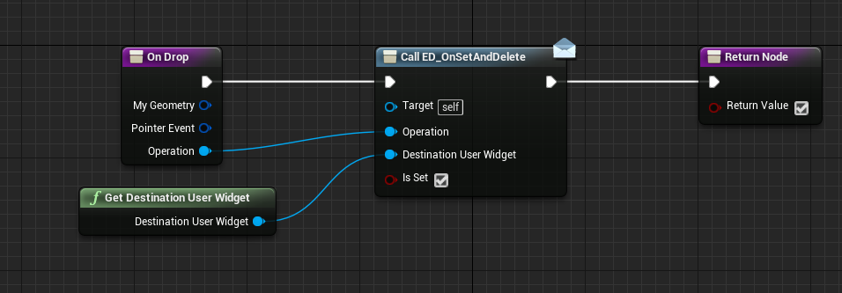

其中ED_OnSetAndDelete 为Event Dispatcher, 其目的是为了将该拖放操作传递给顶层模块，在顶层模型进行进一步的操作。

Event OnSetAndDelete 事件从Operation 中解析出传递过来的数据，从DestinationUserWidget 中得到拖拽目的地的控件。

(注意要把允许Drag Drop 操作的窗口的Root 设置其Visibility参数为Visible,(默认为SelfHitTestInvisible).这样才能接收拖放事件。)

[Reference]

1. <https://docs.unrealengine.com/latest/INT/BlueprintAPI/UserInterface/CreateDrag_DropOperation/index.html>