***Pontus Olofsson, Christopher E. Holden, Eric L. Bullock***

*Boston Education in Earth Observation Data Analysis/*

*Department of Earth & Environment, Boston University*

**S4. Methods: Estimation**

## S4.1 Sample design

### S4.1.1 Determine sample size and allocation

1. Display your map in QGIS by clicking *Layers* > *Add Raster Layer*.
2. Color it if you haven’t already: right-click the map in the layer pane and click *Properties* > *Style*; set *Render Type* to *Singleband pseudocolor*; click the green plus-sign 7 times and set values to 1-7, and give each category an appropriate name and color.
3. Determine the areas of each map category: open a terminal, navigate to you directory and type: gdalinfo -hist stratification_massachusetts_utm.tif
4. This gives the number of pixels of each map class; in the New Brunswick example, gdalinfo gives the following areas in pixels (third row percent, calculated from pixels):

|  |  |  |  |  |  |  |
| --- | --- | --- | --- | --- | --- | --- |
|  | *Non-forest* | *Forest* | *Water* | *Forest loss* | *Forest gain* | *For. loss/gain* |
| Area | 47,996 | 228,551 | 13,795 | 3,561 | 293 | 87 |
| *Wi* | 16.3% | 77.6% | 4.69% | 1.21% | 0.10% | 0.03% |

1. To determine the sample size for a stratified random sample, we will use Eq. 5.25 in Cochran (1977): $n≈{\left(\frac{\sum{W_{i}S_{i}}}{S\left(\hat{P}\right)}\right)}^{2}$ where $W_{i}$ is the stratum weight and $S_{i}$ is the standard error for stratum *i*; the latter is estimated as $\sqrt{p_{i}(1-p_{i})}$ where $p_{i}$ is the proportion of forest loss in stratum *i*. $S\left(\hat{P}\right)$ is the target standard error of the forest loss estimate. If assuming one error of omission of forest loss in *non-forest* and *forest* per 100 units and a user’s accuracy of 0.8 and a target standard error of the forest loss estimate of 0.5% (i.e. a confidence interval of 1%); we get following information for determining the sample size:

|  |  |  |  |  |  |  |
| --- | --- | --- | --- | --- | --- | --- |
|  | *Non-forest* | *Forest* | *Water* | *Forest loss* | *Forest gain* | *For. loss/gain* |
| $$p_{i }$$ | 0.01 | 0.01 | 0 | 0.8 | 0 | 0 |
| $S_{i}$ | 0.099 | 0.099 | 0.000 | 0.400 | 0 | 0 |
| $$S(\hat{P})$$ |  |  |  | 0.005 |  |  |

This in turn gives: $n≈{\left(\frac{\sum{W_{i}S_{i}}}{S\left(\hat{P}\right)}\right)}^{2}={\left(\frac{0.098}{0.005}\right)}^{2}=387$ (note that this is just an example and users need to specify their own target errors and expected accuracy and omission errors).

1. The second step is to determine how to allocate these units to strata. Good practices stipulate that 50, 75 or 100 units are allocated to the smaller classes depending on the total sample size and that the rest is proportionally allocated to the larger strata. In this all strata are small relative forest and the sample is allocated to strata as (*Forest gain* and *Forest gain/loss* are so small fractions of the map that we will not attempt to estimate them; if they were larger they would be included):

|  |  |  |  |  |  |  |
| --- | --- | --- | --- | --- | --- | --- |
|  | *Non-forest* | *Forest* | *Water* | *Forest loss* | *Forest gain* | *For. loss/gain* |
| $$n_{i }$$ | 55 | 230 | 50 | 50 | 0 | 0 |

### S4.1.2 Select sample

1. QGIS does not have built-in tools for drawing samples (this hold true also for most propretiary software) so we need to make use of Python script: copy the “sample_map.py” and “docopt.py” from *Desktop* to your working directory (or download from <https://github.com/ceholden/accuracy_sampler/tree/master/script> and <https://github.com/docopt/docopt>); make sure both files are stored in the same folder.
2. If not using the Virtual Machine but a Windows operating system and *OS4Geo*, click the Windows Start button > *QGIS* > *OSGeo4W Shell*; in the terminal, navigate to the working directory. In the Virtual Machine, open a terminal. Type python sample_map.py -h and read about the different options.
3. To select a stratified random sample, type: python sample_map.py -v –mask 0 --size 385 --allocation "55 230 50 50 0 0" --vector sample.shp stratified stratification_massachusetts_utm.tif
4. This will create a shapefile “sample.shp” that contains the sample. **Note:** if the script halts with the message “MemoryError”, the memory allocation when starting the Virtual Machine needs to be increased (in *Oracle VirtualBox Manager*: *Settings* > *System* > increase *Base Memory* beforelaunching the VM).

## S4.2 Response Design

### S4.2.1 Interpreting sample

1. Display the reference data in QGIS, i.e., display the data you will use to interpret the sample you just created. This is likely a combination of different data sources, such as Landsat, RapidEye and Google Earth, acquired around the same times as the data used to create the map (in this case 2000 and 2012), and preferably also in-between.
2. Display the shapefile containing the sample, i.e. the file you created in Section 3.
3. Right-click shapefile in *Layer* pane; *Open Attribute Table*; then and then ; delete the STRATUM column.
4. Click the *New column* button to add a column; name it “reference”; leave options as default except *Width* which should be set to 3.
5. Now provide a label for each of the units in the sample by manually examining the reference data. Add labels that correspond to the grid codes of the map: for example, if the forest loss class has the grid code “4” in the map, then provide each sample unit exhibiting forest loss with label “4”. **Since your final area estimates are based on the** **interpretation of this sample it is important that the labels are correct** – if you can’t provide a correct label then delete the unit rather than guessing. You can click to jump to the highlighted unit. Make sure you save the shapefile regularly.
6. NOTE: If you want to open the sample in Google Earth TM, right click the shapefile with the sample > *Save As...* > in the *Save As* dialog, set *Format* to *Keyhole Markup Language [KML]*, specify an output file and set *NameField* to *ID*; leave other options as default > click *OK* . You can also use the GDAL program “ogr2ogr” ([www.gdal.org/ogr2ogr.html](http://www.gdal.org/ogr2ogr.html)) to create the KML file: either paste the following into the terminal: ogr2ogr -f "KML" test_ge.kml test.shp -dsco NameField=ID

### S4.2.2 Construct the error matrix

1. With each unit having a map label and a reference label we can construct an **error matrix**. This can be done in various ways but we recommend using a home-made script that executes in the terminal; if not present, download the script from <https://raw.githubusercontent.com/ceholden/accuracy_sampler/master/script/crosstab.py> and place it in the directory where the sample shapefile is located.
2. Open a MATE terminal and navigate to the directory where the sample shapefile and “crosstab.py” are located.
3. Type python crosstab.py -v -a [column] [map].tif [shapefile].shp errormatrix.txt where [column] is the column in the shapefile that contains the reference labels, “[map].tif” is the map that is being assessed (the stratification created in Section 3 in this case) and “[shapefile].shp” is the sample shapefile. This will create textfile that contains the error matrix called “errormatrix.txt”.
   1. Note: If the script gives you an error to due with varying input shapes, check to make sure your raster file has the same number of values as the shapefile. If the edges of your map contain 0s, you do not have any 0 values in your shapefile, and 0 is not the no data value of your raster, the script will not work. To fix this create a new raster with 0 as the no data value by going to *Raster -> Conversion -> Translate.* For *Input Layer* select the classified raster, select a name for the *Output file,* and for *No data* put 0 (or whatever you want to declare the no data value).

## S4.3 Analysis

The error matrix (with the mapped areas of each map category) contains all the information needed to perform the analysis which includes stratified estimation of area and confidence intervals. Again, this can be done various way but we recommend implementation in spreadsheet program to provide the user with an understanding of the estimation procedure.

1. The first step of the analysis open the error matrix in a spreadsheet software: open “LibreOffice Calc” from the Desktop menu in the VM (*Office* > *LibreOffice Calc*).
2. In LibreOffice Calc > *File* > Open > browse and open the text file created in subsection S4.2.2 above. The screen should like below:

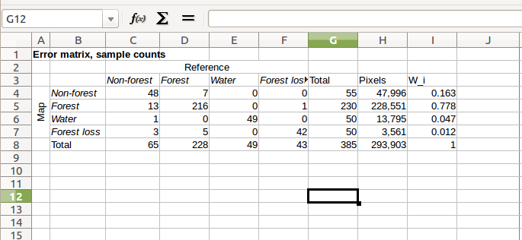

1. In this case, the sample is stratified and the number of sample units per stratum is disproportionate relative to the area of the stratum; it is therefore necessary to estimate the area proportions $({\hat{p}}_{ij})$ for each cell in the error matrix rather than sample counts before proceeding with the analysis. The area proportions are estimated as ${\hat{p}}_{ij}=W_{i}×n_{ij}÷n_{i}$ where $W_{i}$ are the stratum weights (the area proportion of stratum *i*), $n_{ij}$ is the sample count in cell *i,j*, and $n_{i}$ is the total number of sample counts in map category *i*.
2. In “LibreOffice Calc” copy the column and row headers and paste below the matrix, and the “Pixels” and “W_i” columns to below the sample counts error matrix.
3. In the first cell in the area proportions matrix, calculate ${\hat{p}}_{11}=W_{1}×n_{11}÷n_{1}$ (the spreadsheet expression should be “=$I4*C4/$G4” without the quotation marks; see screenshot below).

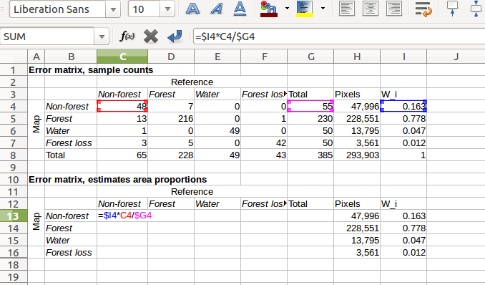

1. Then just populate the rest of the first row of the matrix by highlighting the first cell and then “grabbing” the little black square at the bottom right of the cell (mouse pointer turns into a plus sign) and drag to the end of the row.
2. Then highlight the first row of the matric and and drag down to populate the entire matric; highlight all cells > right click > *Format cells...* > set format to *Number* with 4 decimals.
3. The error matrix you just created contains all of the information required for stratified estimation area! And estimators are now easily obtained as the column totals of the estimated area proportions. Calculate the row and columns totals by highlighting the row or the cell and clicking the sum sign (∑) above the B column. To check if you got it right: the row totals should equal *Wi* and the totals should sum to 1:

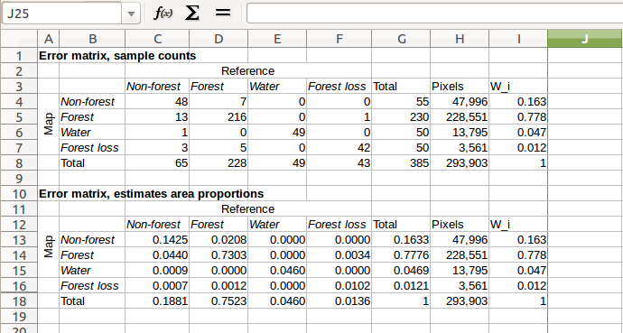

1. You have just calculated unbiased estimates of area! I.e. the column totals. To express these in hectares rather proportions multiply the column totals by the stratum size and the pixel size in hectares (302/1002). For example, an unbiased area estimate of map class 1 in hectares is calculated as “=C18*H18*30^2/100^2”. Do this calculation on row 14 for all classes. (It’s a good idea to first calculate the area in pixels and calculate the sum to make sure it matches the total map area). In my example, I get the following unbiased area estimates: 4,977 ha, 19,899 ha, 1,217 ha and 359 ha:

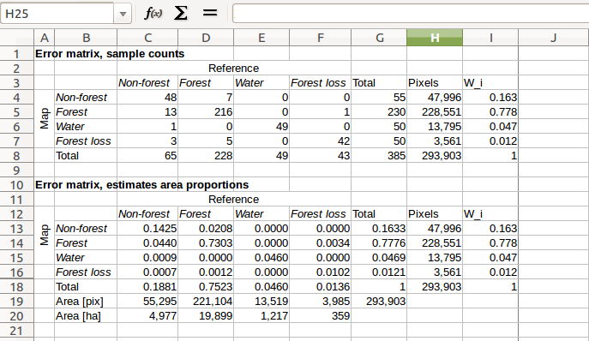

1. The next step is to calculate the standard errors of the area estimates, which are given by the following equation for a stratified random sample:

$S\left({\hat{p}}_{∙j}\right)= \sqrt{\sum_{i}{\frac{W_{i}{\hat{p}}_{ij}-{\hat{p}}_{ij}^{2}}{n_{i∙}-1}}}$

This can be tricky to get right in a spreadsheet! Calculate the standard errors in row 21; the $S\left({\hat{p}}_{∙1}\right)$ which is the standard error for map class 1 (first column total) is calculated as =SQRT(($I$13*C13-C13^2)/($G4-1)+($I$14*C14-C14^2)/($G$5-1)+($I$15*C15-C15^2)/($G$6-1)+($I$16*C16-C16^2)/($G$7-1))”; then just can drag the expression to complete the row:

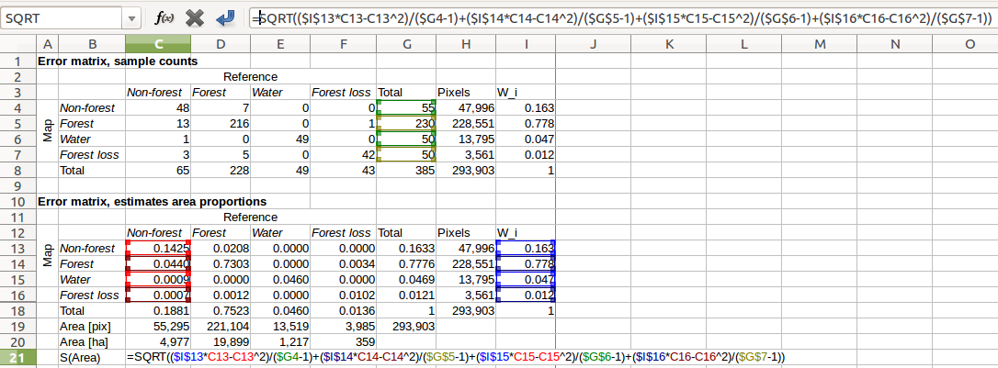

1. Now, calculate the standard errors in the units of hectares by multiplying by the total number of pixels of the times 30^/100^2; 95% confidence intervals are given by multiplying the standard errors by 1.96. The spreadsheet should look like below:

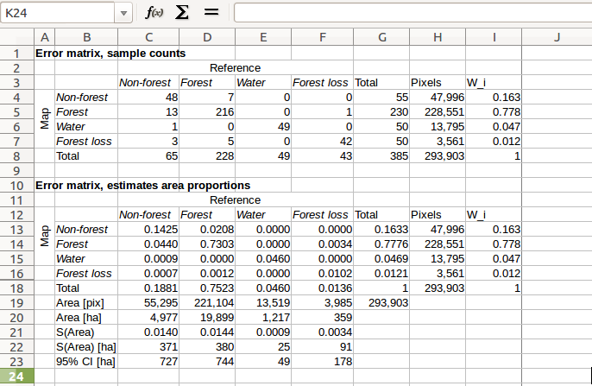

1. Finally, we can estimate the accuracy of the map. Three different accuracy measures are of interest: i) **overall accuracy** which is simply the sum of the diagonals in the error matrix of estimated area proportions; ii) **user’s accuracy** which for a map category *i* is given by ${\hat{U}}_{i}={\hat{p}}_{ii}÷{\hat{p}}_{i∙}$ and iii) **producer’s accuracy** for map category *j* given by ${\hat{P}}_{i}={\hat{p}}_{jj}÷{\hat{p}}_{∙j}$ where ${\hat{p}}_{i∙}$ and ${\hat{p}}_{∙j}$ are the row and columns totals respectively. In my example, I calculated user’s accuracy in row 24 (${\hat{U}}_{1}$“=C13/G13”), producer’s in row 25 ( ${\hat{P}}_{1}$“=C13/C18”) and overall in row 26 (“=sum(C13,D14,E15,F16)”). This gives the final spreadsheet with areas in green cells and accuracies in blue cells:

