BSc Data Sciences & Analytics
School of Social Sciences
Semester V - Advanced Data Analytics & Visualization
LAB 5: D3.JS FORCE-DIRECTED GRAPHS & GITHUB PAGES DEPLOYMENT
Date: 28-09-2026 Lab Session: 9:30 AM - 11:10 AM
Roll Number: 24SSDS415001 | GitHub: https://github.com/Basil-Unk
PROBLEM STATEMENT
Static dashboards and charts show fixed snapshots of data, but they don't let users explore and interact. Interactive visualizations give users power-they can hover, drag, zoom, and discover patterns themselves. D3.js is the industry standard for building these interactive visualizations. However, building in Jupyter notebooks keeps your work private. This lab teaches you to build an interactive force-directed graph using D3.js in Colab, then deploy it to GitHub Pages so you have a permanent, shareable public URL- a portfolio piece you can show employers and clients.
OBJECTIVE
By the end of this lab, you will:
- Write D3.js code in a Colab %%html cell to create an interactive network visualization
- Understand how D3 binds data to visual elements and responds to user interactions
- Build a force-directed graph with draggable nodes and hover effects
- Export your visualization as a standalone HTML file
- Deploy it to GitHub Pages and create a live public URL
- Learn the Git workflow: initialize, commit, and push code to GitHub
TASKS
Develop three interactive D3.js visualizations using provided datasets from a data pipeline: a force-directed graph showing 7 pipeline stages (Data Cleaning, EDA, Feature Engineering, Model Training, Evaluation, Visualization, Deployment) with draggable nodes, a Sankey diagram visualizing data flow from three sources (Web Logs, Mobile App, CRM Export) through processing stages to deployment with flow values and a treemap displaying pipeline data volume across input sources and processing stages.
Task 1: Build a Force-Directed Graph
Create a D3.js force-directed graph in a Colab %%html cell. Your graph should display nodes (as circles) and links (as lines connecting them) with interactive dragging enabled. Refer to the D3.js v7 documentation and the lab notebook for the starter code structure.
Working code (Colab %%html cell):
%%html
<div id="graph"></div>
<script src="https://cdn.jsdelivr.net/npm/d3@7/dist/d3.min.js"></script>
<script>
const width = 700, height = 450;
const nodes = [
{id: "Data Cleaning"}, {id: "EDA"}, {id: "Feature Engineering"},
{id: "Model Training"}, {id: "Evaluation"}, {id: "Visualization"},
{id: "Deployment"}
];
const links = [
{source: "Data Cleaning", target: "EDA"},
{source: "EDA", target: "Feature Engineering"},
{source: "Feature Engineering", target: "Model Training"},
{source: "Model Training", target: "Evaluation"},
{source: "Evaluation", target: "Visualization"},
{source: "Visualization", target: "Deployment"},
{source: "EDA", target: "Visualization"}
];
const svg = d3.select("#graph").append("svg")
.attr("width", width).attr("height", height)
.style("border", "1px solid #ccc");
const simulation = d3.forceSimulation(nodes)
.force("link", d3.forceLink(links).id(d => d.id).distance(110))
.force("charge", d3.forceManyBody().strength(-320))
.force("center", d3.forceCenter(width / 2, height / 2));
const link = svg.append("g")
.selectAll("line").data(links).join("line")
.attr("stroke", "#999").attr("stroke-width", 1.5);
const node = svg.append("g")
.selectAll("circle").data(nodes).join("circle")
.attr("r", 10).attr("fill", "#4C78A8")
.call(d3.drag()
.on("start", (event, d) => { if (!event.active) simulation.alphaTarget(0.3).restart(); d.fx = d.x; d.fy = d.y; })
.on("drag", (event, d) => { d.fx = event.x; d.fy = event.y; })
.on("end", (event, d) => { if (!event.active) simulation.alphaTarget(0); d.fx = null; d.fy = null; }));
const label = svg.append("g")
.selectAll("text").data(nodes).join("text")
.text(d => d.id).attr("font-size", 11).attr("dx", 14).attr("dy", 4);
simulation.on("tick", () => {
link.attr("x1", d => d.source.x).attr("y1", d => d.source.y)
.attr("x2", d => d.target.x).attr("y2", d => d.target.y);
node.attr("cx", d => d.x).attr("cy", d => d.y);
label.attr("x", d => d.x).attr("y", d => d.y);
});
</script>
Task 2: Build a Sankey Diagram
Build a separate Sankey diagram showing flow between stages (e.g., data pipeline: Raw → Clean → Analyze → Deploy).
- Load the d3-sankey library via <script src="https://cdn.jsdelivr.net/npm/d3-sankey@0.12/dist/d3-sankey.min.js"></script>
- Create nodes and links that represent a real flow (data pipeline stages, team workflows, or information flow). Your Sankey should have at least 3 stages with multiple flows between them.
- Add a hover transition: fade node color smoothly on hover using d3.select(this).transition().duration(200).attr("fill", ...).
- Test in Colab to verify it renders correctly. You should see colored rectangles (nodes) with connecting flows between them.
Working code (saved as standalone index.html):
%%writefile index.html
<!DOCTYPE html>
<html lang="en">
<head>
<meta charset="utf-8">
<title>D3 Sankey – Data Pipeline</title>
</head>
<body>
<div id="graph"></div>
<script src="https://cdn.jsdelivr.net/npm/d3@7/dist/d3.min.js"></script>
<script src="https://cdn.jsdelivr.net/npm/d3-sankey@0.12/dist/d3-sankey.min.js"></script>
<script>
function draw() {
const width = 900, height = 450;
const nodes = [
{name: "Web Logs"}, {name: "Mobile App"}, {name: "CRM Export"},
{name: "Data Cleaning"}, {name: "Rejected"}, {name: "EDA"},
{name: "Feature Engineering"}, {name: "Model Training"},
{name: "Evaluation"}, {name: "Visualization"}, {name: "Deployment"}
];
const links = [
{source: "Web Logs", target: "Data Cleaning", value: 5000},
{source: "Mobile App", target: "Data Cleaning", value: 3000},
{source: "CRM Export", target: "Data Cleaning", value: 2000},
{source: "Data Cleaning", target: "EDA", value: 8500},
{source: "Data Cleaning", target: "Rejected", value: 1500},
{source: "EDA", target: "Feature Engineering", value: 6000},
{source: "EDA", target: "Visualization", value: 2500},
{source: "Feature Engineering", target: "Model Training", value: 4800},
{source: "Feature Engineering", target: "Evaluation", value: 1200},
{source: "Model Training", target: "Evaluation", value: 4800},
{source: "Evaluation", target: "Deployment", value: 5000},
{source: "Evaluation", target: "Visualization", value: 1000}
];
const svg = d3.select("#graph").append("svg")
.attr("width", width).attr("height", height)
.style("border", "1px solid #ccc");
const graph = d3.sankey()
.nodeId(d => d.name).nodeWidth(16).nodePadding(20)
.extent([[10, 10], [width - 10, height - 10]])
({nodes: nodes.map(d => ({...d})), links: links.map(d => ({...d}))});
const color = d3.scaleOrdinal(d3.schemeTableau10);
svg.append("g")
.selectAll("path").data(graph.links).join("path")
.attr("d", d3.sankeyLinkHorizontal())
.attr("fill", "none")
.attr("stroke", d => color(d.source.name))
.attr("stroke-opacity", 0.4)
.attr("stroke-width", d => Math.max(1, d.width));
const node = svg.append("g")
.selectAll("rect").data(graph.nodes).join("rect")
.attr("x", d => d.x0).attr("y", d => d.y0)
.attr("width", d => d.x1 - d.x0).attr("height", d => d.y1 - d.y0)
.attr("fill", d => color(d.name))
.on("mouseover", function (event, d) {
d3.select(this).transition().duration(200)
.attr("fill", d3.color(color(d.name)).brighter(0.7));
})
.on("mouseout", function (event, d) {
d3.select(this).transition().duration(200)
.attr("fill", color(d.name));
});
svg.append("g")
.selectAll("text").data(graph.nodes).join("text")
.text(d => d.name).attr("font-size", 11)
.attr("x", d => d.x0 < width / 2 ? d.x1 + 6 : d.x0 - 6)
.attr("y", d => (d.y0 + d.y1) / 2).attr("dy", "0.35em")
.attr("text-anchor", d => d.x0 < width / 2 ? "start" : "end");
}
(function wait() {
if (window.d3 && window.d3.sankey) draw(); else setTimeout(wait, 50);
})();
</script>
</body>
</html>
Step 2 Completion: Final working code saved as a standalone index.html file (see GitHub repository; also present as sankey.html).
Task 3: Build a Treemap (All Levels)
- Create an interactive treemap visualization showing hierarchical data.
- Load d3-hierarchy library: <script src="https://cdn.jsdelivr.net/npm/d3@7/dist/d3.min.js"></script>
- Use d3.hierarchy() to structure your data and d3.treemap() to calculate positions and sizes.
- Render rectangles (leaf nodes) with colors representing categories. Add labels and hover effects for interactivity. Save as treemap.html.
Working code (saved as treemap.html):
<!DOCTYPE html>
<html lang="en">
<head>
<meta charset="utf-8">
<title>D3 Treemap – Data Pipeline Volumes</title>
</head>
<body>
<div id="treemap"></div>
<script src="https://cdn.jsdelivr.net/npm/d3@7/dist/d3.min.js"></script>
<script>
function drawTreemap() {
const width = 900, height = 540;
const data = {
name: "Data Pipeline",
children: [
{ name: "Input Sources", children: [
{ name: "Web Logs", value: 5000 },
{ name: "Mobile App", value: 3000 },
{ name: "CRM Export", value: 2000 }
]},
{ name: "Processing Stages", children: [
{ name: "Data Cleaning", value: 1800 },
{ name: "EDA", value: 2200 },
{ name: "Feature Engineering", value: 1600 },
{ name: "Model Training", value: 1200 },
{ name: "Evaluation", value: 900 },
{ name: "Visualization", value: 800 },
{ name: "Deployment", value: 500 }
]}
]
};
const svg = d3.select("#treemap").append("svg")
.attr("width", width).attr("height", height)
.style("border", "1px solid #ccc");
const root = d3.hierarchy(data)
.sum(d => d.value)
.sort((a, b) => b.value - a.value);
d3.treemap()
.size([width, height - 40])
.padding(3)
.round(true)(root);
const color = d3.scaleOrdinal()
.domain(["Input Sources", "Processing Stages"])
.range(["#4C78A8", "#F58518"]);
const cell = svg.selectAll("g")
.data(root.leaves()).join("g")
.attr("transform", d => `translate(${d.x0},${d.y0})`);
cell.append("rect")
.attr("width", d => d.x1 - d.x0)
.attr("height", d => d.y1 - d.y0)
.attr("fill", d => color(d.parent.data.name))
.attr("stroke", "#fff")
.on("mouseover", function (event, d) {
d3.select(this).transition().duration(200)
.attr("fill", d3.color(color(d.parent.data.name)).brighter(0.7));
})
.on("mouseout", function (event, d) {
d3.select(this).transition().duration(200)
.attr("fill", color(d.parent.data.name));
});
cell.append("text")
.text(d => {
const maxChars = Math.floor((d.x1 - d.x0 - 12) / 6.8);
return d.data.name.length > maxChars ? d.data.name.slice(0, Math.max(4, maxChars - 1)) + "…" : d.data.name;
})
.attr("x", 6).attr("y", 16)
.attr("font-size", 12).attr("font-weight", "bold").attr("fill", "#fff")
.style("display", d => (d.x1 - d.x0 > 90 && d.y1 - d.y0 > 36) ? null : "none");
cell.append("text")
.text(d => d.data.value.toLocaleString() + " records")
.attr("x", 6).attr("y", 32)
.attr("font-size", 10).attr("fill", "#fff")
.style("display", d => (d.x1 - d.x0 > 90 && d.y1 - d.y0 > 36) ? null : "none");
const legend = svg.append("g").attr("transform", `translate(${width - 230}, ${height - 26})`);
["Input Sources", "Processing Stages"].forEach((name, i) => {
legend.append("rect").attr("x", i * 110).attr("y", 0)
.attr("width", 12).attr("height", 12).attr("fill", color(name));
legend.append("text").attr("x", i * 110 + 16).attr("y", 10)
.attr("font-size", 11).text(name);
});
}
(function wait() {
if (window.d3) drawTreemap(); else setTimeout(wait, 50);
})();
</script>
</body>
</html>

Task 4: Deploy to GitHub Pages
- Create a new GitHub repository (e.g., d3-lab-<yourname>). Deploy any ONE of the html file visualizations. E.g: Add index.html file containing the visualization.
- Enable GitHub Pages in your repo: Go to Settings → Pages → Under "Source" select "Deploy from a branch" → Choose branch and "/(root)" folder → Save.
- Wait ~1-2 minutes for deployment. Click the tabs to switch between Force-directed Graph, Sankey Diagram, and Treemap.
Deployment details (this submission):
- GitHub repository: https://github.com/Basil-Unk/DV-LAB5
- Live visualization URL: https://basil-unk.github.io/DV-LAB5/
The deployed index.html (repository root, /(root)) contains all three visualizations behind tabs: Force-directed Graph | Sankey Diagram | Treemap. GitHub Pages source: branch arena/01a107ec-dv-lab5 (or main after merging), folder /(root); enable via Settings → Pages as above - the site then goes live at the URL shown.

SUBMIT YOUR WORK
1. GitHub repository link
- Repository: https://github.com/Basil-Unk/DV-LAB5
2. Live visualization URL (GitHub Pages link)
- Live site: https://basil-unk.github.io/DV-LAB5/
3. Screenshot of your graph
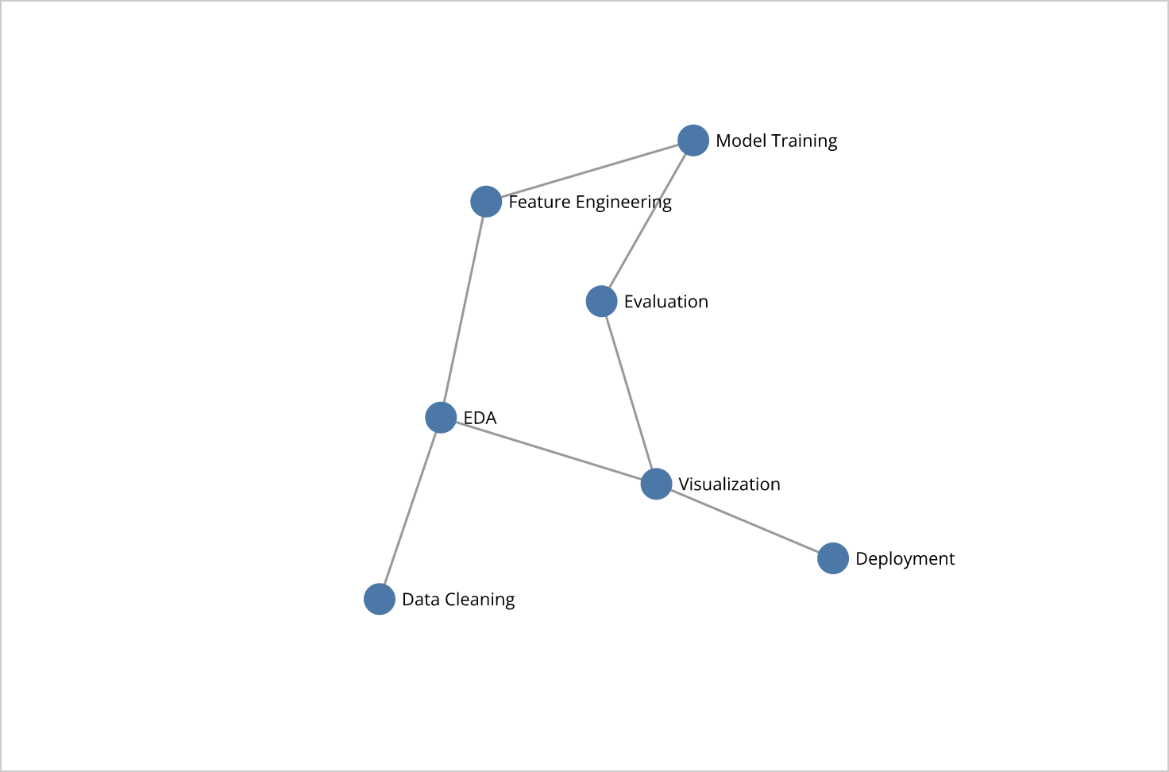
- Force-directed graph of the 7 pipeline stages (draggable nodes).
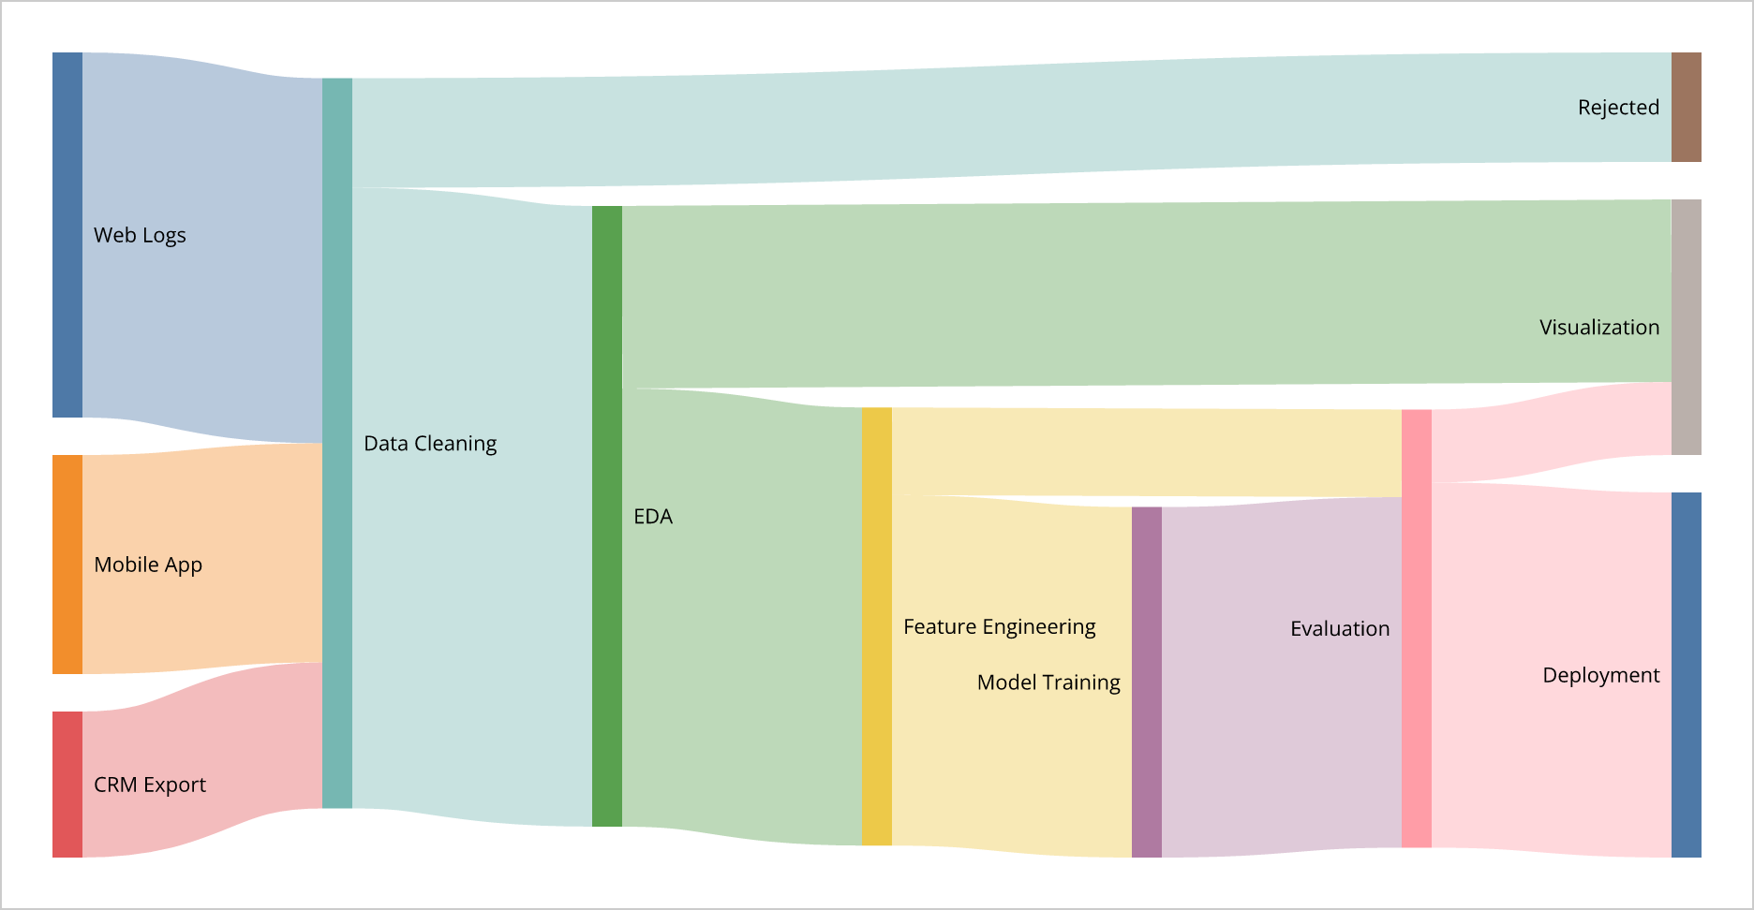
- Sankey diagram: three sources → processing stages → deployment, with flow values.
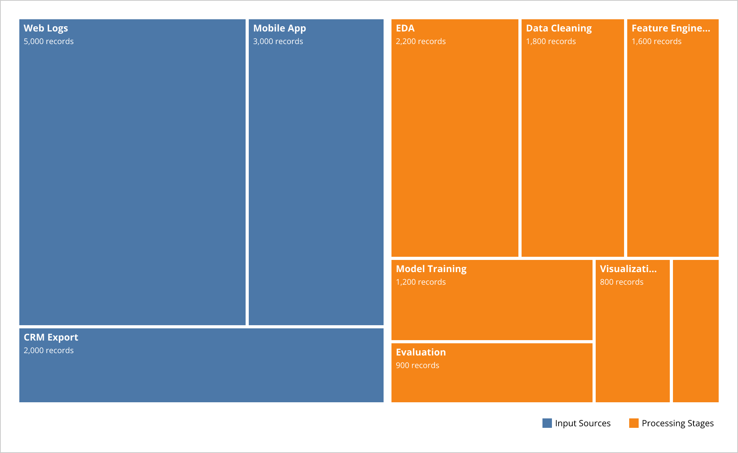
- Treemap: pipeline data volume across input sources and processing stages.
4. Screenshot of git commit history
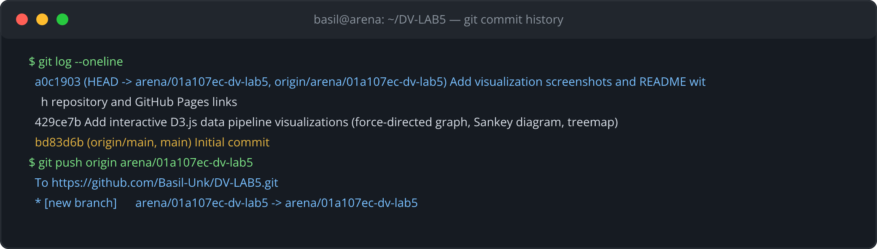
5. Brief report (1 page): What you built, how it works, what you learned
What I built
For Lab 5 I built three interactive D3.js (v7) visualizations of a data pipeline and deployed them to GitHub Pages. The force-directed graph (Task 1) draws the 7 pipeline stages as draggable circular nodes joined by links; the Sankey diagram (Task 2) shows record volumes flowing from three input sources (Web Logs, Mobile App, CRM Export) through Data Cleaning, EDA, Feature Engineering, Model Training and Evaluation to Deployment, including a Rejected branch; and the treemap (Task 3) displays pipeline data volume across input sources and processing stages as proportional, labelled, colour-coded rectangles. All three live in one tabbed index.html that is published by GitHub Pages, with standalone copies (force.html, sankey.html, treemap.html) kept in the repository and in the submission folder ADV_Lab/Lab_5/24SSDS415001_Lab_5.
How it works
Each visualization uses D3's data-join pattern (selectAll().data().join()) to bind data arrays to SVG elements. The force graph runs d3.forceSimulation with forceLink (distance 110), forceManyBody (strength -320) and forceCenter; on every tick the handler re-positions lines, circles and labels, and d3.drag pins fx/fy while dragging and reheats the simulation with alphaTarget. The Sankey uses d3.sankey() (nodeId, nodeWidth 16, nodePadding 20, extent) to compute node rectangles and link ribbons, rendered with d3.sankeyLinkHorizontal() and stroke widths equal to the flow's width; hovering a node runs a 200 ms transition that brightens its fill and mouseout restores it. The treemap converts the nested JSON with d3.hierarchy().sum().sort(), lays it out with d3.treemap().size().padding(), and renders leaf rectangles coloured by category with name/value labels, a legend and the same brighten-on-hover transition. The pages load D3 (and d3-sankey) from CDN, and GitHub Pages serves the committed index.html from the repository root as a static site.
What I learned
I learned how D3 binds data to the DOM and updates it reactively, how force simulations balance link, charge and center forces to produce an organic layout, and how drag handlers cooperate with alphaTarget for smooth interaction. I learned that the Sankey and treemap layouts are just functions that turn data into geometry (x0/y0/x1/y1), which I then render myself. I also practised the full developer workflow: exporting a Colab %%html cell to a standalone HTML file, initializing a Git repository, committing and pushing with git, and enabling GitHub Pages (Settings → Pages → Deploy from a branch, /(root)) to obtain a permanent public URL - turning a lab exercise into a shareable portfolio piece.
SUBMISSION REQUIREMENTS
Upload your complete work to the class drive submission folder ADV_LAB. Folder naming convention used: ADV_Lab/Lab_5/24SSDS415001_Lab_5 (this document, the four HTML files and the screenshots folder).

