**Design Document**

Stories:

As a user, I want to add a new product or update a current product in the system.

1) I want to add or update a product to the system and see it in my database

2) I want to load a product from my database and see it in the UI

As a user, I want to add a new customer or update a current customer in the system.

1) I want to add or update a customer to the system and see it in my database

2) I want to load a customer from my database and see it in the UI

As a user, I want to add a new purchase or update a current purchase in the system.

1) I want to add or updated a purchase to the system and see it in my database

2) I want to put in bad or incomplete information and be given a prompt from the UI telling me

Data Access Client: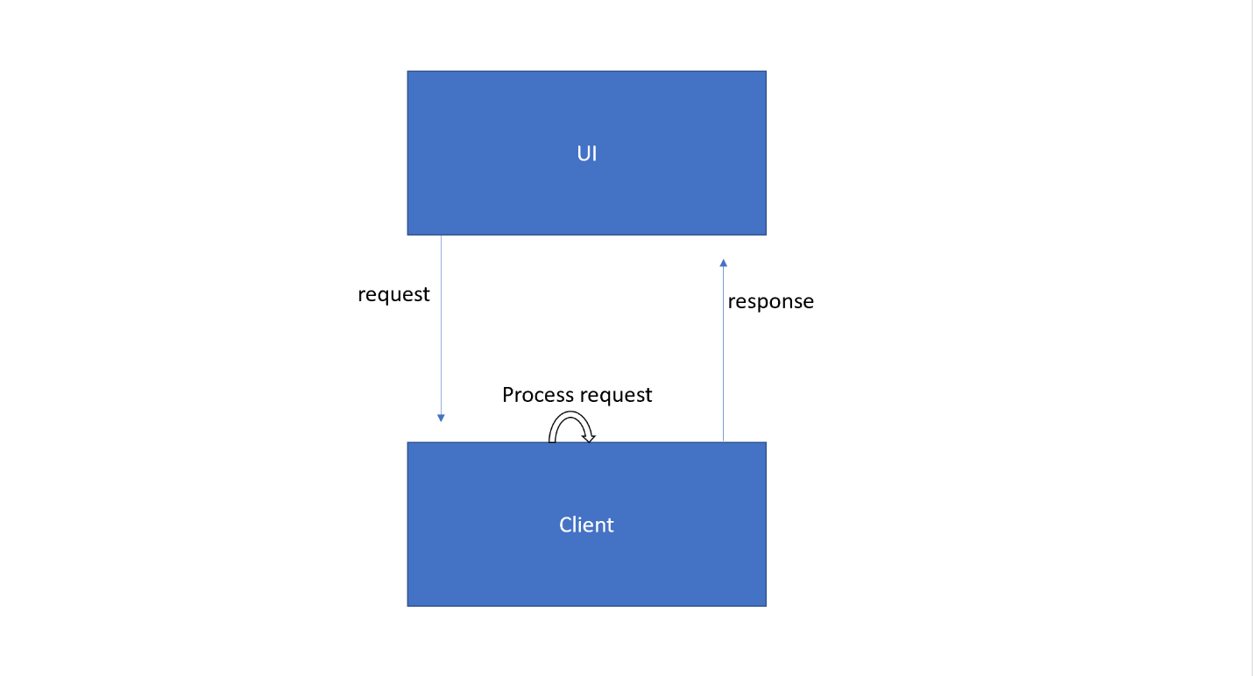

Explanation: The UI gets input from the user and that request from the UI determines what information the Client needs to fetch from the server and then sends a response back to the UI so that the User knows if it worked or not.

Data Access Server:

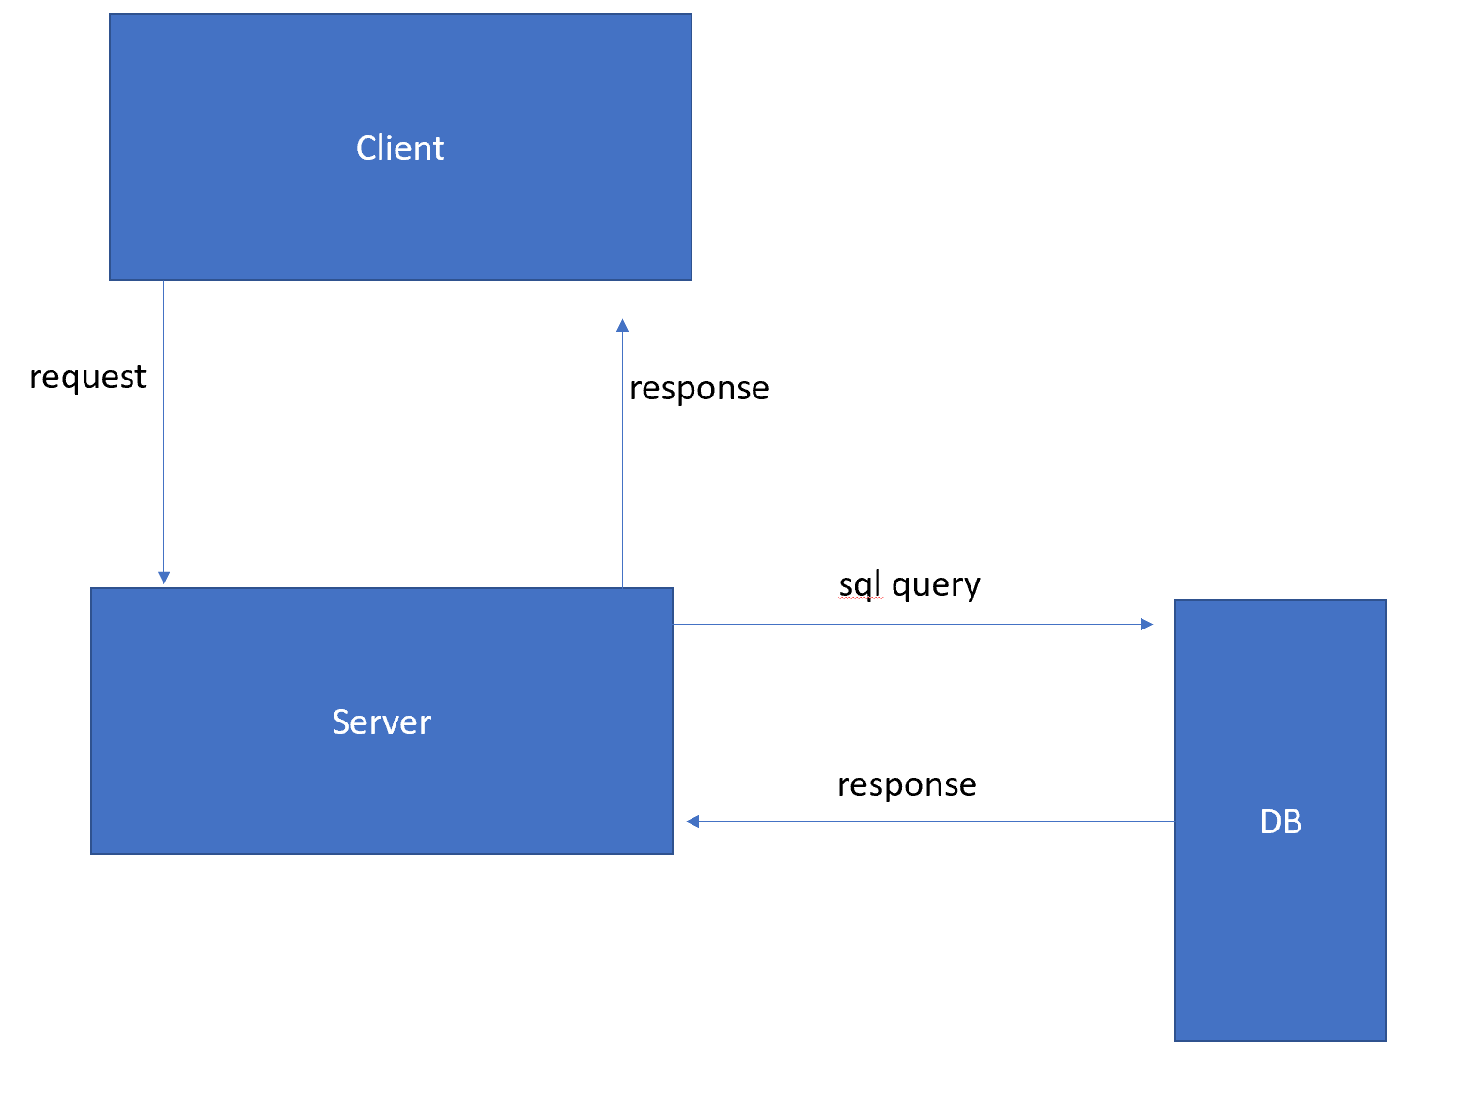

Explanation: The Client sends a request to an “endpoint” of the server. These endpoints are just arguments including what information it needs to access/change in the database and then the server will build the SQLite query that does what the client asked of it to do. It will then send that query to the SQLite database and get a response back from it. The server then takes that response and feeds it back up to the client. The client will handle the request and lets the User know through the UI if the request they sent was successful or not.