ActionFusion — Project Report
Abstract
This report summarizes the multimodal fusion experiments implemented in this repository on the UTD-MHAD dataset. We compare three fusion strategies: data-level (early) fusion, feature-level fusion, and decision-level fusion (both majority-vote and a learned late-fusion network). Evaluation is performed with the original subject holdout split and with Leave-One-Subject-Out (LOSO). The report includes tables and plots generated during experiments and a short comparison to two reference papers on UTD-MHAD.
Methodology
- Preprocess each modality to a fixed-size feature vector (skeleton, inertial, depth, RGB).
- Implement three fusion strategies:
  - Data-level (early) fusion: concatenate all modality features and train an SVM.
  - Feature-level fusion: per-modality feature selection (variance across classes on train set) then concatenate selected features and train an SVM.
  - Decision-level fusion: train per-modality SVMs producing class probability vectors; combine with (a) majority vote, and (b) a small neural network (LateFusionNet) trained on stacked modality probability vectors.
- Evaluate under multiple protocols: fixed subject holdout (subjects 1,3,5,7) and LOSO.
Dataset
We use the UTD-MHAD dataset (UTD Multimodal Human Action Dataset). Key facts:
- 27 actions, 8 subjects, each action repeated multiple times (original dataset ~861 sequences after cleaning).
- Modalities: RGB video, depth video, skeleton joint positions, wearable inertial sensor signals.
- Data are temporally synchronized and stored as .avi (RGB) and .mat files (depth, skeleton, inertial).
See the original paper UTD-MHAD: A Multimodal Dataset for Human Action Recognition (Chen et al.) for details on sensors, subjects, and action taxonomy.
Implementation Details
- Preprocessing (utils/preprocessing.py):
  - Skeleton: center on hip, resample to fixed temporal length, flatten.
  - Inertial: z-score per-channel, resample to fixed length, flatten.
  - Depth: compute Depth Motion Map (DMM) from temporal differences, resize to fixed image size, flatten.
  - RGB: sample fixed number of frames, resize, average frames to mean image, flatten.
- Caching: processed arrays saved to data/processed/ as .npy files.
- Models (summary):
  - Data-level: SVC pipeline with StandardScaler.
  - Feature-level: train-only variance-based feature selection per modality, then SVC on fused selected-features.
  - Decision-level: per-modality SVC (probabilities), then majority vote or LateFusionNet (PyTorch) trained with cross-entropy.

Evaluation Protocols
- Subject holdout (default): test subjects 1,3,5,7 vs rest for training.
- Leave-One-Subject-Out (LOSO): each subject held out once (strong subject-independent test).
All metric calculations use accuracy, macro precision, macro recall, and macro F1.

Results
Overall Comparison (Subject holdout)
The table below shows the overall fusion comparison for the subject holdout split (from results/tables/step9_fusion_comparison.csv):
Method | Accuracy | Precision (macro) | Recall (macro) | F1 (macro)
Data-Level | 0.3016 | 0.4767 | 0.3015 | 0.3144
Feature-Level | 0.4107 | 0.5974 | 0.4100 | 0.4112
Decision-Level Vote | 0.8190 | 0.8621 | 0.8190 | 0.8231
Decision-Level Learned | 0.7285 | 0.8164 | 0.7278 | 0.7273
Full CSV: results/tables/step9_fusion_comparison.csv

LOSO Results
LOSO overall comparison (from results/tables/step9_loso_fusion_comparison.csv):
Method | Accuracy | Precision (macro) | Recall (macro) | F1 (macro)
Data-Level | 0.3751 | 0.5533 | 0.3752 | 0.4047
Feature-Level | 0.5134 | 0.6528 | 0.5138 | 0.5397
Decision-Level Vote | 0.86295 | 0.8700 | 0.86305 | 0.8645
Decision-Level Learned | 0.80023 | 0.8747 | 0.80048 | 0.81327
Full CSV: results/tables/step9_loso_fusion_comparison.csv

Per-subject (LOSO) Fold Metrics
We provide per-subject fold metrics in results/tables/step9_loso_fold_metrics.csv. Example excerpt (subjects 1–8):
fold | held_out_subject | method | accuracy | precision_macro | recall_macro | f1_macro
1 | 1 | Decision-Level Vote | 0.9533 | 0.9611 | 0.9537 | 0.9514
2 | 2 | Decision-Level Vote | 0.9352 | 0.9481 | 0.9352 | 0.9347
3 | 3 | Decision-Level Vote | 0.8426 | 0.8641 | 0.8426 | 0.8345
4 | 4 | Decision-Level Vote | 0.8056 | 0.7683 | 0.8056 | 0.7696
5 | 5 | Decision-Level Vote | 0.8704 | 0.9041 | 0.8704 | 0.8619
Full CSV: results/tables/step9_loso_fold_metrics.csv

Plots and Confusion Matrices
Accuracy comparison (subject holdout):
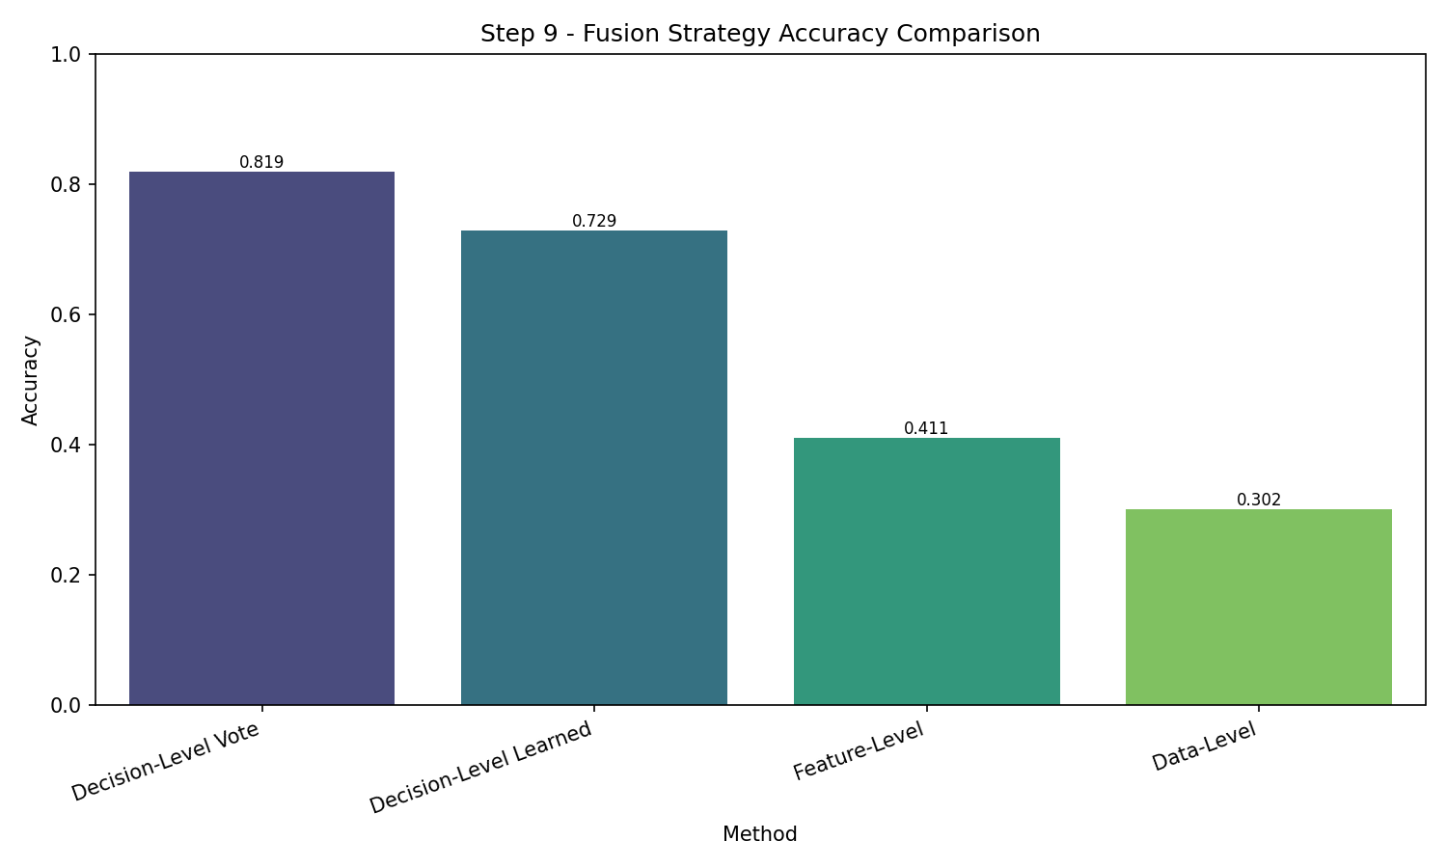
Accuracy comparison (LOSO):
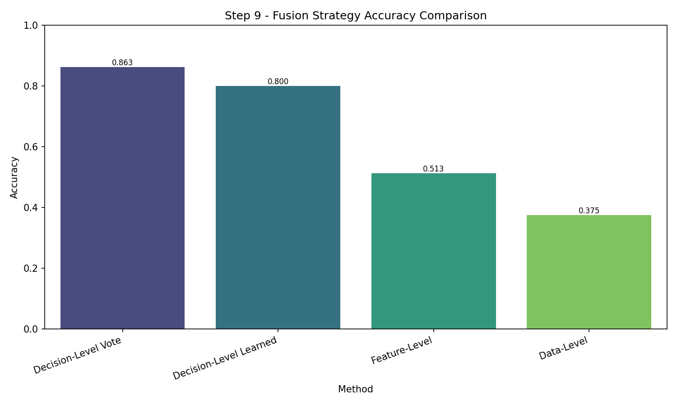

Confusion matrices (subject holdout):
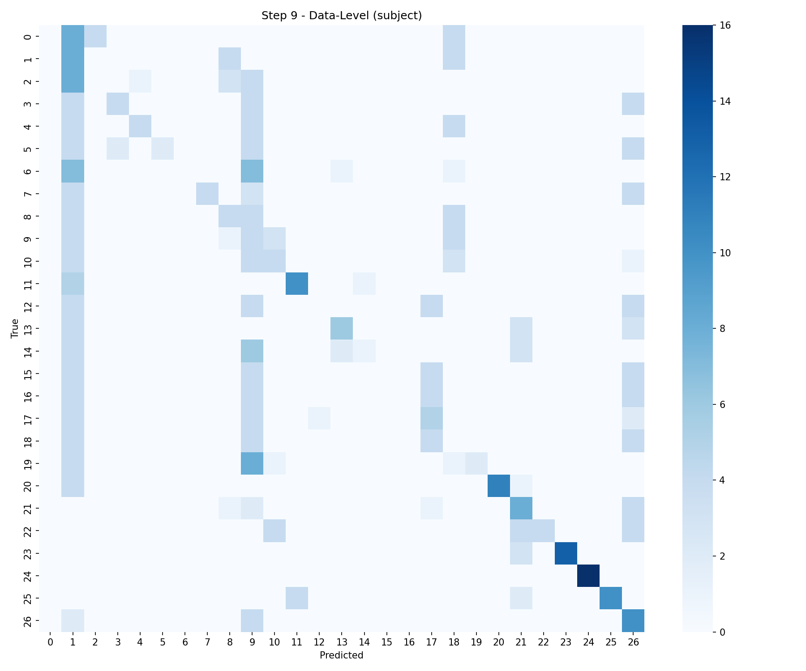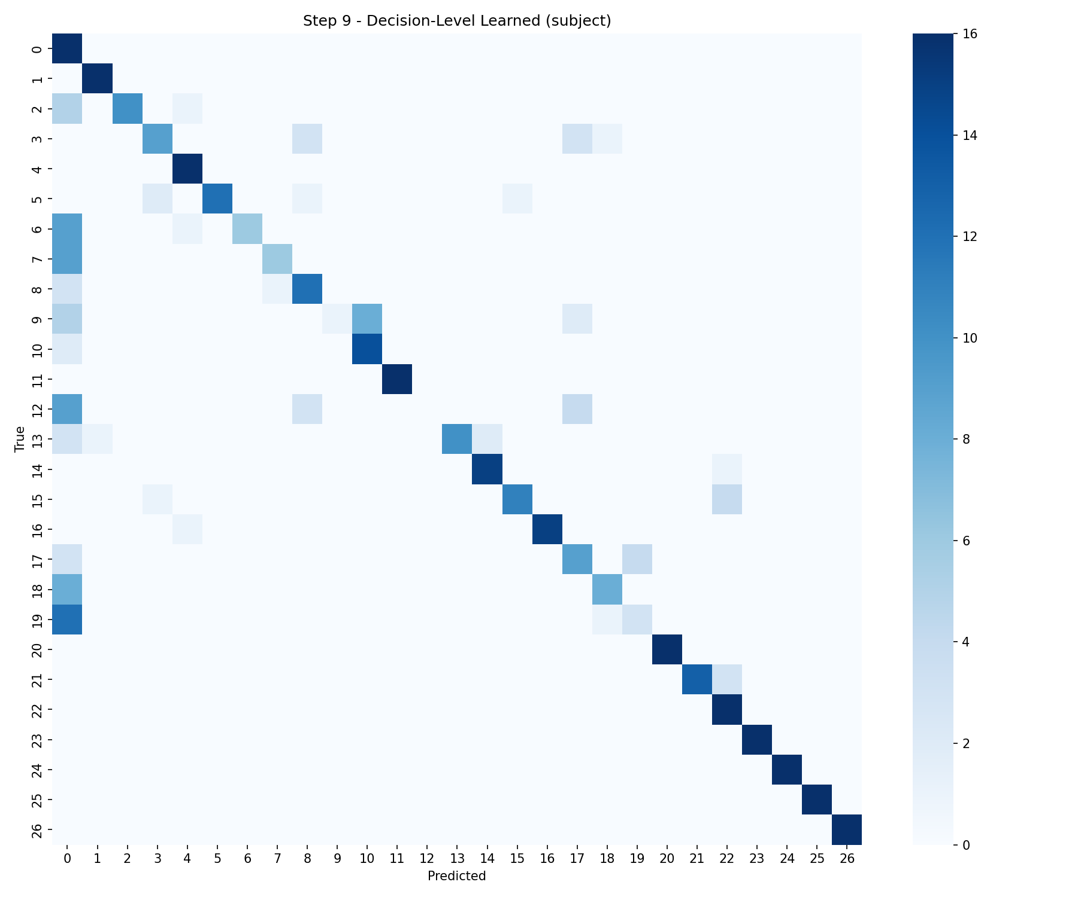
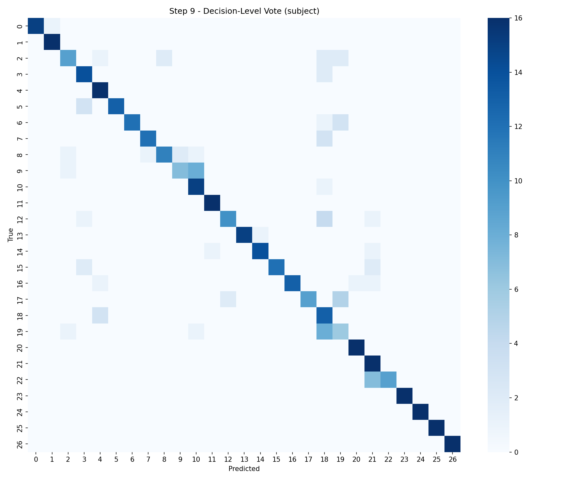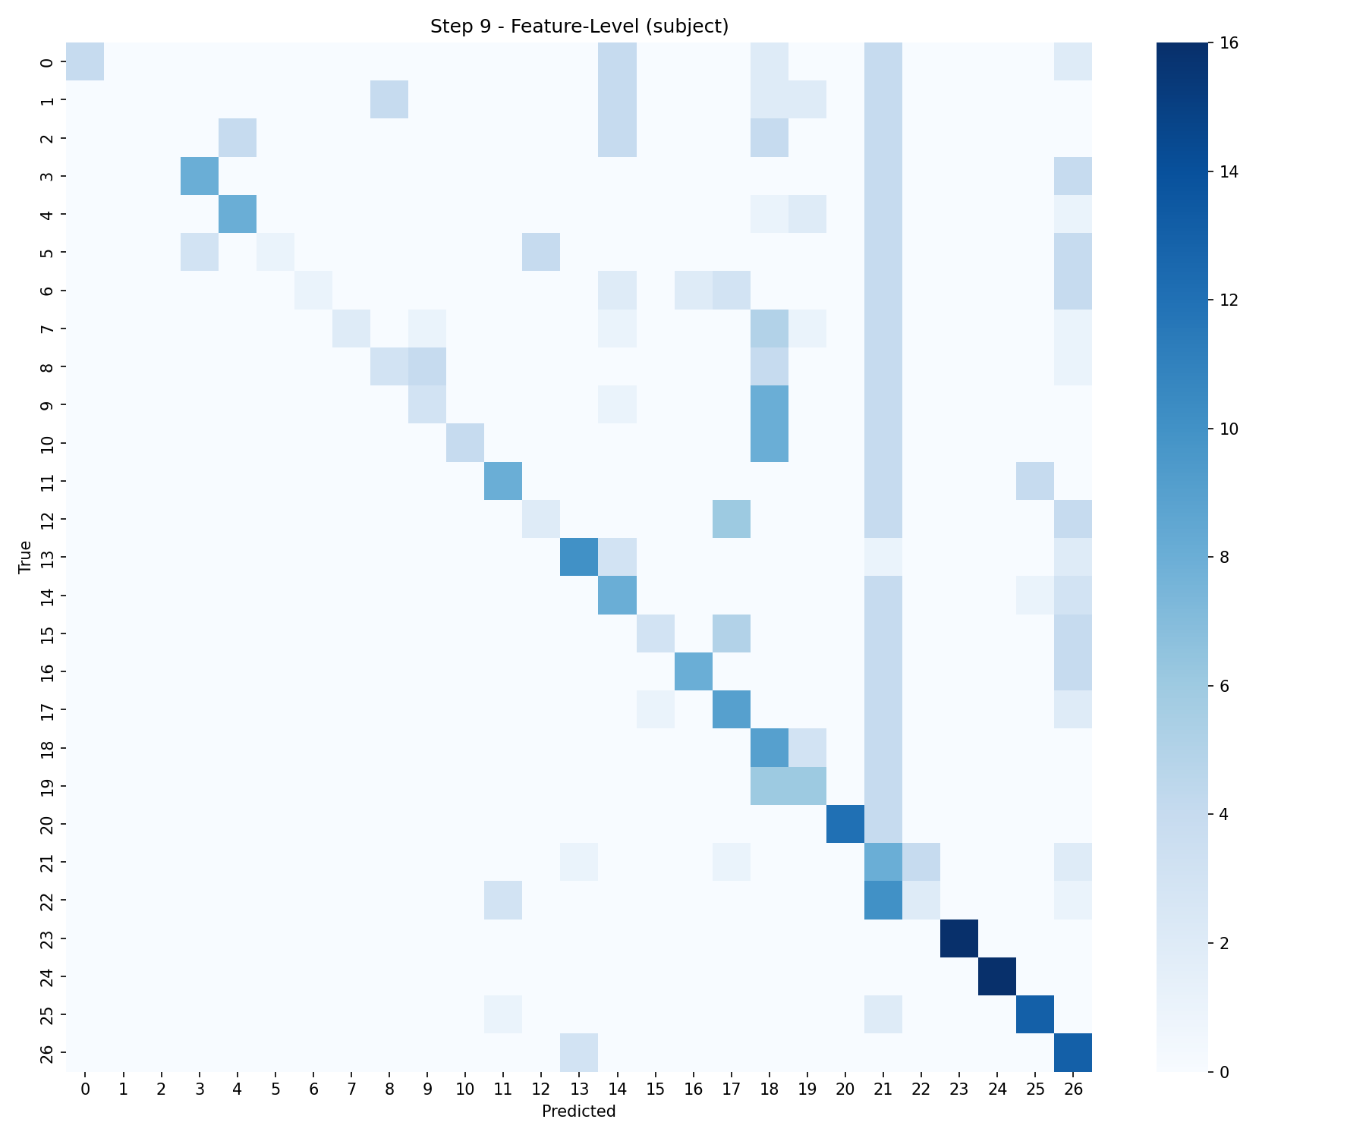
Confusion matrices (LOSO):
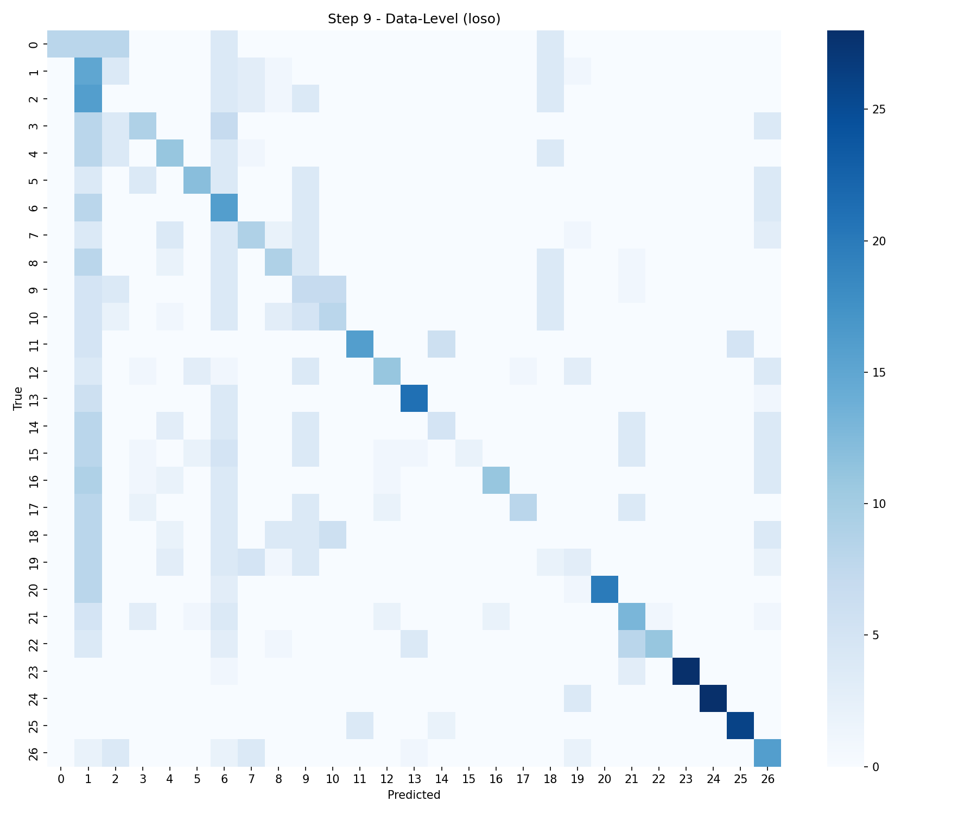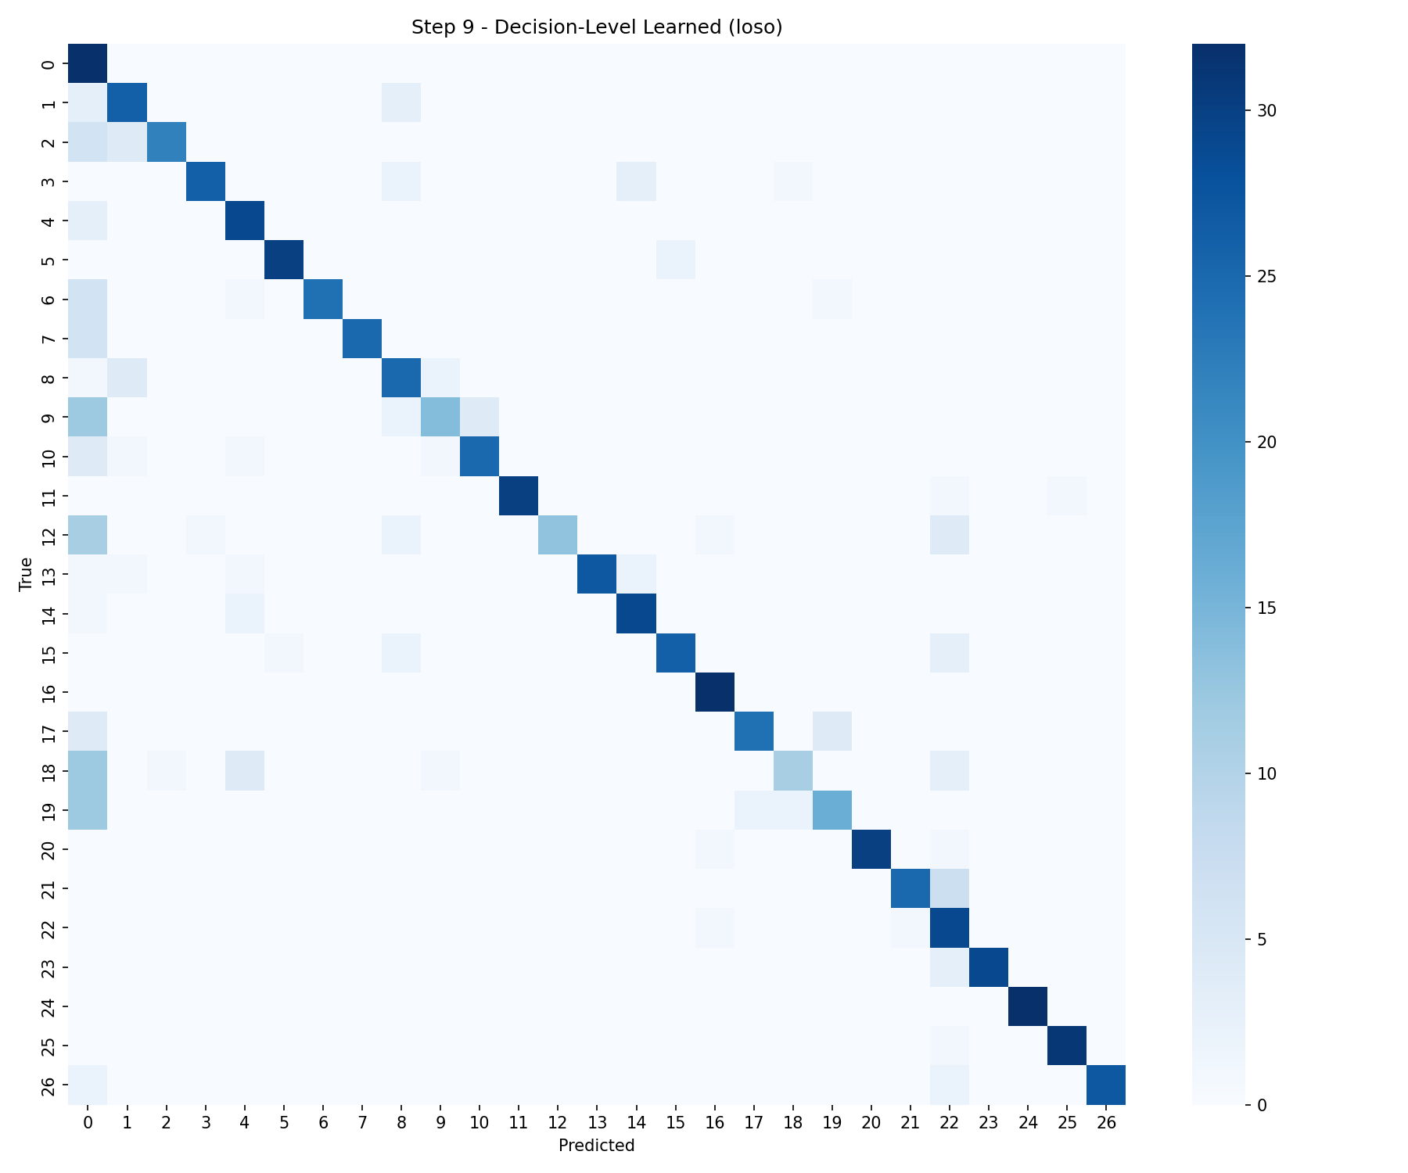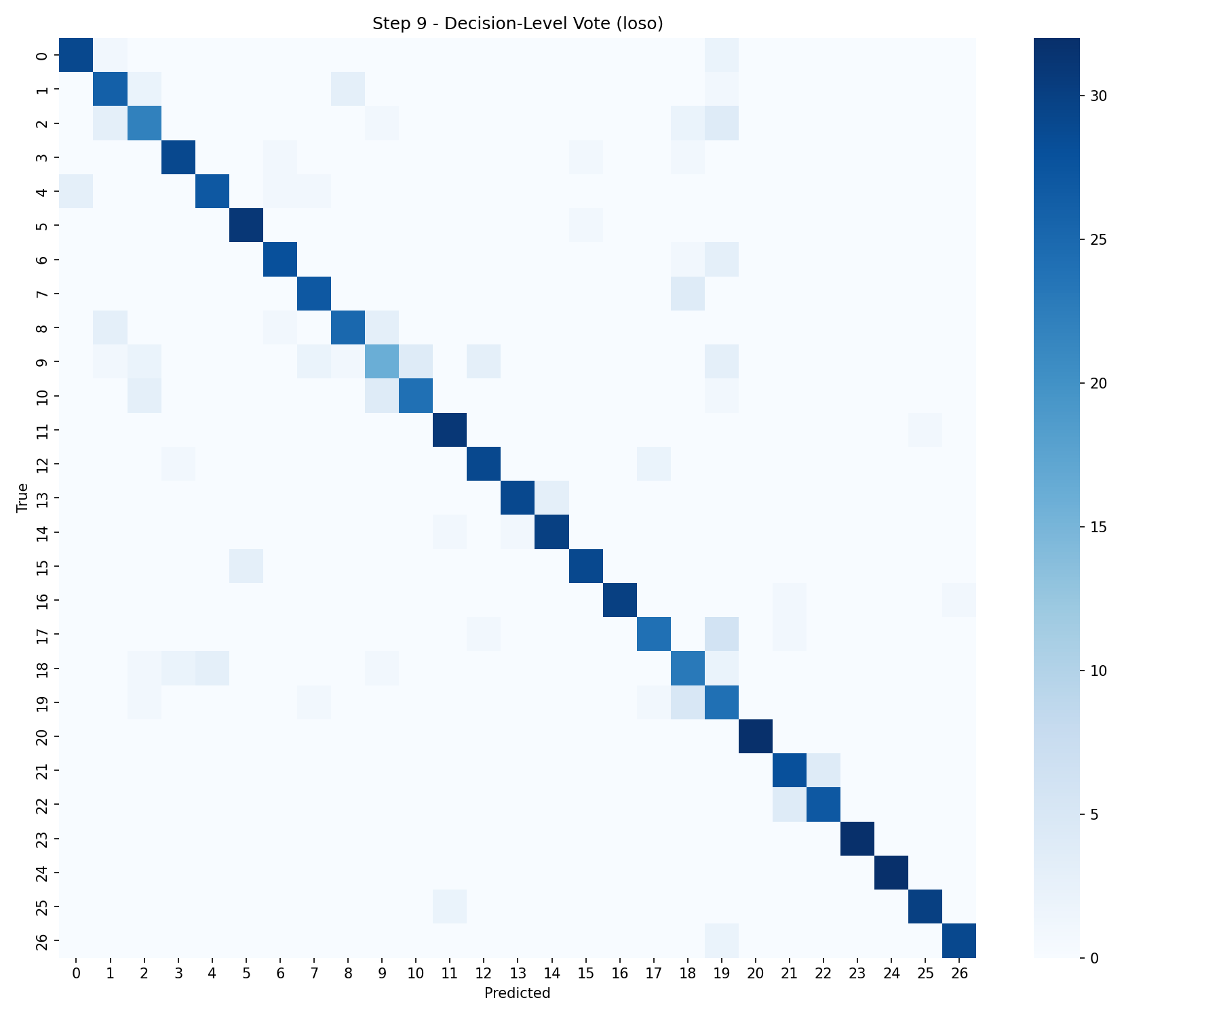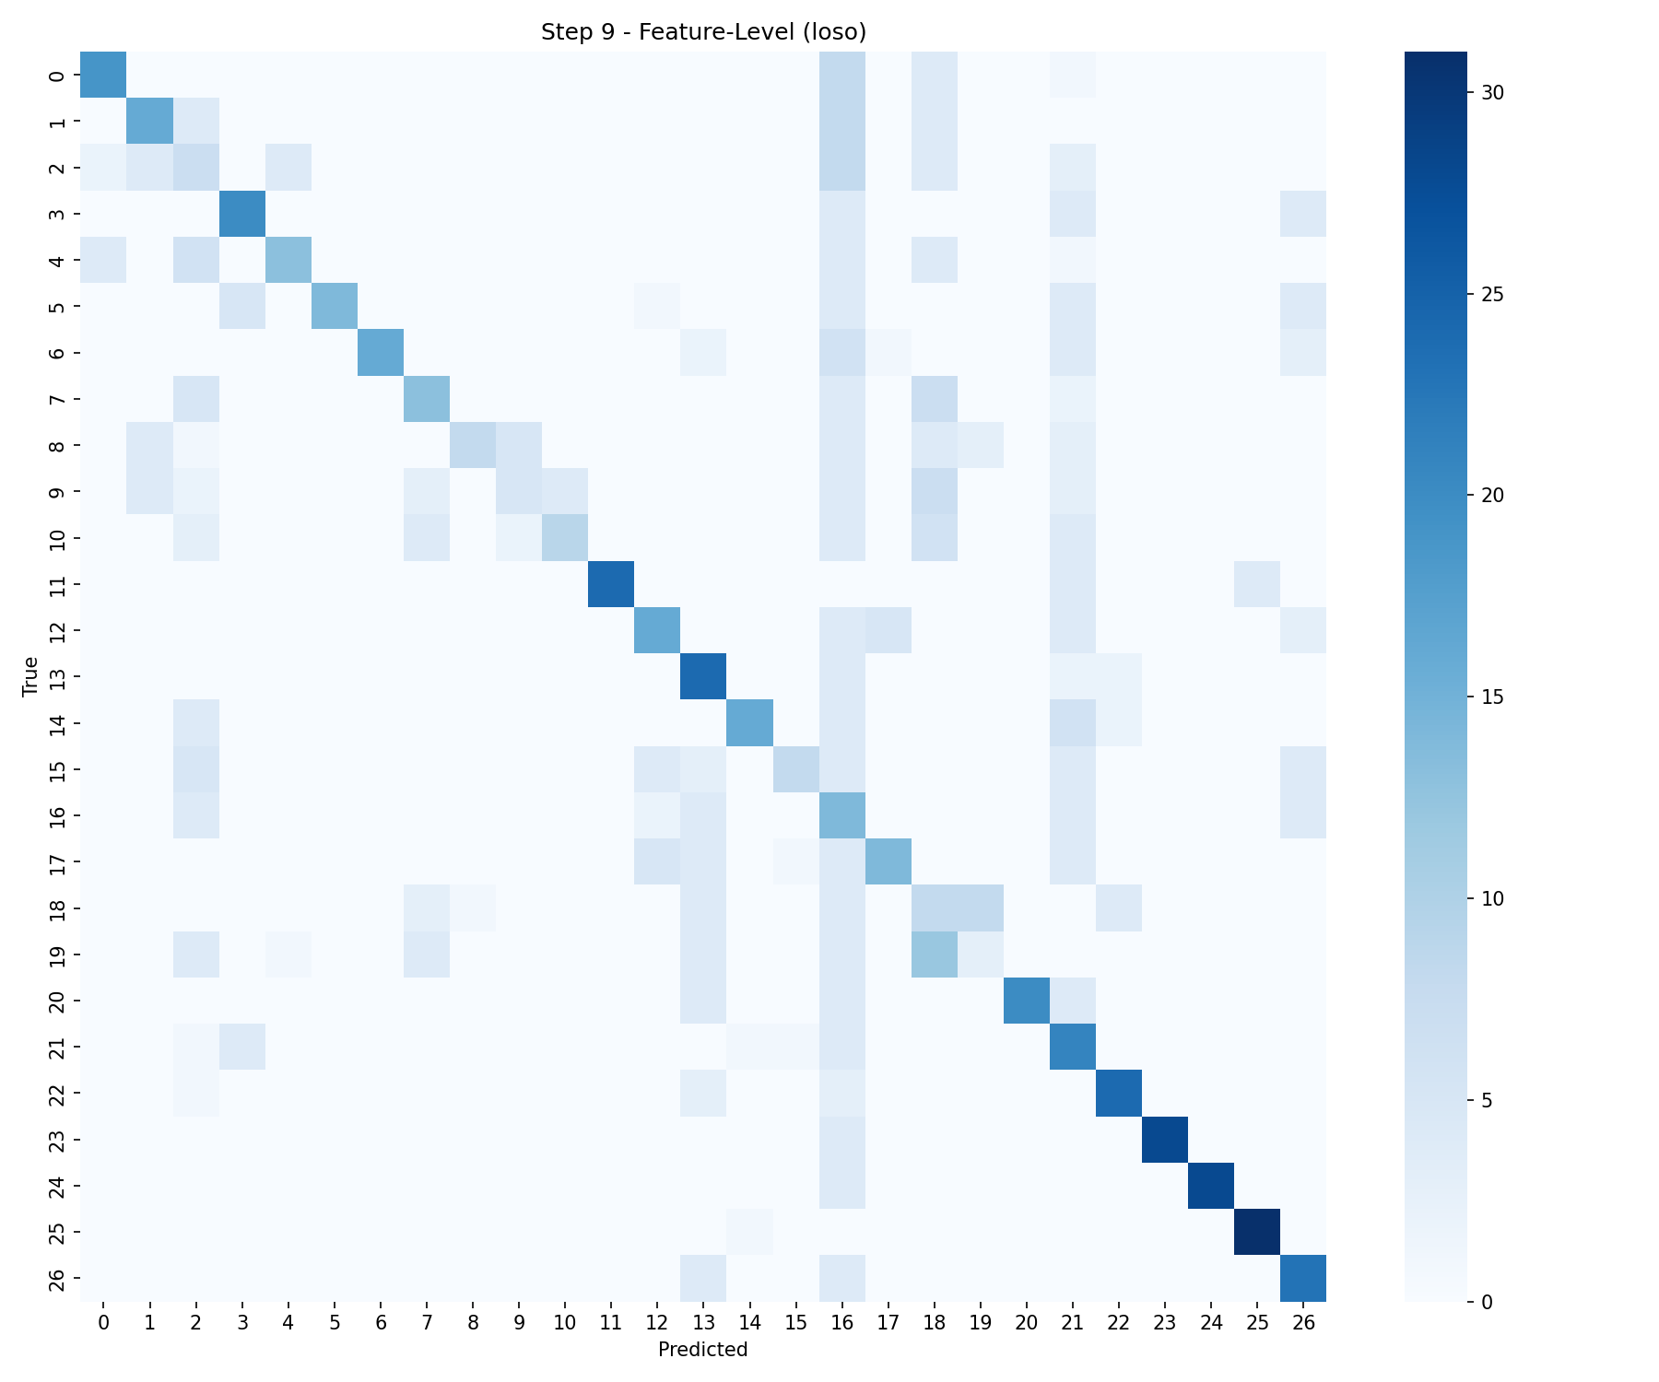

Discussion
- Decision-level fusion (majority vote) produced the best performance in our experiments (Accuracy ~81.9% subject holdout, ~86.3% LOSO).
- Learned late fusion performed well but lower than simple vote on the subject holdout split; on LOSO it is closer to the vote but still behind (~80.0%). Possible reasons:
  - Per-modality SVM outputs are already highly informative; a shallow neural combiner can overfit if training data for the combiner is limited.
  - Majority vote is robust and requires no training, while learned fusion requires careful regularization and validation.
- Feature-level fusion improves over naive early fusion but is still substantially lower than decision-level fusion, indicating the value of modality-specific modeling.
Related Work & Comparison
We compare our results with two relevant papers on UTD-MHAD:
- Chen et al., "UTD-MHAD: A Multimodal Dataset for Human Action Recognition" — dataset description and baseline results using DMM+inertial fusion (classical methods). (See dataset description and earlier baselines in that paper.)
- Wei et al., "Fusion of Video and Inertial Sensing for Deep Learning-Based Human Action Recognition" — deep models (3D CNN for video, 2D CNN for inertial), evaluated with LOSO. Reported accuracies (from paper):
Modality / Fusion | Reported LOSO Accuracy (paper)
Video only | 76.0%
Inertial only | 90.5%
Feature-level fusion | 94.1%
Decision-level fusion | 95.6%

Comparison notes:
- Our decision-level LOSO (vote) = 86.3% vs reported 95.6% in Wei et al. Differences likely due to:
  - Wei et al. use deep CNNs (3D/2D) for modality-specific modeling which are more expressive than SVMs on handcrafted features.
  - Their preprocessing converts video volumes and inertial signals into formats suitable for CNNs (e.g., video volumes 320×240×32, inertial as small 2D images), then trains end-to-end.
  - Our pipeline uses classical features (DMM for depth, averaged RGB frames, flattened skeleton/inertial vectors) and SVMs, so lower capacity but faster training and much smaller data requirements.
- Nevertheless, our results show decision-level fusion (even with classical SVMs) strongly outperforms data- or feature-level SVM baselines, which qualitatively agrees with the finding that combining modality-specific strengths improves recognition.
References
- Chen C., Jafari R., Kehtarnavaz N., "UTD-MHAD: A Multimodal Dataset for Human Action Recognition", University of Texas at Dallas.
- Wei H., Jafari R., Kehtarnavaz N., "Fusion of Video and Inertial Sensing for Deep Learning-Based Human Action Recognition".
Group Members:
Basil Yaqoob (22K-4634)
Syed Samroze Ali (22K-4187)

