**What Are African Easterly Waves?**

AEWs are large-scale disturbances in the AEJ—a mid-level easterly jet around 600–700 hPa (~15 m/s). These waves typically form over West Africa and move westward, often serving as seeds for tropical cyclones in the Atlantic   
[nature.com]  
[slideplayer.com+15nature.com+15researchgate.net+15](https://www.nature.com/articles/s41612-025-01014-y?utm_source=chatgpt.com).  
  
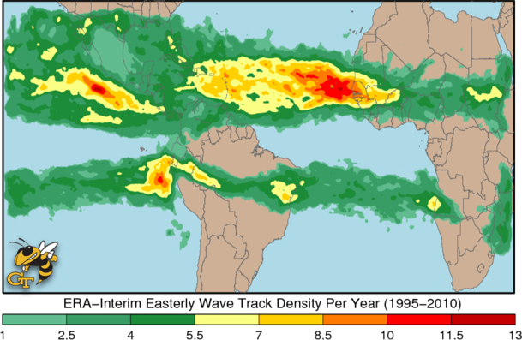 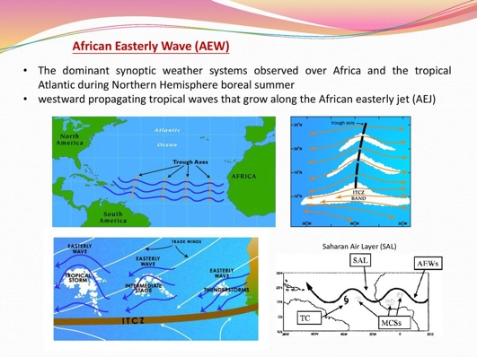  
[image: ncei.noaa.gov]. [**Source:** Adapted from Atlantic Tropical Cyclogenesis (slide from meteorology training presentation, Lin C. Ventrice et al., Monthly Weather Review 2012; image likely from COMET Program/MetEd).]

**Notable Strong AEWs & Case Studies**

**1. Case Study: Late July intense AEW (central North Africa)**

* **Date & location**: Initiated around 30 July near ~11°N, 23°E.
* **Highlights**: Strong vorticity and deep convection as it moved westward across West Africa   
  [journals.ametsoc.org]  
  [journals.ametsoc.org+1courses.seas.harvard.edu+1](https://journals.ametsoc.org/view/journals/mwre/133/4/mwr2884.1.xml?utm_source=chatgpt.com).

**2. AEWs that Led to TC Chantal (2013)**

* A tropical wave moved offshore on 4 July; by 7 July it became **Tropical Storm Chantal**.
* It originated from a robust AEW interacting with other waves (Kelvin wave) just offshore West Africa   
  [en.wikipedia.org]  
  [mdpi.com+15en.wikipedia.org+15agupubs.onlinelibrary.wiley.com+15](https://en.wikipedia.org/wiki/Tropical_Storm_Chantal_%282013%29?utm_source=chatgpt.com).

**3. Hurricane Fred (2015)**

* Developed from an unusually vigorous wave over Guinea in late August.
* The system became a hurricane offshore—uncommonly eastward in the Atlantic   
  [en.wikiopedia.org]  
  [en.wikipedia.org](https://en.wikipedia.org/wiki/Hurricane_Fred_%282015%29?utm_source=chatgpt.com).

**Research Highlights & Statistics**

* A tracking dataset (1995–2010) shows high AEW occurrence across West Africa and the tropical Atlantic   
  [atmos.albany.edu]  
  [agupubs.onlinelibrary.wiley.com+3atmos.albany.edu+3journals.ametsoc.org+3](https://www.atmos.albany.edu/facstaff/chris/papers/AEW-TC.pdf?utm_source=chatgpt.com).
* Strong AEWs—characterized by higher vorticity and cold-core structures—have a higher likelihood to develop into tropical cyclones   
  [atmos.albany.edu]  
  [fox4now.com+15atmos.albany.edu+15agupubs.onlinelibrary.wiley.com+15](https://www.atmos.albany.edu/facstaff/chris/papers/AEW-TC.pdf?utm_source=chatgpt.com).
* Recent studies suggest AEWs are intensifying over the Sahel–Sahara region due to increased temperature gradients and warming patterns   
  [nature.com]  
  [nature.com](https://www.nature.com/articles/s43247-024-01981-9?utm_source=chatgpt.com).

**Future Trends**

* Climate models project stronger AEWs in the late 21st century, driven by warming-driven amplification of AEJ shear and Sahel heat lows   
  [nature.com]  
  [nature.com+1researchgate.net+1](https://www.nature.com/articles/s43247-024-01981-9?utm_source=chatgpt.com).
* This could mean more and stronger tropical disturbances originating over West Africa.

**Summary Table**

| **Instance / Study** | **Timing & Location** | **Key Notes** |
| --- | --- | --- |
| July 200X intense AEW | ~30 July, 11°N 23°E | Central origin, high vorticity + deep convection ([en.wikipedia.org](https://en.wikipedia.org/wiki/Hurricane_Fred_%282015%29?utm_source=chatgpt.com), [journals.ametsoc.org](https://journals.ametsoc.org/view/journals/mwre/133/4/mwr2884.1.xml?utm_source=chatgpt.com)) |
| Chantal (2013) | 4–7 July, off Guinea | AEW + wave interaction → Tropical Storm |
| Hurricane Fred (2015) | Late August, Guinea → Cape Verde | Very eastward hurricane originating near West Africa |
| ERA-Interim Climatology | 1995–2010 | Wave track density mapped over region |
| Developing vs non-developing AEWs | Composite (1979–2001) | Cold-core, high vorticity structure differentiate developing AEWs |
| Projected future AEWs | By end-21st century, Sahel/Sahara | Intensification tied to warming & baroclinicity increases |