**PSYCHOLOGY**

**ASSIGNMENT # 01**

**MOHAMMAD BASIL ALI KHAN**

**20K-0477**

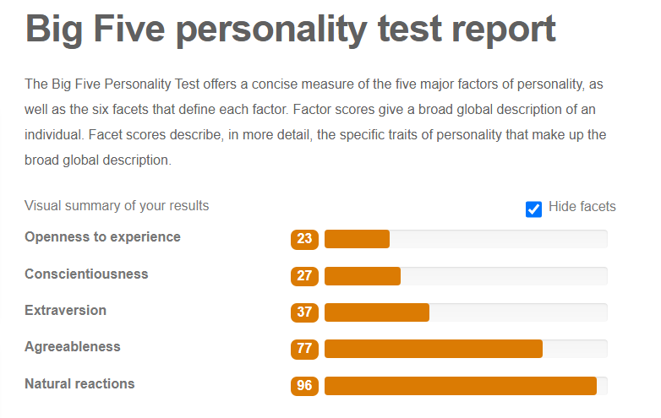

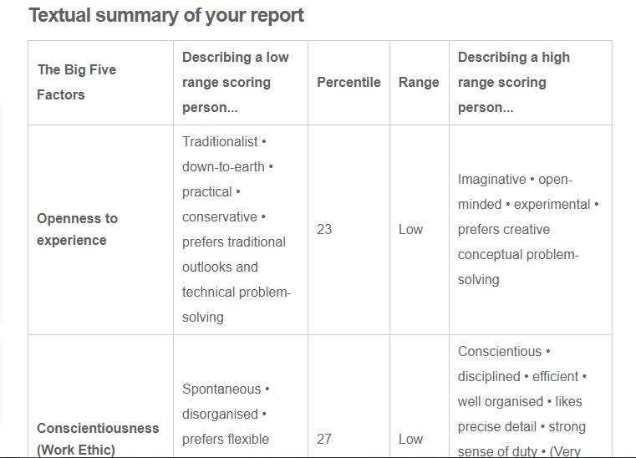

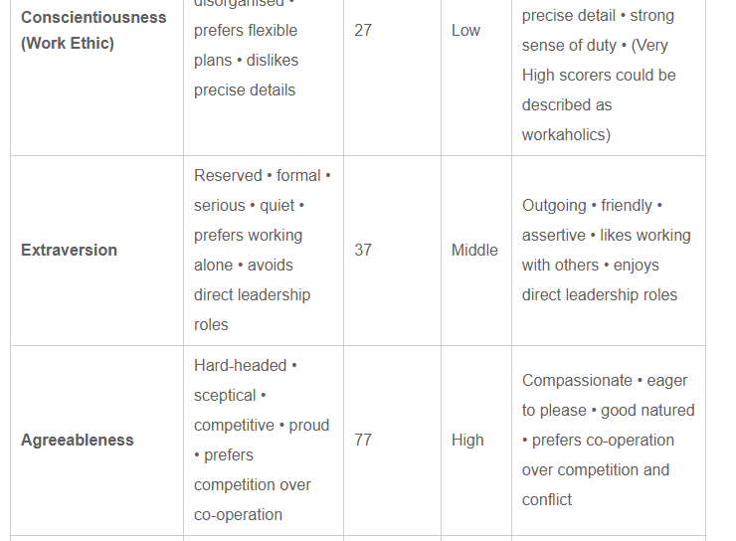

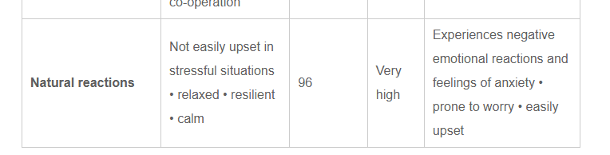

**EXAMPLES**

**Openness to Experience:**

More comfortable with practical rather than theory courses. Good in technical and problem solving related courses and very much good in solving issues related to tech and software related issues. And always eager to learn and enroll in technical related courses through online webs like courses.

**Conscientiousness:**

Always get scolded by mother for forgetting things where I put them and always keeping my room messy. Forgets my license when going for drive and getting challan from police. Forgets my id card and etc. gets bored for a long talk also depend on person.

**Extraversion:**

I am always quiet and mostly shy a person. I avoid to take part in class discussion even though teacher says it is graded because even if I try I am not being able to speak I don’t know the reason behind but I am comfortable with that I m a good listener but avoids to take part in. but sometimes I am a talkative person it depends on my surrounding there is only 2 to 3 person I am open to them. Also avoids leading because afraid of getting blamed if something goes wrong.

**Agreeableness:**

I am very much into in keeping my buddies and my homies and closed ones happy and comfortable. I am very good with everyone and if someone is good I try to be best with them. I am good in working with groups but avoid leading I am good in team work but depend on who are my teammates. Avoid conflicts and try to resolve matter because of my calm nature.

**Natural Reactions:**

Just before getting into university I was a person who doesn’t take any worries about anything but as I have got into university I am taking so much tension even for quizzes assignments event for this assignment I was worry “ke kia likhon apne baare me kuch feel hi nhi hota apne baare me. “but then decided to write something by my heart what I feel. Now I take so much tension that a night before papers I started feeling vomiting and don’t eat dinner. I don’t know why maybe just because as I am going towards my professional life and my eagerness to do something for me and my family.