Electrocardiogram Documentation

# Background Theory

It has been known for centuries that certain tissues within the human body produce electric potentials. Excitable cells are primarily muscle and nerve which display characteristic responses when monitored. Heart muscle is of primary interest for analysis in a clinical setting due to the vital physiological role played by the heart. Electrocardiograms (ECGs) offer a non-invasive method to monitor, record and interpret cardiac signals that can lead to diagnosis and appropriate medical intervention.

A human heart beat is produced by a group of cells within the heart known as the Sinoatrial node (SA Node). These cells display a characteristic known as automaticity. Automaticity is when excitable cells exhibit self-excitation in a rhythmic manner without external stimulus. Once this impulse is produced in the SA node it travels through the atria causing contraction, until eventually reaching the Atrioventricular node (AV node). The AV node is a large bundle of excitable tissue that slows the conduction of this impulse before it enters the ventricles. Once the excitation passes this junction, it is carried through each ventricle on a structure known as the bundle of His. This impulse spreads throughout the entirety of ventricles causing contraction, completing the cardiac cycle. Each one of the steps outlined in this process displays characteristic electrical activity, collectively known as the electrocardiogram.

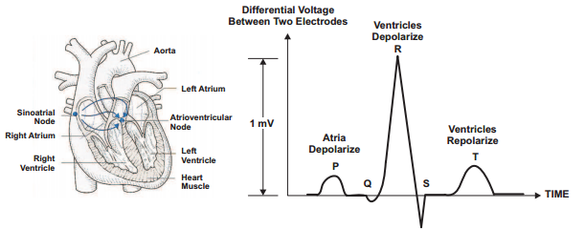

**Figure 1: Anatomy of the Hyman Heart and corresponding ECG Waveform [1]**

The interpretation of this waveform has offered clinical insight into the physiology of the human heart for over one hundred years [2]. The appearance of certain changes within this waveform have been correlated with clinical pathology which is useful in diagnosis. The acquisition of this signal requires hardware that is portable and capable of recording low level signals in a variety of electrically noisy environments. A typical ECG signal will have a peak amplitude of 1-2mV at a frequency ranging from 0.5-4 Hz [1]. This small signal must be recovered from other interference such as ambient 60Hz noise, patient movement and superficial muscle activity. Each of these competing signals is generally larger in amplitude and may also overlap in frequency making high-quality design paramount.

|  |  |  |  |
| --- | --- | --- | --- |
| **Lead** | **Electrode Combination** | **Lead** | **Electrode Combination** |
| I | LA – RA | V1 | V1 – (RA + RL + LL)/3 |
| II | LL – RA | V2 | V2 – (RA + RL + LL)/3 |
| III | LL – LA | V3 | V3 – (RA + RL + LL)/3 |
| aVR | RA – (LA + LL)/2 | V4 | V4 – (RA + RL + LL)/3 |
| aVL | LA – (RA + LL)/2 | V5 | V5 – (RA + RL + LL)/3 |
| aVF | LL – (LA + RA)/2 | V6 | V6 – (RA + RL + LL)/3 |

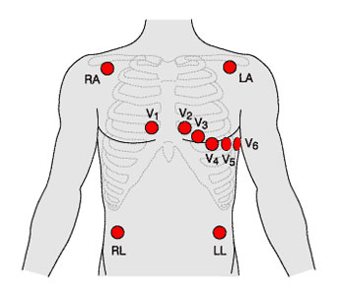 Different ECG signals are produced by amplifying the difference between two points on the body with reference to a common ground. Historically clinical ECG uses 12 different leads which are formed through different combinations of 10 different electrode placements shown below.

**Figure 2: ECG Electrode Placement and Lead Formation [3]**

Each of these electrode combinations gives different information about the electrical activity within the heart and allows for localizations of pathology. A typical output is shown below:

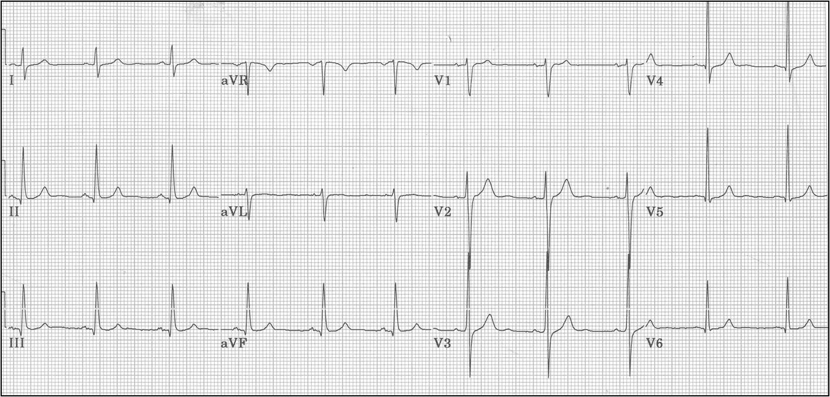

**Figure 3: Standard Clinical 12 Lead ECG Output**

This document is not intended to give insight into the interpretation techniques of clinical ECG (*Rapid Interpretation of EKG’s* by *Dale Dubin* is recommended for this purpose1). Rather this figure is presented as an example of what a clinician would interpret when diagnosing a patient. In all situations, especially in emergency, trauma and intensive care units the information supplied by an ECG is invaluable. This data has the ability to save lives and accurately guide the judgement of healthcare professionals and belongs in all hospitals worldwide.

[1] EKG-Based Heart-Rate Monitor Implementation on the Launchpad Using MSP430G2xx from: <http://www.ti.com/lit/an/slaa486a/slaa486a.pdf>

[2] “Willem Einthoven". *IEEE Global History Network*. IEEE. Retrieved 10 August 2011.

[3] <http://www.indiana.edu/~p409/labecg.html>

[4] <http://ecg.utah.edu/lesson/3>

# Engineering - Background Theory

From an engineering perspective bio-potentials have been of great interest since the 1800s when Luigi Galvani first documented his experiments involving frog myocytes [1]. This initial investigation was followed by numerous attempts to both elicit and monitor electrical response from biological tissues. In the late 1800s it was known that a heartbeat created electrical currents, but the equipment at the time was not adequate to measure and characterize these waveforms without the direct application of electrodes to an exposed heart. In 1901 a first attempt at non-invasive measurements was made by Willem Einthoven who used a string galvanometer and a pair of large electromagnets to record cardiac potentials [1]. This machine was large and complicated weighing over 500lbs and requiring 5 operators but was the first step towards clinical diagnosis of heart pathologies.

Using the setup created by Einthoven clinicians began studying pathological heart behaviour. Atrial fibrillation, changes during angina, ST elevations during myocardial infarctions (STEMIs) as well as different types of blocks were described in the following 25 years. During this time of research, the biomedical industry was working to create a more reasonable system eventually producing an ECG weighing 50lbs and powered by six car batteries. Improvements became greater as the electronics industry developed allowing for further innovation and research to flourish. In current time ECG systems can be as small as a pack of playing cards and powered by a 9V battery. Given below is a block diagram of the ECG system designed and implemented by project Glia.

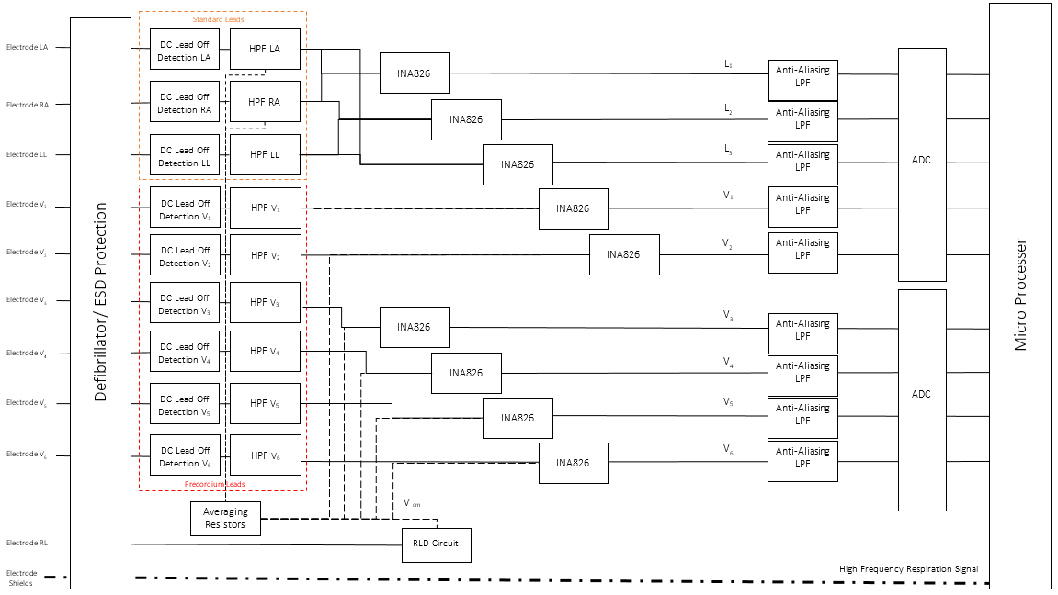

**Figure 1: Standard 12 Lead ECG Block Diagram**

Although this diagram seems complicated at first, upon further investigation it can be seen that the overall circuit is comprised of 10 simple individual channels. A further breakdown of each of these modules is given in the following pages.

## Defibrillator / Electro-Static Discharge Protection

As previously stated, the amplitude of an ECG signal is roughly 1mV. However, there are other expected sources of electrical input into the system that may have a much higher voltage. Electrostatic discharge (ESD) can result from simple mechanisms such as a patient combing their hair or dry clothes brushing against skin. These actions lead to the build-up of charge which can suddenly discharge through paths of low resistance such as the electrodes used to record cardiac signals. This discharge can reach voltages of tens to hundreds of bolts depending on environmental factors [2]. An input of this magnitude would damage the ECG circuit, rendering it unable to record further signals.

Another more drastic voltage that may enter the circuit can occur during emergency situation in the form of a defibrillator pulse. Certain heart rhythms can be corrected through the application of a large pulse of current through the myocardium. When this current is applied up to 5000V at 50A may enter the electrodes which is many orders of magnitude larger than the expected ECG waveforms [3]. If protection circuitry is not put in place then this potentially lifesaving pulse could be diverted through the ECG circuitry damaging the system and diverting the needed energy away from the patient.

Overvoltage protection circuit devices come in many different flavours of circuit devices including diodes, spark tubes, gas lamps, fuses and thyristors to name a few. Each of these components operates using slightly different technology but share the same general principle. At voltages below a certain threshold these devices have an extremely high impedance and let very little current pass. Once a threshold voltage is reached the device begins to conduct, exhibiting a drastic drop in resistance allowing large amounts of current through. When used correctly a circuit protection device shunts away high levels of current and voltage away from sensitive components to ground. A plot exemplifying this behavior is shown below:

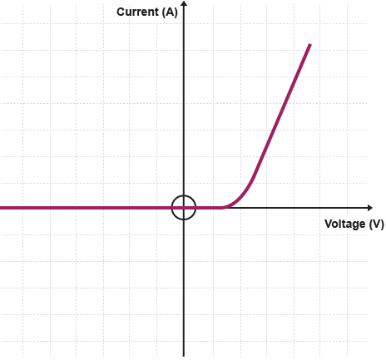

**Figure 2: Current-Voltage Relationship of Circuit Protection Device [4]**

These devices are used to interface the electrodes attached to the patient with the ECG hardware. This allows for protection from random static discharges and also makes it possible for electrodes to remain attached during a defibrillation maneuver. Continuity in recording gives clinicians the needed information to determine if this intervention was successful and to plan future therapy.

## Lead off Detection

A second practical design consideration when constructing an ECG circuit is a method to determine the status of each electrode. With electrodes serving as the interface between the patient and circuitry a good connection is necessary to produce high quality signals. The contact of the electrode can deteriorate over time as the result of patient movement, sweat and error in application. Generally speaking there are two approaches that can be used to monitor the connection status: DC or AC lead off detection.

DC lead off topologies employ a pull up or pull down resistors to set up a voltage divider with the impedance of the electrode-patient interface. A DC signal is injected through a large resistor into the signal path where it passes through the electrode to ground. When the electrode has good contact (i.e. low impedance) the vast majority of the DC voltage is dropped across the pull up resistor imposing minimal interference into the signal path. As the contact breaks down the electrode impedance increase leading to a larger DC bias imposed on the input which can be detected during signal analysis. This basic scheme is displayed below:

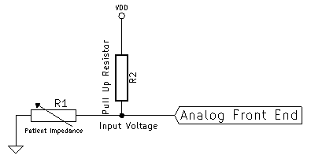

**Figure 3: DC Lead off Protection Topology**

A typical impedance of a well applied electrode is roughly 5 $kΩ$ but can deteriorate and become as high as 500 $kΩ$ [5]. Assuming a pull up resistor of 1 $MΩ$ and a pull-up voltage of 5V the effect of these changes on input DC bias can be plotted as a function of time.

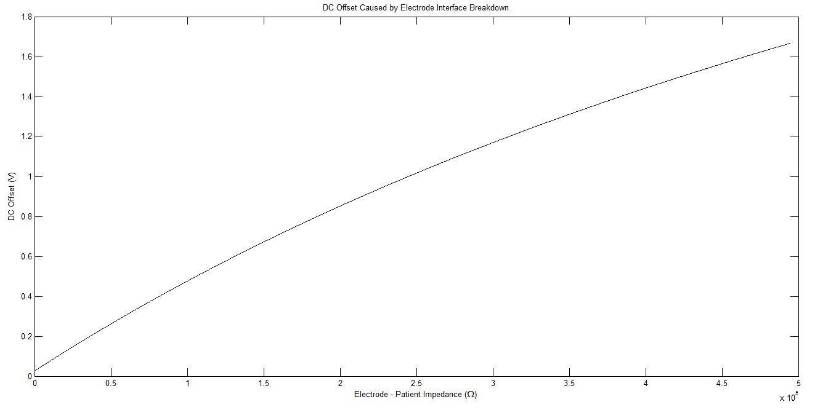

**Figure 4: Effect of Electrode Breakdown on DC Offset Voltage**

When a good connection is present the DC offset is minimal, less than 0.1V. As the connection breaks down a bias approaching 2V is imposed. This signal can be sensed using a comparator or other digital monitoring to notify the operator that a bad connection has been made.

The second setup that can be used is AC lead off detection. In this scheme an AC signal is injected into the patient through an auxiliary path such as the Right Leg Drive circuit or cable shielding. The AC signal will be superimposed on the standard ECG waveform but can later be separated based on frequency differences. A simulation showing this combined signal is displayed in figure 5.

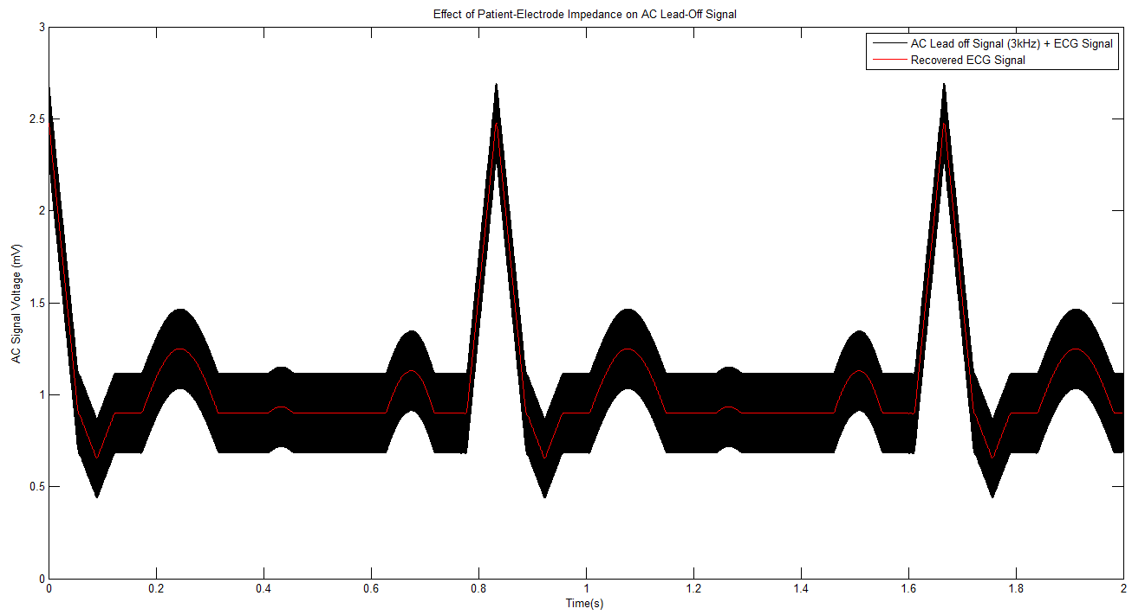

**Figure 5: AC Lead off Voltage Simulation**

When patient-electrode impedance is low, this signal will remain small relative to the ECG component. As the contact breaks down the AC signal will grow larger, indicating electrode impedance is increasing and signal quality may begin to suffer.

## Plethysmography

In addition to the information gained regarding a patient’s heart rate and rhythm, an ECG signal can also be used to monitor a patient’s respiratory rate. To directly monitor breathing volumes spirometry can be used. This setup monitors the flow of oxygen moving in and out of a mouthpiece using accelerometers. This may be uncomfortable and invasive if the patient does not require ventilation. Instead, ECG offers an indirect method of measurement using impedance.

The impedance of the lungs is made of two components: a static portion which is attributed to the intrinsic properties of lung tissue and a dynamic portion attributed to capacitance of alveoli. This can be modelled using basic circuit elements as shown below:

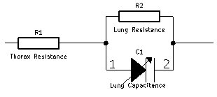

**Figure 6: Circuit Model of Human Thorax**

This model can be taken advantage of to monitor the respiratory pattern of a patient retroactively with digital processing or in a dynamic matter with the addition of some additional circuitry. To create a retroactive protocol, only software is required in addition to the ECG system. Due to the fact that the resistance of the chest changes with breathing, the voltage of the recorded ECG signal will also vary with breathing. During times of inspiration when resistance is high, the waveform recorded will have decreased amplitude, the opposite can be said of expiration. Using this idea, the low frequency respiratory signal can recovered with some basic digital filters as is demonstrated in figure 7.

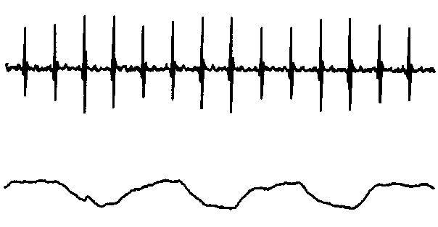

**Figure 7: Retroactive Respiration Signal Recovery form ECG [6]**

The heart rate is almost always at least twice that of the breathing rate so typically the signal is reproduced reliably. A drawback to this scheme is that the sampling resolution is determined by the patient’s heart and cannot be improved. An alternative method of impedance plethysmography uses a similar scheme to that discussed in AC lead off detection. A circuit diagram of this setup is shown below. Please note that the lung resistance and lung capacitance have been simplified into a single resistor “Lung Impedance”

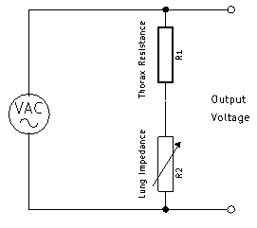

**Figure 8: Active Impedance Plethysmography Circuit Model**

The constant thorax and lung tissue resistance is typically on the order of 10 $kΩ$ whereas the variable capacitance accounts for rough 5 $Ω$ of impedance. This change is small but can be appreciated by the sensitive electronics already being employed to recover the ECG signal. The high frequency AC signal is injected and recovered using the same method as described in the AC leadoff section of this document. When the signal is separated and recovered a modulated sine wave is recovered in which the low frequency variation corresponds to the respiration rate.

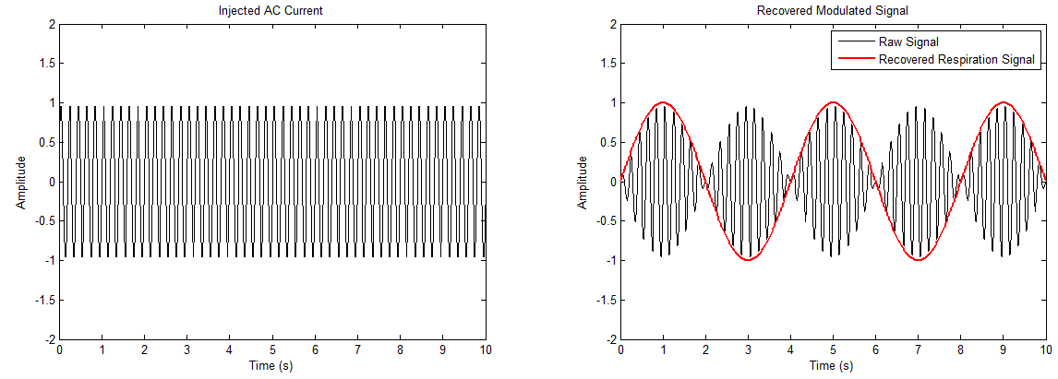

**Figure 9: Respiration Rate Signal Recovery from Injected AC Signal**

Although this setup requires some additional software as well as a method to inject a signal into the patient it will produce a higher quality signal that can measure the respiratory rate of a patient dynamically.

## Analog Signal Conditioning

The analog signal conditioning module of any bio-potential amplifier must filter out noise while amplifying the signal of interest to an appropriate level. The human heart rate will range from approximately 30-200 bpm corresponding to a frequency range of roughly 0.5-4Hz. The magnitude of this signal typically has a maximum value of 1-2mV [7]. Along with the desired signal, other electronic interference such as mains power noise (60Hz and 50 Hz in North America and Europe respectively), patient movement, electrode half potentials will also be present. The challenge of this circuit design is to adequately suppress these unwanted signals while preserving the quality of the ECG. A basic signal processing chain block diagram is presented below, followed with an elaboration of each module.

High-Pass Filter

Instrumentation Amplifier

Low-Pass Filter

ADC

Electrodes

**Figure 10: Analog Signal Processing Chain**

### High Pass Filter

Depending on the electrodes used, a large DC offset can occur at the electrode-skin interfaces as the result of half-cell potentials. A half-cell potential may occur any time a metal is placed in contact with an electrolyte. This offset can be on the order of several hundred millivolts [**CITE**] and threaten to saturate the following gain stages. For this reason the DC signal must be removed before any amplification occurs, this is accomplished using a first order high-pass filter, as depicted below.

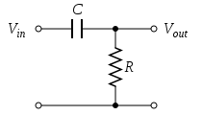 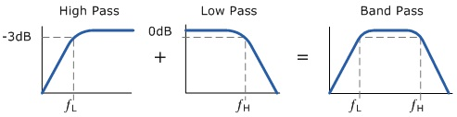

**Figure 13: First Order High-Pass Filter**

### Instrumentation Amplifier

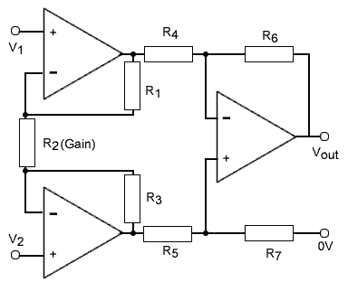Each of the 12 leads of a standard clinical ECG is created by taking the difference of two different electrodes (*The various combinations are given in figure 1 of the previous section*). The most straightforward to carry out this operation electronically is to use a differential amplifier, specifically an instrumentation amplifier. This is a circuit device composed of 3 operational amplifiers arranged in such a way that they produce large differential gains while maintaining a high common mode rejection ratio. Given below is the symbol, circuit schematic and transfer function of this element.

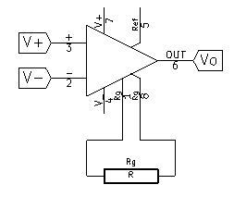

$Vo=\left(V_{1}-V_{2}\right)×G$

**Figure 12: Instrumentaiton Amplifier**

### Low Pass / Anti-Aliasing Filter

Once the lead signal has been produced by the instrumentation amplifier at the head stage of this system the next concern is to digitize the incoming data stream. When any analog signal is sampled there are certain mathematical requirements that the sampling must satisfy in order to be able to reproduce the data reliably. According to the Nyquist theorem, when sampling an analog signal the rate at which the data is sampled must be at least twice that of the highest frequency present in the data. When designing this system, the sampling rate of the ADC will be known and a filter can be designed in order to meet this criteria. By creating a low pass filter that rejects signals with spectral components greater than half the sampling rate of the ADC artifacts such as aliasing can be avoided. The addition of this filter has the added benefit of rejecting higher frequency noise.

As was previously noted, along with the 0.5-4Hz ECG waveform the signal is also corrupted with bio-potentials from muscles in the chest wall, power line interference, base line drift and other artifacts. With the exception of base line drift, the rest of these expected noise signals occupy a bandwidth above that of an ECG and will be attenuated by a low pass filter. Given below is a typical implementation of a Sallen and Key active 2nd order low pass filter as well as its Bode plot.

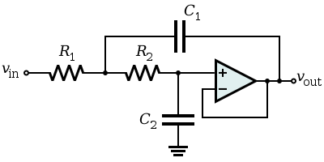 

**Figure 13: Low Pass Filter Circuit and Transfer Function**

## Right Leg Drive Circuit

The final circuit module in this ECG system is a block that is used to reduce common mode interference. Regardless of the steps taken to shield the circuit and filters used to reduce noise, there will still be a power-line signal coupled to the patient during recording. This common mode signal would normally be rejected by the differential nature of the instrumentation amplifier. However, in practical applications there are non-idealities within input resistances that can transform any common mode noise into a differential signal which will greatly corrupt the signal. For this reason, any common mode signal must be minimized or eliminated.

[1] Whittaker, E. T. (1951), [*A history of the theories of aether and electricity. Vol 1*](http://www.archive.org/details/historyoftheorie00whitrich), Nelson, London

[2] http://www.minicircuits.com/app/AN40-005.pdf

[3] <http://www.frca.co.uk/article.aspx?articleid=100392>

[4] <http://www.bbc.co.uk/schools/gcsebitesize/science/triple_ocr_gateway/electricity_for_gadgets/charging/revision/1/>

[5] <http://www.analog.com/static/imported-files/tech_docs/ECG-EEG-EMG_FINAL.pdf>

[6] <http://www.physionet.org/physiotools/edr/cic85/edr85.html>

[7] EKG-Based Heart-Rate Monitor Implementation on the Launchpad Using MSP430G2xx from: <http://www.ti.com/lit/an/slaa486a/slaa486a.pdf>