Assignment 1

CS321 Winter 2023, Professor Christopher Diggins

## Assigned: Tuesday January 17th, 2023

## Due: Sunday February 5th, 2023 (late as you want)

# Part 1

Download and Install Visual Studio Community on your Personal Computer

1. Create a Hello World Console Project
2. Run it
3. Take a screenshot of the output (should like the image below)
4. Submit the screenshot as cs321-assg1-part1.png

# Part 2

Write a simple program that lists the contents of a directory (like “dir”). It should take the name of the directory as a command-line argument. It should list the names of all the files first, and then the names of all the directories.

Output should looks something like:

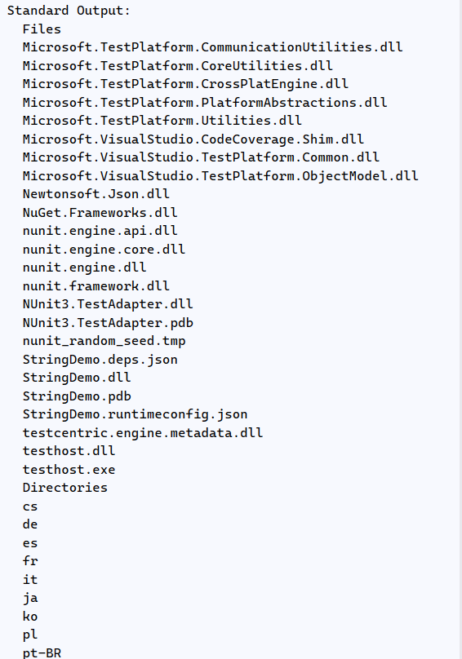

1. Submit the following work in a single text file: cs321-assg1-part2-plan.txt
   1. A list of hypothetical functions that you think you will need
   2. Some high-level pseudo-code (reasonable attempt)
   3. A list of actual C# functions you find online that you think might help you
2. Write a working C# program using .NET Framework 6.0. Submit the main source file as “Assg1Part2Program.cs” and submit the project file as “Cs321Assg1Part2.csproj”.
3. Demonstrate it working and submit a screenshot: cs321-assg1-part2.png.

## Grading Criteria

1. Part 1:
   1. Screenshot: **2 Point**
2. Part 2:
   1. Plan: 
      1. List of hypothetical functions: **1 Point**
      2. Pseudo-code: **1 Point**
      3. List of C# functions that might help: **1 Point**
   2. Actual code:
      1. Understandable and with comments: **1 Points**
      2. Valid C# 10 and .NET 6 code: **1 Point**
      3. Uses at least one function other than main: **1 Point**
   3. Project:
      1. Compiles, Runs, and works on my test directory: **1 Point**
   4. Screenshot: **1 Point**
   5. Bonus:
      1. Outputs sizes and dates of files: **1 Bonus Point**
3. Total: **10 Points + 1 Bonus Points**