Reporting of hepatic injury with example-drug: a disproportionality analysis of a synthetic spontaneous reporting database
  - Hepatic injury with example-drug

Abstract
Background. Drug-induced hepatic injury is a common reason for regulatory action. Methods. Disproportionality analysis of a synthetic spontaneous reporting database covering 2015 to 2024, comparing reports of hepatic injury for example-drug against all other drugs. Results. Of 4000 reports, 77 described hepatic injury with example-drug. The reporting odds ratio was 3.84 (95% CI 2.89 to 5.12). Conclusions. Reporting of hepatic injury is disproportionate for example-drug in these synthetic data. Disproportionality is not incidence and cannot establish risk.

Introduction
Drug-induced hepatic injury is among the most common reasons for regulatory action on a marketed medicine. In a national cohort, the crude incidence was about 14 per 100 000 person-years (Fictional and Fictional 2021), and a disproportionality signal has been reported for the drug class as a whole (ROR 2.6) (Fictional and Fictional 2019). The national agency estimated that 41 200 patients had been exposed by the end of its last published review.
Whether the signal extends to example-drug specifically remains unexamined.

Methods
We analysed a synthetic spontaneous reporting database covering 2015 to 2024, a period of 10 years. Reports were included without restriction on age or sex. Each record carries a unique report identifier and the generator emits no duplicates, so no de-duplication step was applied; a real database would require one, and its absence here is a property of the synthetic data rather than a design choice.
Hepatic injury is the single event term used by the data generator. Real work would need a case definition — a MedDRA Standardised Query or an explicit preferred-term list — and the choice of definition would change the counts. The terms actually used are published in Table S1, emitted from the lists the analysis filtered on rather than retyped, which is what RECORD 6.1 asks for and what makes a case definition checkable.
The reporting odds ratio was computed from a 2 x 2 table contrasting reports of hepatic injury with all other reported events, for example-drug against all other drugs in the database. Confidence intervals were derived from the standard error of the log odds ratio and are 95% confidence intervals, two-sided at an alpha of 0.05; the main estimate is also given with its 90% confidence interval, for comparison with signal-detection practice.
A signal was defined by the classical criterion: at least 3 cases together with a lower bound of the 95% confidence interval of the reporting odds ratio above 1. No p-value threshold was used as a decision rule, which is not how a disproportionality analysis reaches its conclusion.
Adjusted for age group and sex, the two patient characteristics the database records for every report, the reporting odds ratio was also estimated by logistic regression of hepatic injury on exposure to example-drug, with both characteristics entered as categories. The reporting year, which every report also carries, was not adjusted for: calendar time is a common adjustment in disproportionality analyses, but the data generator draws the year independently of the drug, so here it cannot confound the estimate. Its interval is the model’s Wald interval for the exposure coefficient, at the same alpha. Table S2 describes the model as it was fitted.
The analysis was run in Python 3.12.3 with statsmodels 0.14.2.
Reporting follows the checklist declared in paper.yaml.

Results
The database contained 4000 reports, of which 426 named example-drug. Hepatic injury was reported in 77 of these; 28 were flagged as serious (36.4%). Baseline characteristics are shown in Table 1.
Reports by drug group. Values are n (%) unless stated.
Characteristic | example-drug | All other drugs
Reports | 426 | 3574
Hepatic injury | 77 (18.1) | 194 (5.4)
Age 18-44 | 92 (21.6) | 884 (24.7)
Age 45-64 | 116 (27.2) | 866 (24.2)
Age 65-74 | 103 (24.2) | 938 (26.2)
Age 75+ | 115 (27.0) | 886 (24.8)
Female | 226 (53.1) | 1737 (48.6)
Serious | 160 (37.6) | 1356 (37.9)
Reporting of hepatic injury was disproportionate for example-drug, with a reporting odds ratio of 3.84 (95% CI 2.89 to 5.12; 90% CI 3.02 to 4.89). The signal criterion defined in the Methods was met. The estimate is shown in Figure 1, and the counts it was computed from in Table 2, so a reader can reconstruct it. Adjusted for age group and sex, the reporting odds ratio was 3.845 (95% CI 2.885 to 5.123), given to three decimal places because to two it is the crude estimate: the data generator draws both characteristics independently of the drug.
Contingency table underlying the reporting odds ratio.
 | Hepatic injury | Other events
example-drug | 77 | 349
All other drugs | 194 | 3380
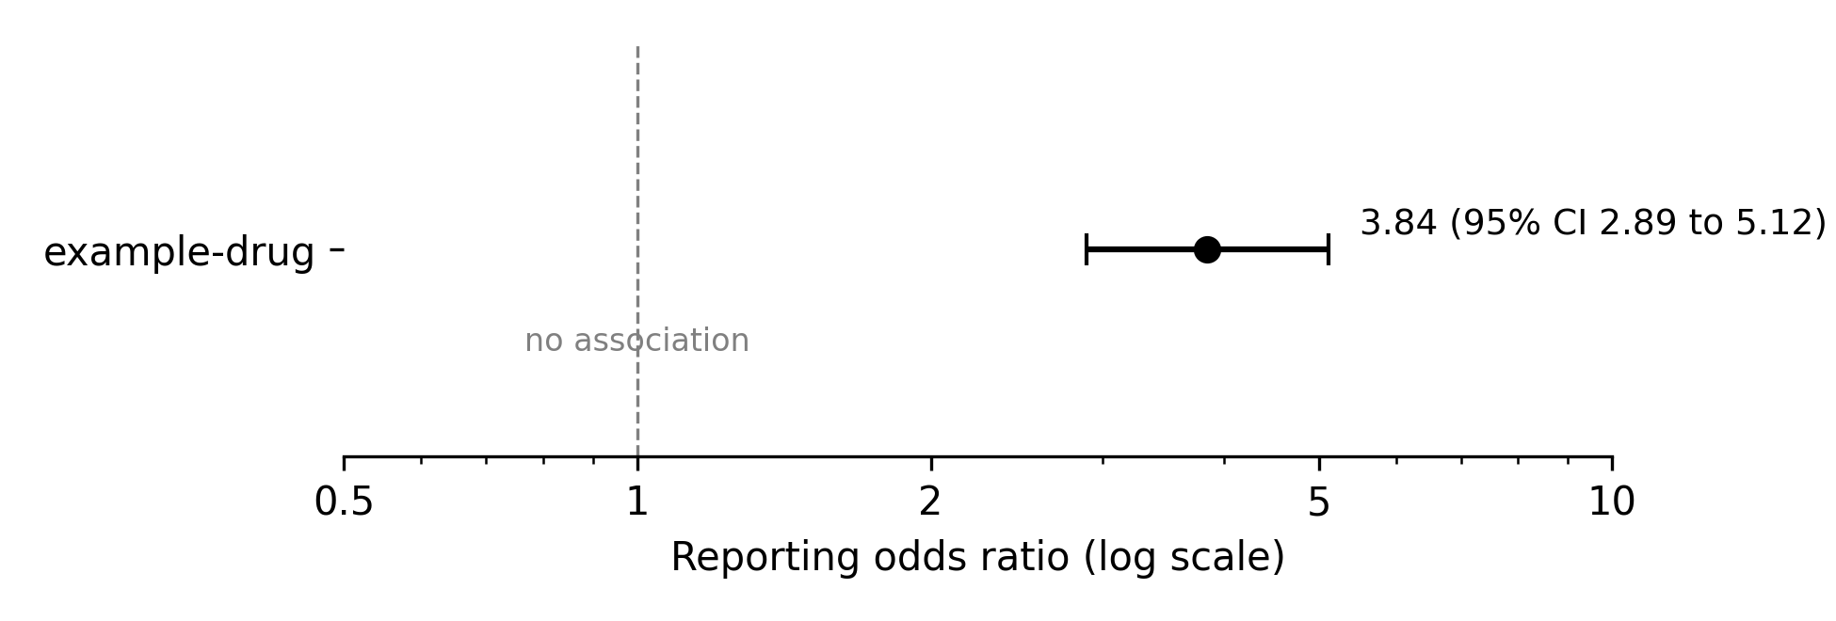

Discussion
The reporting odds ratio observed here exceeds the class-level estimate of 2.6 reported previously (Fictional and Fictional 2019), although the two are not directly comparable: that analysis pooled the class and drew on a different reporting period.
Disproportionality is not incidence, and nothing in these data supports a rate. The cohort incidence of 14 per 100 000 person-years (Fictional and Fictional 2021) is the only population-level figure available, and it predates the marketing of example-drug.
Several limitations follow from the design. Spontaneous reports are subject to notoriety bias, and the denominator is unknown. Grade 3 and higher events cannot be distinguished from milder ones in these data. The exposure figure of 41 200 patients rests on a printed agency report that is no longer publicly available, and is recorded as an author attestation rather than a stored source.

Data availability
The synthetic dataset, the code that generates it and the analysis that reads it are all in this repository. No real patient data were used, and no ethical approval was required.

Funding
This work received no funding.

Competing interests
None declared.
Fictional, Anne, and Bernard Fictional. 2021. ‘Hepatic Injury in a Fictional National Cohort, 2010–2019’. Journal of Imaginary Pharmacoepidemiology 12: 101–9.
Fictional, Claire, and Daniel Fictional. 2019. ‘A Disproportionality Signal for a Fictional Drug Class’. Imaginary Drug Safety Reports 7: 45–52.

