GLAXIT
MERN Stack Internship — Daily Progress Report
Day 3: Scalable CSS & Architecture
Intern Name | Basim Ali
Company | Glaxit, Taxila
Program | MERN Stack Internship
Day | Day 3
Topic | Scalable CSS & Architecture (CSS Variables & BEM)
Date | 8-Jul-2026
1. Topics Studied
• CSS Custom Properties (variables): declaration with -- prefix, scope via :root, and usage with the var() function.
• Benefits of CSS variables for maintaining a consistent design system (single source of truth for colors, spacing, fonts).
• BEM (Block, Element, Modifier) methodology for writing scalable and maintainable CSS in large projects.
• BEM naming syntax: .block, .block__element, and .block--modifier.
• Avoiding deep nesting and specificity conflicts by adopting a flat, component-based class structure.
2. Task Performed
Refactored the CSS from previous tasks (portfolio website and number base converter UI) using strict BEM naming conventions. Introduced a root-level brand color palette using CSS custom properties, covering primary, secondary, accent, and neutral tones, and replaced all hard-coded color values throughout the stylesheets with references to these variables.
Key steps carried out:
• Defined a :root block with variables for primary, secondary, accent, and neutral (background/text/border) colors.
• Renamed existing classes to follow the Block__Element--Modifier pattern (e.g. .card__title, .nav__link--active).
• Removed nested/overly specific selectors in favor of single, flat BEM class selectors.
• Replaced all literal color codes (hex values) in the stylesheet with var(--variable-name) references.
• Verified that visual appearance remained unchanged after refactoring, confirming the CSS variables and BEM classes were mapped correctly.
3. Code Screenshots
:root variable declarations — brand color palette:
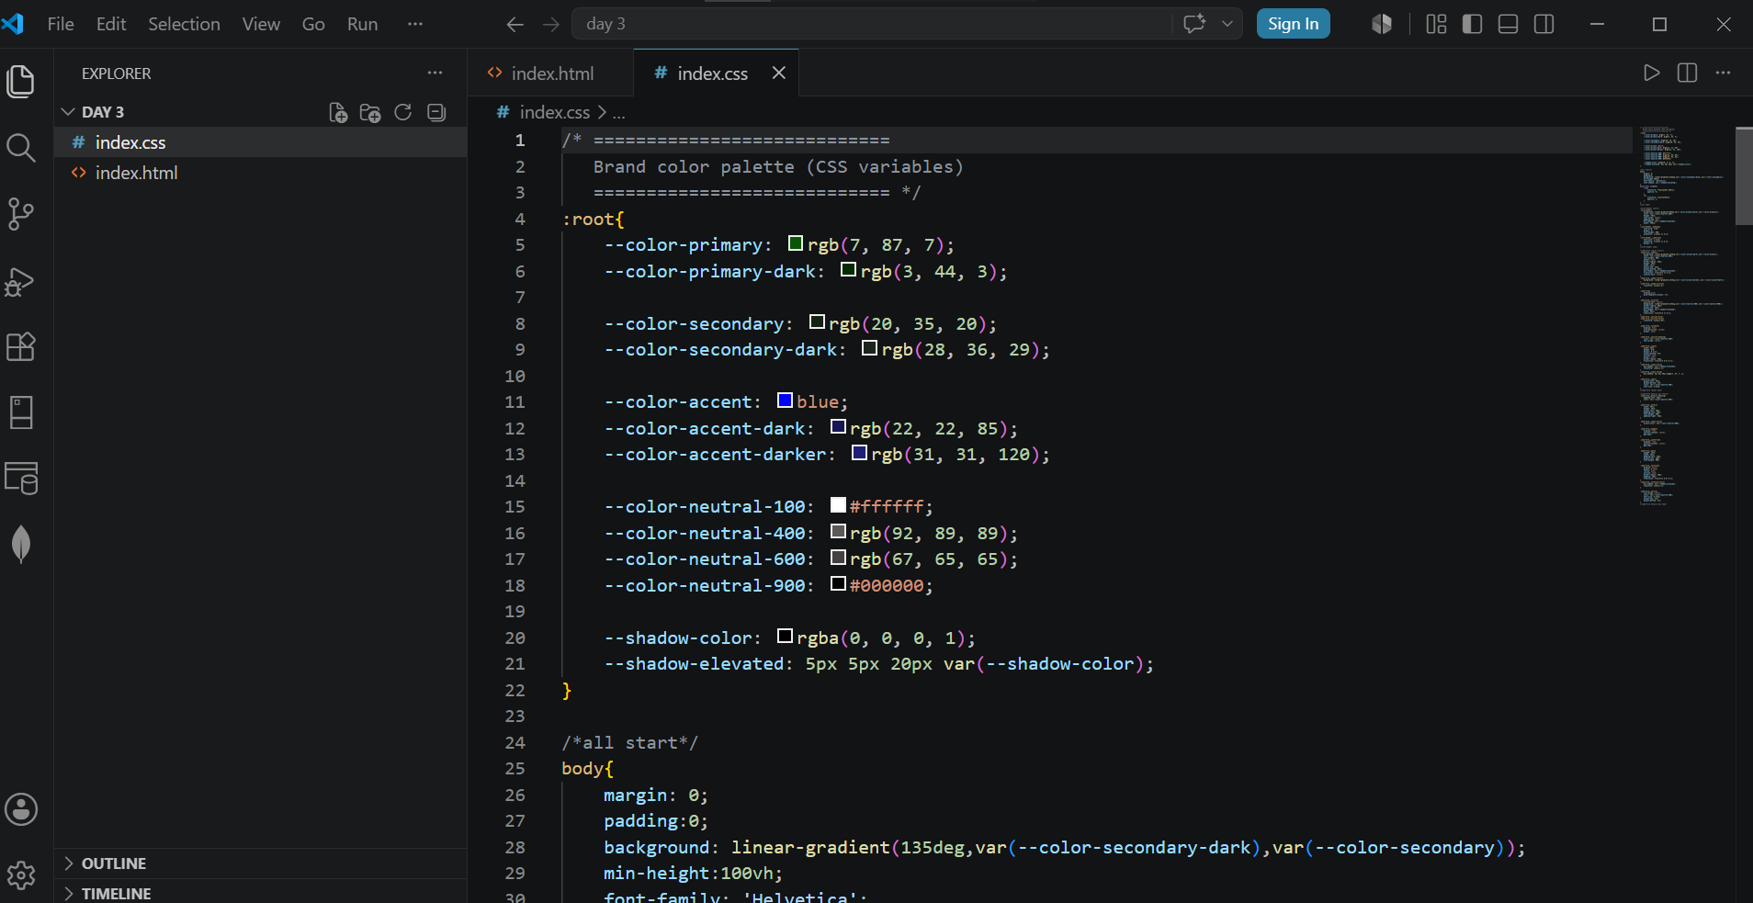
Refactored HTML with BEM class naming applied:
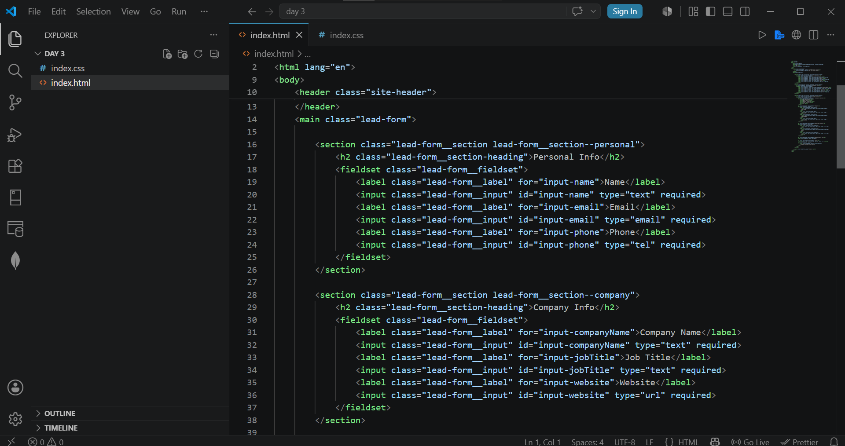
Refactored CSS using BEM selectors and var() references:
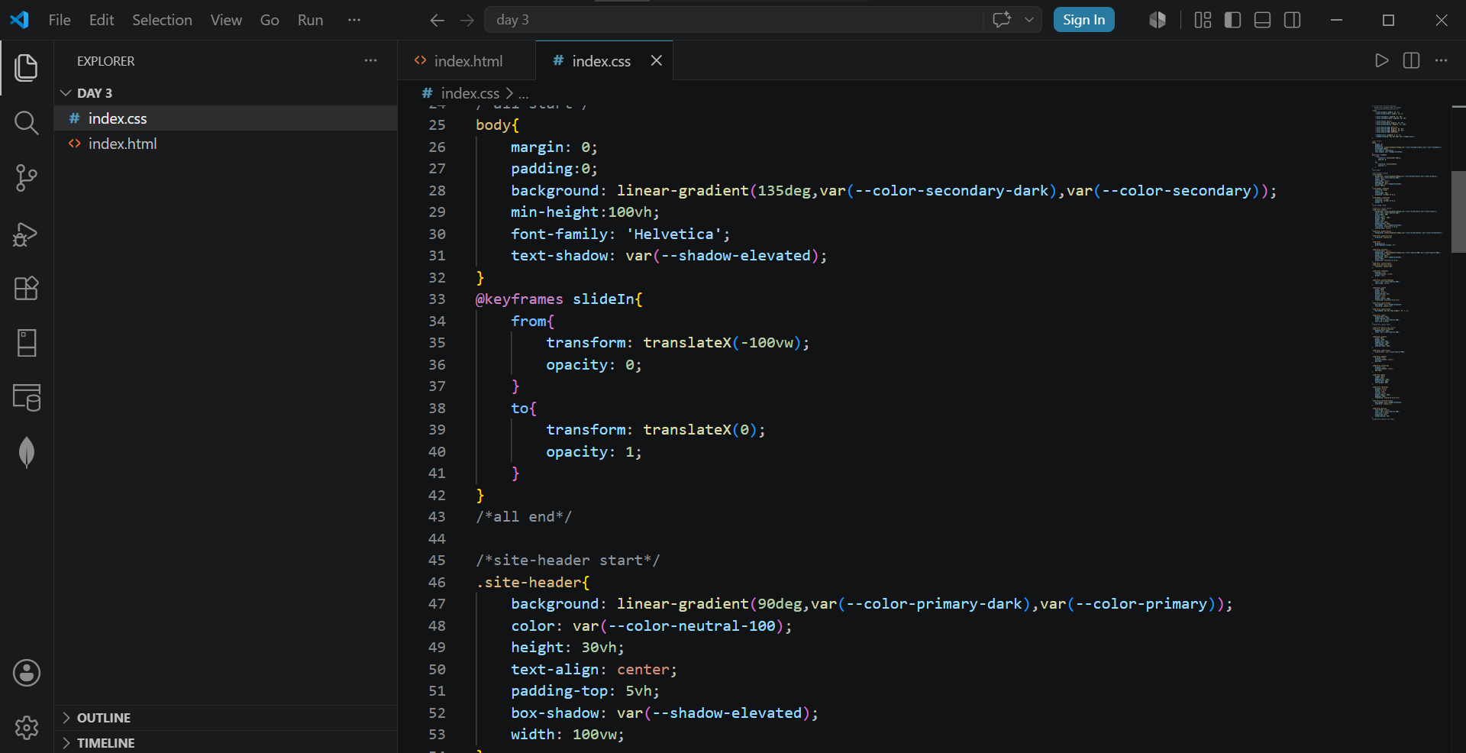
4. Key Learnings
• CSS variables centralize theme values, making future rebranding or theme changes a one-line edit instead of a project-wide find-and-replace.
• BEM naming removes ambiguity about what a class does and where it can safely be reused, which scales well in larger codebases.
• Flat BEM selectors reduce specificity conflicts and make CSS easier to override predictably.
• A documented naming convention improves collaboration, since any team member can infer a class's role directly from its name.
5. Challenges Faced
• Deciding consistent Block boundaries for existing markup that was not originally structured with BEM in mind.
• Ensuring no visual regressions occurred while renaming classes and swapping hard-coded colors for variables.

