Daily Internship Progress Report
Day 5 — Introduction to JavaScript & The DOM
Intern Name: | Basim Ali
Internship Program: | MERN Stack Internship
Organization: | Glaxit, Taxila
Day: | Day 5
Date: | 10-Jul-2026
1. Topics Studied
- JavaScript basics: declaring variables using let and const
- Primitive data types: String, Number, Boolean, undefined, null
- Functions: declarations, function expressions, and arrow functions
- Introduction to the Document Object Model (DOM)
- DOM selection methods: getElementById, querySelector, querySelectorAll
- DOM manipulation: toggling classes, updating text content, and reading properties
2. Task Description
Attached a JavaScript file to the Day 4 CRM Dashboard and implemented the following functionality:
- A click event listener on the "Menu" button that toggles the visibility of the sidebar navigation, allowing the layout to adapt on smaller screens.
- A script that reads the user's local system time on page load and displays a dynamic greeting message ("Good Morning", "Good Afternoon", or "Good Evening") based on the current hour.
3. Implementation Details
3.1 Sidebar Toggle Script
A "click" event listener was attached to the Menu button. On each click, the sidebar element's CSS class is toggled, switching between hidden and visible states. This allows the sidebar to collapse on smaller screens and expand again when the Menu button is clicked.
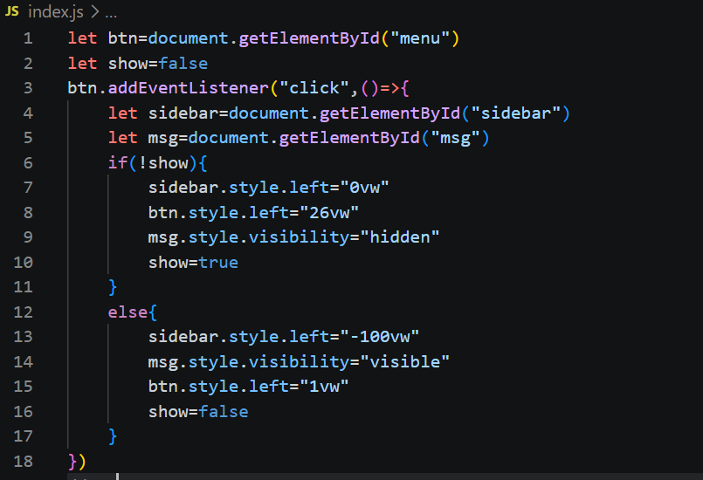

3.2 Dynamic Greeting Script
On page load, the script creates a new Date object to read the user's local time. The current hour is checked against defined ranges to determine whether to display "Good Morning", "Good Afternoon", or "Good Evening", and the result is inserted into the greeting element in the DOM.
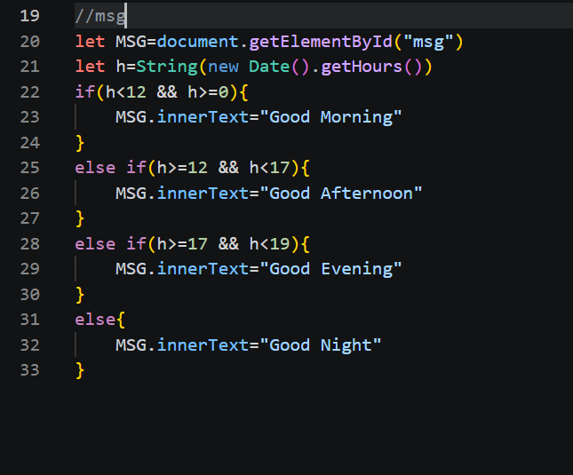
3.3 CRM Dashboard with JavaScript Linked
The JavaScript file was linked to the Day 4 CRM Dashboard HTML file using a script tag placed before the closing body tag, ensuring the DOM elements are fully loaded before the script runs.
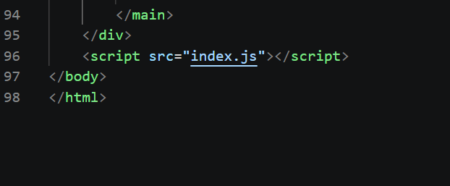

4. Key Learnings
- Understood the difference between let and const and when to use each for variable declaration.
- Learned how JavaScript primitive data types behave and are stored in memory.
- Practiced writing functions using both traditional and arrow function syntax.
- Gained a working understanding of the DOM tree and how JavaScript interacts with HTML elements.
- Learned to attach event listeners and dynamically update the UI in response to user actions.
- Understood how to work with the Date object to build time-based dynamic content.

