Style Guidelines for Final Year Project ReportsEduMate
Software Engineering Project



Primary Advisor: Ms. Nosheen Sabahat

Presented by:
261039078 Soban Khan
261031499 Basima Maham
261042129 Tahreem Fatima

Department of Computer Science

Forman Christian College (A Chartered University)
EduMate – Collaborative Learning Platform

By

Soban Khan, Basima Maham, Tahreem Fatima

Project submitted to

Department of Computer Science,

Forman Christian College (A Chartered University),

Lahore, Pakistan.

in partial fulfillment of the requirements for the degree of

BACHELOR OF SCIENCE
IN
COMPUTER SCIENCE (Honors)

Primary Project Advisor |  | Secondary Project Advisor

Senior Project Management Committee Representative

Abstract
The increasing reliance on scattered communication tools such as WhatsApp, Zoom, and informal file-sharing platforms has made academic collaboration inefficient, disorganized, and insecure for university students. To address these challenges within Forman Christian College University (FCCU), this project develops EduMate, a unified digital platform designed to centralize study coordination, resource sharing, tutoring, and academic communication within a secure, authenticated ecosystem. Our approach involves designing a cross-platform application that integrates FCCU email verification, intelligent study-partner matching, group session management, built-in communication tools, tutoring services, resource exchange, and smart scheduling supported by AI-assisted features. Through requirements elicitation, system modeling, and detailed functional and non-functional specifications, we outline the architecture needed to deliver a platform that enables students to collaborate more effectively and reduce the time lost to fragmented tools. Initial analyses indicate that by consolidating these academic activities into a single system, EduMate can significantly improve study coordination efficiency, reduce dependency on external applications, and enhance peer learning engagement across the FCCU community. The resulting system provides a scalable and privacy-preserving academic network with the potential to meaningfully strengthen collaborative learning culture and serve as a model for university-specific educational platforms.

Acknowledgement
We would like to express our sincere gratitude to our course instructor, Ms. Nosheen Sabahat, for providing continuous guidance, constructive feedback, and encouragement throughout the duration of this project. Their insights helped shape our understanding of software engineering practices and strengthened the overall quality of our work.
We are also thankful to our teaching assistants for their timely support and clarification of concepts, especially during the phases of requirements gathering, system modeling, and testing. Their assistance played a key role in helping us stay aligned with course expectations.
This project would not have been possible without the collective effort and dedication of our team members. Each phase, ranging from the project proposal, requirements elicitation, and detailed specifications to the creation of use case diagrams, sequence diagrams, state diagrams, activity diagrams, class diagrams, and well-structured test cases, was completed through active collaboration and mutual support. We especially acknowledge the additional effort put into developing a functional frontend prototype instead of using third-party design tools, which allowed us to translate our theoretical understanding into a practical and interactive interface.
Finally, we appreciate the encouragement of our peers and the feedback we received during various checkpoints. Their suggestions helped us refine our ideas and improve our system's overall usability and structure.

List of Figures
Figure 1 Figure 1 Title page number

2.6.1 Use Case Diagram 9

3.1.1 Class Diagram 11

3.1.2 Activity Diagram 12

3.2.1 Sequence Diagram – Find Study Partner 14

3.2.2 Sequence Diagram – Request a Tutor 14

3.2.3 Sequence Diagram – Tagging Locations 15

3.2.4 Sequence Diagram – Comment on Post 15

3.2.5 Sequence Diagram – User Reports a Post 16

3.2.6 Sequence Diagram – Upload Notes 16

3.3.2.1 Prototype – Login Page 17

3.3.2.2 Prototype – Register Page 17

3.3.2.3 Prototype – Dashboard / Feed 18

3.3.2.4 Prototype – Dashboard / Feed Dark Mode 18

3.3.2.5 Prototype – Find Study Group Page 19

3.3.2.6 Prototype – Find Tutor Page 19

3.3.2.7 Prototype – Offer Tutoring Page 20

3.3.2.8 Prototype – Browse Questions Page part 1 20

3.3.2.9 Prototype – Browse Questions Page part 2 21

3.3.2.10 Prototype – Browse Resources Page 21

3.3.2.11 Prototype – Upload Resources Page 22

3.3.2.12 Prototype – Browse Books Page 22

3.3.2.13 Prototype – Subscription Sharing, My Groups Page part 1 23

3.3.2.14 Prototype – Subscription Sharing, My Groups Page part 2 23

3.3.2.15 Prototype – Subscription Sharing, Join Group Page 24

3.3.2.16 Prototype – My Profile Page part 1 24

3.3.2.17 Prototype – My Profile Page part 2 25

3.4.1 State Diagram – User Account 25

3.4.2 State Diagram – Study Session 26

3.4.3 State Diagram – Joining a Study Group 26

List of Tables
Table 1 Table 1 title page number

2.2.1 User Classes and Characteristics 3

2.5.1.1 UC-01 4

2.5.2.1 UC-02 5

2.5.3.1 UC-03 5

2.5.4.1 UC-04 5

2.5.5.1 UC-05 6

2.5.6.1 UC-06 7

2.5.7.1 UC-07 7

2.5.8.1 UC-08 8

2.5.9.1 UC-09 9

4.1.1.1 TC-01 28

4.1.2.1 TC-02 28

4.1.3.1 TC-03 29

4.1.4.1 TC-04 29

4.1.5.1 TC-05 30

4.1.6.1 TC-06 31

4.2.1 Summary of All Test Results 31

Table of contents
Abstract i
Acknowledgement ii
List of Figures iii
List of Tables V
Chapter 1. Introduction 1
1.1 Introduction 1
1.2 Objectives 1
1.3 Problem Statement 1
1.4 Scope 2
Chapter 2. Requirements Analysis 3
2.1 Literature Review 3
2.2 User Classes and Characteristics 3
2.3 Design and Implementation Constraints 3
2.4 Assumptions and Dependencies 4
2.5 Functional Requirements 4
2.6 Use Case Diagram 9
2.7 Nonfunctional Requirements 10
2.8 Other Requirements 10
Chapter 3. System Design 12
3.1 Application and Data Architecture 12
3.2 Component Interactions and Collaborations 13
3.3 Screenshots/Prototype 17
3.4 Other Design Details 25
Chapter 4. Test Specification and Results 28
4.1 Test Case Specification 28
4.2 Summary of Test Results 31
Chapter 5. Conclusion and Future Work 33
5.1 Project summary 33
5.2 Problems faced and lessons learned 33
5.3 Future work 33
References 35
Appendix A Glossary 36
Appendix B Deployment/Installation Guide 36
Appendix C User Manual 36
Appendix D Student Information Sheet 36

Revision History
Name | Date | Reason For Changes | Version
Basima Maham | 2025-11-27 | Added acknowledgment, project proposal, requirements elicitation, and specification sections to the final document. | 1.0
Soban Khan | 2025-11-28 | Added abstract, system diagrams (use case, sequence, activity, state, class) and organized their formatting. | 1.1
Tahreem Fatima | 2025-11-30 | Added test cases and prototype screens, conclusion and future work sections. Ensured consistency across sections. | 1.2
Basima Maham | 2025-12-02 | Added indexes and performed document formatting, structure improvements, and proofreading. | 1.3
Soban Khan | 2025-12-03 | Added list of figures and tables and updated technical descriptions and refined diagram explanations. | 1.4
Tahreem Fatima | 2025-12-04 | Added glossary and references. Did a review of the whole report and polished language. | 1.5
All three | 2025-12-05 | Did a final review and editing before finalizing the document for submission. | 2.0

Introduction

Introduction
Students often struggle to manage their academic communication, study planning, and collaboration due to the use of scattered platforms such as WhatsApp, Gmail, Zoom links, and informal group chats. Important announcements get lost, study groups lack structure, and students have no central mechanism to find peers for studying, sharing resources, or getting support.
Our project, EduMate, addresses this gap by presenting a conceptual design of a unified academic collaboration platform tailored for FCCU students. The purpose of this project, within the scope of this course, was not to fully implement the system, but to analyze, design, specify, and model how such a platform should work. Throughout the semester, we completed the complete Software Engineering documentation cycle: requirements gathering, requirement specification, system modeling, test case design, and prototype creation.
To visualize the final system, we developed a non-functional frontend prototype that demonstrates the look, layout, and user flow of the platform. While the prototype does not contain backend logic or working functionality, it helps translate the documented requirements into a conceptual interface.
EduMate highlights the importance of structured academic collaboration, reduced communication gaps, and improved accessibility for students. The work presented in this project lays the foundation for a system that can later be fully implemented in a real-world environment.

Objectives
The main objectives of EduMate, achieved by the end of the project, were:
- To identify and analyze the problems faced by students in academic collaboration.
- To gather and specify detailed functional and non-functional requirements for a unified academic platform.
- To model the system using UML diagrams, including use case, activity, sequence, class, and state diagrams.
- To define clear test cases based on documented requirements.
- To design a conceptual user interface representing how the final system might look.
- To ensure that all documentation follows proper Software Engineering standards and methods.
- To create a non-functional frontend prototype that visually represents the intended system layout and user flow.

Problem Statement
EduMate is a software design project that addresses the problem of fragmented academic collaboration among FCCU students. Prior to this project, students relied on multiple disconnected platforms for communication, study sessions, and resource sharing, which caused inefficiencies and limited access to peer support.
The project provides a comprehensive documentation and system design package, including requirements, specifications, system diagrams, test cases, and a visual prototype, illustrating how a dedicated academic collaboration platform could function. It serves as a design blueprint rather than a fully functional application, providing guidance for future implementation or research.

Scope
The scope of the EduMate project includes:
- Producing detailed software requirements and specifications.
- Designing system models and diagrams that capture the intended structure, behavior, and interactions within the platform.
- Creating a non-functional frontend prototype to demonstrate the look, feel, and user navigation flow.
- Developing test cases to validate the system’s design logic and workflows.
The project does not include the full backend implementation, database integration, or deployment of a working application. Its focus is on producing a complete software engineering documentation package and visual representation of the proposed platform, which can serve as a foundation for future development.

Requirements Analysis

Literature Review
Academic collaboration faces significant challenges in the digital age, primarily due to platform fragmentation. Research by Zhou and Shen (2024) confirms that web-based fragmented learning leads to "increased complexity in knowledge acquisition" and "cognitive impairment" among college students as they navigate "explosive, fragmented, diversified, random, and discrete knowledge and information" across multiple platforms. This academic validation underscores the real problem EduMate addresses: reducing cognitive load and complexity by consolidating academic tools into one unified platform.

The need for specialized academic networks is further supported by research on professional platforms. Meishar-Tal and Pieterse (2017) found that academics use dedicated academic social-networking sites primarily for "consumption of information," "sharing of information," and "interaction with peers," motivated by needs for professional knowledge acquisition and community belonging. This demonstrates that purpose-built platforms effectively serve specific academic needs, a principle EduMate extends to the undergraduate collaborative learning context.

While existing research confirms both the problem of fragmentation and the efficacy of specialized academic networks, a gap remains: no such integrated platform exists specifically for undergraduate collaborative learning within institutional boundaries. EduMate addresses this gap by synthesizing these findings to propose a secure, university-verified platform that provides the structure and integration needed to mitigate fragmentation's negative impacts while fostering the community and knowledge-sharing benefits demonstrated in academic networking research.

User Classes and Characteristics
User Class | Characteristics & Key Needs | Priority
Student (Primary) | FCCU undergraduate/graduate; seeks study partners, notes, groups, tutoring; varies in tech-savviness; needs simple, quick access. | Critical – All core features designed for this class.
Tutor / Senior Student | Experienced students or TAs; offers paid/free help; needs profile management, schedule, and reputation (rating) system. | High – Essential for tutoring module success.
Society Representative | Student club/society heads; organizes official study sessions/workshops; needs announcement tools and group management privileges. | Medium – Supports community building.
Administrator | Admin or appointed staff; oversees user verification, content moderation, system health, and data security. | High – Required for system integrity and safety.

Table 2.2.1: User Classes and Characteristics
Casual observers or non-FCCU affiliates are explicitly excluded from access.

Design and Implementation Constraints
- Policy and Security: Must comply with FCCU’s IT and data privacy policies. All user data must reside within the university’s jurisdiction.
- Authentication: Login must use FCCU email verification only; no social logins.
- Technology: Frontend prototype is built with HTML/CSS/JS(React/Vue). Final system would require a scalable backend (e.g., Node.js/Python) and relational database (e.g. PostgreSQL).
- APIs: Depends on Google Maps API for location features and a secure email service API for verification tokens.
- Platform: Must be a responsive web application with future potential for iOS/Android wrappers.
- Standards: Code and documentation must follow university-prescribed SE standards for maintainability.

Assumptions and Dependencies
Assumptions:
- All target users have a valid, active FCCU email address.
- The university administration will support the platform and provide necessary student enrollment data for validation.
- Users will have a stable internet connection when using communication and real-time features.
Dependencies:
- Google Maps API: Essential for location tagging and "find nearby" features.
- FCCU Email System: Critical for user verification and communication.
- Secure Payment Gateway: Required for implementing the tutoring payment and subscription-sharing modules in a live version.

Functional Requirements

Register and Login
Identifier |  | UC-01
Purpose |  | Allow students to create accounts and log in using FCCU email verification.
Priority |  | High
Pre-conditions |  | - User has valid FCCU email.  - User has the app installed.
Post-conditions |  | - User account is created or authenticated.  - User gets access to system dashboard.
Typical Course of Action
S# | Actor Action |  | System Response
1 | User enters FCCU email. |  | System validates email format.
2 | User submits verification request. |  | System sends token to FCCU email.
3 | User enters token. |  | System verifies token.
4 | - |  | System creates account / logs user in.
Alternate Course of Action
S# | Actor Action |  | System Response
1 | User enters invalid or expired token. |  | System rejects attempt and asks to retry.
2 | User email not in valid FCCU list. |  | System blocks registration.

Table 2.5.1.1: UC-01

Manage Study Group
Identifier |  | UC-02
Purpose |  | Create, join, leave and manage groups and resources.
Priority |  | High
Pre-conditions |  | User must be logged in.
Post-conditions |  | - Study group created/updated.  - Files/resources shared and saved.
Typical Course of Action
S# | Actor Action |  | System Response
1 | User selects “Create Group”. |  | System opens creation form.
2 | User enters subject, time, location. |  | System saves group.
3 | User invites or joins group. |  | System updates membership.
4 | User uploads notes/files. |  | System stores and shares with group.
Alternate Course of Action
S# | Actor Action |  | System Response
1 | User tries to join full group. |  | System shows “Group Full”.
2 | User uploads unsupported file. |  | System shows error.
Table 2.5.2.1: UC-02

Matchmaking for Study Sessions
Identifier |  | UC-03
Purpose |  | Match students by subject, time, proximity, and mode (online/in-person).
Priority |  | High
Pre-conditions |  | User has completed profile (subjects, schedule).
Post-conditions |  | Users receive matched study sessions.
Typical Course of Action
S# | Actor Action |  | System Response
1 | User selects “Find Study Partners”. |  | System fetches preferences.
2 | User selects subject/time/location. |  | System runs matchmaking algorithm.
3 | - |  | System displays best matches.
Alternate Course of Action
S# | Actor Action |  | System Response
1 | No match found. |  | System suggests alternative times or online sessions.
Table 2.5.3.1: UC-03

Chat and Video Conferencing
Identifier |  | UC-04
Purpose |  | Enable group communication.
Priority |  | High
Pre-conditions |  | User is member of a study group.
Post-conditions |  | Messages or video session established.
Typical Course of Action
S# | Actor Action |  | System Response
1 | User opens group chat. |  | System loads chat history.
2 | User sends message. |  | System broadcasts to group.
3 | User starts video call. |  | System opens conference room.
Alternate Course of Action
S# | Actor Action |  | System Response
1 | User opens chat / video conference, but network is weak / offline. |  | System displays “Unable to load, check connection”.
2 | User sends a message, but delivery fails. |  | System shows “Message not sent. Retry?”.
3 | User attempts to start a video call but microphone/camera permissions are blocked. |  | System prompts: “Allow camera/microphone access to continue”.
Table 2.5.4.1: UC-04

Tutor Registration and Review
Identifier |  | UC-05
Purpose |  | Tutors register, show availability, and receive ratings.
Priority |  | Medium-High
Pre-conditions |  | - User is logged in.  - User must select “Register as Tutor.”
Post-conditions |  | - Tutor profile is created or updated.  - Tutor availability is visible to students searching for help.  - Ratings/reviews are stored and linked to tutor profile.
Typical Course of Action
S# | Actor Action |  | System Response
1 | Tutor registers profile. |  | System approves tutor account.
2 | Tutor enters subjects, expertise, bio & hourly availability. |  | System validates all required fields and displays it in tutor list and marks status as Active Tutor.
3 | Student completes a study session with tutor. |  | System triggers rating/review prompt.
4 | Students leave ratings/review. |  | System updates tutor’s profile score and shows new review.
Alternate Course of Action
S# | Actor Action |  | System Response
1 | Tutor submits incomplete or incorrect registration info. |  | System displays validation error e.g. “Subject field required.”
2 | Tutor skips availability setup. |  | System marks tutor as registered but “Unavailable for Booking”.
3 | Student tries to submit offensive or inappropriate review. |  | System detects flagged keywords / content, blocks submission and shows “Review violates community guidelines.”
Table 2.5.5.1: UC-05

Manage Shared Subscription
Identifier |  | UC-06
Purpose |  | Allow users to form groups for shared paid plans.
Priority |  | Medium
Pre-conditions |  | - User is logged in.  - User must have a valid payment method added to their account (card on file).  - A subscription plan must exist in the system.  - If joining an existing group, the group must have available slots and group admin must have an active subscription.
Post-conditions |  | - If user creates a group, new active group created, creator becomes admin.  - If user joins a group, user becomes member, payment share set for auto-deduction.  - Transaction history updated for all processed payments.
Typical Course of Action
S# | Actor Action |  | System Response
1 | User creates/joins subscription group. |  | System verifies payment method and makes user member/admin of group.
2 | System deducts monthly share, |  | Transaction logged.
3 | User (member) leaves group. |  | System updates billing division.
4 | User (admin) leaves group. |  | System asks member for new admin volunteer or deletes group.
Alternate Course of Action
S# | Actor Action |  | System Response
1 | Payment fails. |  | System gives grace period and reminder.
2 | Payment fails again. |  | System removes user from group.
Table 2.5.6.1: UC-06

Buy and Sell Academic Materials
Identifier |  | UC-07
Purpose |  | User trades books/notes.
Priority |  | Medium
Pre-conditions |  | - User is logged in.  - User has accessed the marketplace feature.  - For selling: user has entered required item details (title, price, condition).
Post-conditions |  | - Item is listed and visible to other users.  - Chat is opened between buyer and seller when contact is initiated.  - When sale is completed, item status is updated to “Sold.”
Typical Course of Action
S# | Actor Action |  | System Response
1 | User posts book for sale. |  | System lists item.
2 | User contacts seller. |  | System opens chat.
3 | User updates sale as completed. |  | System updates listing status.
Alternate Course of Action
S# | Actor Action |  | System Response
1 | User enters incomplete item details, |  | System rejects listing and asks for missing fields.
2 | Sale is cancelled by either user. |  | System marks listing as “Available” again.
Table 2.5.7.1: UC-07

Social Study Wall
Identifier |  | UC-08
Purpose |  | Allow posting, commenting and reporting content.
Priority |  | Medium
Pre-conditions |  | - User is logged in.  - For posting: user has entered required content (text/image).
Post-conditions |  | - Post is published and visible on the wall.  - Comments/likes are added to the post activity.  - Reported posts are flagged and sent to admin for review.
Typical Course of Action
S# | Actor Action |  | System Response
1 | User posts content. |  | System verifies with community guidelines and publishes to wall.
2 | User comments/likes a post. |  | System updates post.
3 | User reports a post. |  | System alerts admin.
Alternate Course of Action
S# | Actor Action |  | System Response
1 | User has left content empty or invalid. |  | System rejects post.
2 | User posts/comment/likes/report but network is weak/offline. |  | System displays “Unable to post/comment/like/report, check connection”.
Table 2.5.8.1: UC-08

Submit Feedback/Bugs
Identifier |  | UC-09
Purpose |  | Allow users to report issues and suggestions.
Priority |  | Low
Pre-conditions |  | - User is logged in.  - Feedback form page is accessible.  - User has entered required feedback text.
Post-conditions |  | - Feedback/bug report is saved in the system.  - Admin can review the submitted report in the dashboard.
Typical Course of Action
S# | Actor Action |  | System Response
1 | User opens feedback form. |  | System displays form.
2 | User submits feedback. |  | System saves and logs.
3 | Admin reviews report and marks status. |  | System updates status.
Alternate Course of Action
S# | Actor Action |  | System Response
1 | User leaves a required field empty. |  | System does not submit feedback and shows a missing field error.
2 | User submit but network is weak/offline. |  | System cancels submission and user is prompted to retry.
Table 2.5.9.1: UC-09

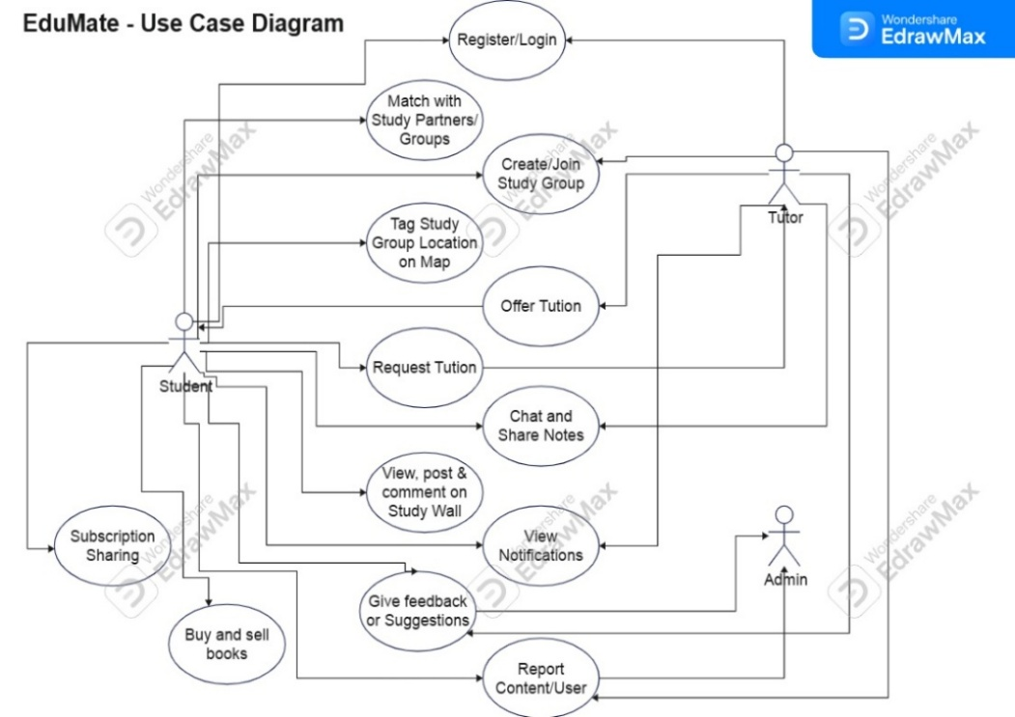
Use Case Diagram
Figure 2.6.1: Use Case Diagram

Nonfunctional Requirements

Performance Requirements
- Response Time: 95% of all user interactions (page loads, chat sends, search queries) must complete within 2 seconds under normal load (up to 1,000 concurrent users).
- Search & Matching: The study partner/matchmaking algorithm must return results within 3 seconds.
- Scalability: The system architecture must support scaling to 10,000 concurrent users during peak periods (e.g., finals week) without significant degradation (<5s response time).
- Video Conferencing: Integrated video calls must maintain a latency of <150ms and support at least 10 participants per session clearly.

Safety Requirements
- Physical Safety: The "Tag Location on Map" feature must only share specific location data with confirmed members of a private study group. Public groups must show only generalized areas (e.g., Main Library, S Block).
- Content Safety: The system must prevent the sharing of malicious files (executables) and include warnings against sharing personal, sensitive information in public chats or walls.
- Regulatory Compliance: The platform must adhere to FCCU's student code of conduct and Pakistan's cybersecurity guidelines for educational institutions.

Security Requirements
- Authentication & Access: Strict FCCU email-based authentication. Role-based access control (RBAC) to ensure students, tutors, and admins see only authorized features.
- Data Protection: All data in transit must be encrypted using TLS 1.3. Passwords must be hashed (using bcrypt/scrypt) and never stored in plaintext.
- Privacy: Personal data (phone numbers, payment info) will be kept separate from profile data and accessible only to the user and necessary system modules (e.g., payment gateway).
- Compliance: Must comply with general data protection principles relevant to educational data.

Additional Software Quality Attributes
- Usability: The system shall achieve a System Usability Scale (SUS) score of >80 from first-time users in beta testing. Interface must be intuitive for non-technical users.
- Reliability: The application shall maintain 98% uptime during the academic semester, excluding scheduled maintenance.
- Maintainability: The codebase shall be modular with clear documentation, allowing a new developer to understand and update a core module (e.g., chat) within one week.
- Portability: The web application must render and function correctly on the latest two versions of Chrome, Firefox, Safari, and Edge browsers.

Other Requirements
- Database Requirements: Requires a relational database to maintain complex relationships between Users, Groups, Posts, Transactions, and Sessions. Must support daily automated backups.
- External Interface Requirements:
  - Hardware: Must work on standard laptops, tablets, and smartphones.
  - Software: Must interface with FCCU's email server (SMTP/IMAP) and Google Maps JavaScript API.
- Legal Requirements: Terms of Service and Privacy Policy must be drafted and accepted by users upon registration, clarifying data usage and user responsibilities.
- Internationalization: The interface shall be primarily in English, but support for Urdu text input and display must be considered for future versions.

System Design

Application and Data Architecture
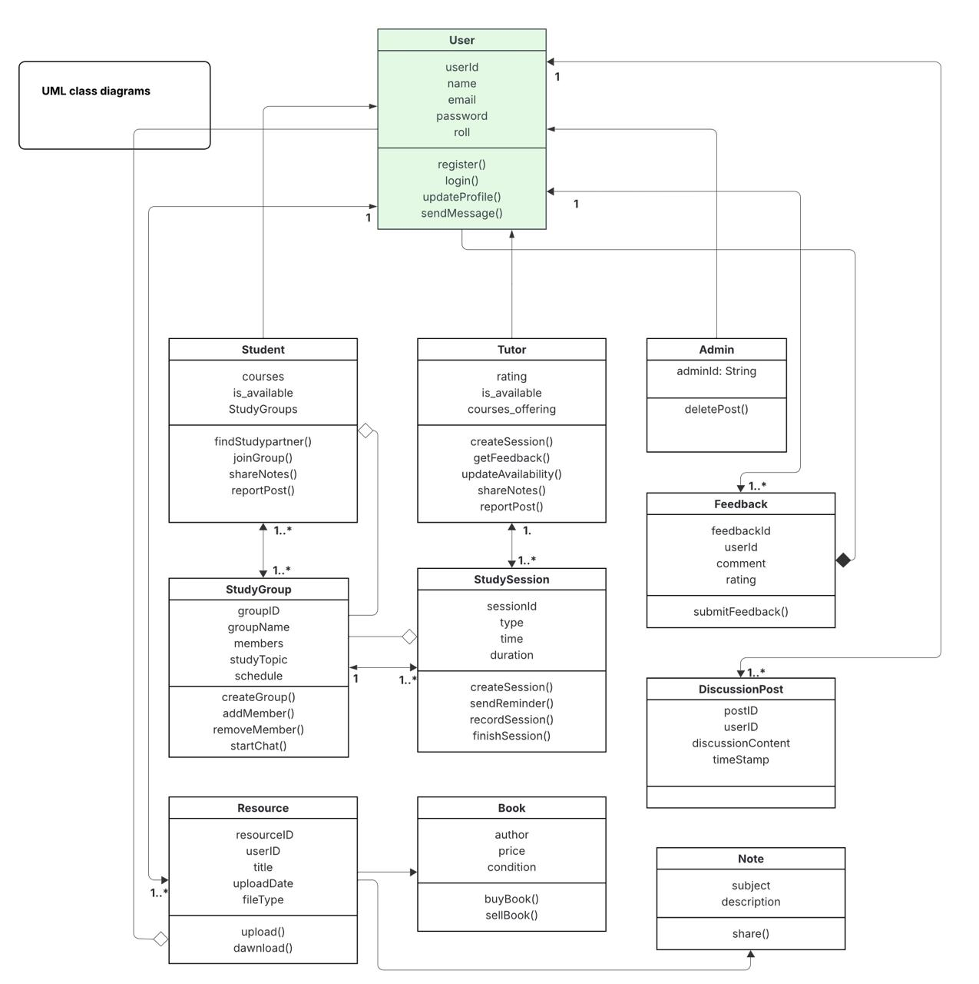
This section presents the structural design of EduMate, focusing on the logical organization of system components and data relationships.
Figure 3.1.1: Class Diagram
The class diagram (Figure 3.1.1) models the core entities of EduMate and their relationships. The User class serves as the parent for Student, Tutor, and Admin, employing inheritance to share common attributes (userId, name, email) while allowing specialization. Key associations include: a Student can join multiple StudyGroup instances; a Tutor can create multiple StudySession instances; and all users can create DiscussionPost and Resource objects. The diagram shows composition relationships where Resource is specialized into Book and Note classes, capturing the different attributes and methods needed for each resource type. This static structure forms the foundation for the database schema and object-oriented implementation.
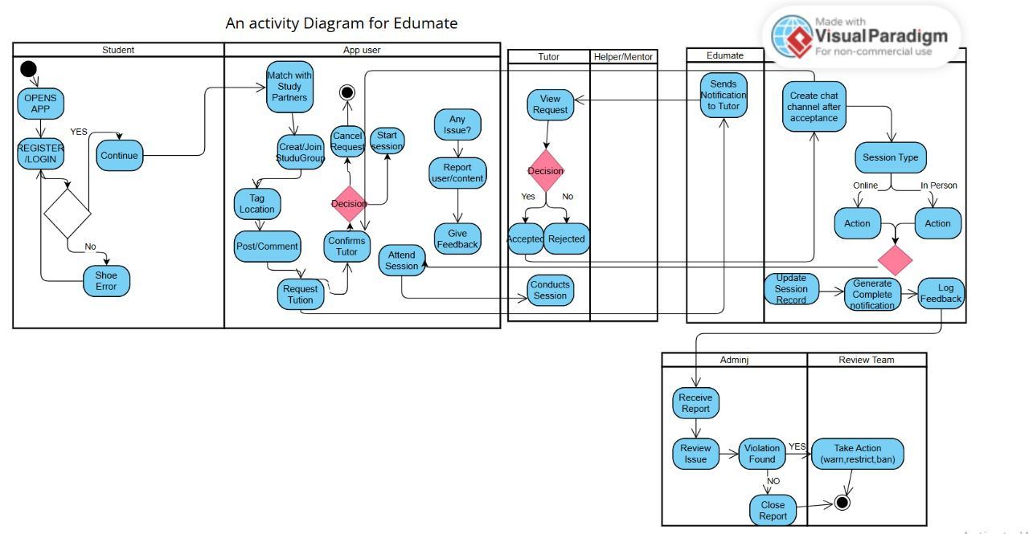
Figure 3.1.2: Activity Diagram
This Activity diagram (Figure 3.1.2) visualizes the high-level workflow of a student using EduMate. The process begins with registration/login, followed by key activities like matching with study partners, creating/joining study groups, and attending sessions. Decision points handle scenarios like request acceptance/rejection and session type (online vs. in-person). The parallel swimlanes for Student, Admin, and Tutor show coordinated activities, particularly in the reporting workflow where admins review flagged content.

Component Interactions and Collaborations
This section details the dynamic behavior and communication between system components during specific operations.
Sequence Diagrams: The following sequence diagrams illustrate key interactions:

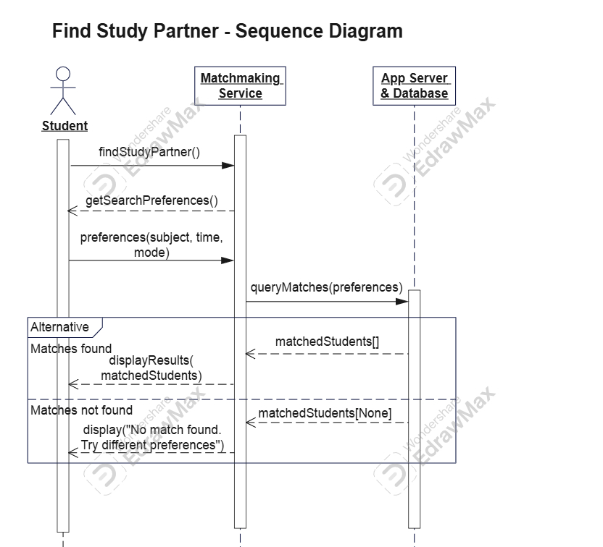
Figure 3.2.1: Sequence Diagram – Find Study Partner
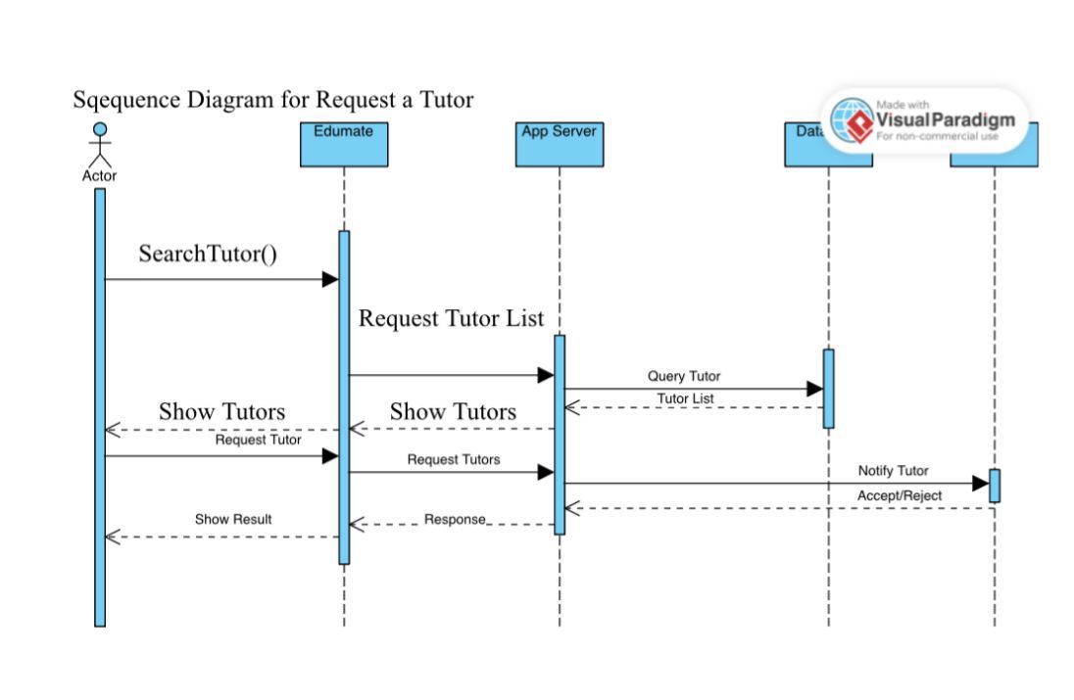
- Find Study Partner (Figure 3.2.1): Shows the finding study partner flow where the App Server matches the preferences of the students with other students in its database, generates a list of matched students, and displays it to the student or asks the user to change preferences if no match is found.

Figure 3.2.2: Sequence Diagram - Request a Tutor
- Request a Tutor (Figure 3.2.2): Illustrates how students search for tutors, send requests, and how tutors receive notifications and respond with acceptance/rejection decisions.

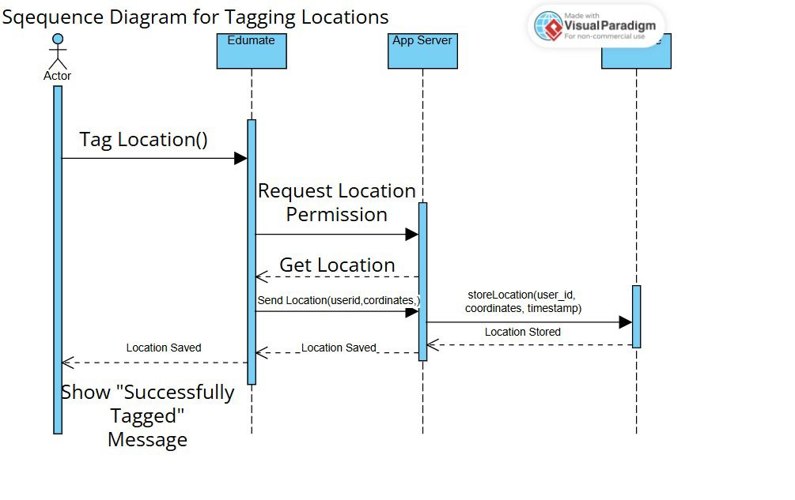
Figure 3.2.3: Sequence Diagram – Tagging Locations
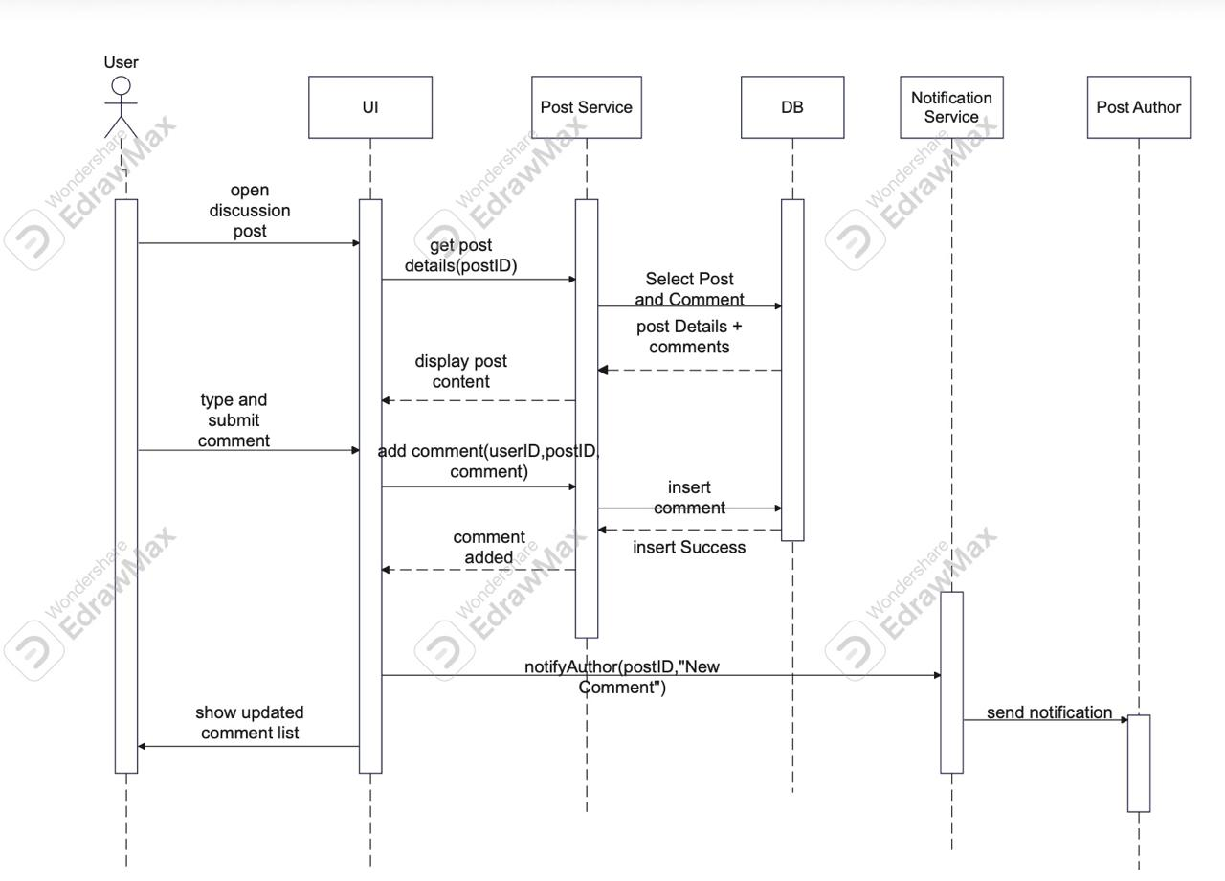
- Tagging Locations (Figure 3.2.3): Demonstrates the integration with device location services, where the app requests permission, obtains coordinates, and saves them to the server for study group mapping.
Figure 3.2.4: Sequence Diagram – Comment on Post
- Comment on Post (Figure 3.2.4): Details the interaction between User, Post Service, Database, and Notification Service when a user comments on a discussion post, including automatic notification to the post author.

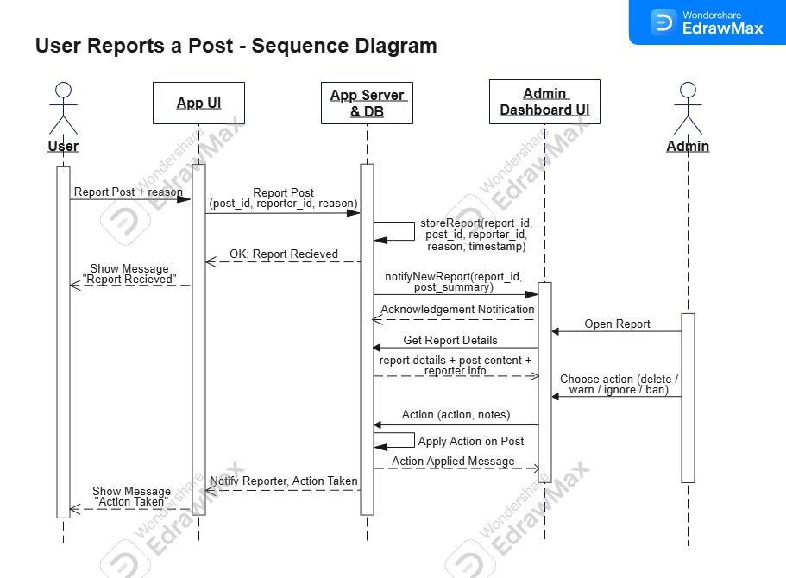
Figure 3.2.5: Sequence Diagram – User Reports a Post
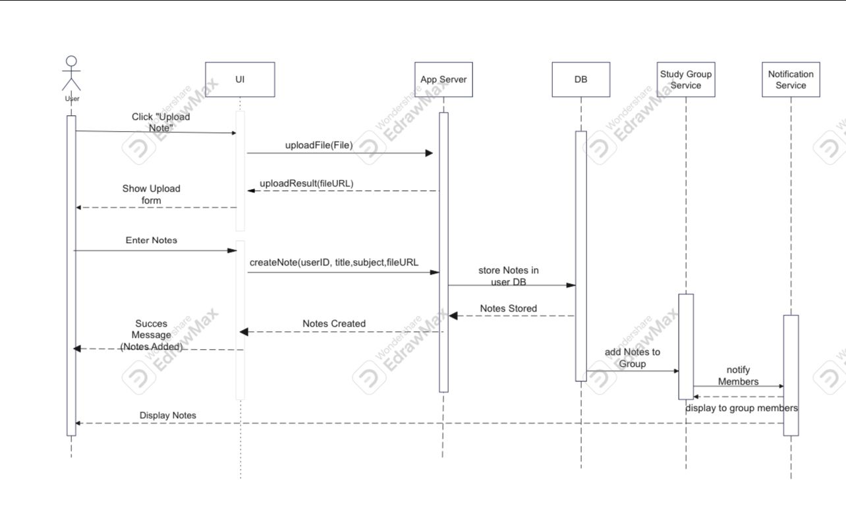
- User Reports a Post (Figure 3.2.5): Shows the reporting workflow where reports are stored, admins are notified, and administrative actions are applied to content moderation.
Figure 3.2.6: Sequence Diagram – Upload Notes
- Upload Notes (Figure 3.2.6): Though not diagrammed, this would follow a similar pattern to Sequence Diagram 4, with the Resource/Note classes handling file upload, storage, and sharing permissions.

These interactions demonstrate how the static class structure comes to life through message passing between objects during runtime execution.

Screenshots/Prototype

Workflow
The primary user journey begins with FCCU Email Verification. After verification, users access a dashboard showing study groups, partner suggestions, and the study wall. The Activity Diagram (Figure 3.1.2) captures the complete workflow from registration through session participation, including parallel admin moderation processes.

Screens
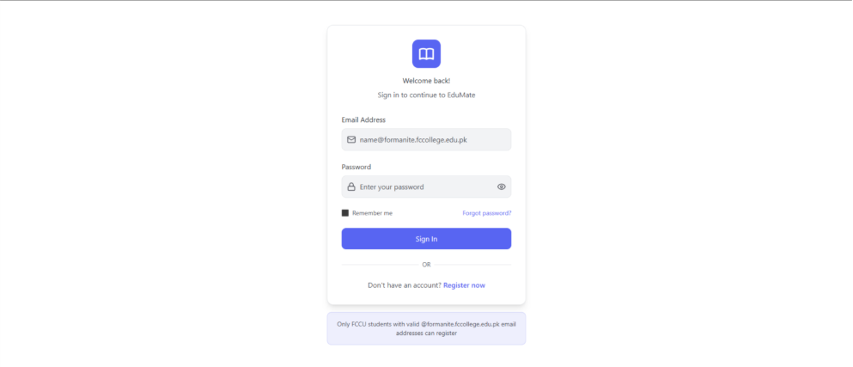
Figure 3.3.2.1: Prototype – Login Page
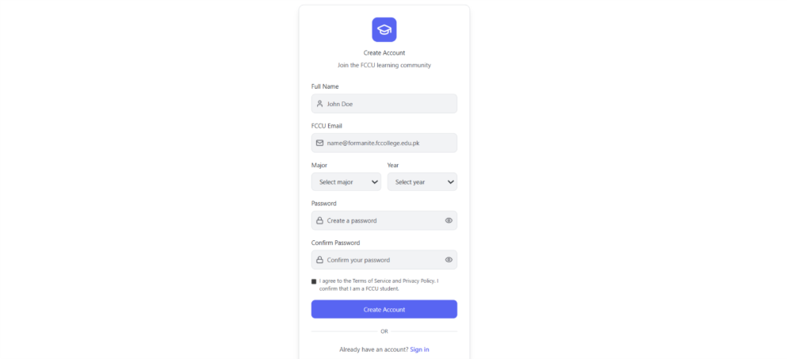
Figure 3.3.2.2: Prototype – Register Page

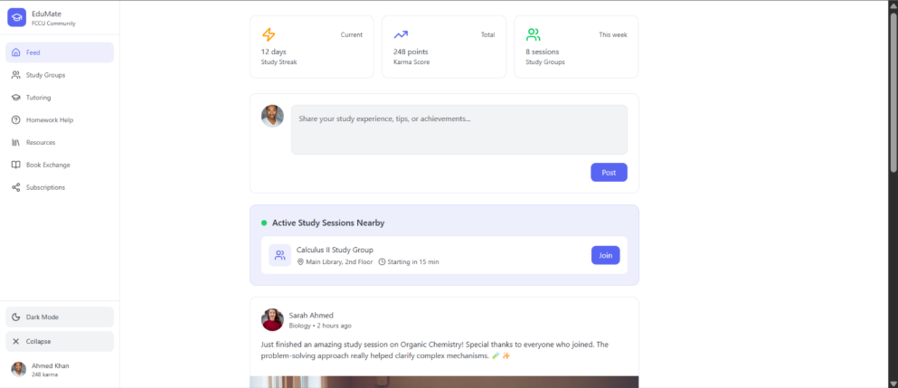
Figure 3.3.2.3: Prototype – Dashboard / Feed
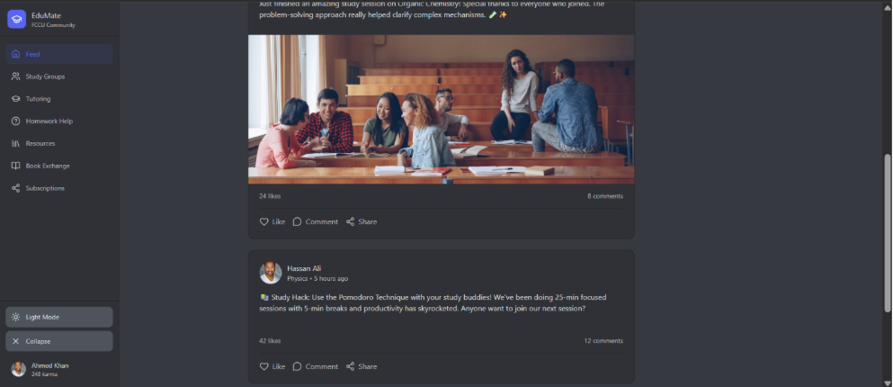
Figure 3.3.2.4: Prototype – Dashboard / Feed Dark Mode

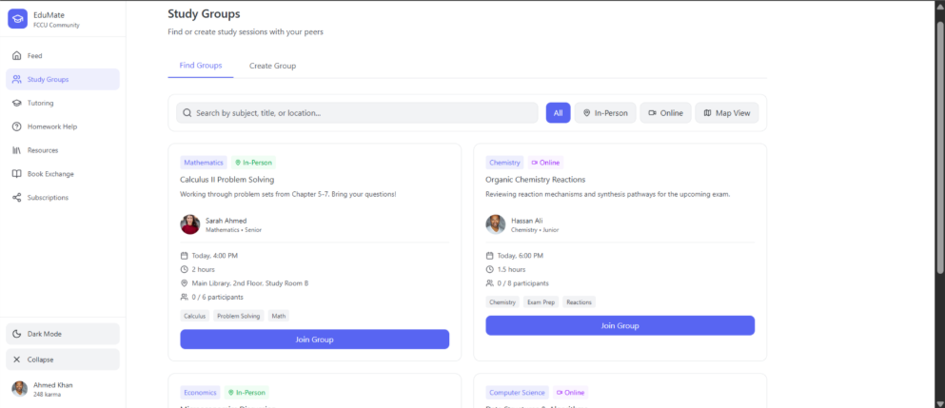
Figure 3.3.2.5: Prototype – Find Study Group Page
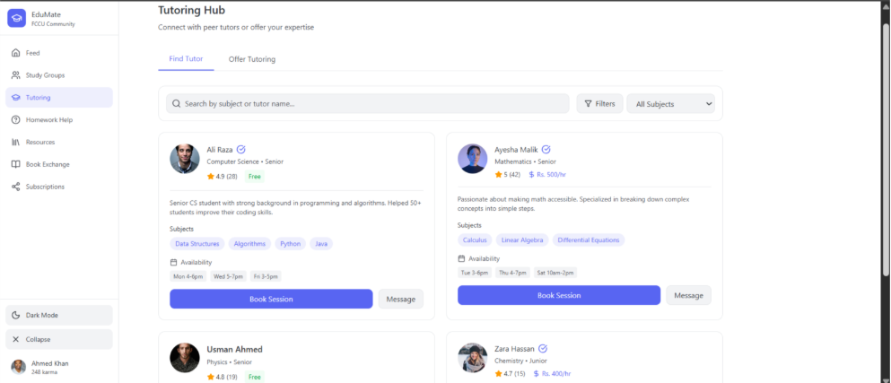
Figure 3.3.2.6: Prototype – Find Tutor Page

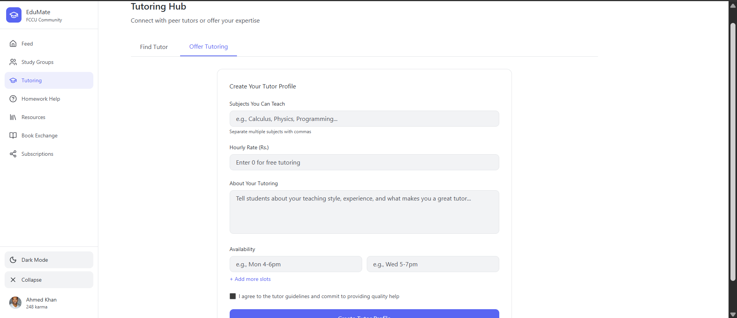
Figure 3.3.2.7: Prototype – Offer Tutoring Page
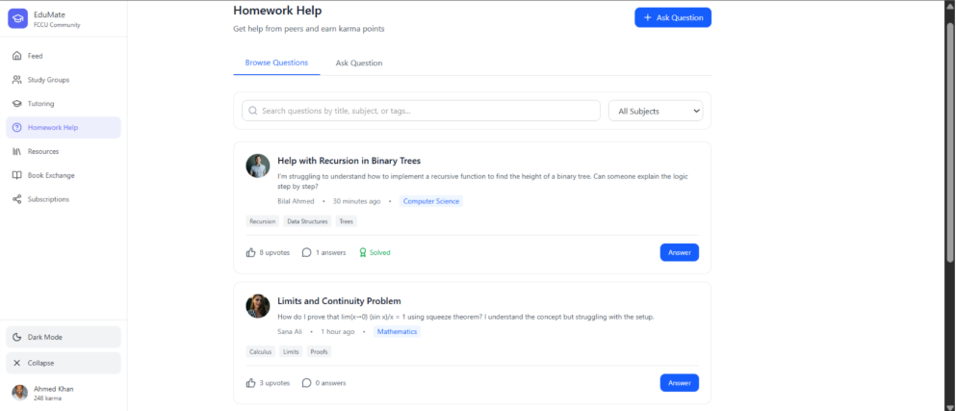
Figure 3.3.2.8: Prototype – Browse Questions Page part 1

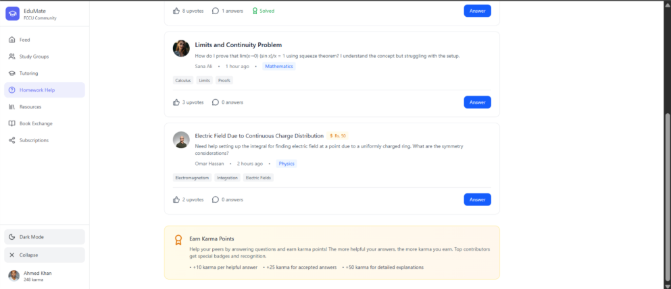
Figure 3.3.2.9: Prototype – Browse Questions Page part 2
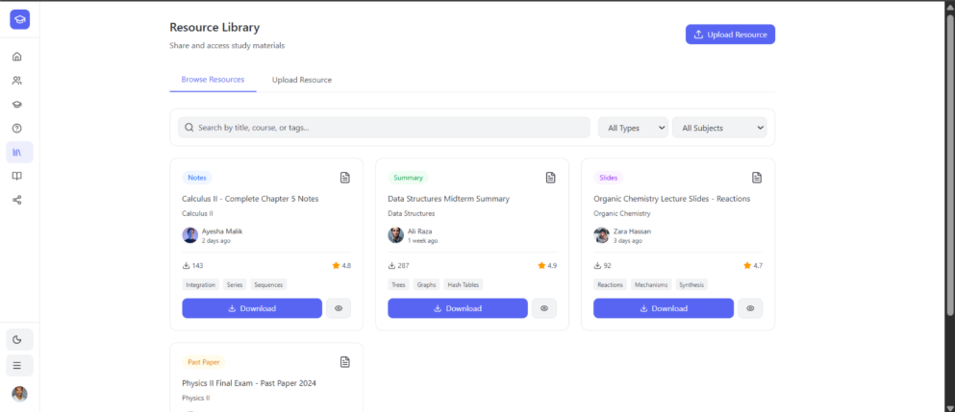
Figure 3.3.2.10: Prototype – Browse Resources Page
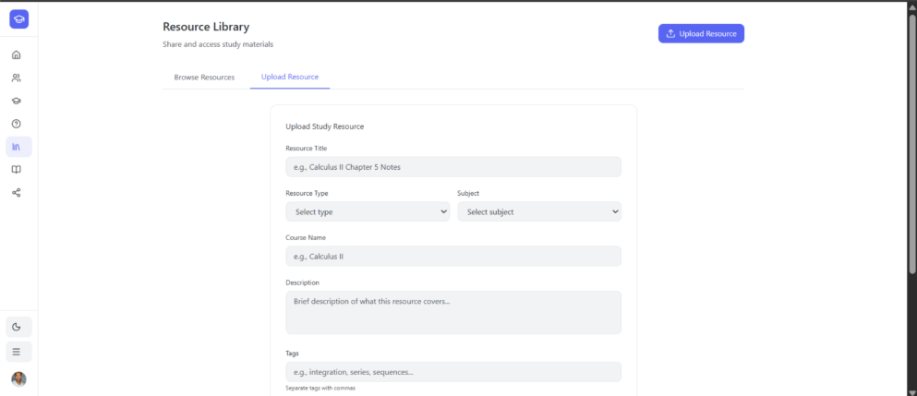
Figure 3.3.2.11: Prototype – Upload Resources Page
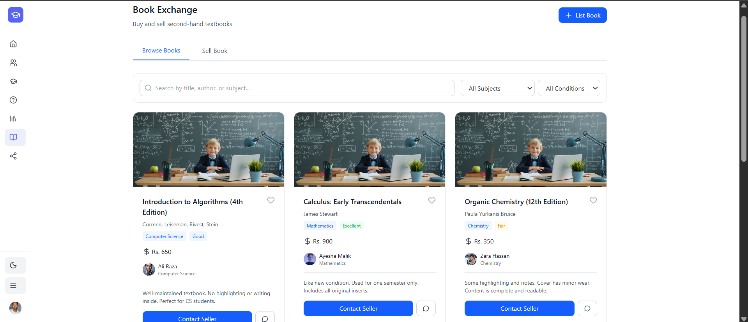
Figure 3.3.2.12: Prototype – Browse Books Page
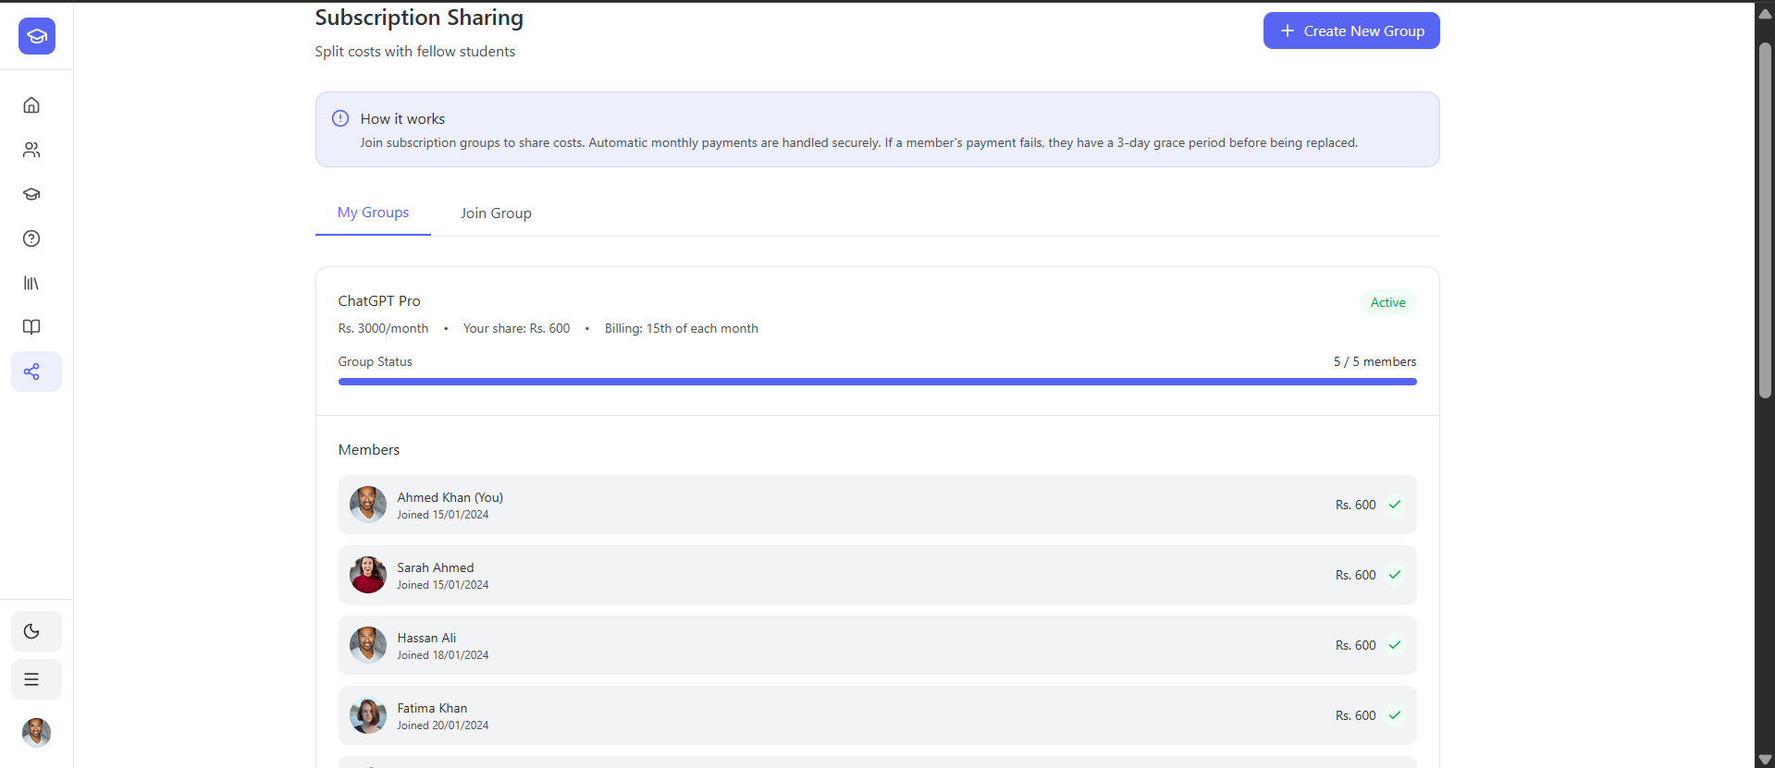
Figure 3.3.2.13: Prototype – Subscription Sharing, My Groups Page part 1
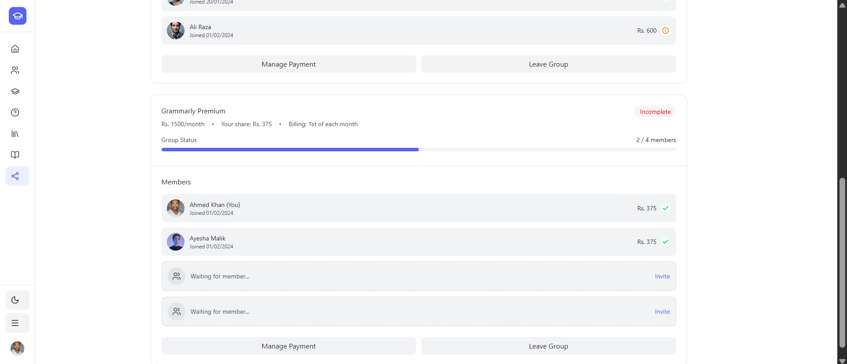
Figure 3.3.2.14: Prototype – Subscription Sharing, My Groups Page part 2
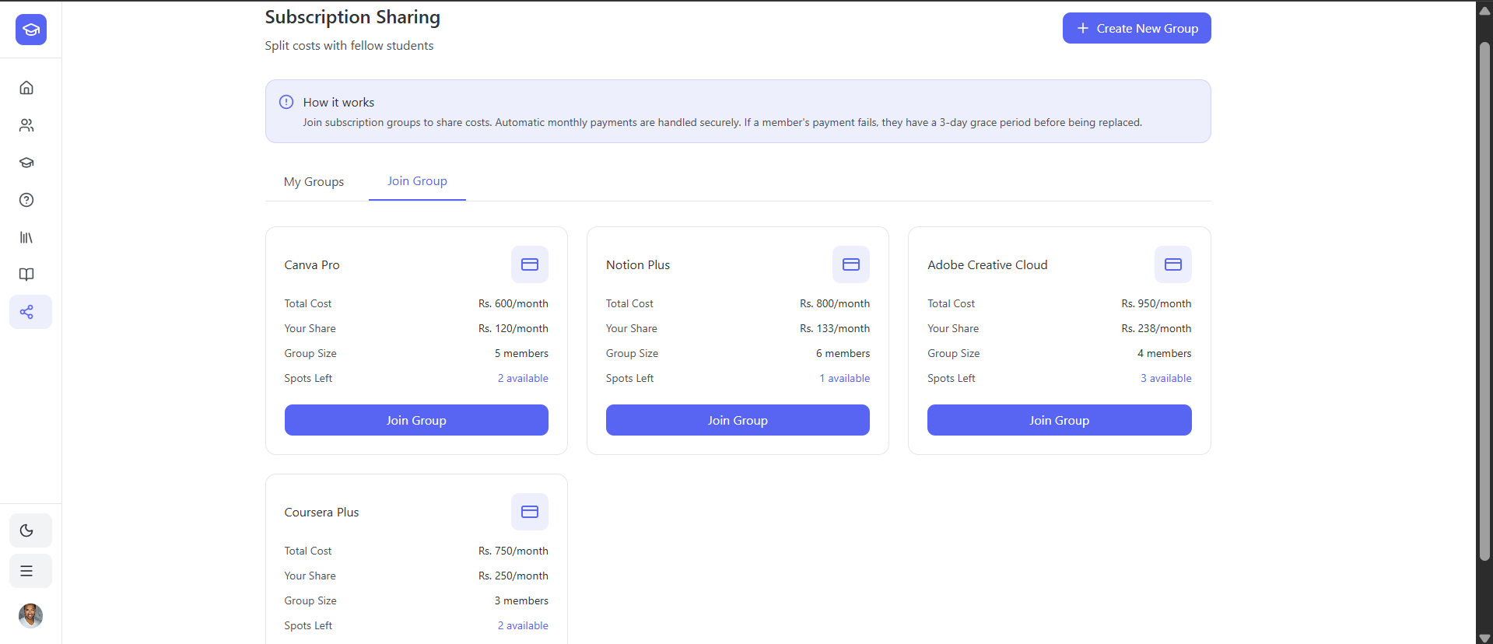
Figure 3.3.2.15: Prototype – Subscription Sharing, Join Group Page
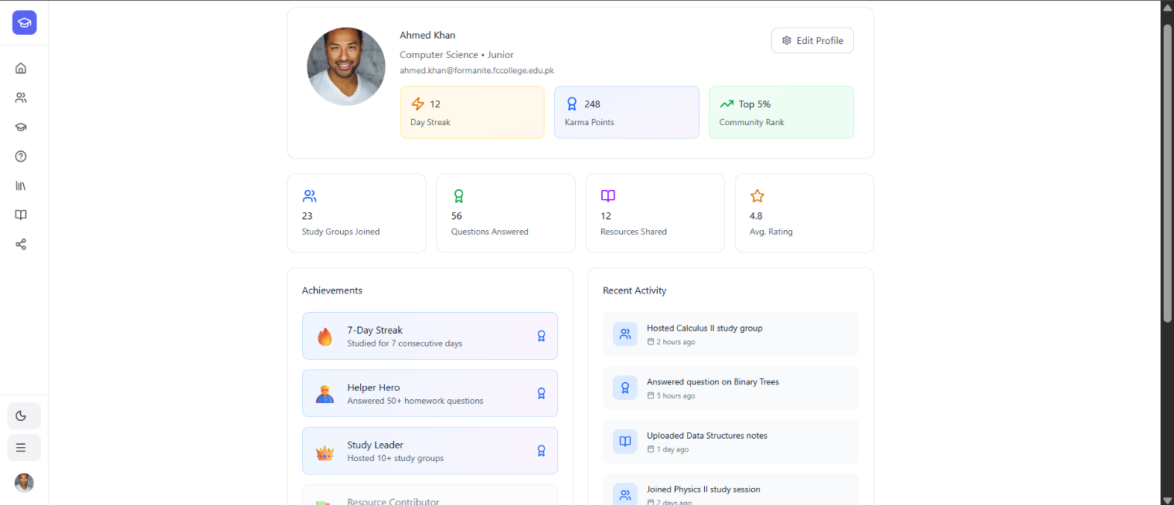
Figure 3.3.2.16: Prototype – My Profile Page part 1
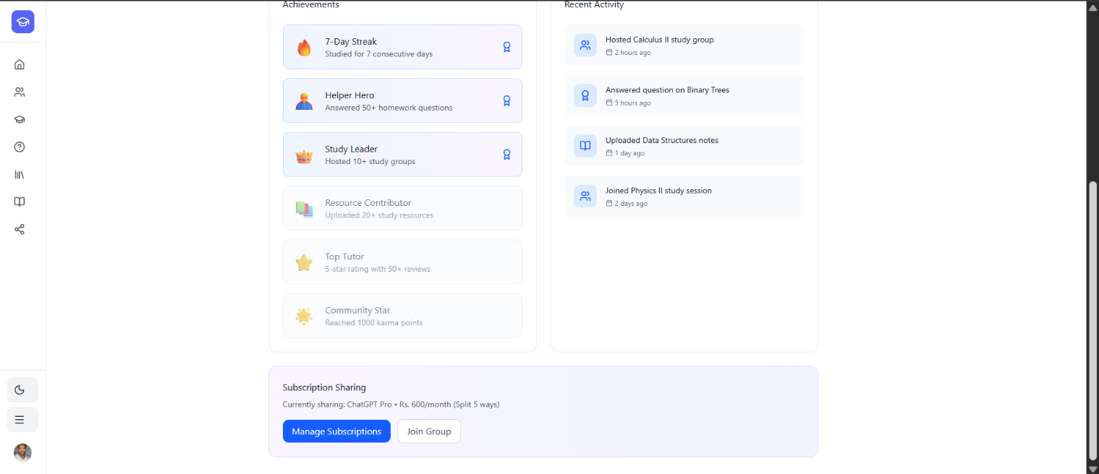
Figure 3.3.2.17: Prototype – My Profile Page part 2

Other Design Details
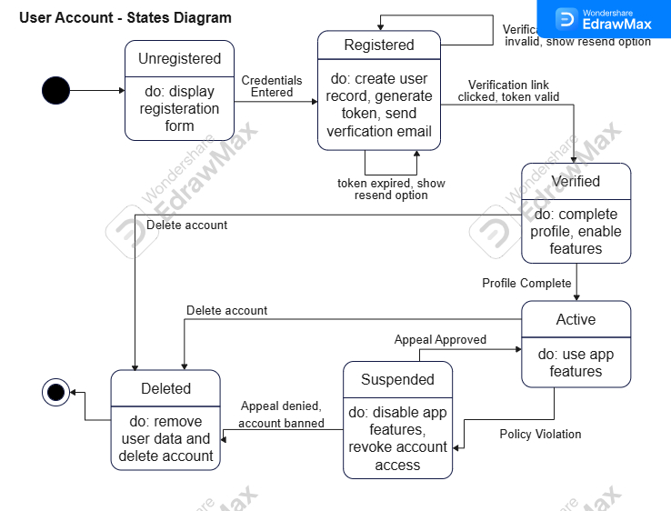
State Diagrams: These diagrams capture the behavioral states of key entities:

Figure 3.4.1: State Diagram – User Account
- User Account (Figure 3.4.1): Details account states from Unregistered, Registered (unverified), Verified, Active, Suspended, to Deleted, with transitions based on user actions and policy violations.

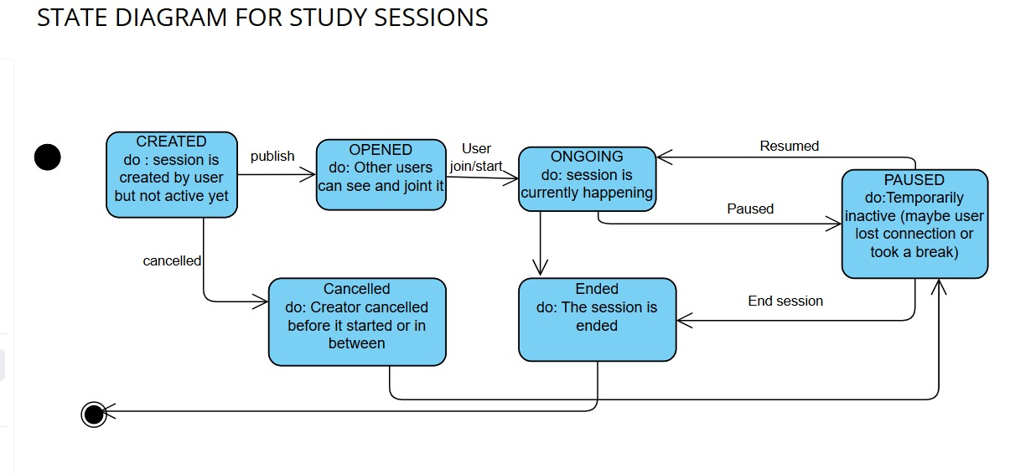
Figure 3.4.2: State Diagram – Study Session
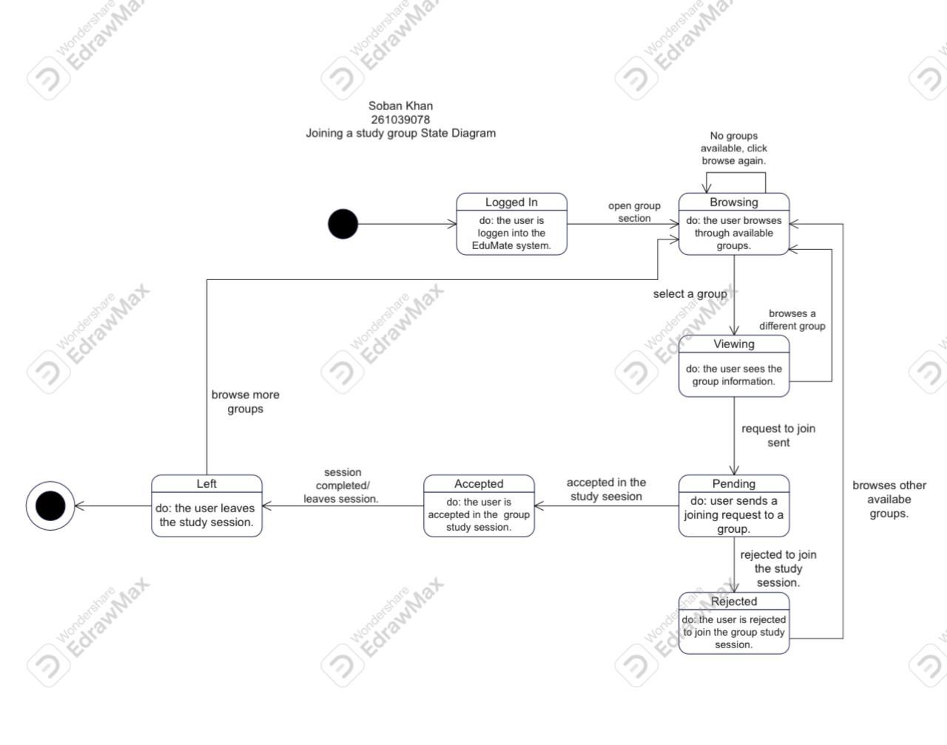
- Study Session (Figure 3.4.2): Captures the lifecycle of a session from Created, Open for Joining, Ongoing, potentially Paused, to final states of Ended or Cancelled.
Figure 3.4.3: State Diagram – Joining a Study Group
- Joining a Study Group (Figure 3.4.3): Models the user’s journey from Browsing available groups, Viewing details, sending a Request, entering Pending status, and reaching final states of Accepted or Rejected.
Design Decisions:

- Privacy-First Location Sharing: The tagging feature (Figure 3.2.3) implements optional sharing with explicit permission requests.

- Asynchronous Moderation: The reporting system (Figure 3.2.5) queues content for admin review rather than taking immediate automated actions.

- Karma Points System: Designed as a gamification layer within the User class to encourage positive participation without financial incentives.

Test Specification and Results

Test Case Specification
Based on the functional requirements and use cases documented in Chapter 3, the following test cases were designed and executed to validate the EduMate system's core functionalities.

Manage Study Group
Identifier | TC-01
Related requirements(s) | UC-02 Assignment 3 (SRS) Section 2.5.2 Manage Study Group
Short description | Verify that a logged-in user can create, join, leave, and manage a study group, including sharing files/resources.
Pre-condition(s) | User is logged in.
Input data | - Group details (subject, time, location).  - File(s) or notes to upload.
Detailed steps | - User selects “Create Group”.  - User enters subject, time, and location.  - User submits the form.  - User invites members or joins an existing group.  - User uploads notes/files to the group.
Expected result(s) | - Group creation form opens.  - New group is created and saved.  - Membership is updated.  - Files/resources are stored and visible to group members.
Post-condition(s) | - Study group exists or is updated.  - Shared files/resources are stored in the system.
Actual result(s) | System successfully opened the group creation form, saved the new study group, updated group membership, and uploaded files that became visible to all group members.
Test Case Result | Test Case Passed

Table 4.1.1.1: TC-01

Matchmaking for Study Sessions
Identifier | TC-02
Related requirements(s) | UC-03 Assignment 3 (SRS) Section 2.5.3 Matchmaking for Study Sessions
Short description | Verify that a user can receive study partner matches based on subject, schedule, proximity, and session mode.
Pre-condition(s) | - User is logged in.  - User has completed their profile (subjects + availability).
Input data | - Selected subject  - Preferred time  - Preferred location or online mode.
Detailed steps | - User selects “Find Study Partners”.  - User chooses subject, time and location/mode.  - System processes the inputs using the matchmaking algorithm.
Expected result(s) | - System retrieves stored preferences.  - System identifies and displays the best available matches.
Post-condition(s) | User receives a list of matches study partners/sessions.
Actual result(s) | System successfully fetched user preferences and displayed matched partners based on subject, time, and proximity.
Test Case Result | Test Case Passed

Table 4.1.2.1: TC-02

Chat and Video Conferencing
Identifier | TC-03
Related requirements(s) | UC-04 Assignment 3 (SRS) Section 2.5.4 Chat and Video Conferencing
Short description | Verify that a logged-in user, can send/receive chat messages, start or join a video call, and use collaboration tools like screen sharing and the whiteboard during an online study session.
Pre-condition(s) | User is logged into the system and is a member of at least one study group.
Input data | - Text message content.  - Video call request.  - Screen sharing request.  - Whiteboard interaction (drawing, writing).
Detailed steps | - User opens a study group or private chat.  - User types and sends a chat message.  - Another user replies (system simulation).  - User selects “Start Video Call.”  - Another group member joins the call (simulated).  - User shares their screen.  - User opens the built-in whiteboard and writes a note.  Both users end the call.
Expected result(s) | - Chat window loads correctly and messages are delivered instantly.  - Video call starts without errors.  - Other members can join the call smoothly.  - Screen sharing works and is visible to all participants.  - Whiteboard tools function correctly and update in real time.  - Call ends properly and returns to the study group interface.
Post-condition(s) | - Chat history is saved.  - Video call session logs (duration, participants) are stored.  - Shared whiteboard data remains accessible to group members if saved.
Actual result(s) | The system successfully opened the chat, delivered messages instantly, started a video call, allowed members to join, enabled screen sharing and whiteboard collaboration, and ended the session smoothly with data saved properly.
Test Case Result | Test Case Passed

Table 4.1.3.1: TC-03

Tutor Registration and Reviews
Identifier | TC-04
Related requirements(s) | UC-05 Assignment 3 (SRS) Section 2.5.5 Tutor Registration and Reviews.
Short description | Verify that a logged-in user can register as a tutor and receive reviews from other users.
Pre-condition(s) | User is logged in.
Input data | - Tutor profile details (subjects, experience, availability).  - Review text and rating.
Detailed steps | - User opens the “Become a Tutor” section.  - User enters tutoring details and submits the form.  - Another user selects the tutor’s profile.  - User writes a review and submits a rating.
Expected result(s) | - Tutor registration form opens and accepts valid input.  - Tutor profile is created and visible to others.  - Reviews and ratings are submitted and displayed on the tutor’s profile.
Post-condition(s) | - Tutor profile is stored in the system.  - Review and rating are saved and linked to the tutor.
Actual result(s) | System successfully registered the user as a tutor, displayed the new tutor profile, and saved the submitted review and rating.
Test Case Result | Test Case Passed

Table 4.1.4.1: TC-04

Manage Shared Subscription
Identifier | TC-05
Related requirements(s) | UC-06 Assignment 3 (SRS) Section 2.5.6 Manage Shared Subscription
Short description | Verify that a logged-in user can manage an existing shared subscription, including leaving the group, updating billing division, and handling admin departure or payment failures.
Pre-condition(s) | • User is logged in.  • User is already a member of an active shared subscription group.  • Subscription plan exists in the system.  • Group admin is assigned.
Input data | • Group leave request  • Admin leave request  • Payment method details (for system simulation)
Detailed steps | - User opens “Shared Subscriptions” and selects an existing group.  - A member chooses “Leave Group.”  - System updates billing share for remaining users.  - Admin chooses “Leave Group.”  - System prompts remaining members to choose a new admin OR deletes the group if none accept.  - System simulates monthly payment deduction.  - Payment fails twice and system removes the user from the group after grace period.
Expected result(s) | • Group details load correctly.  • System updates billing division when a member leaves.  • When admin leaves, system either reassigns admin or deletes the group.  • Failed payments trigger a grace reminder, and repeated failures remove user from the group.
Post-condition(s) | • Subscription group is updated (admin changed, user removed, or group deleted).  • Transaction and removal logs updated.  • Payment failure history stored.
Actual result(s) | System correctly managed the group, reassigned admin when required, adjusted billing after members left, and removed users after failed payments.
Test Case Result | Test Case Passed

Table 4.1.5.1: TC-05

Buy and Sell Academic Material
Identifier | TC-06
Related requirements(s) | UC-07 Assignment 3 (SRS) Section 2.5.7 Buy and Sell Academic Materials
Short description | Verify that a logged-in user can list an item for sale, contact sellers, and update an item’s sale status.
Pre-condition(s) | • User is logged in.  • User has accessed the marketplace section.  • For selling: user has item details (title, price, condition).
Input data | • Item title  • Item description  • Condition (New/Used)  • Price  • Chat message to seller  • Status update (“Mark as Sold”)
Detailed steps | - User opens the marketplace and selects “Post Item for Sale.”  - User enters title, description, condition, and price.  - User submits the listing.  - Another user (buyer) clicks “Contact Seller.”  - System opens chat between buyer and seller.  - Seller marks item as “Sold” after completing the transaction.
Expected result(s) | • Item listing form opens and accepts valid data.  • Item becomes visible in the marketplace.  • Chat window between buyer and seller opens successfully.  • Item status changes to “Sold” and is updated across the system.
Post-condition(s) | • Item listing is stored in the system.  • Chat history between buyer and seller is saved.  • Item is updated as sold and no longer available for new buyers.
Actual result(s) | System successfully created the listing, opened chat between buyer and seller, and updated the sale status to “Sold.”
Test Case Result | Test Case Passed

Table 4.1.6.1: TC-06

Summary of Test Results
The following table summarizes the test execution results:

Module Name | Test cases run | Number of defects found | Number of defects corrected so far | Number of defects still need to be corrected
Authentication and User Management | TC-01 | 0 | 0 | 0
Study Group Management | TC-01, TC-03 | 0 | 0 | 0
Matchmaking and Partner Search | TC-02 | 0 | 0 | 0
Tutoring System | TC-04 | 0 | 0 | 0
Marketplace and Resources Sharing | TC-05 | 0 | 0 | 0
Subscription and Payment Management | TC-06 | 0 | 0 | 0
Communication Module | TC-03 | 0 | 0 | 0
Complete System | TC-01 to TC-06 | 0 | 0 | 0
Table 4.2.1: Summary of All Test Results

Conclusion and Future Work

Project summary
EduMate successfully addresses FCCU students fragmented academic collaboration by designing a unified platform. The solution replaces scattered tools like WhatsApp and email with integrated study groups, partner matching, tutoring, and resource sharing—all secured through FCCU email authentication.
The design was validated through:
- Requirements tracing from problems to specifications
- Comprehensive design diagrams (12 diagrams)
- Test case execution (6/6 passed)
- Prototype demonstration of user workflows
Evidence confirms EduMate reduces communication gaps, improves resource access, and creates structured collaboration within FCCU's verified community.

Problems faced and lessons learned
Technical Challenges:
- Designing integrations (FCCU auth, Google Maps) without actual APIs.
- Modeling real-time features (chat, video) conceptually.
- Creating representative prototype without backend.
Team Coordination:
- Maintaining documentation consistency across members.
- Balancing academic deadlines with project milestones.
- Remote collaboration on diagrams and documents.
Lessons Learned:
- Detailed requirements prevent redesigns.
- Regular diagram reviews catch inconsistencies early.
- Prototypes validate UX even without functionality.

Future work
Immediate Implementation:
- Develop backend (Node.js/PostgreSQL) and frontend (React).
- Integrate with FCCU IT for email authentication.
- Add JazzCash/EasyPaisa payment processing.
Near-term Enhancements:
- Build mobile apps (iOS/Android).
- Sync with FCCU's LMS for schedules.
- Implement AI-based matchmaking algorithm.
- Add admin analytics dashboard.
Long-term Vision:
- Expand to other Pakistani universities.
- Add AI features: resource recommendations, study optimization.
- Implement gamification (karma points, rewards).
- Support research collaboration tools.

References
1. Zhou, Y., & Shen, Y. (2024). Research on Web-based Fragmentation Learning and Impact Analysis for College Students. The Educational Review, USA, 8(3). https://www.hillpublisher.com/ArticleDetails/3100

2. Meishar-Tal, H., & Pieterse, E. (2017). Why Do Academics Use Academic Social Networking Sites? International Review of Research in Open and Distributed Learning, 18(1), 1-22. https://www.erudit.org/en/journals/irrodl/2017-v18-n1-irrodl05016/1066176ar/abstract/

Glossary
- EduMate: The proposed academic collaboration platform for FCCU students
- FCCU: Forman Christian College University
- UC: Use Case
- TC: Test case
- SD: Sequence Diagram
- SRS: Software Requirements Specification
- API: Application Programming Interface
- SMTP: Simple Mail Transfer Protocol (for email)
- IMAP: Internet Message Access Protocol (for email)
- SSL/TLS: Secure Sockets Layer/Transport Layer Security (encryption)
- Karma Points: Gamification system rewarding helpful behavior
- Study Wall: Social feed for academic discussions
- Matchmaking Algorithm: System pairing students based on preferences

Deployment/Installation Guide
As a conceptual design project, actual deployment details would be determined during implementation based on FCCU's IT infrastructure policies, available resources, and technical team preferences. The architecture is designed to be platform-agnostic, supporting deployment on standard web hosting environments.

User Manual
C.1 Student User Guide
- Registration: Use FCCU email, verify via link
- Dashboard: View groups, matches, notifications
- Finding Partners: Use matchmaking filters
- Joining Groups: Browse and request to join
- Using Chat: Send messages, start video calls
- Marketplace: Post/contact for books/notes
C.2 Tutor Guide
- Registration: Complete tutor profile
- Availability: Set tutoring hours
- Sessions: Accept/decline requests
- Reviews: View student feedback
C.3 Admin Guide
- Dashboard: View reports, system metrics
- Moderation: Review reported content
- User Management: Suspend/remove users
- System Monitoring: Check uptime, logs.

Student Information Sheet
Roll No | Name | Email Address (FC College) | Frequently Checked Email Address | Personal Cell Phone Number
261039078 | Soban Khan | 261039078@formanite.fccollege.edu.pk | Thunderstorm20115@gmail.com | 03138691448
261031499 | Basima Maham | 261031499@formanite.fccollege.edu.pk | basimamaham@gmail.com | 03303670110
261042129 | Tahreem Fatima | 261042129@formanite.fccollege.edu.pk | tahreem29fatima@gmail.com | 03233198518

