**Mohammad Basir Uddin**

Hagenbekstr.60, Hamburg, Germany +49 157 52446087  [uddinbasir72@gmail.com](mailto:uddinbasir72@gmail.com)

<https://github.com/Basir-ku> <https://www.linkedin.com/in/basir782/>



[Recipient Name]

[Title]

[company]

[Recipient Street Address]

[Recipient City, ST zip]

Dear [Recipient Name] - [Hiring Manager]

I am writing to express my strong interest in the data analyst position at [company name] as advertised on [source of job posting]. As a self-motivated and passionate data analyst is always exciting and challenging for me to turn the raw data into meaning full insights. I am confident to my ability to contribute to the success of your organization.

I am currently pursuing a master's degree in ocean and climate physics, where I have acquired comprehensive knowledge in statistics, data visualization, and predictive modeling. Through coursework and hands-on projects, I have developed strong programming skills in Python and Fortran, as well as gained expertise in machine learning and deep learning, climate modeling, the Climate Data Operator (CDO), Linux, and shell programming. These courses have ignited my passion for data science and motivated me to delve deeper into this exciting field.

I have completed numerous courses on DataCamp, a reputable online platform dedicated to data science. Through these, I have honed my python skill and develop proficiency in SQL for effective data querying. I am adept at importing data into python from various sources, including flat files such as .txt, .csv, Stata, SAS, MATLAB files, Net-CDF and relational database such as SQLite and PostgreSQL. Furthermore, I have experience in extracting data from web sources and APIs, allowing me to leverage a wide range data analysis.

Once the data is imported, I utilize the pandas library to clean, manipulate and transform the data to ensure its quality and suitability for analysis, I am skilled at handeling missing values, outliers, data inconsistencies. This enables to perform comprehensive data cleaning and preparation tasks, which are vital for accurate and meaningful analysis. I am also proficient in performing statistical analysis on the data, leveraging various techniques to extract valuable insights.

When it comes to machine learning and deep learning algorithms, I possess in-depth mathematical knowledge and practical experience. I have a strong understanding of linear regression, support vector machines (SVM), decision trees, k-nearest neighbors (KNN), k-means clustering, logistic regression, principal component analysis (PCA), and feature selection methods. Moreover, I am adept at working with imbalanced data and employ techniques such as oversampling, undersampling, and ensemble methods to address class imbalance challenges. Additionally, I have a thorough understanding of optimization algorithms and have successfully applied them to enhance model performance. I am proficient in implementing ensemble methods such as random forest, XGBoost, AdaBoost, and have experience working with convolutional neural networks (CNN), recurrent neural networks (RNN), TensorFlow, and Keras for deep learning tasks. Additionally, I am well-versed in using tools such as Excel, Tableau, and Power BI for data analysis and visualization.

I am thrilled about the opportunity to join [Company Name], a renowned industry leader known for its commitment to innovation and data-driven decision-making. I am confident that my skills, passion, and drive would make me a valuable asset to your data analysis team.

Thank you for considering my application. I have attached my resume for your review, and I would welcome the opportunity to discuss how my qualifications align with your requirements in more detail. I am available for an interview at your convenience

|  |
| --- |
|  |

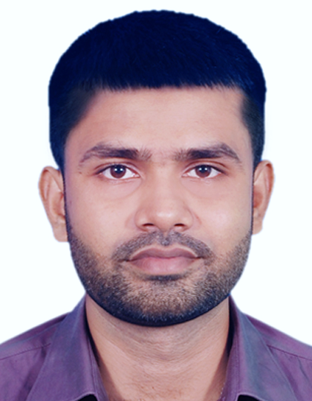Aal

**Mohammad Basir Uddin**

***About Me***

Highly skilled and experienced data professional with expertise in data cleaning, processing, statistical analysis, machine learning, and data visualization. Proven track record of transforming complex datasets into actionable insights and driving data-driven decision-making. Proficient in creating reports, dashboards, and presentations that effectively communicate findings to stakeholders. Strong ability to leverage technical skills and domain knowledge to provide valuable solutions.

***Experience***

**Impact of Autumn Atlantic Ocean SST over EU in winter**

Statistics, expandable ai, neural network, classifications

Universität Hamburg

2023 – current

**Project on Heart Disease prediction with multiple Algorithms**

.csv file, encode, scaling, sampling, classification, RF, extra-tree classifier, KNN, decision tress, k-fold, evaluation, precision, recall, confusion matrix, PCA, tuning.

Self- project

2023-2023

**Ocean and Climate data Analysis**

Netcdf, Seaborn, Matplotlib, statistical analysis, ML, DL

Universität Hamburg

2022-2022

**Scientific Programming Fortran and python**

Python, Fortran, Shallow water model

Universität Hamburg

2022-2022

**Climate Modeling**

0d-EBM, volcanic eruption

Universität Hamburg

2022-2022

***Education***

**Masters in Ocean and Climate Physics**

Universität Hamburg, Germany

2021 - current

**Bachelor in Physics**

Khulna University

2015- 2019

***Contact Information***

Hagenbekstr.60, Hamburg, Germany

+49 157 52446087

[uddinbasir72@gmail.com](mailto:uddinbasir72@gmail.com)



<https://github.com/Basir-ku>



<https://www.linkedin.com/in/basir782/>



***Hard Skills***

Python

Machine Learning

Deep Learning

Statistics

Mathematics

Matplotlib

Seaborn

Cartopy

Numeric Python

Pandas

Xarray

Machine learning

Deep Learning

Tensor Flow

Kears

Scikit-Learn

SQL

Git & Github

Windows, Mac

Linux and shell programing

Climate data operator

***Certifications from Data Camp***

1. Introduction to **python**
2. **Data science** **in python**
3. Intermediate **Python**
4. Python **Data Science** Toolbox (Part 1)
5. Python **Data Science** Toolbox (part 2)
6. **Supervised** learning in **Scikit-learn**
7. **Unsupervised** learning in **Scikit-learn**
8. **Deep learning** with python
9. Data Manipulation with **Pandas**
10. **Joining Data** with **pandas**
11. Data visualization with **matplotlib**
12. Data visualization with **seaborn**
13. Introduction to **SQL**
14. **Intermediate SQL**
15. **Joining data** in **SQL**
16. Introduction to **power Bi**
17. **Dax in power Bi**
18. **Data preparation** in **power Bi**
19. Data analysis in **Excel**

Power bi

Tableau

Dax

spreadsheet

Microsoft Excel

Microsoft PowerPoint

Microsoft word

Latex

***Soft skills***

Conflict Resolution

Written Communication

Leadership

Public Speaking

Team Work

**Language**

English

Bangla

|  |
| --- |
|  |