Name: Basira Shirzad .

**Python for Data Analytics**

1. What is Python and why is it useful?

* Python is a scripting language, which is a combination of object-oriented programming and functional programming. It has libraries that make it much easier to perform data analytics and visualizations and it is open-sourced and free to use. Python is useful because it can work with very large datasets and makes analyzing data easy. It can also perform complex operations from machine learning to web development and can save and re-run making processes automated and a huge time saver.

1. Are the following variable names allowed in python?
   1. 1_message Not Allowed
   2. Greeting_message Allowed
   3. Message_1 Allowed
   4. First name Not Allowed
   5. Full_name Allowed
2. Create a variable that holds the string “hello there!”

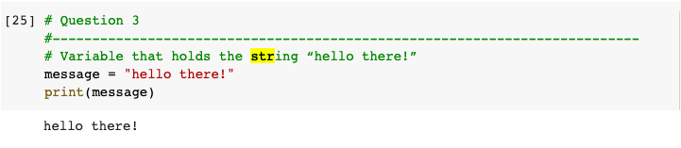

1. Create a variable for first name, last name and an email extension. Concatenating all three together to form an email address. For example: [firstnamelastname@gmail.com](mailto:firstnamelastname@gmail.com)

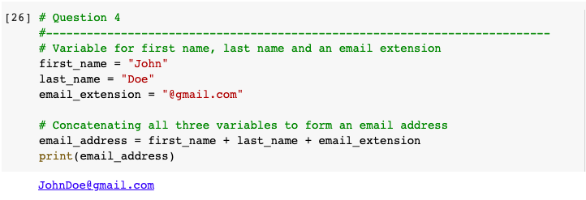

1. Store someone you know's name in a variable called name. Print their name in lower and uppercase using a method.

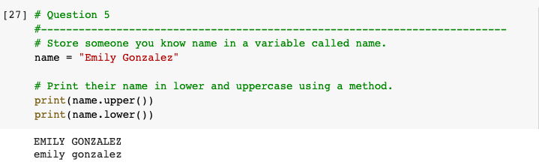

1. Using a variable, ask your friend if they want to hang out on the 15th of the month. For example, “Do you want to hang out on the 15th of this month?” You should have to convert the number to a string.

