Name: Basira Shirzad .

Lesson 3: Working with Lists

1. Create a list of 5 of your favorite tv shows.

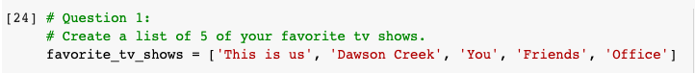

1. Print the list in its original order.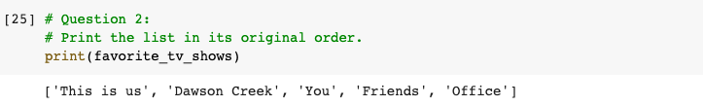
2. Use the sorted() function to print the list in alphabetical order. How is sorted() different from sort()?

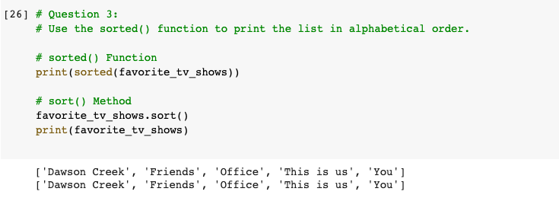

* The difference between the function sorted() and sort() is that sort() function modifies the list it is called on, while the sorted() function will create a copy of the list called on and will sort that copy and not the original list. So, it will return the sorted list of the copy version. The sort() function, however, sorts the original list and does not return anything back, it just modifies the original list.

1. Print out your original list.

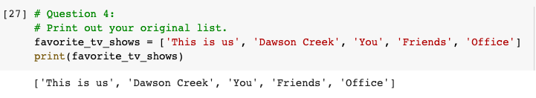

1. Used sorted() to print your list in reverse alphabetical order.

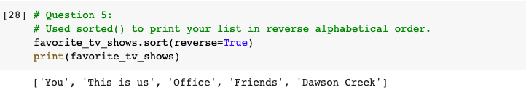

1. Create a message indicating how many favorite TV shows you have – use the len() function.

