Name: Basira Shirzad .

Lesson 4 – Looping

1. Create a list that holds 5 data variables.

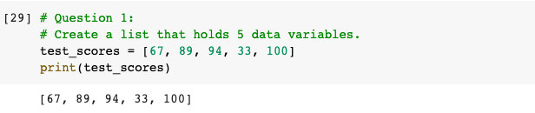

1. Print out those variables by using a for loop.

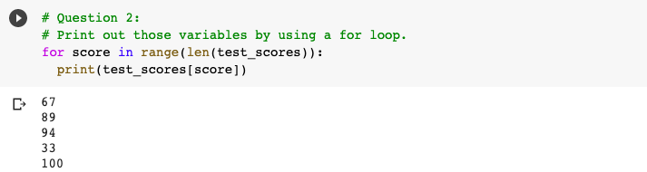

1. Modify your for loop to add a message to your for loop

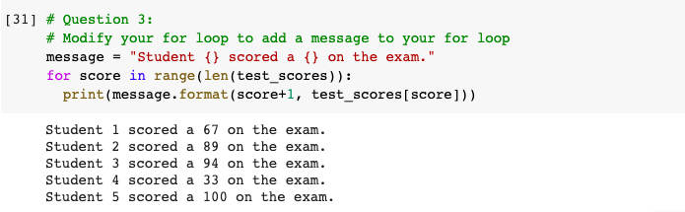

1. Use a for loop to print even numbers from 1-20.

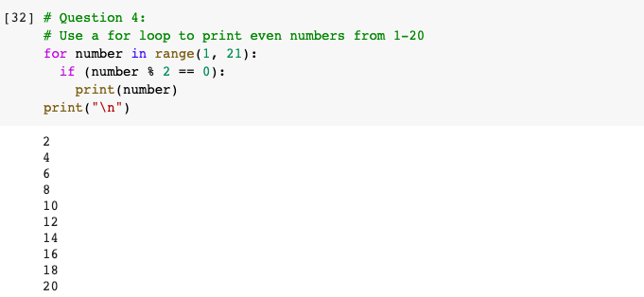

1. Sort your list in alphabetical order.

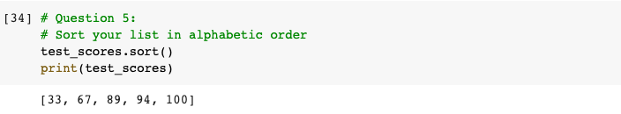

1. Print out the first three elements of your list.

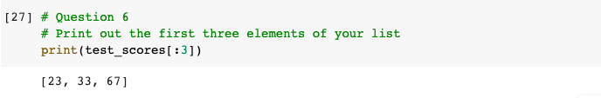

1. Create a loop to print the last 2 elements of your list.

