System Architecture — five-layer view: client → application → core services → data / integrations → infrastructure
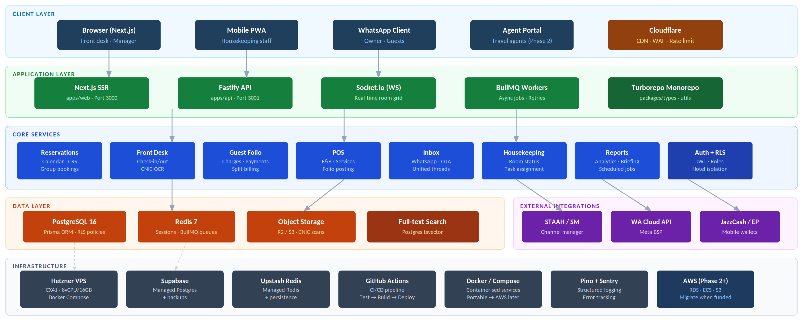
Technology Stack — canonical reference for all tooling decisions
Category Technology Description / Notes  Monorepo Turborepo + npm workspaces Shared build cache · apps/api · apps/web · packages/types · packages/utils  Frontend Next.js 14 (App Router) SSR + static, dashboard, housekeeping PWA · TypeScript · Tailwind · shadcn/ui  Backend Fastify (Node.js 20) REST API, WebSocket server, webhook handlers · TypeScript · Zod · domain modules  ORM Prisma Type-safe DB access, migrations · RLS enforced at Postgres level  Database PostgreSQL 16 Primary store, full-text search · Supabase (MVP) → AWS RDS (Phase 2)  Cache / Queue Redis 7 + BullMQ Sessions, pub/sub, async jobs, retries · Upstash (MVP) → ElastiCache later  Real-time Socket.io Live room grid sync · Redis adapter for multi-instance · Scoped by hotel_id  File Storage Cloudflare R2 / S3-compat CNIC scans, receipts, photos · S3-compatible API — change endpoint to migrate  Auth Custom JWT + bcrypt Access token + httpOnly refresh cookie · Roles: Owner, Manager, Front Desk, HK |  | Category Technology Description / Notes  Channel Mgr STAAH / SiteMinder (adapter) OTA availability + rate sync, booking webhooks · Adapter pattern, Phase 2  WhatsApp Meta Cloud API (BSP) Unified inbox, confirmations, owner briefing · ~$0.003/utility msg (PK)  Payments JazzCash · Easypaisa · 1Link Mobile wallet + bank transfer · Merchant onboarding runs in parallel with dev  OCR Google Vision API CNIC/passport scan → auto-fill guest profile · $1.50/1,000 units  CI/CD GitHub Actions Test → build → push Docker image → deploy · Secrets via GitHub Secrets / Doppler  Hosting (MVP) Hetzner CX41 + Supabase 4 vCPU/16 GB VPS + managed Postgres + Redis · ~$53/month · Docker Compose  Observability Pino + Sentry + BetterUptime Structured JSON logs, error tracking, uptime alerts · Grafana Loki in Phase 2  CDN / Security Cloudflare (Free → Pro) CDN, WAF, DDoS protection, rate limiting, SSL · Pro ($20/mo) at ~30 hotels
Key Architecture Principles
Modular Monolith  One repo, domain-separated modules. Extract to services only when a module needs independent scaling. | Adapter Pattern  STAAH, WhatsApp, JazzCash each sit behind an interface. Swap vendors by changing the adapter only. | Tenant Isolation  hotel_id on every table. Postgres RLS enforces data isolation at the DB level — app bugs can't leak. | Cloud-Portable  Docker Compose today, ECS/RDS tomorrow. All config via env vars. AWS is a deployment change, not code.

