HOTEL PMS
A Manager-First Operating System
for Independent Hotels in Pakistan

Concept & MVP Architecture
Investor Briefing Document
Target Market: 20–80 Room Hotels • Northern Pakistan
Hunza • Skardu • Naran • Swat • Gilgit

1. Executive Summary
Tourism in northern Pakistan is growing 20–30% year-over-year, and new independent hotels are opening monthly. Yet the vast majority operate on paper registers, WhatsApp groups, and spreadsheets. Existing local software is desktop-only and outdated. Foreign solutions like Cloudbeds and Oracle OPERA are priced in USD, lack Urdu support, and have no integration with Pakistani payment systems or tax compliance.
This document presents the concept for a cloud-based Property Management System (PMS) purpose-built for this market — a manager-first operating system that replaces the notebook and the WhatsApp group with a single trusted workspace. The product is designed for properties of 20 to 80 rooms, the segment most underserved by existing tools.

The Opportunity
- A growing tourism economy in Pakistan with no dedicated software backbone.
- Hundreds of small hotels in GB and KP regions running on manual systems.
- Existing tools fail on language, payments, taxation, and connectivity for this geography.
- First-mover advantage available with a 3–5 year window before well-funded foreign or regional competitors enter.

The Approach
- Web-based, manager-facing only. Guests do not interact with the system directly.
- Bookings enter from multiple channels — OTAs, WhatsApp, phone, walk-ins — and are managed in a single unified workspace.
- Pakistan-specific compliance, payments, and language are first-class concerns, not afterthoughts.
- MVP designed for delivery within 8 weeks, with a clear path to expansion.
Strategic Position
This is not a PMS competing on features. It is the operating system for an emerging tourism economy that does not yet have one. The PMS is the wedge; the long-term play is to become the data and transaction layer connecting hotels, travel agents, tour operators, and payment providers across the region.

2. Market and Problem

2.1 The Target Customer
Independent hotels with 20 to 80 rooms in northern Pakistan — Hunza, Skardu, Naran, Swat, Gilgit, and surrounding areas. These properties are typically family-owned, locally operated, and managed by a small team of 5 to 15 staff. The owner is often based in Islamabad, Lahore, or Karachi, while a local manager runs day-to-day operations.

2.2 How Hotels Operate Today
- Bookings arrive via WhatsApp, phone, Booking.com, and walk-ins — and are recorded in a paper register or Excel sheet.
- OTA bookings require manual re-entry into the local system, creating data silos and overbooking risk.
- Payments are split across cash, JazzCash, Easypaisa, and bank transfers — often with advance deposits and balance-at-checkout arrangements.
- Owners receive ad-hoc updates from managers via voice notes and screenshots, with no consolidated view of revenue, occupancy, or cash position.
- Tax compliance (FBR, provincial revenue authorities) is handled manually, often inaccurately, by accountants outside the hotel.
- Guest details required by law (CNIC capture, foreigner reporting) are recorded on paper and rarely structured for retrieval.

2.3 Why Existing Solutions Fail
Solution Type | Why It Fails for This Market
Foreign Cloud PMS | USD pricing, English-only, no JazzCash/Easypaisa, no FBR integration, no support for local OTAs or operational realities.
Local Desktop Software | Outdated, single-machine installs, no OTA integration, no mobile access, frequently pirated, abandoned by original developers.
Spreadsheets + WhatsApp | The de facto status quo. No transaction integrity, no audit trail, no reporting, lost messages, and frequent overbookings.

3. Product Architecture
The system follows a layered architecture with three primary functional layers, plus a cross-cutting compliance and localization layer that integrates throughout.

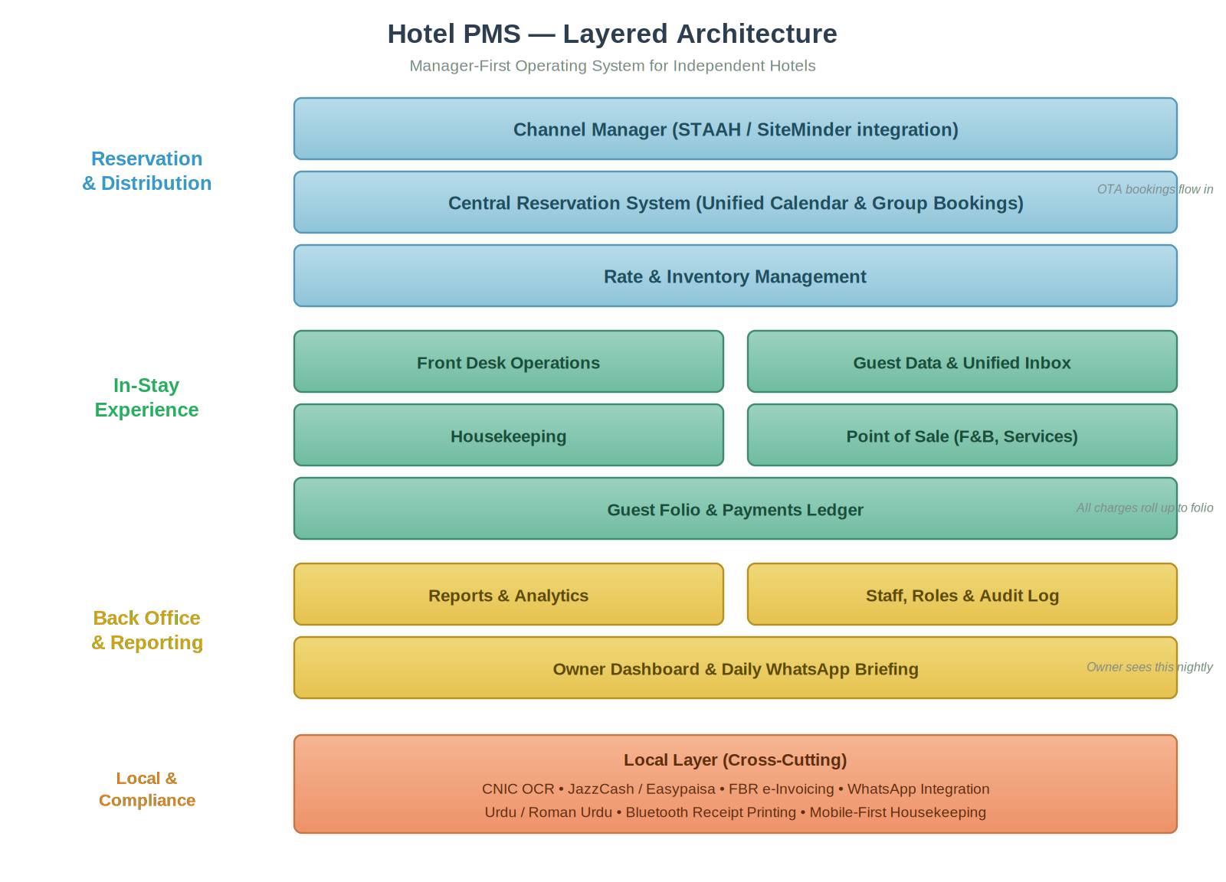
Figure 1: Layered architecture showing reservation/distribution, in-stay experience, back-office, and the cross-cutting local compliance layer.

3.1 Layer 1 — Reservation and Distribution
- Channel Manager Integration: Bookings from Booking.com, Agoda, Airbnb, and local OTAs flow in through a third-party channel manager (STAAH or SiteMinder) via API. We do not build the channel manager ourselves; we integrate as a reseller.
- Central Reservation System: A unified booking calendar that consolidates reservations from every source — OTAs, WhatsApp leads, phone calls, walk-ins — into one place. Supports individual and group bookings.
- Rate and Inventory Management: Per-room-type rates with seasonal overrides, minimum-stay rules, and inventory blocks for renovation or seasonal closure.

3.2 Layer 2 — In-Stay Experience
- Front Desk Operations: Drag-and-drop room grid for assignment and check-in, keyboard shortcuts for high-volume periods, and CNIC OCR to auto-fill guest data from a phone camera.
- Guest Data and Unified Inbox: Every guest has a single profile aggregating bookings, communications, and stay history. The unified inbox threads WhatsApp, OTA messages, and SMS by guest, not by channel.
- Housekeeping: Mobile-first interface for cleaning staff. Room status updates with photo capture for issue reporting. Designed to work on entry-level Android phones over 3G.
- Point of Sale: Restaurant, room service, and ancillary services charge directly to the guest folio. Simple single-screen interface, no complex menu hierarchies.
- Guest Folio and Payments Ledger: Every charge and payment posts to a per-stay ledger. Supports advance payments, split payments, third-party billing (tour operator pays, guest stays), and cash drawer reconciliation.

3.3 Layer 3 — Back Office and Reporting
- Reports and Analytics: Daily status, occupancy, ADR, RevPAR, channel performance, staff performance, and channel ROI. Custom scheduled reports delivered to owner via WhatsApp or email.
- Staff, Roles and Audit Log: Role-based access (owner, manager, front desk, housekeeping). Every action is logged for accountability and dispute resolution.
- Owner Dashboard and Daily WhatsApp Briefing: An automated nightly summary sent to the owner via WhatsApp — occupancy, revenue, cash position, tomorrow's arrivals, and any flagged anomalies.

3.4 Cross-Cutting — Local Compliance Layer
- CNIC and Passport Capture: Phone-camera OCR to auto-extract guest identity data. Required by law and a major time-saver at check-in.
- Payments: JazzCash and Easypaisa for mobile wallet collections; bank transfer reconciliation; card support where applicable.
- FBR e-Invoicing: Integration with the Federal Board of Revenue's electronic invoicing system. Certification process started early; full integration phased in over months 4 to 6.
- WhatsApp Integration: WhatsApp Business Cloud API as a first-class communication channel — for receipts, booking confirmations, owner briefings, and the unified inbox.
- Language Support: English UI for MVP, with Roman Urdu input accepted in all text fields. Full Urdu UI in Phase 2.

4. Integration Map
The PMS Core sits at the center of a network of external systems. All integrations are abstracted behind adapter interfaces, allowing vendors to be swapped without changes to the core application.

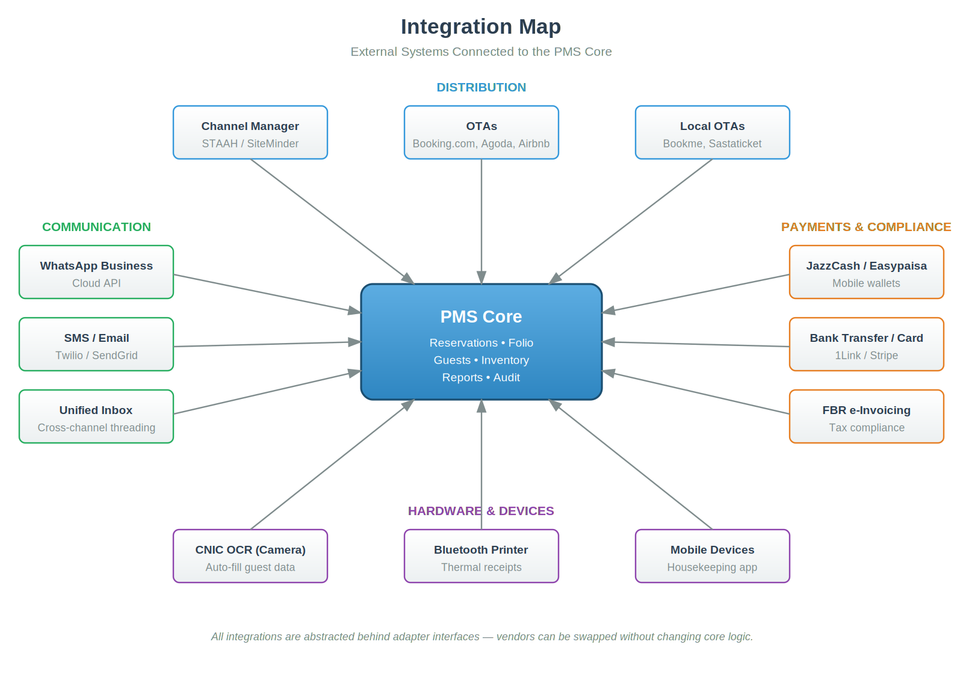
Figure 2: External integrations grouped by category — distribution, communication, payments and compliance, and hardware.

4.1 Integration Categories
Category | Systems and Purpose
Distribution | STAAH or SiteMinder as the channel manager middleware; Booking.com, Agoda, Airbnb as OTAs reached through it; Bookme.pk and Sastaticket.pk for local distribution.
Communication | WhatsApp Business Cloud API for messaging and notifications; SMS and email via Twilio and SendGrid as fallback channels; unified inbox threading across all channels.
Payments and Compliance | JazzCash and Easypaisa for mobile wallet payments; bank transfer reconciliation through 1Link; card payments via Stripe or local acquirers; FBR e-invoicing for tax compliance.
Hardware | Phone-camera OCR for CNIC and passport scanning; Bluetooth thermal printers for receipts; entry-level Android devices for housekeeping staff.

5. MVP Scope (8-Week Build)
The MVP is deliberately ruthless about what it includes. The goal is not to launch a complete PMS; it is to launch the smallest product that a manager will trust enough to retire the notebook. Every feature below is justified by direct contribution to daily manager workflow.

5.1 Core MVP Features
Module | MVP Capability | Why It's Critical
Reservation Calendar | Drag-and-drop room grid; create, edit, move, extend bookings visually | Visual hook that sells the demo
Booking Entry | Manual booking entry for OTA, WhatsApp, phone, walk-in sources; group bookings supported | Replaces paper register
Check-In / Check-Out | CNIC OCR via phone camera; auto-fill guest details; one-click check-in and check-out | Fastest manager win
Guest Folio | Line-item charges (room, food, services, taxes); advance and balance payments; cash drawer tracking | Replaces ledger book
Point of Sale | Single-screen POS for F&B and room service; charges roll up to folio automatically | Captures ancillary revenue
Unified Inbox | WhatsApp Business integration; thread by guest; quick reply templates; auto-link by phone number | Where the manager lives
Owner Briefing | Automated nightly WhatsApp summary — occupancy, revenue, cash variance, tomorrow's arrivals | Owner-side stickiness
Reports | Daily status report; monthly revenue report; channel mix; export to PDF and WhatsApp | Decision-making
Staff and Audit | Role-based access (owner, manager, front desk); complete audit log of all actions | Trust and accountability

5.2 Out of MVP Scope (Phase 2 and Beyond)
These are intentionally deferred. Adding them to the MVP would extend the timeline by 3 to 6 months and dilute the wedge.
- Direct OTA channel manager (use STAAH integration in MVP, build later only if economics justify it).
- Dynamic pricing and revenue management automation.
- Full housekeeping mobile app (paper checklist works for first cohort; build in Phase 2).
- Offline mode and local sync (cloud-only for MVP; revisit once real failure patterns are understood).
- Multi-property / hotel chain support.
- Full Urdu UI (Roman Urdu input is sufficient for MVP).
- AI-driven features beyond OCR (anomaly detection, reply suggestions come in Phase 2).

5.3 Build Timeline
Weeks | Milestone
1–2 | Core data model, authentication, reservation calendar with drag-and-drop, room grid
3–4 | Check-in/out flow with CNIC OCR, guest folio, payments ledger, basic POS
5–6 | WhatsApp integration, unified inbox, owner WhatsApp briefing, daily and monthly reports
7–8 | Audit log, role-based access, onboarding flow, pilot hotel deployment and training
Parallel | STAAH partnership conversations, FBR e-invoicing certification process, JazzCash merchant onboarding

The Killer Feature
Every night at 11pm, the owner receives a WhatsApp message — occupancy, revenue, cash variance, tomorrow's arrivals, any flagged issues. The owner is the buyer, often based far from the property. If this single message arrives reliably and accurately every night, the product sells itself through the buyer's natural communication channel.

6. Business Model

6.1 Primary Revenue: SaaS Subscription
Monthly per-property subscription with tiered pricing based on room count. Pricing is set in PKR, not USD, to align with local affordability and avoid currency-driven churn.
Tier | Target | Indicative Pricing
Starter | Up to 20 rooms | To be set during pilot phase
Growth | 21 to 50 rooms | To be set during pilot phase
Professional | 51 to 80 rooms | To be set during pilot phase

Note: Exact pricing will be finalized after pilot deployments validate willingness-to-pay. Annual billing will be offered at a discount to address seasonality.

6.2 Secondary Revenue Streams
- Setup and Onboarding Fees: One-time charge for on-site setup, data migration from spreadsheets, and staff training. Funds first-year operations.
- Payment Processing Take-Rate: A small percentage of transactions processed through integrated payment rails. Scales with hotel revenue rather than seat count.
- Channel Manager Reselling: Margin on STAAH or SiteMinder subscriptions sold through us.
- WhatsApp Business API: Resell verified WhatsApp Business numbers with monthly fees per property.

6.3 Future Revenue (Phase 3 and Beyond)
- Tour Operator and Travel Agent Marketplace: Transaction fee on bookings made by agents and operators against hotel inventory.
- Tourism Data Products: Anonymized occupancy and demand data sold to tourism boards and ecosystem partners.
- Embedded Financial Services: Referral revenue from microfinance partners offering working capital loans based on verified booking data.

6.4 Unit Economics Logic
The economic logic is straightforward: SaaS subscription covers cost-to-serve; payment take-rate and ancillary revenue drive margin expansion as customers grow. Once 200 to 500 properties are on the platform, marketplace and data products become viable additional layers without requiring proportional increases in headcount.

7. Competitive Position

7.1 Why a Foreign Entrant Cannot Easily Win Here
- Language and Cultural Fit: Urdu and Roman Urdu support, local idioms in templates, owner briefings designed for WhatsApp habits — none of which a Cloudbeds or Mews will prioritize for this market size.
- Local Payment Rails: JazzCash, Easypaisa, 1Link, and FBR e-invoicing are non-trivial integrations that require months of local relationship-building and certification.
- Boots-on-Ground Distribution: Onboarding small hotels in Hunza and Skardu requires physical presence and trust. A foreign player will not send a product manager to Karimabad.
- Local OTA Coverage: Bookme.pk, Sastaticket.pk, and emerging regional booking platforms — outside the scope of global channel managers.

7.2 Building Long-Term Defensibility
- Travel Agent Network: A platform where Karachi and Lahore travel agents book inventory directly creates two-sided network effects. Hotels cannot leave without losing distribution.
- Regulatory Integration: Official certification with FBR, KP and GB Tourism Departments, and provincial revenue authorities creates real entry barriers that take a year or more to replicate.
- Shared Data Network: A cross-property database of problem guests, no-show patterns, and demand signals — valuable only to participants, sticky as it grows.
- Proprietary Tourism Data: Two years of booking data across the region produces demand forecasts no competitor can match without operating history.
What Is Not the Moat
Features, design, and price are all copyable within 6 months. The moat is local presence, regulatory relationships, the travel-agent network, and accumulated data. The MVP earns the right to build these; it is not the moat itself.

8. Risks and Mitigations
Risk | Mitigation
Manager Resistance — managers may skim cash or under-report; transparency threatens them | Design features that make the manager's job easier; performance dashboards that help them look good to the owner; not just owner-side transparency
Seasonality — hotels earn 70% of revenue May–September and resist winter SaaS fees | Annual contracts with discounts; seasonal pricing aligned with hotel cash flow; pre-payment incentives
OTA API Access — Booking.com and Expedia certifications take months | Use STAAH as the certified intermediary in MVP; start direct OTA partnership applications in parallel with development
Offline Sync Complexity — internet is unreliable in northern regions | Cloud-only MVP with optimized 3G performance; offline mode added in Phase 2 after observing real failure patterns
Piracy of On-Premise Versions | Cloud-only architecture with no desktop installer; server-side license validation; subscription-based access
Regulatory Whiplash — FBR and provincial tax rules change frequently | Dedicated ongoing engineering capacity for compliance; partnerships with local tax consultants; flexible tax configuration
Adoption Friction — older owners and staff resistant to digital tools | In-person onboarding and training for first cohort; mobile-friendly interfaces; WhatsApp-native workflows that mirror existing habits

9. Go-to-Market Approach

9.1 Pilot Phase (Months 1–3)
- Recruit 3 to 5 design-partner hotels in Hunza and Skardu, selected for diversity of size, ownership style, and operational maturity.
- Free or heavily discounted access in exchange for weekly feedback sessions and the right to use their name in marketing.
- In-person onboarding and training — the founder personally drives to each property, sets up the system, trains staff over two days.
- Weekly product iteration cycle based on real usage data and direct manager feedback.

9.2 Early Growth (Months 4–9)
- Expand to 20 to 30 paying properties across Hunza, Skardu, Naran, and Swat.
- Hire one in-region customer success person who can drive between properties for onboarding and support.
- Launch travel agent portal beta with 10 to 20 agents in Karachi, Lahore, and Islamabad.
- Complete FBR e-invoicing certification.
- Begin payment processing integration to capture take-rate revenue.

9.3 Scale Phase (Months 10–18)
- Target 100+ properties across northern Pakistan and select Punjab and Sindh tourist destinations (Murree, Bahawalpur, Hyderabad).
- Launch full travel agent and tour operator marketplace.
- Begin tourism board data product conversations with GB Tourism Department and KP Tourism.
- Evaluate expansion to AJK and Balochistan.

10. Future Work and Roadmap
The MVP establishes the wedge. The features below define what the product becomes over the following 12 to 24 months as the customer base grows and additional revenue streams are unlocked.

10.1 Phase 2: Operational Depth (Months 3–9)
- Housekeeping Mobile App: Dedicated Android app for cleaning staff with room status, photo issue reporting, and supervisor task assignment.
- Maintenance Module: Ticket system for property maintenance — geysers, generators, water tanks. Asset registry and preventive maintenance schedules.
- Group Bookings and Tour Operators: First-class support for tour operator-managed group bookings with rooming lists, split payments, and tour-operator-as-payer billing.
- Driver and Vehicle Management: Pickup and drop scheduling, driver rosters, vehicle assignments — important for hotels running their own transport from Gilgit and Skardu airports.
- Special Branch / Police Reporting Automation: Automated foreign guest reporting required by law in GB and KP.
- Reviews Management: Pull and consolidate reviews from Booking.com, Google, and other sources. Alert managers to negative reviews.
- Full Urdu UI Toggle: Complete Urdu interface for staff who prefer it.

10.2 Phase 3: Revenue Optimization (Months 9–15)
- Dynamic Pricing and Revenue Management: Seasonal rate rules, demand-based pricing recommendations, competitor rate tracking, festival surge pricing for Eid and peak tourism windows.
- Direct OTA Integrations: Direct connections to Booking.com and Agoda for top-volume properties, bypassing the channel manager fee for those flows.
- Upsell Engine: Front-desk prompts at check-in for tour packages, room upgrades, and ancillary services.
- Multi-Property Management: Single login spanning multiple properties for hotel owners and small chains.
- Offline Mode: Local sync with conflict resolution for areas with persistent connectivity issues.

10.3 Phase 4: Ecosystem and Platform (Months 12–24)
- Travel Agent and Tour Operator Marketplace: Two-sided platform where agents book inventory and operators co-create itineraries with hotels.
- Porter and Guide Registry: For trekking-focused properties — rosters, rates, availability, and payment tracking.
- Tourism Board Data Products: Anonymized regional occupancy and demand reports sold to government tourism authorities.
- Working Capital Lending Referrals: Partnership with microfinance institutions to offer working capital loans backed by verified booking data.
- AI Operational Assistant: Anomaly detection in operations, draft replies for the unified inbox, voice-to-text staff notes, smart search across guest communications.
- Hotel Supplies Marketplace: B2B procurement for toiletries, linens, kitchen supplies — leveraging hotel consumption data.

10.4 Long-Term Vision
The endgame is not to be Pakistan's PMS — it is to be the operating system of the regional tourism economy. The PMS is the wedge that brings hotels onto the platform. From there, the platform becomes the system of record for travel agents, tour operators, payment flows, and tourism data — a position no foreign incumbent can replicate without years of local presence.

Summary
An 8-week MVP solves the immediate pain — replacing notebooks, WhatsApp groups, and overbookings with a single trusted workspace. The 12-month plan turns that wedge into a marketplace. The 24-month plan turns the marketplace into an ecosystem moat.

11. Closing Note
This document presents a deliberately constrained MVP scope — what can be built in 8 weeks and put into the hands of real hotels in northern Pakistan. The constraint is intentional. Most PMS startups die from feature sprawl before they learn what their users actually need. The plan is to ship a small, sharp product, get it onto real properties, and iterate from real usage rather than imagined requirements.
The opportunity is large enough to justify the effort. The market is unserved. The competition is a paper register and a WhatsApp group. The window is open.

Hotel PMS — Investor Concept Document

