**Q.1)**  **what is SEO? And explain the 3 factor that leads to success or failure in SEO?**

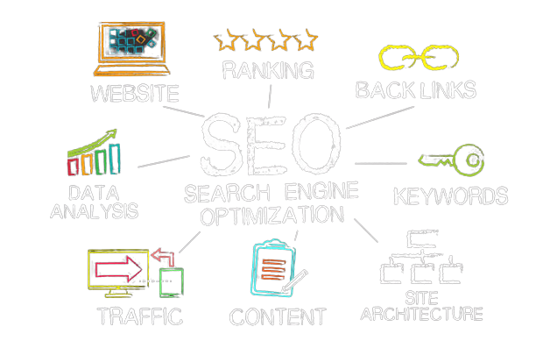**Ans.1) SEO, or search engine optimization, is the process of optimizing websites so that they rank well on search engines through organic (non-paid) searches. This is one of the most crucial marketing strategies for any business.**

[**https://searchengineland.com/guide/what-is-seo**](https://searchengineland.com/guide/what-is-seo)

* **The 3 Key Factors to Be Successful With SEO**

**1. A willingness to invest enough to truly compete with the growing competition**

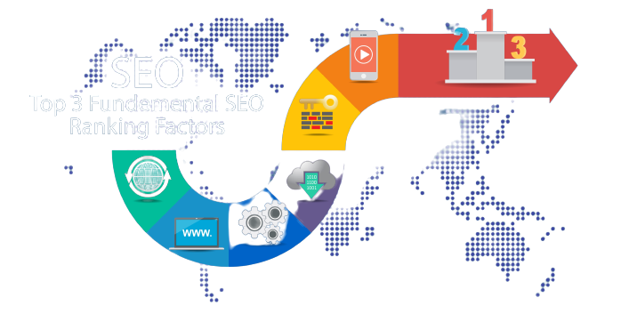**2. A focus on a healthy mix of SEO tactics**

**3. The dedication to overcome inevitable setbacks along the way to the coveted #1 Google ranking.**

[**https://www.mainstreetroi.com/3-key-factors-to-be-successful-with-seo/**](https://www.mainstreetroi.com/3-key-factors-to-be-successful-with-seo/)

**Q.2)**  **How Google’s Search Engine Works to rank Website?**

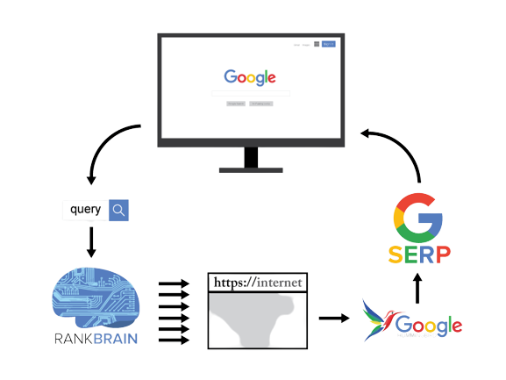**Ans.2)** **To rank websites, Google uses web crawlers that scan and index pages. Every page gets rated according to Google’s opinion of its authority and usefulness to the end-user. Then, using an algorithm with over 210 known factors, Google orders them on a search result page.**

[**https://morningscore.io/how-does-google-rank-websites/**](https://morningscore.io/how-does-google-rank-websites/)

**Q.3)**  **Describe and Illustrate Organic and Paid SEO?**

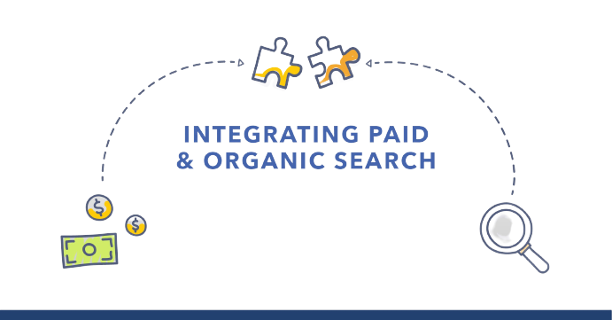**Ans.3)** **The difference between organic searches vs. paid search is simple: it’s the cost.**

**While organic search focuses on unpaid rankings in search results, paid search focuses on paid rankings. With organic search, companies use SEO to optimize their site’s visibility or rankings in search results. In comparison, paid search allows users to pay for a prominent spot in search results.**

[**https://www.webfx.com/seo/learn/organic-search-vs-paid-search/**](https://www.webfx.com/seo/learn/organic-search-vs-paid-search/)

**Q.4)** **Why do companies and individual ecommerce business need SEO?**

**Ans.4) E-commerce business SEO is the way toward making your online store more apparent in the search engine result pages (SERPs). At the point when individuals look for items that you sell, you need to rank as exceptionally as could be expected so you get more traffic.**

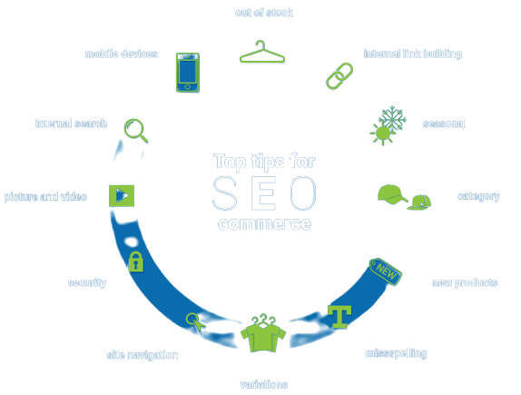**SEO is that magic that can transform your small business into a well-known one. It can maximize the profitability of your website with simple strategies that you can implement on your website. A good ecommerce SEO optimization agency will help your website improve online visibility on the search engines. Having you can expect many leads in your sales** [**https://resources.c2corner.com/booster-blogs-en/why-is-seo-important-for-your-ecommerce-business**](https://resources.c2corner.com/booster-blogs-en/why-is-seo-important-for-your-ecommerce-business)

**Q.5)**  **What are Search Engines looking for? List and describe seven (5) of them such as &quot;Quality&quot; of Content?**

**Ans.5) SEO has never been more important. If your business doesn’t show up in a relevant Google search, for customers, it may as well not exist. People explore the internet through search engines and to stay on their radar, companies should build a robust search engine optimization (SEO) strategy.**

* **Relevancy**
* **Quality of content**
* **User experience**
* **Speed**
* **Compatibility**
* **Internal linking**
* **Backlinks**
* **Meta descriptions**
* **Schema markup**
* **Image tagging**
* **Evergreen content**
* **Fresh content**
* **Pillar pages**
* **YouTube descriptions**
* **Long-tail keywords in title tags**
* **Unique content ideas**

**Relevancy**

**Search engines are becoming smarter, and they try to provide the most updated and relevant information to their users. Whether it’s a simple question or a more complex query, search engines will always try to filter the best information out there that matches the user’s intent.**

**Quality of Content**

**If content is king, then quality is the army. A king with a weak army is vulnerable while a strong army strengthens the king’s reign. . It affects the overall user experience and that’s really important to search engines.**

**User Experience**

**User experience, in short, is how a visitor actually feels when they are on your website. The overall site design, color combination, navigation, website speed, and content contribute to the user experience.**

**Speed**

**Website speed wasn’t so important a few years back but with the core webs vitals update, how fast your website loads can be a deciding factor in terms of SEO.**

**Schema Markup**

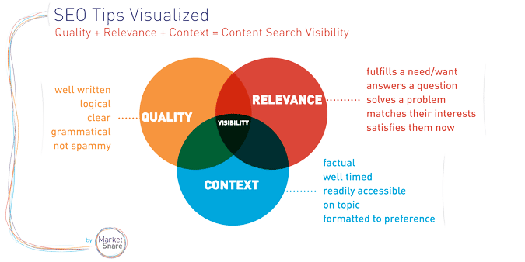**Schema markup is really important for SEO, because it provides another way to help Google understand and index your content. By providing structured data describing the nature of the information, the goals, the format, etc., the bots are more likely to understand your page properly and show it in relevant searches.**

[**https://devrix.com/tutorial/search-engines-looking-16-facts-seo-need-right-now/**](https://devrix.com/tutorial/search-engines-looking-16-facts-seo-need-right-now/)

**Q.6) Describe and Discuss - Keywords, Keyword Phases and why are they important and how do they impact SEO and web content?**

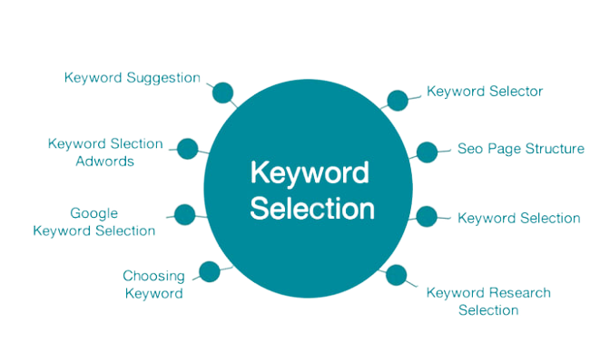**Ans.4)** **Keywords are ideas and topics that define what your content is about. In terms of SEO, they're the words and phrases that searchers enter into search engines, also called "search queries." If you boil everything on your page — all the images, video, copy, etc. — down to simple words and phrases, those are your primary keywords**

**Keywords are important because they are the linchpin between what people are searching for and the content you are providing to fill that need. Your goal in ranking on search engines is to drive organic traffic to your site from the search engine result pages (SERPs), and the keywords you choose to target (meaning, among other things, the ones you choose to include in your content) will determine what kind of traffic you get. If you own a golf shop, for example, you might want to rank for "new clubs" — but if you're not careful, you might end up attracting traffic that's interested in finding a new place to dance after dark.**

[**https://moz.com/learn/seo/what-are-keywords**](https://moz.com/learn/seo/what-are-keywords)

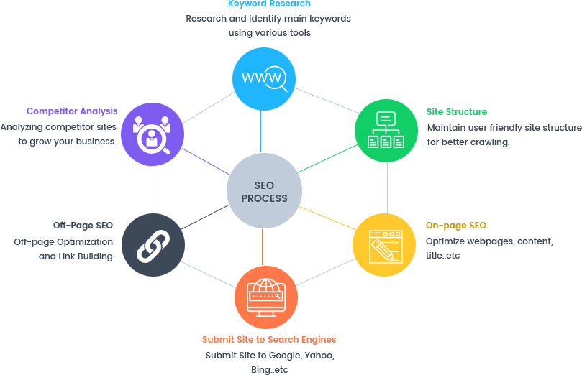**Over the years Google’s search algorithms continue to evolve. Pay close attention to these changes, since they tell you how to get on Google’s good side and help your pages be in top spots on the SERPs.**

**SEO content is not just any content, it needs to be high-quality and useful to the visitor. User experience is an important factor in how Google decides which content should rank in the search engines for top positions. Unfortunately, there’s a lot of bad content on the internet.**

[**https://moz.com/learn/seo/what-are-keywords**](https://moz.com/learn/seo/what-are-keywords)