**User Guide for the Project**

**Visualizing the effect of temperature, fossil fuels on Climate Change**

By Team N

Abdul Basith Mohammed (T00700187)

Raheem Mohammed (T00702587)

Shanavaz Mohammad (T00683492)

Murtuza Hussain Ghouri Mohammed (T00701906)

Contents

Software Requirements: 2

Data: 2

Raw Data 2

Processing the raw data: 2

Clean Data: 3

Visualizations: 3

Visualizing in Tableau: 3

Visualizing in Dash: 4

Visualizing in Treemap-4.1.2: 6

Visualizing in PowerBI: 7

# **Software Requirements:**

1. Anaconda3 (for Python and Spyder).
2. Plotly dash library
3. Tableau
4. PowerBI
5. Treemap-4.1.2 (Java is Pre-requisite)

# **Data:**

## **Raw Data**

The data for this project was taken from the below websites.

1. Food and Agriculture organization (FAO) of the United Nations’ Temperature change

<https://www.fao.org/faostat/en/#data/ET>

1. World bank’s Fossil fuel energy consumption

https://data.worldbank.org/indicator/EG.USE.COMM.FO.ZS

[https://www.fao.org/faostat/en/#data/ET](https://www.fao.org/faostat/en/)

## **Processing the raw data:**

1. Used Python (Pandas) to process the data initially.
2. Later used Microsoft Excel to clean the data.

The python code is present in the following Jupyter Notebooks under “Python_Notebooks” folder.

1. Files present in the **Data\Raw_Data** folder were processed by using the below Notebooks.
   1. Fossil_Fuel_DP.ipynb – Used for processing the fossil fuel raw data.
   2. Temp_Change_DP.ipynb – Used for processing the Temperature change raw data.
2. The processed files were kept under the folder **Data\Processed_Data**, further processed using Microsoft Excel.
3. Countries_Grouping.xls data was used by us for categorizing the countries as Developed and Developing economies.
4. Only the data from 1981 to 2014 was used because it was consistent.
5. The average of every year was considered for creating the graphs.

## **Clean Data:**

The clean data which can be used for visualization is placed under the folder **Data\Clean_Data** by representing the task names.

# **Visualizations:**

## **Visualizing in Tableau:**

Below are the steps for visualizing the clean data in the Tableau.

1. Open Visuals\Tableau\**Info_Viz_Project.twbx** in Tableau Desktop. You will be able to see the below dashboard. 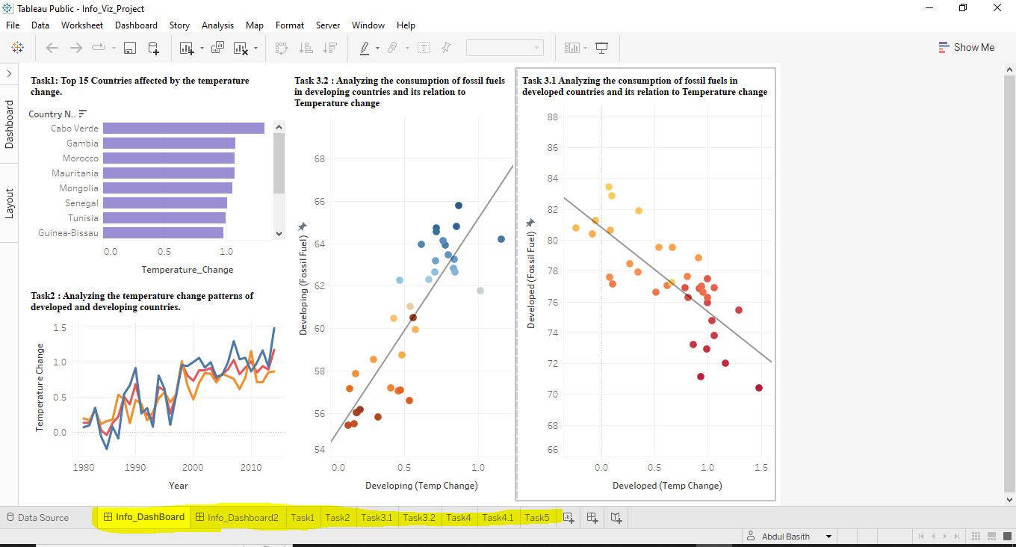
2. Here you can see there are two dashboards and many different tasks. You can navigate to all the tasks and dashboards to go through the visuals.

**Note:** Tableau Public 2022.2 was used to develop and test this tableau project.

## **Visualizing in Dash:**

***Installing the dash library.***

Open Anaconda Prompt and run the below commands to install dash if you do not have it already installed.

*pip install dash (Mandatory)*

*pip install jupyter-dash (Recommended)*

*pip install pandas (Recommended)*

For more info regarding installation. Please visit <https://dash.plotly.com/installation>

***Running the program:***

1. Open the python file “**Visuals\Dash\Info_Viz_Project.py**” in Spyder.
2. Run it.
3. Open any browser such as Google Chrome, Microsoft Edge etc.,
4. Enter the URL <http://127.0.0.1:8050/> in the address bar.
5. You should see the interactive visuals as the webpage.

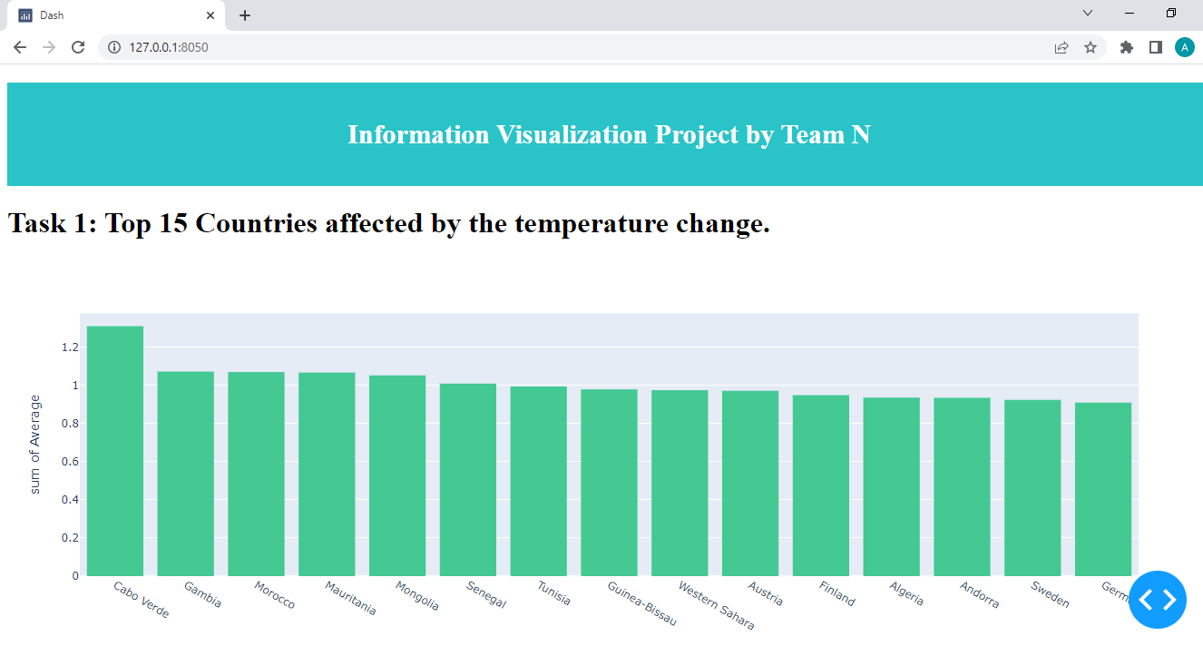

Note:

1. All the excel files required to run the code are present in Visuals\Dash folder.
2. If you are unable to load the page, it may be due to some other port being assigned to your webpage. So, please look for the address on which your site is running on the right-hand bottom side as indicated below screenshot.

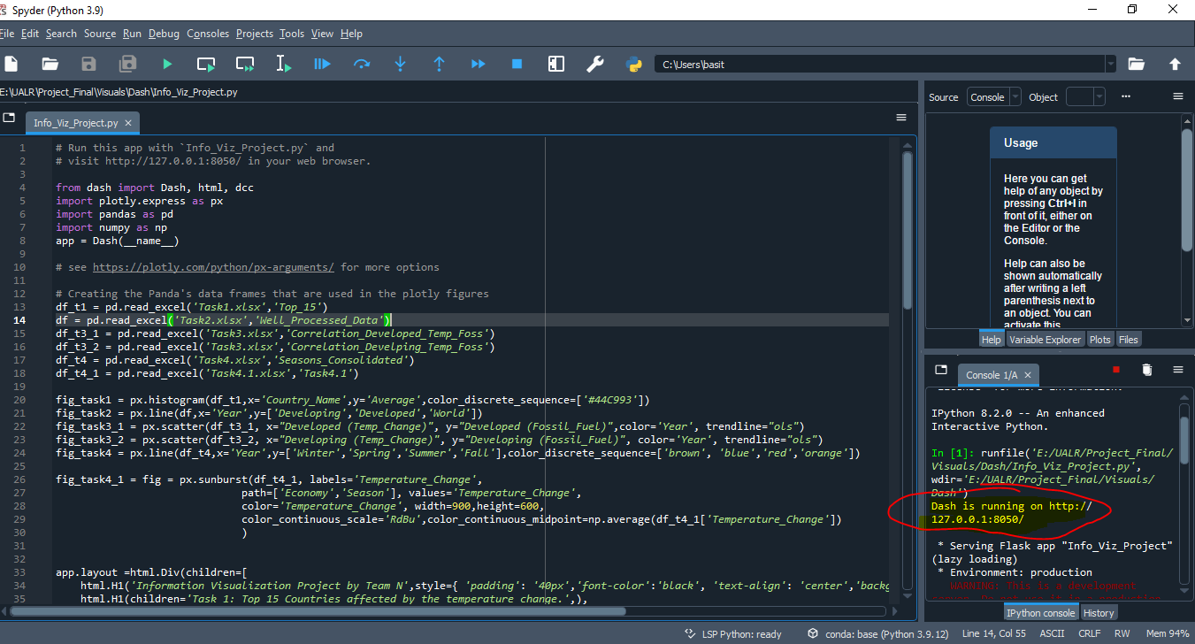

1. The pdf of the webpage is placed under the root folder\Info_Viz.pdf for the quick reference.

## **Visualizing in Treemap-4.1.2:**

**For Task4.1:**

Goto the folder **Visuals\Treemap-4.1.2,** run the file treemaps.jar🡪Agree. Select “Treemap-4.1.2\data\task4.1.tm3” as data file for task 4**.** To apply the configuration, Click on **File🡪Open🡪task4.1.tms🡪OK.** You should be able to see below screenshots.

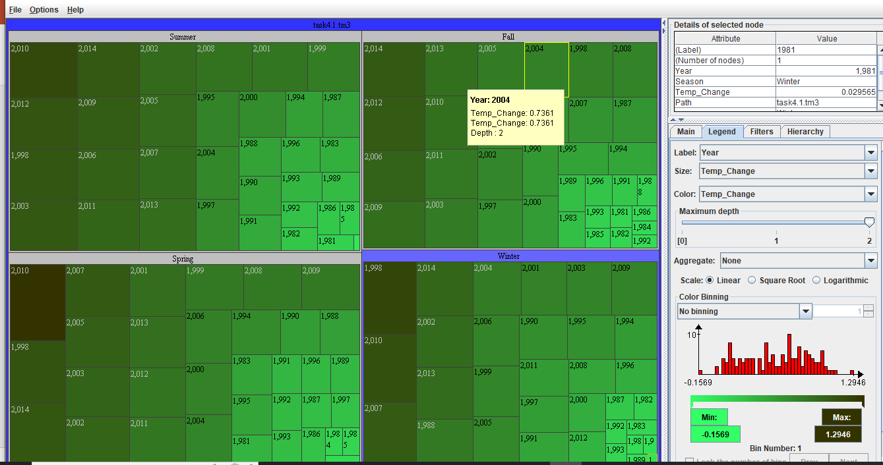

**For Task 5:**

Click on **File🡪Open🡪** **Treemap-4.1.2\data\Task5.tm3🡪OK,** “Task5.tm3” as data file for task 5**.** To apply the configuration, Click on **File🡪Open🡪Treemap-4.1.2\data\Task5.tms🡪OK.** You should be able to see below screenshots.

**(OR)**

Goto the folder **Visuals\Treemap-4.1.2,** run the file treemaps.jar🡪Agree. Select “Treemap-4.1.2\data\Task5.tm3” as data file for task 5**.** To apply the configuration, Click on **File🡪Open🡪Treemap-4.1.2\data\Task5.tms🡪OK.** You should be able to see below screenshots.

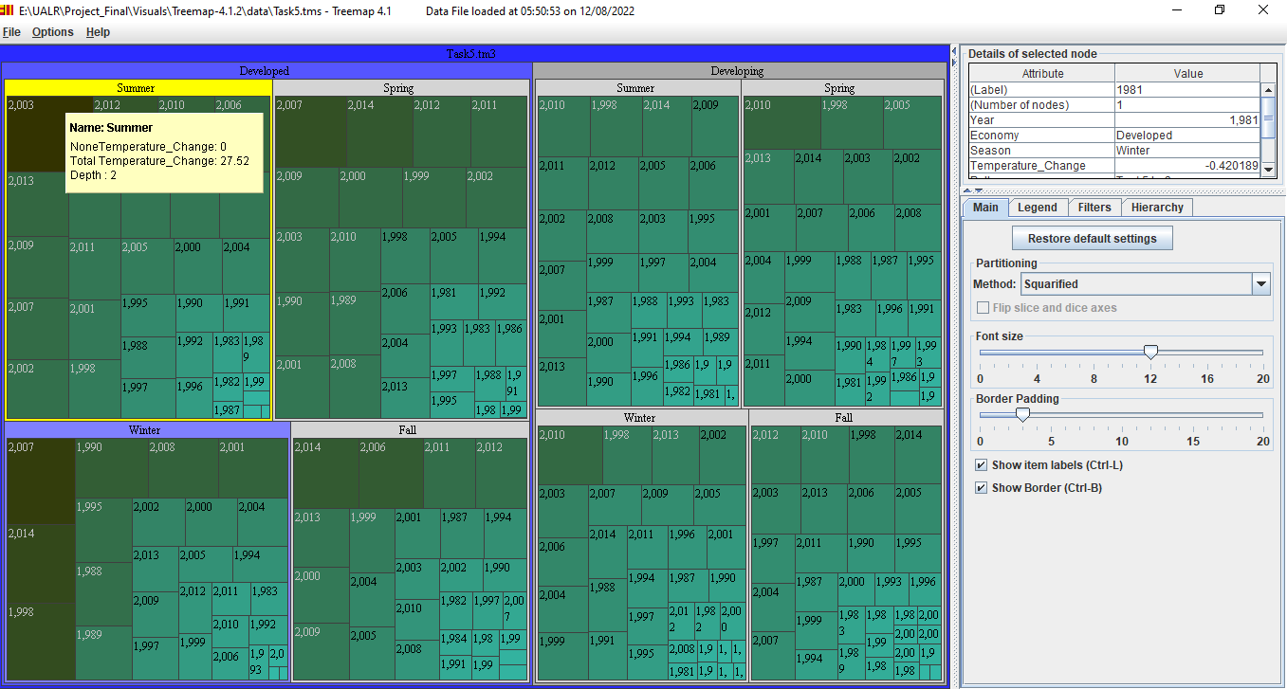

Note: You will have to install Java Runtime Environment on your workstation to rum Treemap-4.12

## **Visualizing in PowerBI:**

Below are the steps for visualizing the clean data in the PowerBi.

1. Open Visuals\PowerBi\ **Info_Viz_Project.pbix** in PowerBi Desktop. You will be able to see the below dashboard.

1. Here you can see there are two dashboards and many different tasks. You can navigate to all the tasks and dashboards to go through the visuals.

**Note:** PowerBi Public Version: 2.111.590.0 64-bit was used to develop and test this PowerBI project.