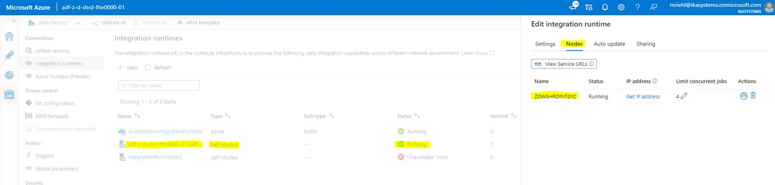

**Azure VM with the Runtime installed:**

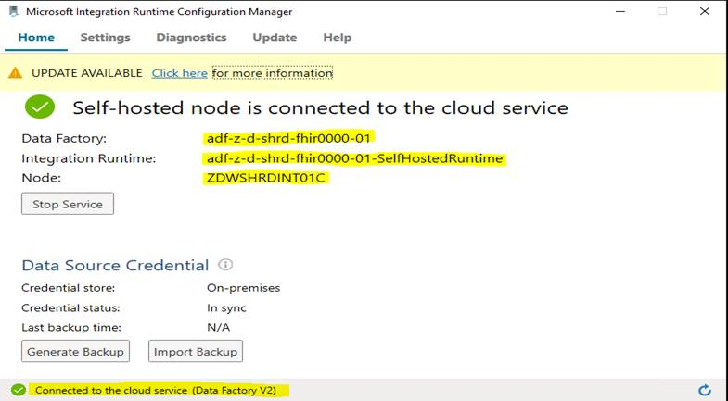

**On the Runtime Server you will need to install the following:**

1. Self Hosted Integration Runtime (Downloaded from ADF)
2. Oracle Client
3. Update TNSNAMES.ora file with the Oracle connection string

**TNSNAMES.ora Connection String: (located at F:\oracle\product\12.1.0\client_64\network\admin)**



**Oracle client Installation Link:**

[Application Setup Documentation - Cloud Operations - Knowledge Center (advantasure.com)](https://confluence.advantasure.com/display/DCO/Application+Setup+Documentation?preview=%2F107216625%2F107216683%2FOracle+Client+Installation+%26+Testing.docx)

**App Service Plans that have been created per Environment:**

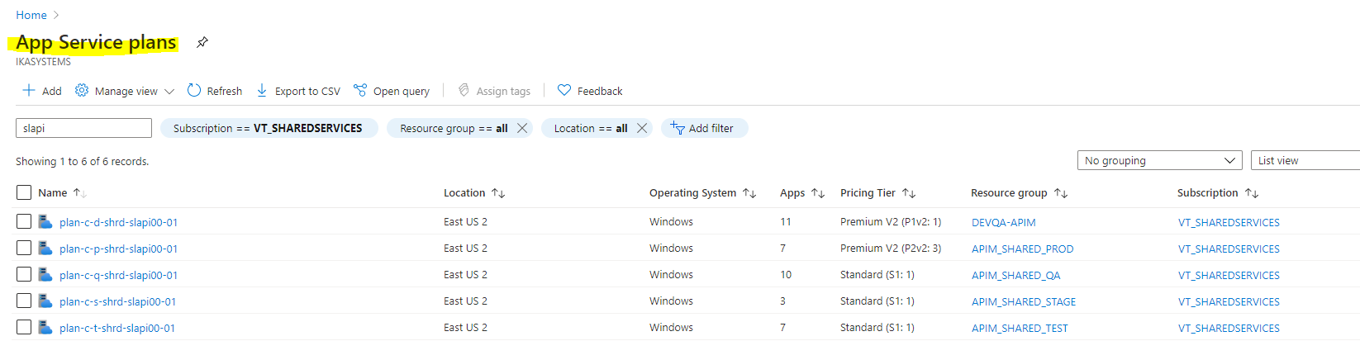

**Attached Documents:**

1. Sample Build Sheet
2. App Service Build Instructions

If you have any other questions or if I missed something we discussed please let me know.

Thanks,