**HANDSON TRIGGERS**

**Tables: Features, Sales, Stores**

**DML Triggers:**

The DML Trigger performs an event in Insert, Update or Delete commands in a **table or view**.

1. **Create a insert trigger for the Sales table.**

**//Insert Trigger Creation**

create trigger trigger_insert on Sales

after insert

as

begin

PRINT'YOU HAVE INSERTED A ROW'

end

**//To view the trigger activation**

insert into Sales values (9,4,'04-11-2012',15670.50,'FALSE')

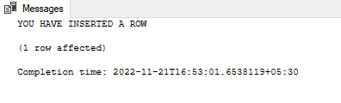

1. **Create a update trigger in Stores table.**

**//Update Trigger Creation**

create trigger trigger_update on Stores

after update

as

begin

PRINT'YOUR RECORD HAS BEEN UPDATED!'

end

SELECT * FROM [dbo].[Stores]

**//To view the trigger activation**

UPDATE Stores set Type='A' where Store =1

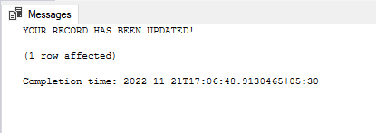

1. **Create a delete trigger in Features table.**

**//Delete Trigger Creation**

create trigger trigger_delete on Features

after delete

as

begin

PRINT'YOUR RECORD HAS BEEN DELETED!'

end

select * from [dbo].[Features]

**//To view the trigger activation**

delete Features where Temperature='38.51'

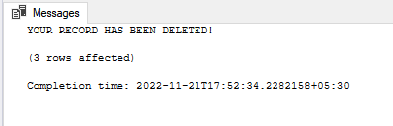

**DDL Triggers:**

The DDL Trigger performs an event in Create, Alter or Drop commands in a **database**.

1. **Create a create trigger for your database.**

**//Create Trigger Creation**

create trigger create_trigger

on database

after create_table

as

begin

Print 'Table Created'

End

**//To view the trigger activation**

create table sample_table (id int)

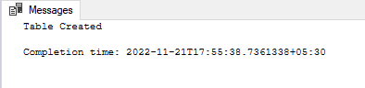

1. **Alter a create trigger from your database to drop trigger.**

**//Altering Create Trigger to Drop Trigger**

alter trigger create_trigger

on database

after drop_table

as

begin

Print 'Table Dropped'

End

**//To view the trigger activation**

drop table sample_table

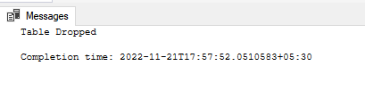

1. **Create a alter trigger for your database.**

**//Alter Trigger Creation**

create trigger alter_trigger

on database

after alter_table

as

begin

Print 'Table Altered'

end

**//To view the trigger activation**

alter table sample_table

alter column id varchar(5)

