M S BASKARAN - FSD - B52WD2 TAMIL

Javascript Day 3 Task

horizontal line

# **1.To compare two JSON properties are same or not**

## Code:

// Task day 3 question 1

// To compare two JSON properties

let obj1 = {

name : "Person 1",

age : 5

};

let obj2 = {

age : 5,

name : "Person 1"

};

// the above two objects are unorder with same property

// we need to campare there keys~

//console.log(obj1, obj2);

let key1 = Object.keys(obj1).sort();

let key2 = Object.keys(obj2).sort();

//console.log(key1, key2);

let object1 = JSON.stringify(key1);

let object2 = JSON.stringify(key2);

//console.log(object1, object2);

if(object1 === object2){

console.log("The given two JSON are EQUAL")

}

else{

console.log("The given two JSON are NOT EQUAL")

}

## Output:

“Two JSON are EQUAL”

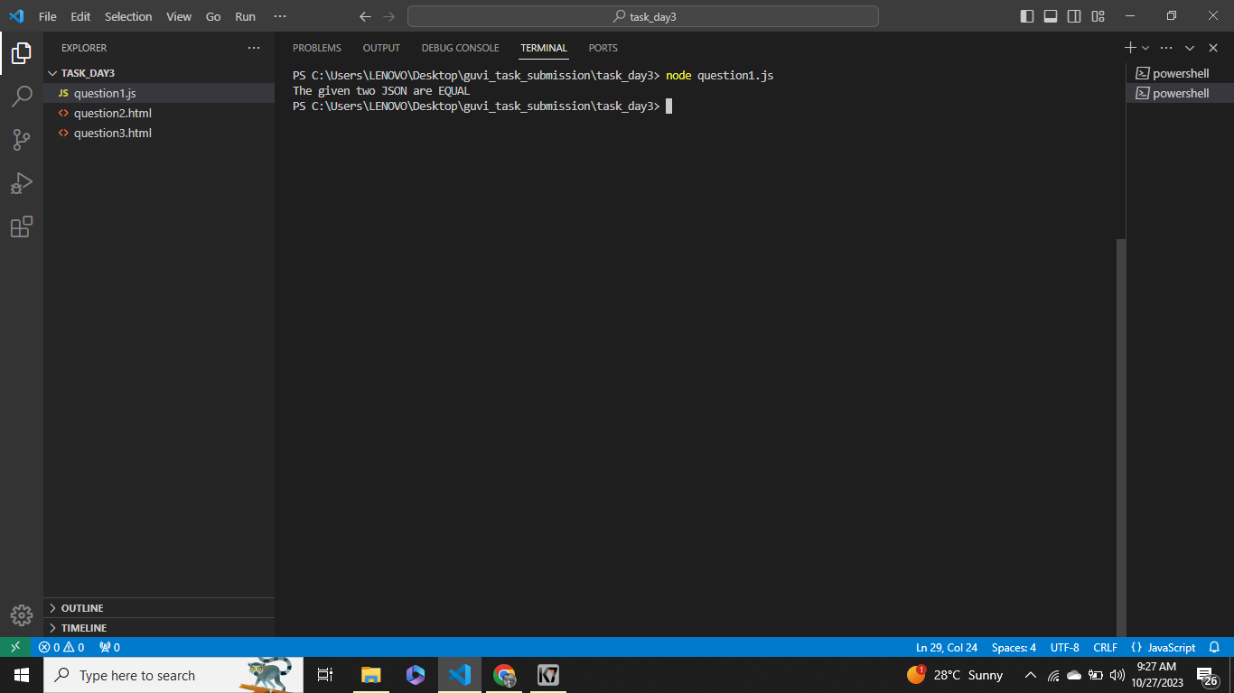

# **2.To print all country flags**

## Code:

<!DOCTYPE html>

<html lang="en">

<head>

<meta charset="UTF-8">

<meta name="viewport" content="width=device-width, initial-scale=1.0">

<title>DAY 3 TASK</title>

</head>

<body>

<h1><b>XMLHttpRequest</b></h1>

<h2><b>To print all country flags in console</b></h2>

<script>

let my = new XMLHttpRequest();

my.open('GET', 'https://restcountries.com/v3.1/all');

my.send();

my.onload = function(){

let a = JSON.parse(my.responseText);

for(let i = 0; i<a.length; i++){

console.log(a[i].flags.png)

}

};

</script>

</body>

</html>

## Output:

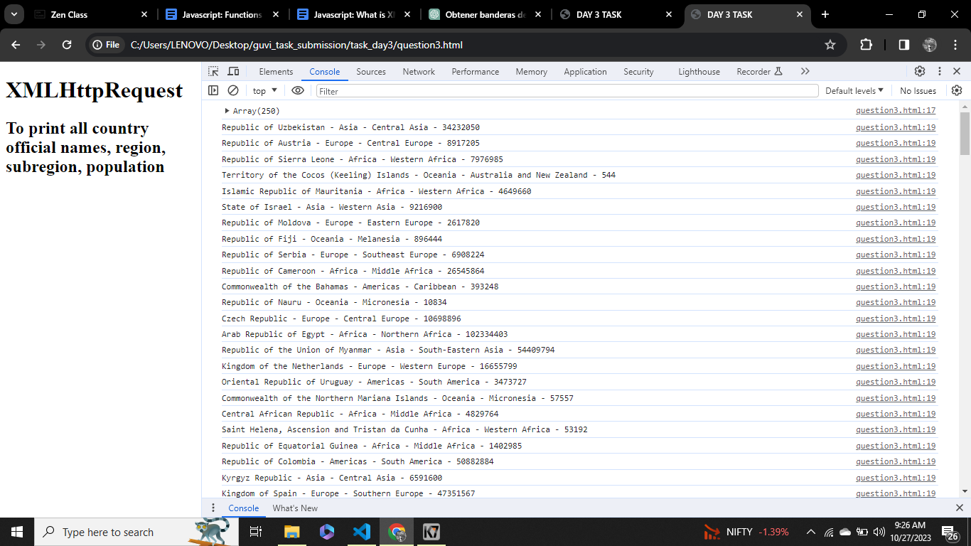

# **3.To print all country names, region, subregion, population**

## Code:

<!DOCTYPE html>

<html lang="en">

<head>

<meta charset="UTF-8">

<meta name="viewport" content="width=device-width, initial-scale=1.0">

<title>DAY 3 TASK</title>

</head>

<body>

<h1><b>XMLHttpRequest</b></h1>

<h2><b>To print all country official names, region, subregion, population</b></h2>

<script>

let my = new XMLHttpRequest();

my.open('GET', 'https://restcountries.com/v3.1/all');

my.send();

my.onload = function(){

let a = JSON.parse(my.responseText);

console.log(a)

for(let i = 0; i<a.length; i++){

console.log(`${a[i].name.official} - ${a[i].region} - ${a[i].subregion} - ${a[i].population}`)

}

};

</script>

</body>

</html>

## Output:

