NBA Play Ranker Software Requirements Specification
INFO45828 Computer Science Capstone Project
Alpha Release
Gurkaranjit Asahan and Abdul Mousa

Contents
Introduction 4
System overview 4
Coach 4
Analyst 4
Administrator 4
Supabase 4
1. System Context Diagram 4
2. Data Foundations and Explorer Overview 5
3. Baseline Playtype Recommender Overview 2.0 5
4. Contextual ML Recommender Overview Diagram 2.0 6
5. Functional Overview - Baseline Comparisons 7
Glossary 8
Business requirements 8
Domain model 9
6. Domain Model Class Diagram 9
Use case summary 9
Detailed use cases 10
7. Reactive Updates on Input Changes 10
8. Review Shot-Plan Recommendations 11
9. Evaluate Next-Season PPP (offline) 12
10. Versioned CSV Tables 13
11. Short Explanations per item 13
12. Compute & Export Top-K Uplift (CSV/JSON) 14
13. Explore Shot Attempts and Heatmaps 15
14. Review Saved Shot-Model Evidence 16
15. Save Notes to Tactics Board / Plan 16
16. Access Analyst Workspace 18
17. Load PBP Parquet 19
18. Run Data Quality Checks 20
19. Export KPIs / Reports 21
20. Seasonal Holdout 22
21. Data Dictionary 23
22. Audit Metadata 23
23. Plain Labels & Readability 24
24. Rank Plays with Game Context 24
25. Ranked List via API (Baseline) 26
26. Validate Coach Access 27
27. Authenticate Analyst Access 28
28. Build & Explore Team Season Data 29
29. Token Access + Endpoint Activity Logs 30
30. Glossary Access 31
31. Timeout Quick-Call Mode (top 3 plays, shot zone and reason in one screen) 31
32. Instructional Label on #1 32
33. Court Graphic + Minimal Captions for Top-K 33
34. Compare Usage and Efficiency 33
35. View Opponent Defensive Weak Spots 34
Planned release requirements 36
36. Compare Play Types with League Average 36
37. Track Play-Type Trends Across Seasons 36
38. Compare Head-to-Head Play-Type Profiles 37
39. View Possession Outcome Rates 37
Verification scope 38

Introduction
NBA Play Ranker helps a basketball coach compare offensive play types, review an opponent's defensive profile and prepare a gameplan. Analysts can inspect the source data and model evidence. The application presents historical basketball statistics and model diagnostics as decision support. It does not make coaching decisions or guarantee a future result. This specification describes the current system and gives detailed requirements for the two Alpha baseline comparison use cases.

System overview

Coach
An approved user who compares matchups, reviews play-type and shot evidence, and prepares a gameplan.

Analyst
An approved user who explores datasets, checks data quality, reviews model metrics and statistical analysis, and exports supporting evidence.

Administrator
Assigns approved account roles. A new account does not grant itself coach or analyst access.

Supabase
External identity and database service used for sessions, approved profile roles and coach-owned saved data.

1. System Context Diagram
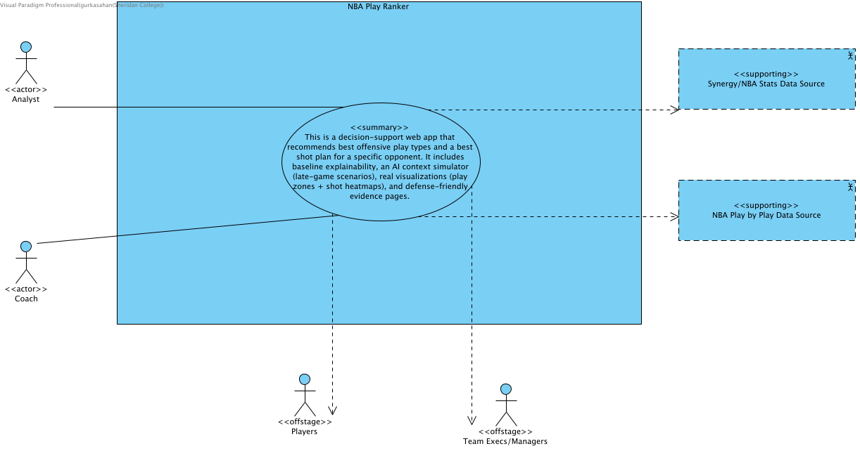

2. Data Foundations and Explorer Overview
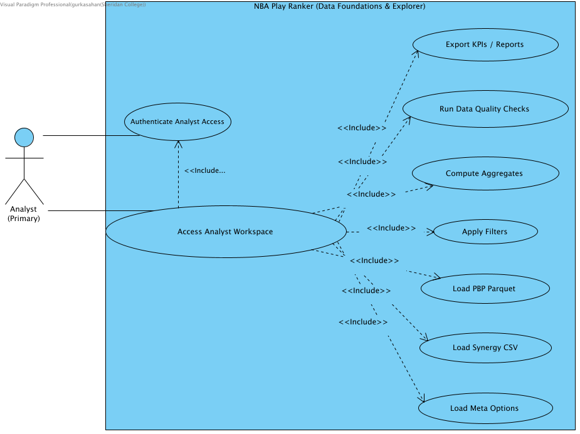

3. Baseline Playtype Recommender Overview 2.0
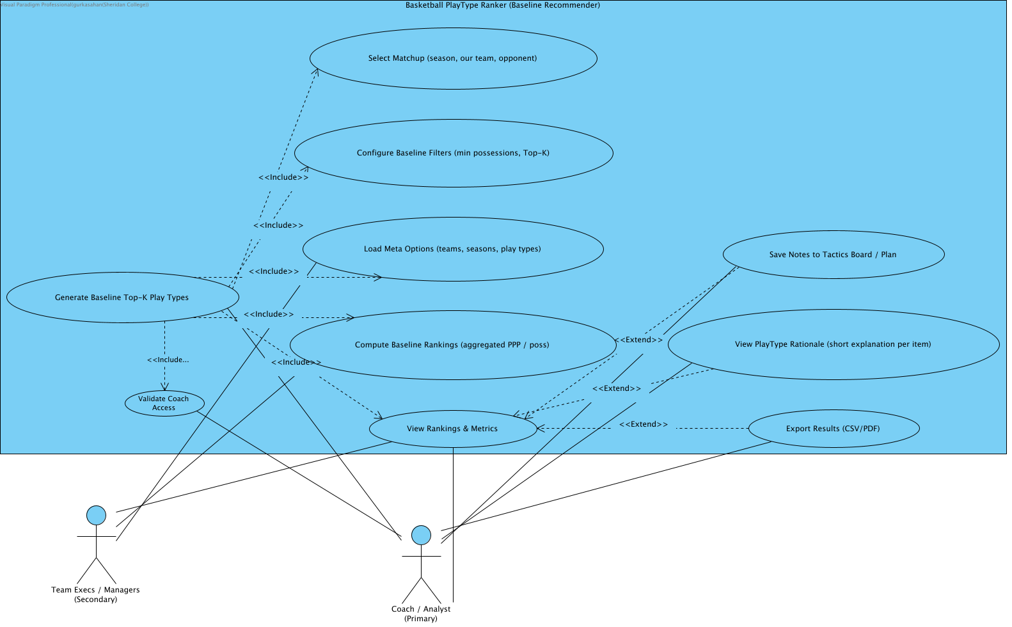

4. Contextual ML Recommender Overview Diagram 2.0
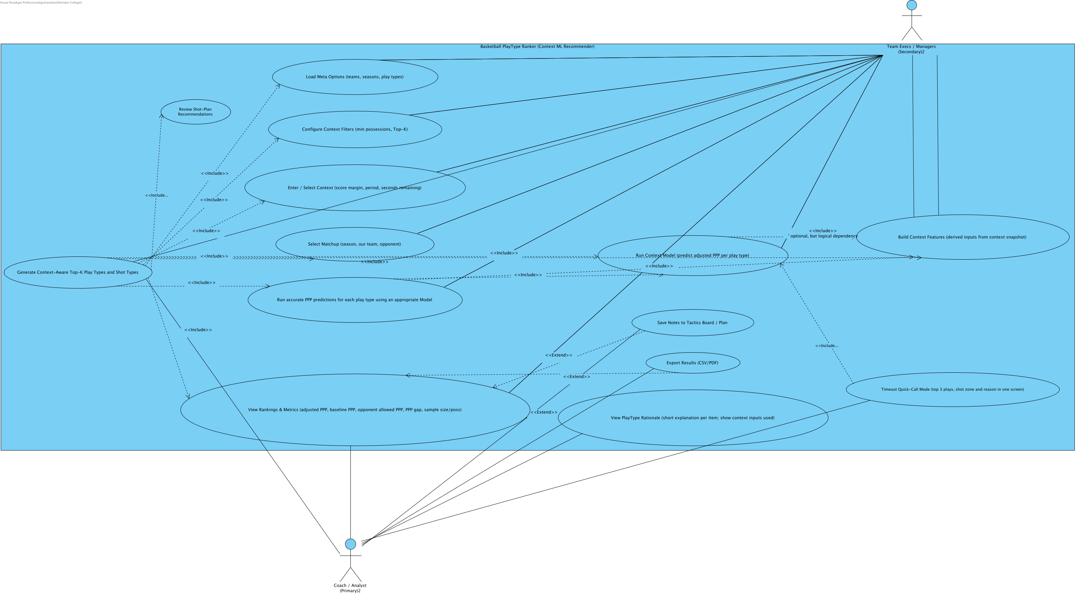

5. Functional Overview - Baseline Comparisons
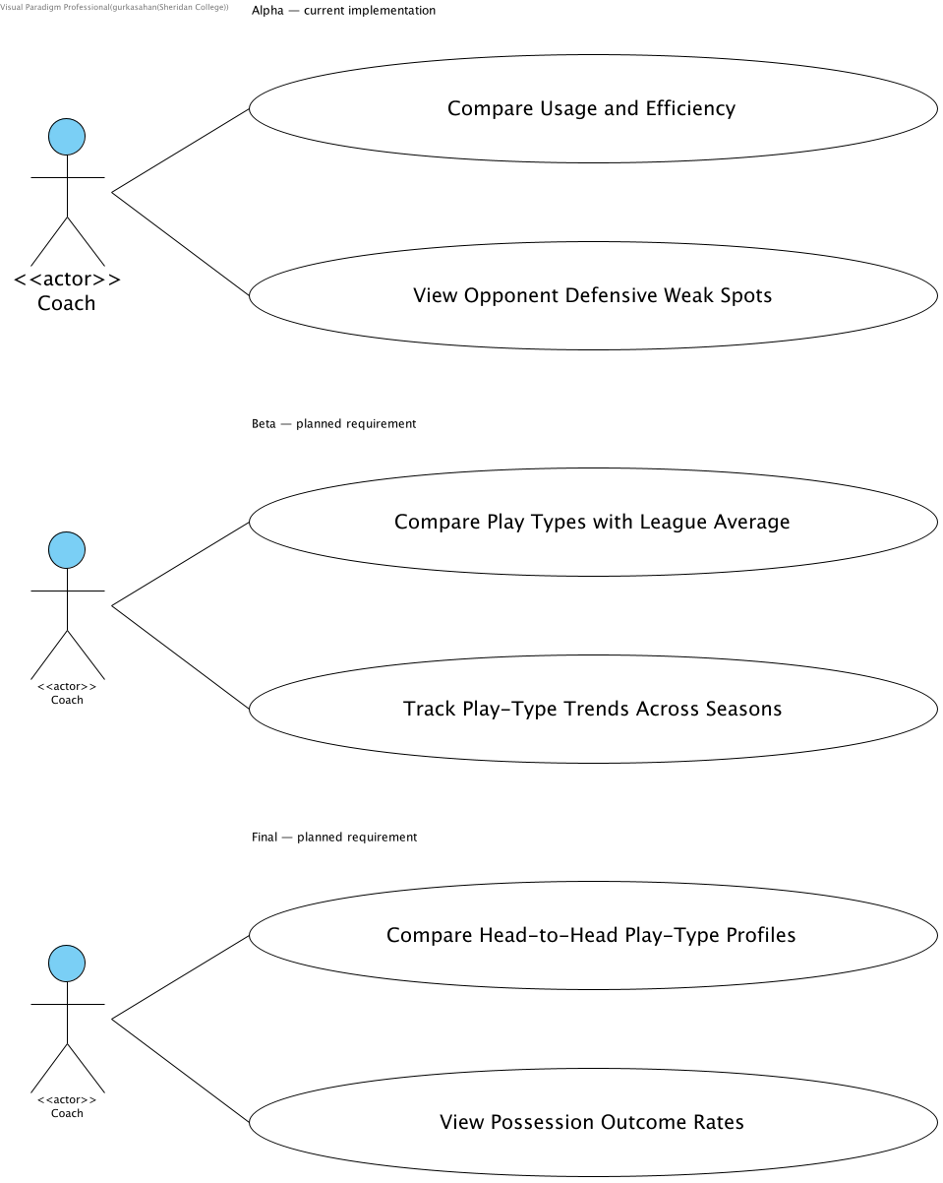
Coach baseline comparative analytics. Alpha: Usage/Efficiency and Opponent Defense. Beta and Final entries are planned requirements, not implemented functionality. Existing baseline ranking and export use cases are preserved separately.

Glossary
Term | Meaning
PPP | Points per possession: total points divided by recorded possessions.
Allowed PPP | Points an opponent scored per possession against the selected defense.
Usage | The percentage of a team's recorded offensive play-type possessions assigned to a play type.
Percentage point | The subtraction of two percentages. A 10 percent usage rate minus an 8 percent reference is a 2 percentage-point difference.
League reference | The pooled value for the same season, side and play type across available teams.
Possession cutoff | A configurable minimum count used to flag small samples and control weak-spot highlights.
Regular season | The season phase used by the play-type comparisons, excluding playoffs.
Play type | A source category such as Handoff, Isolation or Pick and Roll Handler.
Effective field-goal percentage | A shooting rate that gives additional weight to made three-point shots.
Retrospective diagnostic | An evaluation using observations from a completed period. It is not automatically evidence of future prediction accuracy.
Lagged predictor | A feature taken from an earlier season than the outcome being evaluated.

Business requirements
1. Compare the same regular season across all displayed teams and league references. Do not mix playoff records into regular-season totals.
2. Calculate team PPP as total points divided by possessions. Calculate usage as play-type possessions divided by the team's recorded offensive play-type possessions, multiplied by 100.
3. Calculate league values from pooled counts for the same season, side and play type. Calculate FG percentage from field goals made and attempted; weight source effective field-goal rates by attempts.
4. For the usage chart, subtract the same play type's league usage and PPP from the team's values. A high-efficiency, low-usage pattern is a review prompt, not proof that using that play more will improve results.
5. For opponent weak spots, subtract league allowed PPP from the opponent's allowed PPP. Rank the differences from highest to lowest. Highlight at most three positive differences that meet the possession cutoff.
6. The possession cutoff marks small samples without removing rows or changing totals. Small samples cannot receive a weak-spot highlight. The cutoff is a display rule, not a confidence interval.
7. Missing defensive categories remain unavailable. They must not appear as zero points allowed. The current source contains eleven offensive categories and seven defensive categories.
8. These comparisons use whole-season profiles. Selecting two teams does not restrict the data to games played against each other.
9. Only approved coaches can use the matchup dashboard. Validate the current profile role on the API as well as the page route.
10. Discard results that no longer match the selected filters. On an error, remove the stale chart and provide a retry action.
11. Keep source checks, descriptive comparisons, retrospective model diagnostics and prospective evaluation distinct. Observed-season model performance does not establish pre-game forecast accuracy.
12. Treat scoring, turnover and free-throw rates as overlapping measures in the planned final release. Do not combine them into a mutually exclusive 100 percent chart.

Domain model

6. Domain Model Class Diagram
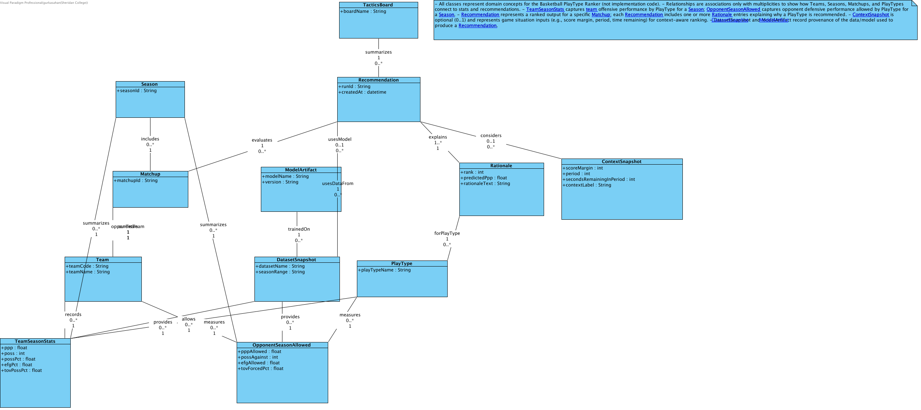

Use case summary
The following list selects the product use cases from the shared model. Validation copies, functional-area summaries and duplicate screen-level variants are not repeated. The model creator is preserved; implementation responsibility is recorded by the linked Jira work. Saving coach notes uses one shared storage contract for baseline and context gameplans.
Use case | Model creator | Scope
Reactive Updates on Input Changes | Abdul Mousa | Existing system
Review Shot-Plan Recommendations | Abdul Mousa | Existing system
Evaluate Next-Season PPP (offline) | Gurkaranjit Asahan | Existing system
Versioned CSV Tables | Abdul Mousa | Existing system
Short Explanations per item | Abdul Mousa | Existing system
Compute & Export Top-K Uplift (CSV/JSON) | Abdul Mousa | Existing system
Explore Shot Attempts and Heatmaps | Gurkaranjit Asahan | Existing system
Review Saved Shot-Model Evidence | Gurkaranjit Asahan | Existing system
Save Notes to Tactics Board / Plan | Gurkaranjit Asahan | Existing system
Access Analyst Workspace | Gurkaranjit Asahan | Existing system
Load PBP Parquet | Gurkaranjit Asahan | Existing system
Run Data Quality Checks | Gurkaranjit Asahan | Existing system
Export KPIs / Reports | Gurkaranjit Asahan | Existing system
Seasonal Holdout | Abdul Mousa | Existing system
Data Dictionary | Abdul Mousa | Existing system
Audit Metadata | Abdul Mousa | Existing system
Plain Labels & Readability | Abdul Mousa | Existing system
Rank Plays with Game Context | Abdul Mousa | Existing system
Ranked List via API (Baseline) | Abdul Mousa | Existing system
Validate Coach Access | Abdul Mousa | Existing system
Authenticate Analyst Access | Abdul Mousa | Existing system
Build & Explore Team Season Data | Abdul Mousa | Existing system
Token Access + Endpoint Activity Logs | Abdul Mousa | Existing system
Glossary Access | Abdul Mousa | Existing system
Timeout Quick-Call Mode (top 3 plays, shot zone and reason in one screen) | Abdul Mousa | Existing system
Instructional Label on #1 | Abdul Mousa | Existing system
Court Graphic + Minimal Captions for Top-K | Abdul Mousa | Existing system
Compare Usage and Efficiency | Gurkaranjit Asahan | Alpha
View Opponent Defensive Weak Spots | Gurkaranjit Asahan | Alpha

Detailed use cases

7. Reactive Updates on Input Changes
ID: UC19
SCRUM-643/644. ShotResultRequest/useShotResult guard shot pages; QuickCallRequest/useQuickCallResult guard QuickCall. This documents Gurk’s integration guard only; SCRUM-628 QuickCall functionality remains Abdul’s work.

7.2. Scenarios

7.2.1. Scenario
1. User changes a result-defining input or selects a preset scenario.
2. Immediately hide the old result and related download actions, and cancel or invalidate the previous request before the debounce completes.
3. After the debounce or explicit Run action, capture the inputs and request the corresponding result.
4. Accept a completion only if it belongs to the latest active request. Store its successful input snapshot with the result.
5. Display only a success whose snapshot matches the current controls. An older success or failure cannot replace it.
Extension:
3.a. User changes inputs again before the prior request returns.
1. UI cancels/ignores the stale response.
2. UI uses only the latest request.
3. Use case resumes at step 4.
4.a. Update request fails.
1. UI clears the failed result and hides its export action; it does not keep an old ranking under changed controls.
2. UI displays the request error. The user can retry or change the inputs; a successful current result restores the list.
3. Use case ends.

7.3. Relationships
Relationship | From | To
unnamed | Keep Results Matched to Inputs | Reactive Updates on Input Changes
unnamed | Coach/Analyst | Reactive Updates on Input Changes
Preconditions A permitted recommendation or shot page with editable inputs.
Postconditions The visible result always belongs to the displayed input snapshot.

8. Review Shot-Plan Recommendations
ID: UC70
SCRUM-544/642/643. Rankings blend our season-wide offense with opponent season-wide defense and league shrinkage. They are not head-to-head-only results, possession PPP, causal defensive weaknesses or individual future-shot guarantees.

8.2. Scenarios

8.2.1. Scenario
1. Analyst or coach opens Shot Plan and selects season, two different teams, k and offense weight; heatmap filters and cap are selected separately.
2. Capture one input set and request season-wide shot-type/zone rankings plus the selected matchup heatmap. Show the plan only after both succeed.
3. Display estimated points per shot attempt, adjusted offense/defense rates and sample sizes. Explain that heatmap type/zone filters do not alter the season-wide rankings.
4. Show the attempt-count heatmap with matching, plotted, invalid-location, outside-half-court and cap-omitted counts.
5. Export PDF through the authenticated same-origin route using the successful filters and cap. The PDF recomputes from current loaded sources and records those versions.
Extension:
2.a. Required shot aggregates or the requested heatmap cannot load.
1. Keep the incomplete Shot Plan hidden and display its request error.
2. Other working play-type pages remain available; their results are independent of this failed shot request.
3. Use case ends.
2.b. Play-by-play data for this matchup is sparse.
1. Show the actual sample counts and sample-size shrinkage; do not invent a confidence score.
2. Disclose sample sizes and league shrinkage; do not invent a confidence interval.
3. Interpret the current plan using the displayed counts and limitations.

8.3. Relationships
Relationship | From | To
unnamed | Generate Context-Aware Top-K Play Types and Shot Types | Review Shot-Plan Recommendations
unnamed | Review Shot-Plan Recommendations | Review Shot-Plan Recommendations
unnamed | Coach/Analyst | Review Shot-Plan Recommendations
Preconditions Signed-in analyst or coach; validated derived shot data; valid distinct teams.
Postconditions A current complete plan or an explicit unavailable/error state is visible.

9. Evaluate Next-Season PPP (offline)
SCRUM-526. Analyst runs the offline evaluation script with the retained Synergy CSV. Preconditions: at least four regular seasons with usable immediately preceding-season rows. The script builds lagged features, tunes Ridge on the penultimate target season, refits earlier targets, scores the final season once, compares two prior-season baselines, then saves report.json and predictions.csv. Missing training/tuning/final coverage raises ValueError. Outcomes are a historical season-ahead backtest, not a live app or pre-game forecast. No deployment or extra API endpoint is implied.

9.1. Scenarios

9.1.1. Main flow
1. Analyst runs run_forecast_evaluation.py with a retained Synergy CSV and an output directory.
2. Build target rows using only the immediately preceding regular season as features; count excluded rows without that coverage.
3. Train on earlier target seasons and tune Ridge alpha on the penultimate target season; fit scaling within each training fit.
4. Refit the selected pipeline using targets earlier than the final season, then score the final target season once.
5. Compare MAE, RMSE and signed bias with prior-team and prior-league baselines; report bins and coverage.
6. Save report.json and predictions.csv with source and prediction hashes. Describe the result as a historical season-ahead backtest.

9.1.2. Invalid coverage
1. If training, tuning or final prior-season coverage is missing, stop with ValueError; do not substitute same-season predictors.

9.2. Relationships
Relationship | From | To
unnamed | Evaluate Next-Season PPP (offline) | Evaluate Next-Season PPP (offline)
unnamed | Developer | Evaluate Next-Season PPP (offline)
Preconditions At least four usable regular seasons with prior-season coverage; Python evaluation environment.
Postconditions Versioned offline evidence files exist; no live forecast endpoint is added.

10. Versioned CSV Tables
ID: UC12
SCRUM-487. A content version establishes identity, not data correctness or prediction accuracy.

10.2. Scenarios

10.2.1. Scenario
1. System loads a CSV or Parquet source while capturing its SHA-256; reject a file that changes during the read.
2. Associate the version with the returned DataFrame and carry that loaded version through API results and supported response headers.
3. User can inspect the active version in source details and exported data. The current UI has no historical version selector.
4. Shared report exports keep the displayed result version. Specialized shot CSV/PDF exports identify the source used when the file is generated.
5. Heatmap PNG and saved-metrics CSV compare the expected displayed version and reject a changed source with 409.
Extension:
4.a. Displayed source version no longer matches a guarded download.
1. Reject the guarded download with409 and keep its error visible; do not offer a historical version selector.
2. User reloads the current result before requesting that download again.

10.3. Relationships
Relationship | From | To
unnamed | Identify Result Data Versions | Versioned CSV Tables
unnamed | Analyst | Versioned CSV Tables
Preconditions A readable versioned source and access permitted for the requested feature.
Postconditions Each result/export identifies its actual input bytes; no unrelated disk hash is substituted.

11. Short Explanations per item
ID: UC21
1–2 sentences driven by PPP gap

11.2. Scenarios

11.2.1. Scenario
1. Coach opens a successful baseline or context ranking.
2. Show a short evidence-based explanation for each ranked play type using the metrics returned with that result.
3. For baseline results, state that season aggregates are used and score, period, clock and coaching conditions do not change the ranking.
4. For context results, identify applied conditions and disclose inputs that were only retained as notes.
5. Keep missing statistics unavailable and avoid unsupported causal claims, invented confidence intervals or guarantees.
Extension:
2.a. Gap is near zero / ambiguous.
1. System selects a neutral template rather than overstating an advantage.
2. Display the explanation with the actual baseline or context scope.

11.3. Relationships
Relationship | From | To
unnamed | Ranked List via API (Baseline) | Short Explanations per item
unnamed | Rank Plays with Game Context | Short Explanations per item
unnamed | Coach | Short Explanations per item
Preconditions A successful current ranking.
Postconditions Each explanation describes its actual result and model scope.

12. Compute & Export Top-K Uplift (CSV/JSON)
ID: UC29
SCRUM-475. Historical modeled Top-K comparison, not causal or held-out performance. Team baseline uses SUM(PTS)/SUM(POSS) over all team-season offensive rows. Selected modeled PPP uses SUM(PPP_PRED*POSS_OFF)/SUM(POSS_OFF). JSON and CSV contain scope, numerators, denominators, K, units, formulas, source SHA-256 and row contributions. Missing PTS fails explicitly; zero baseline gives null relative uplift. SCRUM-474 remains a separate evaluation dependency. Analyst selects season, teams, K and offense weight, then reads or downloads equivalent JSON/CSV evidence. Invalid filters 400/422; no eligible observations 404. Authorization failures 401/403.

12.2. Scenarios

12.2.1. Scenario
1. Analyst selects a retained season, our team, opponent, K and offense weight for the historical matchup comparison.
2. System loads the season-level modeled ranking and the observed source aggregates, with possession-weighted team/play-type rows.
3. Compare the weighted modeled Top-K value with the weighted seasonal comparison and return the numerator, denominator, requested K and actual K.
4. Return JSON or CSV with units and actual source versions so the weighted comparison can be reproduced.
5. Describe the result as historical modeled uplift. It is not a held-out forecast, causal treatment effect or a promise that choosing a play will improve scoring.
Extension:
3.a. No eligible source observations or an unusable comparison denominator.
1. Return a clear data error for missing required values; a zero baseline yields null relative uplift.
2. Keep scope and available sample counts explicit; do not invent a confidence score.
5.a. Export fails.
1. System shows an error.
2. System allows the Analyst to retry.
3. Retry the same valid export request or correct the filters before retrying.

12.2.2. Uplift provenance
1. Return JSON or CSV with requested/actual K, weighted numerators, seasonal comparison, units and source version.
2. Describe modeled Top-K uplift as retrospective evidence, not causal gain or a guarantee from changing play choice.

12.3. Relationships
Relationship | From | To
unnamed | Historical Top-K Uplift | Compute & Export Top-K Uplift (CSV/JSON)
unnamed | Analyst | Compute & Export Top-K Uplift (CSV/JSON)
Preconditions Signed-in analyst; valid filters and readable source data.
Postconditions A versioned historical comparison or a clear request/data error is returned.

13. Explore Shot Attempts and Heatmaps
Analysts browse shot attempts and export CSV. Analysts and coaches render matchup heatmaps and download PNG. Counts describe attempts, not accuracy or defensive weakness. SCRUM-643.

13.1. Scenarios

13.1.1. Main flow
1. Analyst opens Shot Explorer, or analyst/coach opens Shot Heatmap, and selects the permitted season/team/opponent/type/zone filters.
2. Submit the captured inputs. Clear old table/image/download controls while loading; input changes or failure never relabel an older result.
3. Explorer shows matching and returned row counts. CSV uses the same filters with the documented export cap and identifies the current canonical source.
4. Heatmap excludes invalid locations and shots outside the physical half court, then applies deterministic sampling only above the selected cap.
5. Display a linear attempt-count scale for makes and misses together. Matching attempts equal plotted plus each exclusion and cap omission.
6. Download PNG through the same-origin proxy with the displayed filters, cap and source version. Verify current role, fixed upstream, echoed inputs/counts/version and PNG signature before returning a private attachment.

13.1.2. No data or changed source
1. No matches returns a clear no-data message. Matches with no usable half-court locations retain exclusion counts.
2. Reject unauthorized requests and malformed inputs. PNG version mismatch returns409; mismatched/invalid upstream image returns502. Errors are not attachments.

13.2. Relationships
Relationship | From | To
unnamed | Explore Shot Attempts and Heatmaps | Explore Shot Attempts and Heatmaps
unnamed | Coach/Analyst | Explore Shot Attempts and Heatmaps
Preconditions Analyst for shot rows/CSV; analyst or coach for heatmap; valid filters.
Postconditions Current results are labeled with their actual filters and source; valid downloads contain no credentials.

14. Review Saved Shot-Model Evidence
Analysts retrieve saved, source-validated shot metrics and statistical analysis. The web request never trains a model. These are conditional proposed-shot diagnostics, not before-possession forecasts. SCRUM-543/545/549/640.

14.1. Scenarios

14.1.1. Main flow
1. Analyst opens Shot Model Metrics or Shot Statistical Analysis.
2. Load the saved five-fold artifact and verify result kind, artifact version, source hash and fold count. Do not fit a model during the HTTP request.
3. Show training-game cross-validation separately from the untouched later-season diagnostic, with the sample definition and model comparison.
4. State that the model estimates points for a proposed shot with supplied location/type; it is not a before-possession forecast.
5. Metrics can export the training cross-validation table as CSV through the same-origin route after verifying the displayed clean-source hash. Include version and folds in every row.

14.1.2. Unavailable saved result
1. Missing, stale, corrupt or mismatched artifacts return503 and require a new offline evaluation. Reload only retries reading.
2. refresh=true returns400 and never trains on the server. Unknown numerical values display Unavailable; absent results disable export.

14.2. Relationships
Relationship | From | To
unnamed | Review Saved Shot-Model Evidence | Review Saved Shot-Model Evidence
unnamed | Analyst | Review Saved Shot-Model Evidence
Preconditions Signed-in analyst; saved artifacts matching the current cleaned-shot source.
Postconditions Saved evidence is shown with limitations, or a clear unavailable/retry state without stale metrics.

15. Save Notes to Tactics Board / Plan
ID: UC42
SCRUM-481 covers the persisted schema contract only. Coach UI migration and synchronization are separate SCRUM-482/483 work. This collaboration reuses the existing Gameplan Storage structural design. The database does not itself emit an HTTP409 conflict: a conditional update can affect zero rows, which the caller must detect and resolve.

15.1. Scenarios

15.1.1. Scenario
1. An authenticated coach prepares notes, plan and role values for one season and directed matchup. This flow specifies the storage contract, not completion of the separate UI integration.
2. For new state, INSERT the composite key and allowed state fields. Row-level security requires auth.uid() ownership and the current protected profile role coach; constraints validate the payload.
3. For existing state, read its revision and UPDATE only notes, plan and roles using the full owner/matchup key and revision = last_read_revision. Do not use an unconditional upsert.
4. On a successful update, the database increments revision and updated_at. The caller accepts the returned state and revision only after confirming a row was written.
Extension:
3.a. No persisted owner/matchup row exists.
1. The authorized caller INSERTs a new row with allowed state fields; defaults initialize revision and audit timestamps.
2. Validate payload and coach ownership before accepting the inserted state.
3. On duplicate key, reload the existing row and use the conditional-update path instead of upsert.
3.b. Write fails or no conditional update row is returned.
1. Do not confirm a successful save after a denied, invalid or failed write.
2. The caller retains its unsaved edit until it can reload and reconcile with the authorized current revision.
3. Retry only after resolving the error and reading the revision used for a conditional update.

15.1.2. Storage acceptance and conflicts
1. Anonymous, analyst, pending and other-coach sessions cannot read or change this owner state. Authorization uses the protected profile role, not editable signup metadata.
2. If a conditional update writes zero rows, do not report a successful save. Reload the authorized current state and reconcile changes before retrying against its new revision.
3. A duplicate INSERT is a conflict; read the existing owner/matchup row before an explicitly conditional update. Changing owner, season or team keys requires a distinct new record, not an UPDATE.
4. Reject invalid JSON shape, more than50 plan entries, more than100 notes, duplicate plan IDs or state above65536bytes. SQL constraints also require valid team/season formats and different teams.
5. Deleting an auth user removes its owned rows through the existing foreign key. No test here claims teammate client-sync behavior or an end-user recovery workflow.

15.2. Relationships
Relationship | From | To
 | View Rankings & Metrics | Save Notes to Tactics Board / Plan
unnamed | Persist Coach-Owned Gameplan State | Save Notes to Tactics Board / Plan
unnamed | Coach / Analyst | Save Notes to Tactics Board / Plan
Preconditions Authenticated coach; a valid distinct-team matchup; reads and writes use the owning user ID.
Postconditions Only the owner coach can access the state. The matchup identity and audit fields remain immutable to clients; accepted updates advance the revision.

16. Access Analyst Workspace
ID: UC62

16.1. Scenarios

16.1.1. Scenario
1. System verifies the signed-in user and current analyst role before showing analyst pages.
2. Analyst opens Data Explorer, Metrics, Calibration, Statistical Analysis or a permitted shot-analysis page.
3. System requests available source metadata and the selected page data using separate loading and error states.
4. Data is loaded from configured retained sources; this workflow does not offer a source-file upload selector.
5. Analyst applies the page-specific filters and requests current results.
6. Show only results that match the successful inputs, with source identity and appropriate units.
7. Data Explorer reports Synergy source-wide checks separately from filtered preview data and shot diagnostics.
8. Offer only exports supported by that page and its current result; errors remain clear and do not masquerade as downloads.
Extension:
1.a. Authentication fails.
1. System halts the flow.
2. System redirects to sign-in.
3. Use case ends in failure.
4.a. A dataset fails to load (missing file, schema mismatch).
1. System shows an error identifying which dataset failed.
2. Analyst retries or chooses a supported page/filter; a maintainer repairs the configured source offline.
3. Reload the page data after the source becomes available.
7.a. Data quality checks fail (e.g., missing seasons, duplicate rows).
1. System flags the specific issue.
2. Show the failed checks; recommendation enforcement follows the configured block or flag policy, without a user override control.
3. Retry the source checks after the configured data is corrected.

16.1.2. Readiness and unavailable services
1. Required play-type inputs and model availability are checked separately from optional shot artifacts.
2. If a required source cannot load, show a safe unavailable error. Do not expose filesystem paths, credentials or stack traces.
3. A missing optional shot artifact does not block the working play-type pages; shot pages show their own unavailable state.

16.2. Relationships
Relationship | From | To
 | Access Analyst Workspace | Load Meta Options
 | Access Analyst Workspace | Load Synergy CSV
 | Access Analyst Workspace | Load PBP Parquet
 | Access Analyst Workspace | Apply Filters
 | Access Analyst Workspace | Compute Aggregates
 | Access Analyst Workspace | Run Data Quality Checks
 | Access Analyst Workspace | Export KPIs / Reports
unnamed | Access Analyst Workspace | Authenticate Analyst Access
unnamed | TC-AW-01: Analyst Authorized to Access Workspace | Access Analyst Workspace
unnamed | TC-AW-02: Workspace Returns Valid Data | Access Analyst Workspace
unnamed | TC-AW-03: Unauthorized Access Blocked | Access Analyst Workspace
unnamed | Access Analyst Workspace | Access Analyst Workspace
unnamed | Analyst | Access Analyst Workspace
unnamed | Coach/Analyst | Access Analyst Workspace
Preconditions Signed-in approved analyst.
Postconditions The chosen analyst page shows its current result or an appropriate error.

17. Load PBP Parquet
SCRUM-538/549/642. Current retained release has six seasons. Quarantine/count totals belong to versioned evidence, not immutable requirements. No claim of perfect provider coordinates or future forecast accuracy.

17.1. Scenarios

17.1.1. Scenario
1. Maintainer acquires pinned official provider play-by-play files for the documented seasons and records URLs, pull time and raw hashes outside the public source package.
2. Offline rebuild validates unique events, game participants and score continuity. Quarantine inconsistent games with an exclusion manifest; preserve raw input.
3. Derive the shooting team, opponent, pre-shot margin, shot outcome and known attempt value from explicit event evidence. Unknown missed-shot values remain missing.
4. Normalize provider shot types and basket-relative locations. Apply official court boundaries, known two/three-point evidence and explicit geometry-only fallback; flag implausible locations rather than invent coordinates.
5. Rebuild cleaned/canonical shots, team/opponent aggregates and league rates. Invalid spatial locations are excluded from charts/spatial models; unknown zones are excluded from zone rankings.
6. Validate retained events and aggregate counts against pinned raw input. Write source sidecars and hashes, then regenerate saved diagnostics offline before deploying derived files.
Extension:
2.a. File missing or unreadable.
1. Rebuild reports the unreadable source file and stops before replacing validated artifacts.
2. Use case resumes at step 1.
3.a. Schema mismatch.
1. System flags the mismatch.
2. System blocks downstream use until resolved.
3. Use case ends in failure.

17.2. Relationships
Relationship | From | To
 | Access Analyst Workspace | Load PBP Parquet
unnamed | Validate and Rebuild Shot Sources | Load PBP Parquet
unnamed | Developer | Load PBP Parquet
Preconditions Documented raw provider inputs and local rebuild environment; no public upload interface is implied.
Postconditions Validated derived files and provenance exist; excluded or unknown records remain disclosed.

18. Run Data Quality Checks
SCRUM-480. Source data checks; scoped to the Synergy input. SCRUM-640 keeps technical details optional without hiding limitations.

18.1. Scenarios

18.1.1. Scenario
1. Analyst opens Data Explorer or selects Retry data checks. The previous report is cleared while checks load.
2. The API verifies the analyst role and checks required columns, missing keys, duplicate rows and expected team-season coverage against one loaded Synergy source.
3. The response identifies the checked source and generation time; each check is pass, fail or not run with a reason.
4. The panel shows the source-wide status independently of the preview filters. These checks do not measure model accuracy or validate shot data.
5. Analyst can expand check details or retry. A failed, timed-out or superseded request never displays a previous pass as current.
Extension:
4.a. One or more checks fail.
1. System clearly flags which check failed and why.
2. System reports safe_for_use=false for failed source checks; it does not silently relabel the source as safe.
3. Use case resumes at step 5.
4.b. A check cannot be run (e.g., a reference table is missing).
1. System marks that check as not run and states the reason in the report.
2. Use case resumes at step 5.

18.2. Relationships
Relationship | From | To
 | Access Analyst Workspace | Run Data Quality Checks
unnamed | Run Data Quality Checks | Run Data Quality Checks
unnamed | Analyst | Run Data Quality Checks
Preconditions Signed-in analyst; configured Synergy source.
Postconditions Current source status or a clear retry error is visible.

19. Export KPIs / Reports
SCRUM-486/487. Shared displayed-result exports differ from specialized shot CSV/PDF generation, which reads current source files.

19.1. Scenarios

19.1.1. Scenario
1. Coach opens current Matchup or Context results, or analyst opens the displayed Model Metrics holdout table.
2. The shared export control captures the displayed rows, columns, applied filters and dataset versions without recalculating the result.
3. User selects CSV, JSON or PDF. Empty, loading or stale results disable export.
4. The same-origin proxy verifies the cookie identity and session and forwards only to the fixed report endpoint; the backend checks the current role and bounded scalar payload.
5. The native browser download contains the selected format and source versions. JSON/PDF include filters and limitations; CSV preserves numerical negatives and neutralizes spreadsheet formulas.
Extension:
2.a. Displayed snapshot is empty, stale or missing required fields.
1. System rejects missing or invalid snapshot fields with a clear error; no partial report is presented as complete.
2. Refresh the page result and retry export only once it is valid and current.
4.a. Export generation fails.
1. System shows the preflight or upstream error without an attachment response.
2. User retries while the same successful result remains current; changed inputs require a new result first.
3. Retry export while the same successful result remains current.

19.2. Relationships
Relationship | From | To
 | Access Analyst Workspace | Export KPIs / Reports
unnamed | Export KPIs / Reports | Export KPIs / Reports
unnamed | Analyst | Export KPIs / Reports
Preconditions A permitted signed-in user and a successful current displayed result.
Postconditions The exported bounded snapshot matches its displayed rows and applied filters.

20. Seasonal Holdout
ID: UC28

20.2. Scenarios

20.2.1. Scenario
1. Analyst opens Model Metrics or Calibration and selects available model, season or diagnostic filters.
2. Request current diagnostics independently from metadata requests. Regular metric routes may compute and cache evaluations; display each loading, error and ready state separately.
3. Show earlier-season training diagnostics separately from the later-season evaluation; use the exact displayed table for shared metric reports.
4. Calibration groups predicted and realized PPP into bins and reports bias, MAE, RMSE, sample counts and source provenance.
5. Keep the limitation visible: observed-season rate features make these retrospective diagnostics, not pre-game or future-season predictions.
Extension:
3.a. The diagnostic sample has different coverage or observed-season feature scope.
1. Show sample coverage and retrospective limitations beside the metrics.
2. Interpret the current result with those limitations; no future-accuracy claim is added.

20.2.2. Retrospective diagnostic scope
1. Show predicted-versus-realized PPP bins, signed bias, MAE and RMSE for later-season diagnostic folds.
2. Disclose that contemporaneous observed-season features make this a retrospective diagnostic; it does not establish future or pre-game accuracy.
3. Keep metadata, metrics and calibration request states separate so a successful metadata response cannot leave the metrics page stuck loading.

20.3. Relationships
Relationship | From | To
unnamed | PPP Calibration Diagnostics | Seasonal Holdout
unnamed | Analyst | Seasonal Holdout
Preconditions Signed-in analyst and matching prepared model/evaluation inputs.
Postconditions The selected diagnostics and limitations are visible; failed requests do not leave an endless loading state.

21. Data Dictionary
ID: UC13
SCRUM-498/548. Dictionary definitions follow the loaded schema and distinguish coordinate units, pre-shot margin, uncertain shot value and zone method.

21.2. Scenarios

21.2.1. Scenario
1. User opens Data Dictionary with an authenticated session.
2. The API lists actual dataset columns with meaning, units and source.
3. User searches by dataset, column or meaning; the page shows matching and undocumented totals.
4. Unknown definitions are labeled Undocumented column; the page never invents a meaning.
5. A failed request shows Retry; an empty search shows No matching columns.
Extension:
3.a. A field has no dictionary entry.
1. System flags it as undocumented rather than showing a broken/empty definition.
2. Use case ends.

21.3. Relationships
Relationship | From | To
unnamed | Inspect Dataset Columns | Data Dictionary
unnamed | Analyst | Data Dictionary
Preconditions Authenticated session.
Postconditions Actual fields and documented meanings are visible, including explicit unknown definitions.

22. Audit Metadata
ID: UC14
SCRUM-488/489. Source row counts are input-file counts, not filtered preview counts; the catalog covers Synergy, ML predictions, cleaned/canonical shots and two aggregate datasets.

22.2. Scenarios

22.2.1. Scenario
1. Analyst opens Data Explorer and the source panel requests the authenticated dataset catalog.
2. System returns active dataset IDs, availability, actual source row counts and season coverage from the loaded files.
3. The source panel shows the play-type source summary. Expanding Source details reveals the SHA-256 version and recorded pull date.
4. If a pull date is not recorded, display Not recorded; file modification time must not be substituted.
5. On failure, show an error and Retry. Retry clears the previous catalog while loading; unavailable optional datasets do not invalidate other usable entries.
Extension:
2.a. Metadata is missing for a dataset.
1. System shows "audit metadata unavailable" rather than omitting the panel silently.
2. Show Not recorded for a missing pull date or Retry for a failed catalog request.

22.3. Relationships
Relationship | From | To
unnamed | Inspect Source Metadata | Audit Metadata
unnamed | Analyst | Audit Metadata
Preconditions Authenticated session; Data Explorer itself requires analyst access.
Postconditions Current source metadata or a clear unavailable state is visible.

23. Plain Labels & Readability
ID: UC23
SCRUM-640. This records implementation prompted by actual stakeholder feedback; it does not claim the later three-scenario acceptance exercise was completed.

23.2. Scenarios

23.2.1. Scenario
1. User opens an analyst or coach page and sees its main action, result and essential scope in plain language.
2. Use familiar field labels and units: points per shot attempt for shot plans, attempts for heatmaps, and separate training/later-season labels for diagnostics.
3. Keep essential dataset and proposed-shot limitations visible. Place full hashes, implementation details and repeated pipeline explanations in closed Details sections.
4. Loading, unavailable, no-data and error states provide an appropriate next action; missing values display Unavailable rather than a misleading zero.
5. Do not offer unsupported controls, such as changing folds or training via the saved shot-metrics page.
Extension:
2.a. A numeric value or dictionary definition is unavailable.
1. Show Unavailable for a missing numeric value and Undocumented column for an unknown definition.
2. Keep the missing-data state visible without inventing a value or meaning.
3. The user can inspect details or retry the request when appropriate.

23.3. Relationships
Relationship | From | To
unnamed | Present Clear Results and Limits | Plain Labels & Readability
unnamed | Analyst | Plain Labels & Readability
Preconditions A supported current page.
Postconditions The user can identify the action, result and relevant limitation without expanding technical details.

24. Rank Plays with Game Context
ID: UC11

24.1. Primary Actors
Coach

24.3. Scenarios

24.3.1. Scenario
1. Coach selects a matchup and enters numeric context or supported coaching text.
2. On Build, parse the text once and combine parsed margin, period, clock and supported coaching conditions into one request snapshot.
3. Validate regulation versus overtime clock bounds. Period 5 uses a 300-second maximum; invalid conditions return a clear validation error.
4. Send the same complete snapshot to context ranking on the first and later Builds; the response identifies the applied context and conditions.
5. Display ranked play types with predicted PPP, sample support and brief template explanations. Note-only conditions are not presented as applied model inputs.
6. Keep a clear distinction between the baseline shortlist and the context-adjusted ranking.
7. Identify the applied numeric context and supported coaching conditions beside the ranked result.
8. If the request fails, show the error without presenting an older result as the new context.
Extension:
4.a. Context inputs are incomplete.
1. System highlights the missing field.
2. System prompts the Coach to enter it before running the model.
3. Coach corrects the invalid inputs and starts a fresh Build snapshot.
6.a. Context model unavailable/fails.
1. Show the context request error and keep the failed result empty.
2. Do not present a baseline result as a successful context adjustment; QuickCall has a separate explicitly labeled fallback.
3. Coach can retry or open the Baseline page explicitly.
6.b. A supported coaching condition is invalid or an entered condition is unsupported.
1. Reject invalid supported conditions; disclose recognized unsupported conditions as note-only.
2. Rebuild only after the applied numeric and coaching inputs are valid.

24.3.2. Current context acceptance
1. Parse supported coaching conditions once and use the resulting numeric margin, period, clock and conditions on the first Build as well as repeated Build.
2. Period 5 is overtime with a maximum 300-second clock; supported coaching conditions reach the ranker and are echoed in the result.
3. Unsupported conditions are identified as note-only, not presented as applied model inputs; invalid conditions return422.

24.4. Relationships
Relationship | From | To
unnamed | Rank Plays with Game Context | Synergy/NBA Stats Data Source
unnamed | Rank Plays with Game Context | NBA Play by Play Data Source
unnamed | This is a decision-support web app that recommends best offensive play types and a best shot plan for a specific opponent. It includes baseline explainability, an AI context simulator (late-game scenarios), real visualizations (play zones + shot heatmaps), and defense-friendly evidence pages. | Rank Plays with Game Context
unnamed | Rank Plays with Game Context | Rank Plays with Game Context
unnamed | Coach | Rank Plays with Game Context
Preconditions Signed-in coach; valid matchup and available context model.
Postconditions The displayed context result matches the applied snapshot; unsupported coaching inputs are disclosed.

25. Ranked List via API (Baseline)
ID: UC18
Season-level play-type rankings use the selected matchup and offense weighting. Game score, clock and period do not change this baseline. Bounded timing checks are recorded separately and are not a guaranteed service-level agreement.

25.2. Scenarios

25.2.1. Scenario
1. Client calls the baseline ranking endpoint with season/team/opponent/filters.
2. System validates the request parameters.
3. System computes or retrieves cached baseline rankings.
4. System returns the ranked list with metrics as a structured API response.
Extension:
2.a. Invalid/missing parameters.
1. System returns a structured validation error.
2. Use case ends in failure.
3.a. The request is still waiting for the complete baseline ranking.
1. Show loading until the complete response arrives; this endpoint does not stream partial rankings.
2. Display the full result on success or a clear error when the request fails.

25.2.2. Baseline scope and availability
1. Baseline uses season aggregates and ignores game context; show that scope beside the result rather than implying context adaptation.
2. Readiness distinguishes required play-type sources and model availability from optional shot artifacts. Unavailable core data produces a clear error.
3. Agreed bounded acceptance targets are warm p95 below 5 seconds, two-concurrent p95 below 10 seconds and first-after-idle below 45 seconds. These are test targets, not a guaranteed service-level agreement.

25.3. Relationships
Relationship | From | To
unnamed | Ranked List via API (Baseline) | Ranked List via API (Baseline)
unnamed | Coach | Ranked List via API (Baseline)
Preconditions An approved coach is signed in and selects a season, team and different opponent.
Postconditions Show the complete baseline ranking with source version and its season-only scope, or a clear validation/unavailable error; no partial ranking is presented.

26. Validate Coach Access
ID: UC71

26.1. Primary Actors
Coach / Analyst

26.3. Scenarios

26.3.1. Scenario
1. Coach opens a protected page (e.g., Gameplan).
2. System checks for a valid session/credential.
3. System confirms the Coach role has permission for the requested page.
4. System grants access and loads the page.
Extension:
2.a. No valid session.
1. System redirects the Coach to sign-in.
2. Coach signs in.
3. Use case resumes at step 3.
3.a. Session valid but role lacks permission.
1. System denies access.
2. System shows an explanation of the required role.
3. Use case ends in failure.
4.a. Session expires mid-use.
1. System prompts the Coach to re-authenticate.
2. System preserves the current selection where possible.
3. Use case resumes at step 2.

26.4. Relationships
Relationship | From | To
unnamed | Validate Coach Access | Coach / Analyst
unnamed | Generate Baseline Top-K Play Types | Validate Coach Access
unnamed | Validate Coach Access | Validate Coach Access

27. Authenticate Analyst Access
ID: UC69

27.1. Primary Actors
Analyst

27.3. Scenarios

27.3.1. Scenario
1. Analyst opens the Analyst Workspace or issues an API request.
2. System validates the Analyst's token/credential.
3. System confirms the Analyst role has permission for the requested resource.
4. System logs the access (endpoint activity log) and grants access.
Extension:
2.a. Invalid or missing token.
1. System rejects the request with an authentication error.
2. System logs the failed attempt.
3. Use case ends in failure.
2.b. Token valid but expired.
1. System prompts the Analyst to re-authenticate/refresh the token.
2. Use case resumes at step 2.
3.a. Role lacks permission for the specific resource.
1. System denies access.
2. System logs the attempt.
3. Use case ends in failure.

27.4. Relationships
Relationship | From | To
unnamed | Authenticate Analyst Access | Analyst
unnamed | Access Analyst Workspace | Authenticate Analyst Access
unnamed | TC-AA-01: Session Validation | Authenticate Analyst Access
unnamed | TC-AA-02: Role Extraction | Authenticate Analyst Access
unnamed | TC-AA-03: Permission Checking | Authenticate Analyst Access
unnamed | Authenticate Analyst Access | Authenticate Analyst Access

28. Build & Explore Team Season Data
ID: UC09

28.1. Primary Actors
Analyst

28.3. Scenarios

28.3.1. Scenario
1. Analyst opens the Data Explorer page.
2. System loads the cleaned team/season dataset (versioned CSV tables) and available filters (season, team).
3. Analyst selects a season and team to narrow the view.
4. System displays the filtered dataset in a browsable table, including audit metadata (pull date, season coverage, row counts).
5. Analyst optionally opens the Data Dictionary to check a column definition.
6. Analyst optionally opens the Glossary for a basketball or statistical term.
7. Analyst clicks Export to download the current filtered view.
8. System exports the view as CSV/JSON consistent with what's on screen.
Extension:
2.a. Dataset version is stale/out of date.
1. System shows the last pull date and a warning banner.
2. Analyst chooses to continue with the stale data or stop.
3. If the Analyst continues, use case resumes at step 3; otherwise use case ends.
4.a. No data matches the selected season/team.
1. System shows "No rows match your filters".
2. System suggests widening the filter.
3. Use case resumes at step 3.
8.a. Export fails.
1. System shows an error message.
2. System lets the Analyst retry the export.
3. Use case resumes at step 7.

28.4. Relationships
Relationship | From | To
unnamed | Build & Explore Team Season Data | Analyst
unnamed | This is a decision-support web app that recommends best offensive play types and a best shot plan for a specific opponent. It includes baseline explainability, an AI context simulator (late-game scenarios), real visualizations (play zones + shot heatmaps), and defense-friendly evidence pages. | Build & Explore Team Season Data

29. Token Access + Endpoint Activity Logs
ID: UC17

29.2. Scenarios

29.2.1. Scenario
1. Client presents an access token with the API request.
2. System validates the token.
3. System processes the request if the token is valid.
4. System logs the endpoint, timestamp, and caller identity to the activity log.
5. System records the caller's email and role, method, endpoint, query (with credentials removed), status code and duration in the request log, after the response is sent.
6. Analyst opens the Request Log page.
7. System confirms the user is signed in with the analyst role.
8. System shows the most recent requests first (time, user, role, method, endpoint, query, status, duration), 50 per page.
9. Analyst filters by user email, endpoint and date range.
10. System shows only the matching requests with the total count.
11. Analyst moves to the next or previous page of results.
Extension:
2.a. Token invalid/expired.
1. System rejects the request.
2. System logs the failed attempt.
3. Use case ends in failure.
2.b. Rate limit exceeded.
1. System rejects the request with a rate-limit error.
2. System logs it.
3. Use case ends in failure.
7.a. The user is a coach, has no role, or is signed out.
1. System returns 403 (401 if signed out), redirects the page to the user's default workspace, and the use case ends.
9.a. The start date is after the end date, the range is longer than 92 days, or a filter has unsupported characters.
1. System shows a clear message and keeps the previous results; the analyst corrects the filter and resumes at step 9.
10.a. The request log store is unreachable or not configured.
1. System returns 503 and shows that the log is unavailable; recording failures never block or slow the original request.

29.3. Relationships
Relationship | From | To
unnamed | Search Endpoint Activity Log | Token Access + Endpoint Activity Logs

30. Glossary Access
ID: UC15

30.2. Scenarios

30.2.1. Scenario
1. User opens the Glossary (from any page, via a persistent link).
2. System displays the glossary, searchable by term.
3. User searches for or browses to the term.
4. System displays the definition, why it matters, and where it appears in the product.
Extension:
3.a. Term not found.
1. System suggests the closest matches rather than showing a blank result.
2. User selects a suggested term.
3. Use case resumes at step 4.

31. Timeout Quick-Call Mode (top 3 plays, shot zone and reason in one screen)
ID: UC72

31.1. Primary Actors
Coach / Analyst

31.2. Details
Preconditions | Coach is signed in. A matchup and game situation are set on the Context ML page.
Post-conditions | Coach sees 3 ranked plays with a shot zone and reason for the current situation, labelled as context-aware or baseline fallback. Nothing is saved.
Author | Abdul Rahman Mousa
Assumptions | Used during a 30-second timeout on a tablet or laptop; large text is readable at arm's length.

31.3. Scenarios

31.3.1. Scenario
1. Coach opens Quick-Call Mode from the Context ML page during a timeout.
2. System confirms the user is signed in with the coach role.
3. System carries over the matchup (season, our team, opponent) and game situation (score margin, period, time remaining) from the Context ML page.
4. System requests the top 3 context-aware plays for that situation.
5. System shows the top 3 plays in large text, each with its best shot zone and a one-line reason.
6. Coach changes score margin, period or time remaining with the +/- buttons.
7. System refreshes the top 3 plays within 2 seconds.
8. Coach taps a preloaded late-game scenario (for example, down 3 with under 30 seconds left).
9. System applies the scenario's margin, period and time and refreshes the top 3 plays in one tap.
10. Coach makes the call and returns to the Context ML page.
Extension:
2.a. The user is not signed in or is not a coach.
1. System does not open Quick-Call Mode and redirects the user to their default page; the API returns 403 for non-coach roles.
4.a. The context model is unavailable or returns an error.
1. System requests the top 3 baseline plays for the same matchup instead.
2. System shows the baseline plays with a clear notice that game context is not applied, and the use case continues at step 6.
7.a. A value is outside its allowed range (margin -40 to +40, period 1 to 5, time 0:00 to 12:00, or 5:00 in overtime).
1. System keeps the value at the nearest limit and disables that +/- button.

31.4. Relationships
Relationship | From | To
unnamed | Timeout Quick-Call Mode (top 3 plays, shot zone and reason in one screen) | Run Context Model (predict adjusted PPP per play type)
unnamed | Timeout Quick-Call Mode | Timeout Quick-Call Mode (top 3 plays, shot zone and reason in one screen)
unnamed | Coach / Analyst | Timeout Quick-Call Mode (top 3 plays, shot zone and reason in one screen)

32. Instructional Label on #1
ID: UC25
e.g., “Run Pick-and-Roll (BH)”

32.2. Scenarios

32.2.1. Scenario
1. System takes the top-ranked play type and its relevant sub-type/variant (e.g., ball-handler pick-and-roll).
2. System generates a short, imperative instructional label (e.g., “Run Pick-and-Roll (BH)”).
3. System displays the instructional label directly on or beside the #1 highlighted row.
Extension:
1.a. Play type has no clear sub-type/variant to specify.
1. System generates a general instruction without a variant tag.
2. Use case resumes at step 3.

33. Court Graphic + Minimal Captions for Top-K
ID: UC26

33.2. Scenarios

33.2.1. Scenario
1. System retrieves the Top-K play types and their associated court zones/actions.
2. System renders a court graphic (via sportypy) marking the relevant zones/actions for each play type.
3. System adds a minimal caption per marker (play type name, key metric).
4. Coach/Analyst visually scans the court graphic to interpret the recommendations.
Extension:
2.a. A play type has no well-defined court zone mapping.
1. System omits it from the graphic but keeps it in the table.
2. System notes the omission.
3. Use case resumes at step 3.

34. Compare Usage and Efficiency
SCRUM-695. Compare a team’s regular-season play-type usage and points per possession with the same-play-type league reference. Show every available row, flag low possession counts and explain that historical differences do not prescribe which play to run.

34.1. Scenarios

34.1.1. Main success scenario
1. Coach opens /matchup-dashboard from Matchup or coach navigation and selects season, our team, a different opponent and minimum possessions.
2. Once season/team metadata is available, valid filter changes automatically capture all inputs, hide old content and show loading. Usage and Efficiency is the initial view; tab changes reuse the same current response.
3. Client requests GET /analytics/playtypes with the verified session bearer, season, our, opp and min_poss.
4. API checks the coach recommendation permission, valid filter domain and play-type source quality, then uses regular-season team and league aggregates only.
5. Service returns each available offensive play type with possessions, points, usage percent, PPP, league usage/PPP and the differences from league.
6. Chart plots usage_delta_pp horizontally and ppp_delta vertically with zero reference lines. The accessible table exposes the same values and sample_ok.
7. Coach reads more/less frequent and above/below league labels. Display source version, regular-season scope and the warning that association does not show what would happen if usage increased.

34.1.2. Extensions and error paths
1. Unauthenticated or non-coach access: deny the request; offer sign-in or the appropriate workspace. Do not display previously authorized data as current.
2. Missing/invalid season, team, identical teams or an invalid possessions threshold: show a specific validation message. HTTP400 covers domain filters; HTTP422 covers query bounds.
3. Source data is missing or fails the play-type quality gate: HTTP503; show a retryable unavailable state without stale charts. Season/team metadata failure has its own retry. A request taking sixty seconds times out and allows Retry with current filters.
4. Controls change during a request: hide the old result and cancel/invalidate its request. Ignore superseded completions; accept only the latest matching filters.
5. No rows meet the selected sample threshold: keep all available rows visible, label low sample support and suppress unsupported top-three callouts. Missing rates are never converted to zero.

34.1.3. Acceptance criteria
1. Only approved coaches can access the page and API; analyst/pending/anonymous access is denied.
2. Every displayed value matches one loaded regular-season source and includes dataset_versions and aggregation_version.
3. Usage supports eleven offensive categories and defense supports seven categories; the four unavailable defensive categories stay explicit. All available rows stay visible and min_poss only sets sample_ok and highlight eligibility.
4. Charts and tables use identical rows and units. Missing and insufficient samples remain visible without unsupported recommendations.
5. Loading, error, empty and stale-response behavior is deterministic; Retry uses the current filters.
6. Scatter zero axes and labels distinguish usage percentage-point difference from PPP difference.
7. No new hosting component, external service, paid feature, training request or export is introduced.

34.2. Relationships
Relationship | From | To
unnamed | Compare Usage and Efficiency | Compare Usage and Efficiency
unnamed | Coach | Compare Usage and Efficiency
Preconditions Approved coach session; supported regular-season data; valid season and distinct selected teams.
Postconditions A current descriptive comparison with units, sample support and source version is shown, or an explicit validation/unavailable state.

35. View Opponent Defensive Weak Spots
SCRUM-696. Compare the opponent’s regular-season points allowed per possession with the same-play-type league reference. Highlight up to three supported positive differences, keep low-count rows visible and show missing defensive categories as unavailable.

35.1. Scenarios

35.1.1. Main success scenario
1. Coach opens /matchup-dashboard, selects season, our team, a different opponent and minimum possessions, then opens Opponent Defense.
2. Valid filter changes automatically capture the controls and request GET /analytics/playtypes. The same response supports both dashboard views; switching tabs does not make another request.
3. API verifies coach permission, parameters and source quality. Service selects the opponent regular-season defensive play-type aggregates.
4. For each supported defensive category, return allowed PPP, league allowed PPP, their difference, possessions and sample_ok; sort by descending allowed-PPP difference.
5. Show a bar chart and equivalent accessible table with all available rows. min_poss marks low samples; highlight at most three supported, sample_ok categories with a positive difference from the same-play-type league benchmark.
6. Show Cut, Misc, OffRebound and Transition as unavailable defensive categories rather than substituting offensive rows or zero rates.
7. Coach uses the historical comparison as a starting point for review. It is not a head-to-head outcome, forecast or causal instruction to call a play.

35.1.2. Extensions and error paths
1. Unauthenticated or non-coach access: deny the request; offer sign-in or the appropriate workspace. Do not display previously authorized data as current.
2. Missing/invalid season, team, identical teams or an invalid possessions threshold: show a specific validation message. HTTP400 covers domain filters; HTTP422 covers query bounds.
3. Source data is missing or fails the play-type quality gate: HTTP503; show a retryable unavailable state without stale charts. Season/team metadata failure has its own retry. A request taking sixty seconds times out and allows Retry with current filters.
4. Controls change during a request: hide the old result and cancel/invalidate its request. Ignore superseded completions; accept only the latest matching filters.
5. No rows meet the selected sample threshold: keep all available rows visible, label low sample support and suppress unsupported top-three callouts. Missing rates are never converted to zero.

35.1.3. Acceptance criteria
1. Only approved coaches can access the page and API; analyst/pending/anonymous access is denied.
2. Every displayed value matches one loaded regular-season source and includes dataset_versions and aggregation_version.
3. Usage supports eleven offensive categories and defense supports seven categories; the four unavailable defensive categories stay explicit. All available rows stay visible and min_poss only sets sample_ok and highlight eligibility.
4. Charts and tables use identical rows and units. Missing and insufficient samples remain visible without unsupported recommendations.
5. Loading, error, empty and stale-response behavior is deterministic; Retry uses the current filters.
6. Only supported sample_ok rows with positive allowed_ppp_delta can enter the top-three highlight; no positive values means no above-league weak-spot callout.
7. No new hosting component, external service, paid feature, training request or export is introduced.

35.2. Relationships
Relationship | From | To
unnamed | View Opponent Defensive Weak Spots | View Opponent Defensive Weak Spots
unnamed | Coach | View Opponent Defensive Weak Spots
Preconditions Approved coach session; supported regular-season data; valid season and distinct selected teams.
Postconditions A current descriptive comparison with units, sample support and source version is shown, or an explicit validation/unavailable state.

Planned release requirements
Beta: SCRUM-697 adds dedicated league comparisons; SCRUM-698 adds regular-season trends. These are planned, not part of the Alpha completion claim.
Final: SCRUM-699 adds side-by-side team profiles; SCRUM-700 adds independent possession outcome rates. These are planned, not part of the Alpha completion claim.

36. Compare Play Types with League Average
SCRUM-697. Planned Beta requirement. Compare FG, eFG, turnover and free-throw possession rates with the same-play-type league rates. The table uses explicit attempt/possession denominators and includes the selected team in the league reference. This is separate from the Alpha usage/PPP dashboard; it is not implemented in the Alpha release.

36.1. Scenarios

36.1.1. Main success scenario
1. Planned Beta: Coach selects one team, regular season and side, then compares each available play type with the same-season, same-side league baseline. The selected team remains included in that league baseline.
2. Show an accessible table of FG percentage, effective FG percentage, turnover possession rate and free-throw possession rate, with signed percentage-point differences. Use FGM/FGA for FG, FGA-weighted rounded source eFG and POSS-weighted source turnover/free-throw rates. Show the matching attempt or possession counts.
3. Show missing categories and zero denominators as unavailable. Keep current filters and source versions visible. This adds rate comparisons beyond Alpha usage and PPP; no new chart or export is included.

36.1.2. Extensions and error paths
1. Planned: invalid inputs, missing source/season coverage, unsupported categories and insufficient sample support produce clear messages; results stay tied to current inputs.

36.2. Relationships
Relationship | From | To
unnamed | Coach | Compare Play Types with League Average
Preconditions Approved coach session; one selected team; a supported regular season and side with available play-type rates.
Postconditions A current descriptive rate-comparison table shows units, sample counts, signed percentage-point differences and source versions, or an explicit validation/unavailable state.

37. Track Play-Type Trends Across Seasons
SCRUM-698. Beta release. Planned requirement only; not implemented by this model change. Regular-season historical aggregates; no ML fitting, causal claim or future accuracy claim. No new export is included in this use case.

37.1. Scenarios

37.1.1. Main success scenario
1. Planned Beta: Coach selects team, play type and available seasons to compare historical regular-season rates.
2. Show per-season usage, efficiency and possessions with explicit gaps for missing or unsupported data.
3. Keep definition/coverage changes visible. Trends do not imply a forecast or causal effect.

37.1.2. Extensions and error paths
1. Planned: invalid inputs, missing source/season coverage, unsupported categories and insufficient sample support produce clear messages; results stay tied to current inputs.

37.2. Relationships
Relationship | From | To
unnamed | Coach | Track Play-Type Trends Across Seasons
Preconditions Approved coach session; one selected team and play type; available regular seasons with comparable source measures.
Postconditions A current descriptive comparison with units, sample support and source version is shown, or an explicit validation/unavailable state.

38. Compare Head-to-Head Play-Type Profiles
SCRUM-699. Final release. Planned requirement only; not implemented by this model change. Regular-season historical aggregates; no ML fitting, causal claim or future accuracy claim. No new export is included in this use case.

38.1. Scenarios

38.1.1. Main success scenario
1. Planned Final: Coach selects two different teams, season and relevant offense/defense measures to compare their play-type profiles.
2. Display comparable team-season metrics and sample support side by side; keep unavailable defensive categories missing.
3. Label this a comparison of season profiles, not actual head-to-head game results or a prediction.

38.1.2. Extensions and error paths
1. Planned: invalid inputs, missing source/season coverage, unsupported categories and insufficient sample support produce clear messages; results stay tied to current inputs.

38.2. Relationships
Relationship | From | To
unnamed | Coach | Compare Head-to-Head Play-Type Profiles
Preconditions Approved coach session; supported regular-season data; valid season and distinct selected teams.
Postconditions A current descriptive comparison with units, sample support and source version is shown, or an explicit validation/unavailable state.

39. View Possession Outcome Rates
SCRUM-700. Final release. Planned requirement only; not implemented by this model change. Regular-season historical aggregates; no ML fitting, causal claim or future accuracy claim. No new export is included in this use case.

39.1. Scenarios

39.1.1. Main success scenario
1. Planned Final: Coach selects season/team/play type and reviews the independent possession outcome rates available in the source.
2. Display each rate with its own definition, denominator, units and missing-data state.
3. Do not stack or sum overlapping outcomes into a mutually exclusive total; no percentages are invented for missing fields.

39.1.2. Extensions and error paths
1. Planned: invalid inputs, missing source/season coverage, unsupported categories and insufficient sample support produce clear messages; results stay tied to current inputs.

39.2. Relationships
Relationship | From | To
unnamed | Coach | View Possession Outcome Rates
Preconditions Approved coach session; one selected team, play type and supported regular season with available possession outcome rates.
Postconditions A current descriptive comparison with units, sample support and source version is shown, or an explicit validation/unavailable state.

Verification scope
Alpha testing checks source totals, season isolation, aggregation denominators, ranking direction, missing categories, sample cutoffs, access control, filter changes, loading and retry behavior. Initial failures remain linked to their repair tickets. Automated checks and browser checks establish the tested behavior; they do not replace the team's recorded demonstration or a fresh domain-expert review.

