***TP1 LB3 :***

***Basma ARNAOUI***

***Algorithm :***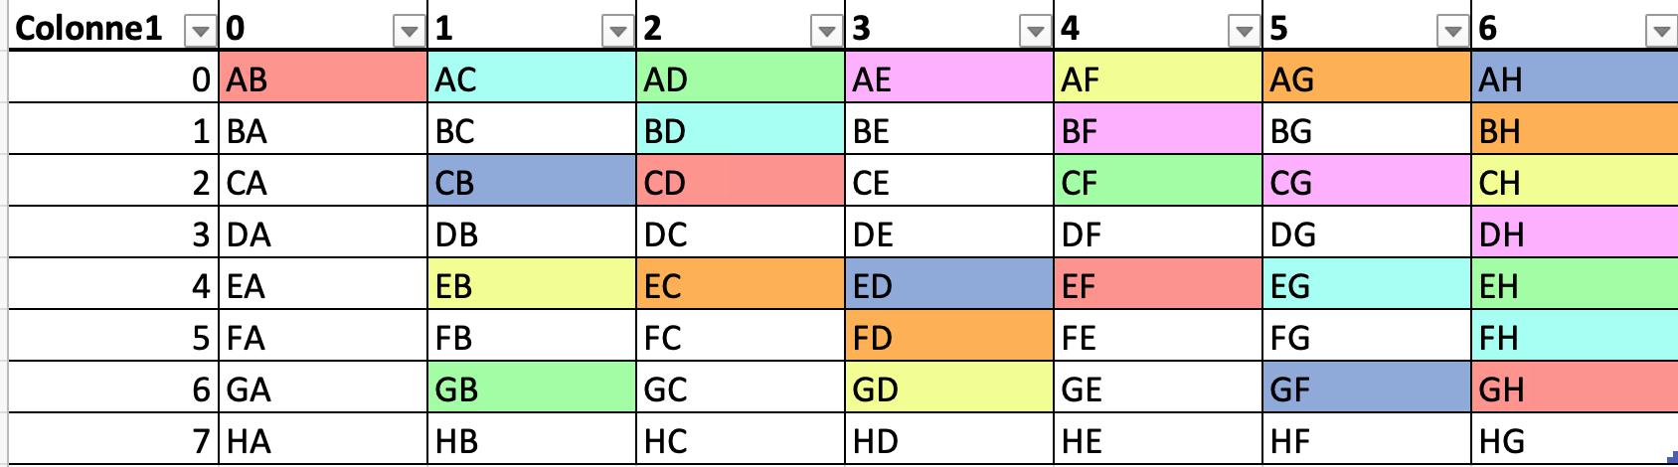

The idea behind my algorithm is to not create new arrays to stock pairs already done,

If we visualise this table above, (example of 8 students), we will see that we can create groups according to 3 conditions :

-If the column number is even (0, 2….) : to get the pairs and not repeat them, we have to move to the right 2 times and go down 2 times .

-If the column number is odd and that number - 1 can be divided by 4 (1,5,9…): to get the pairs we have to go down and right one time, then go down 3 times and move right 3 times, and the 1 down 1 right, 3 down simultaneously (n_students/2 times).

-If the column number is odd but that number -1 can’t be divided by four (3,7,11…) : to get the pairs we have to go down 1 time and move right 1 time until we are done.

(when we are at the bottom and at the right we will go back like a loop )

(we can see the paths of each pais in a different color )

Here for AB its column is 0, so we go down 2times and right 2 times until CD and so on until we have n_students/2 elements in red.

Here for AC since its 1 and 0 can be divided by 4, we firstly go down and right 1 time so BD, then 3 times down and right so EG….

Here for AE since 3-1 can’t be divided by four, we move down and right 1 time so BF->CG…

So our code contains two nested for loops to get the table like the one above.

Then 3 for loops, one for each condition.

At the end we go over all the elements once.