**X-REPORTO**

|  |  |
| --- | --- |
| **Team Members** | |
| **Name** | **Email** |
| **Ahmed Hosny Abdelrazik Abdelghany** | **ahmed.alghany01@eng-st.cu.edu.eg** |
| **Ahmed Sabry Abdelrady Ahmed** | **ahmed.ahmed017@eng-st.cu.edu.eg** |
| **Basma Hatem Farid Elhoseny** | **basma.elhoseny01@eng-st.cu.edu.eg** |
| **Zeinab Moawad Fayez Hassan** | **zeinab.hassan00@eng-st.cu.edu.eg** |

1. **Problem Statement**

Medical diagnosis & automatic report generation of patients’ chest X-rays by denoise image then detect anatomical regions and diseases in each region then writing full medical report using AI solutions.

The project is an AI solution to automatically diagnose chest x-rays by denoising the image, detecting anatomical regions and diseases in each region followed by writing a full medical report.

1. **Motivation**

Reduce high cost of Radiologists’ time by speed up process of diagnosis and create reports of huge number of patients chest x-rays.

A lot of X-rays are pending in a queue where more severe cases have to be checked first.

Shorten the time it takes for radiologists to diagnose patients and generate reports on a large number of chest X-rays.

Many X-rays are waiting in queue, and the more serious cases need to be examined first.

1. 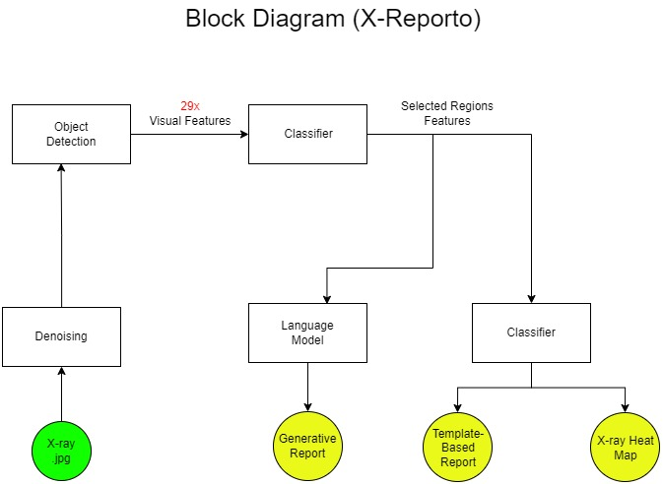**System Architecture**
2. **List of Deliverables**

|  |  |  |  |  |
| --- | --- | --- | --- | --- |
| **Module Name** | **Function** | **Input** | **Expected Output** | **% of used Libraries** |
| Denoising | Remove all possible Device Noises from X-rays while keeping relevant medical information | X-Ray Image | Filtered X-ray image | 5% |
| Region Detection | Detect 29 anatomical medical regions with corresponding visual features of each region | Filtered X-ray Image | 29 visual features along with bounding boxes of each region | 10% |
| Multi-Label Classifier | Detect abnormality in each region then detect diseases | 29 visual features of each region | Selected abnormal visual features of regions to generate report on it with possible diseases in each region | 10% |
| Report Generation | Create full reports using rule based & generative approaches | Selected abnormal visual features with labels | Full report | 5% |
| UI | Annotation tool | results | Corrected results | 12% |
| Integration | Provide tool that combines deployed AI models with interface | X-ray image | Full functionality offered above | 13.5% |

Annotation Functionality:

* Two modes
  + Editing
  + Insertion
* 3-types of editing
  + Bounding Boxes.
  + Disease Classification.
  + Report Editing.
* Saving – Retrieving

Full Functionality:

* Two options
  + View (Old - New).
  + Edit (Old - New).
* Ranking Cases (New).