**X-REPORTO**

|  |  |
| --- | --- |
| **Team Members** | |
| **Name** | **Email** |
| **Ahmed Hosny Abdelrazik Abdelghany** | **ahmed.alghany01@eng-st.cu.edu.eg** |
| **Ahmed Sabry Abdelrady Ahmed** | **ahmed.ahmed017@eng-st.cu.edu.eg** |
| **Basma Hatem Farid Elhoseny** | **basma.elhoseny01@eng-st.cu.edu.eg** |
| **Zeinab Moawad Fayez Hassan** | **zeinab.hassan00@eng-st.cu.edu.eg** |

1. **Problem Statement**

The project is an AI solution to automatically diagnose chest x-rays by denoising the image, detecting anatomical regions and diseases in each region followed by writing a full medical report.

1. **Motivation**

Shorten the time it takes for radiologists to diagnose patients and generate reports on a large number of chest X-rays.

Many X-rays are waiting in queue, and the more serious cases need to be examined first.

1. **System Architecture**

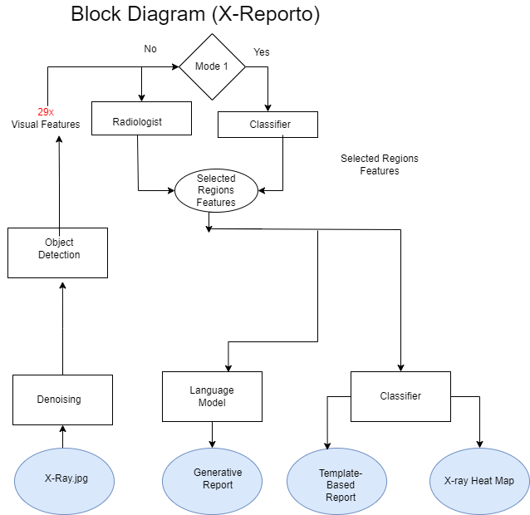

1. **List of Deliverables**

|  |  |  |  |  |
| --- | --- | --- | --- | --- |
| **Module Name** | **Function** | **Input** | **Expected Output** | **% of used Libraries** |
| Denoising | Remove all possible Device Noises from X-rays while keeping relevant medical information | X-Ray Image | Filtered X-ray image | 5% |
| Region Detection | Detect 29 anatomical medical regions with corresponding visual features of each region | Filtered X-ray Image | 29 visual features along with bounding boxes of each region | 10% |
| Multi-Label Classifier | Detect abnormality in each region then detect diseases | 29 visual features of each region | Selected abnormal visual features of regions to generate report on it with possible diseases in each region | 10% |
| Report Generation | Create full reports using rule based & generative approaches | Selected abnormal visual features with labels | Full report | 5% |
| UI | - Annotation tool  - Prioritize cases | Model results | - Corrected results  - Critical cases | 12% |
| Integration | Provide tool that combines deployed AI models with interface | X-ray image | Full functionality offered above | 8% |