SWAPD 453 — Spring 2026
IoT Application Development

Campus Pulse System
Phase 2 Report

Team Members
Sara Mostafa | 202201305 | s-sara.ali@zewailcity.edu.eg
Basmala Alaa | 202201138 | s-basmala.ibrahim@zewailcity.edu.eg
Basmala Amr | 202202213 | s-basmala.abdelfatah@zewailcity.edu.eg
GitHub Repository
https://github.com/Basmala27/iot_Project-

1. Introduction
We started with the Hybrid World Engine — the core protocol layer that extends the Phase 1 physics simulation into a dual-protocol IoT architecture. It implements 100 asynchronous MQTT clients using the gmqtt library and 100 asynchronous CoAP servers using aiocoap, all running concurrently under a single Python asyncio event loop. Each node wraps a Phase 1 Room object so that the thermal model drives both protocol stacks identically. The system also includes a telemetry JSON schema, virtual actuator logic for handling southbound commands, and a DUP flag-based deduplication layer to prevent duplicate message processing across the network.

2. MQTT Nodes
Each MQTT node connects to HiveMQ with a unique Client ID (e.g. campus-mqtt-b01-f01-r101 through campus-mqtt-b01-f10-r1010) and a pre-configured Last Will and Testament. The LWT is published automatically by the broker to the node's status topic if the TCP connection drops, which ThingsBoard reads to mark the device as Offline. All actuator commands arriving on the /cmd topic are subscribed to with QoS 2 (Exactly Once) to guarantee delivery without duplicates. On every 5-second tick, the node runs the Phase 1 physics update and publishes the result to campus/b01/f##/r###/telemetry.

3. CoAP Nodes
Each CoAP node is a UDP server bound to a unique port on 127.0.0.1 using the formula: port = 5683 + (floor−1)×10 + (room_num−11), giving a range of 5683 to 5782 across all 100 nodes. The telemetry endpoint is implemented as an RFC 7641 Observable Resource. The Gateway registers once with a GET request and receives automatic push notifications on every physics tick without polling. Southbound commands arrive as CoAP CON (Confirmable) PUT requests to /f##/r###/actuators/hvac. The node sends a UDP ACK back to stop retransmission, and if a duplicate CON arrives, it returns 2.03 Valid instead of reapplying the command.

4. Virtual Actuator
When a command arrives — whether via MQTT or CoAP — the node calls the same dispatch logic and updates the Room object directly:
- SET_HVAC changes room.hvac_mode to ON, OFF, or ECO, which immediately affects the thermal model on the next tick.
- SET_TEMP updates the target temperature reference.
- SET_OCC toggles occupancy, which changes the heat boost and light level.
- EMERGENCY_LOCKOUT sets HVAC to OFF, occupancy to False, and light level to 0 simultaneously.

After every command, the node publishes a JSON acknowledgement with the new state and a millisecond timestamp used for RTT measurement.

5. Deduplication
The DedupHandler class protects against two categories of retransmission:
- MQTT: When a QoS 1 packet is present with the DUP flag, the broker includes the same packet ID. The handler stores (client_id, packet_id) pairs in a 30-second TTL cache. If the same pair arrives again within that window, the message is silently dropped.
- CoAP: Confirmable messages are retransmitted by the sender until an ACK is received. The handler uses the content_hash field — a 16-character SHA-256 of the sensor readings — to detect byte-identical retransmits. A matched hash returns 2.03 Valid instead of re-applying the command.

6. Telemetry Schema
All 200 nodes emit the same JSON structure regardless of whether they are MQTT or CoAP (schema version 2.0.0):
- Metadata block: sensor ID, building, floor, room number, protocol field ('MQTT' or 'CoAP'), Unix timestamp, and ts_ms in milliseconds for RTT measurement.
- Sensors block: temperature, humidity, occupancy, and light level.
- Actuators block: hvac_mode and lighting_dimmer.
- content_hash: A SHA-256 digest of the sensor values used by the deduplication layer.

7. Async Orchestration, Reliability, and Performance
The entire simulation runs under a single Python asyncio event loop managing 200 concurrent nodes. An async orchestrator coordinates the physics ticks, telemetry publishing, and command handling across all MQTT and CoAP clients without blocking. Reliability features include QoS 2 for MQTT actuator commands, RFC 7641 observe for CoAP telemetry push, and the deduplication layer described above. Performance is measured via RTT timestamps embedded in every telemetry message.

8. Infrastructure & Security (Docker & Configs)
- Dockerized Phase 2 infrastructure setup for the hybrid IoT environment, including HiveMQ CE, ThingsBoard CE, and 10 floor-level Node-RED gateway containers in one unified network.
- Preparation of the cloud backbone and service connectivity, ensuring the system supports the required MQTT/CoAP infrastructure and processing for the campus-scale architecture.
- Provisioning and registration of 200 devices in ThingsBoard, matching the project requirement for full device registry coverage across 100 MQTT nodes and 100 CoAP nodes.
- Construction of the asset hierarchy in ThingsBoard to reflect the required physical topology: Campus → Building → Floor → Room, with devices linked to their corresponding room assets.
- Configuration of ThingsBoard Rule Chains for telemetry routing, threshold-based alerts, and alarm generation, matching the required Rule Engine processing in Phase 2.
- Creation of a real-time ThingsBoard dashboard for telemetry visualization, alarm monitoring, and online/offline fleet health tracking, as required in the cloud monitoring layer.

9. System Screenshots
The following screenshots demonstrate the complete running system across all components: the Node-RED gateway, ThingsBoard cloud platform, Docker container environment, and the Python simulation activating all 100 devices.

9.1 Node-RED Gateway — Flow 2
The Node-RED Flow 2 canvas shows the full routing logic: rt1 through rt17 room nodes feeding into a batch aggregator, a function node for payload transformation, and a CoAP request node forwarding telemetry upstream. The MQTT topic campus/b01/f01/+/cmd and campus/b01/f01/+/telemetry topics are visible in the connecting nodes.
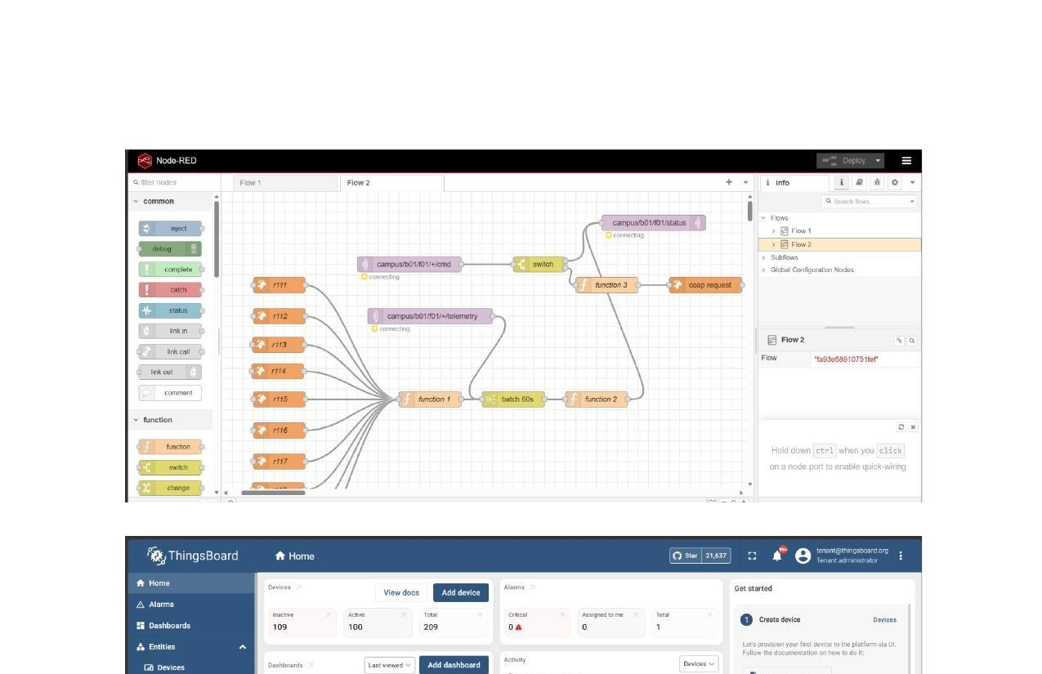
Figure 1 — Node-RED Flow 2 — gateway routing logic for all room nodes

9.2 ThingsBoard CE — Home Dashboard
ThingsBoard confirms 100 Active devices and 209 Total registered devices. The Activity graph shows telemetry flowing in over the last 30 days. The phase2 dashboard is listed under Dashboards, last viewed 5 minutes ago.
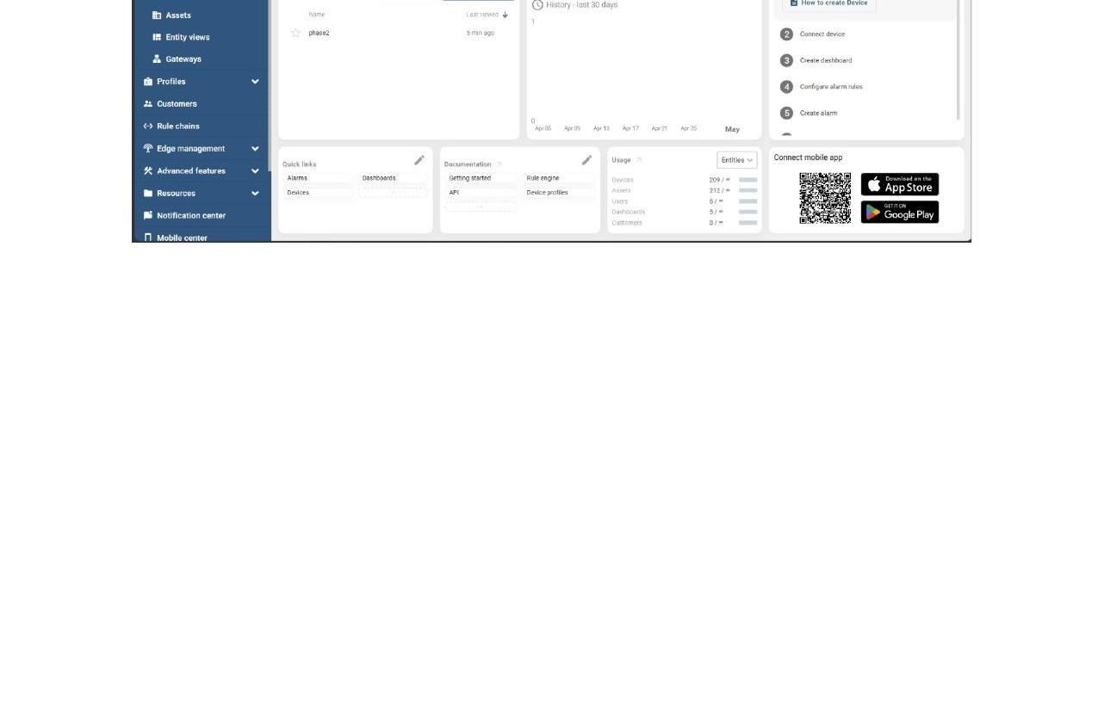
Figure 2 — ThingsBoard CE home — 100 active devices, activity graph, and phase2 dashboard

9.3 Docker — ThingsBoard Container Logs
The ThingsBoard container (107ae5f45886) is shown Running with STATUS for 14 minutes. The logs display healthy DefaultTbEntityDataSubscriptionService stats, confirming zero alarm or query invocation errors across all scheduler threads.
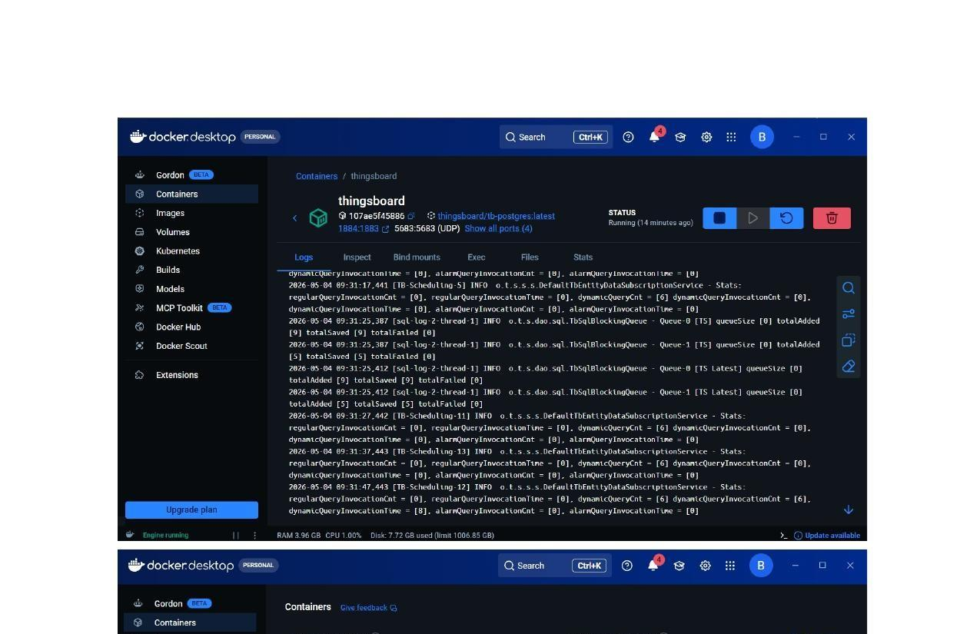
Figure 3 — Docker Desktop — ThingsBoard container logs confirming healthy operation

9.4 Docker — All Running Containers
Docker Desktop lists all 6 containers: campus-pulse (8.7% CPU, 9 min), thingsboard (7.98% CPU, 16 min), hivemq (0.72% CPU, 9 min), and three gateway containers in stopped state. Total CPU usage is 8.70% across 16 cores; memory usage is 2.13 GB / 7.26 GB.
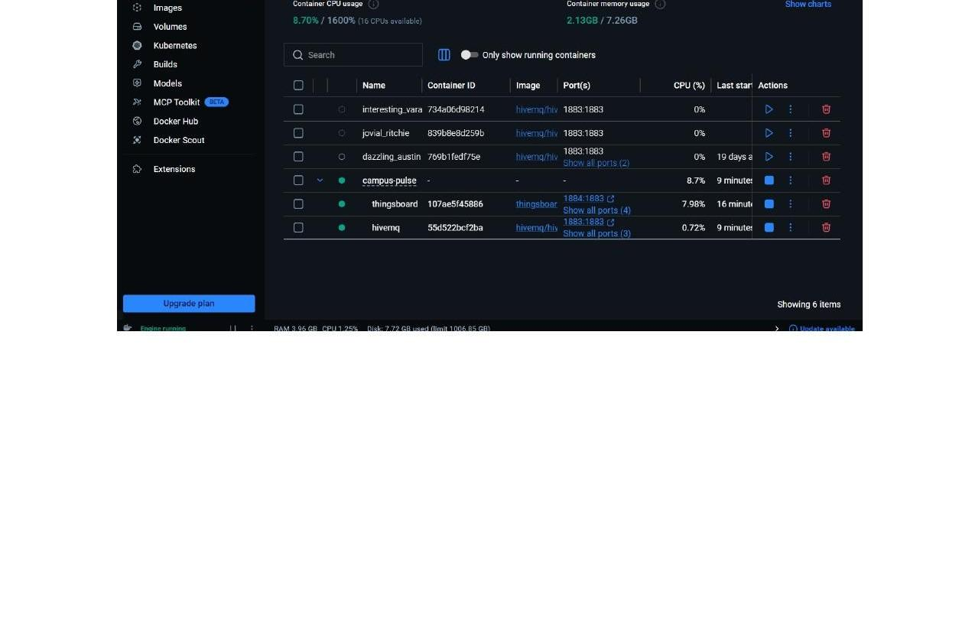
Figure 4 — Docker Desktop — all containers overview with CPU and memory stats

9.5 VS Code — Node-RED Startup & Project Structure
The VS Code explorer (left) shows the campus-pulse project tree including phase2 nodes (coap_node.py, mqtt_node.py), reliability scripts, and supporting files. The terminal (top-right) shows Node-RED starting, loading palette nodes, installing node-red-contrib-coap v0.8.0, and adding CoAP node types before stopping flows.
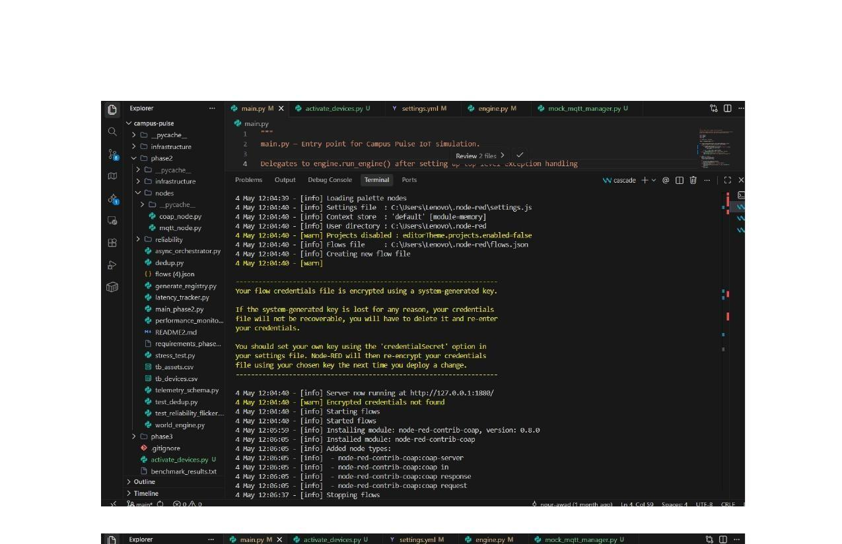
Figure 5 — VS Code — campus-pulse project structure and Node-RED startup terminal output

9.6 VS Code — Device Activation Script (100/100 Devices)
The bottom terminal runs activate_devices.py, sequentially activating nodes 4-03 through 4-10 and beyond. Each node publishes a message and connects to ThingsBoard MQTT. The script finishes with "Finished! Activated 100/100 devices. Devices should now appear as active in ThingsBoard."
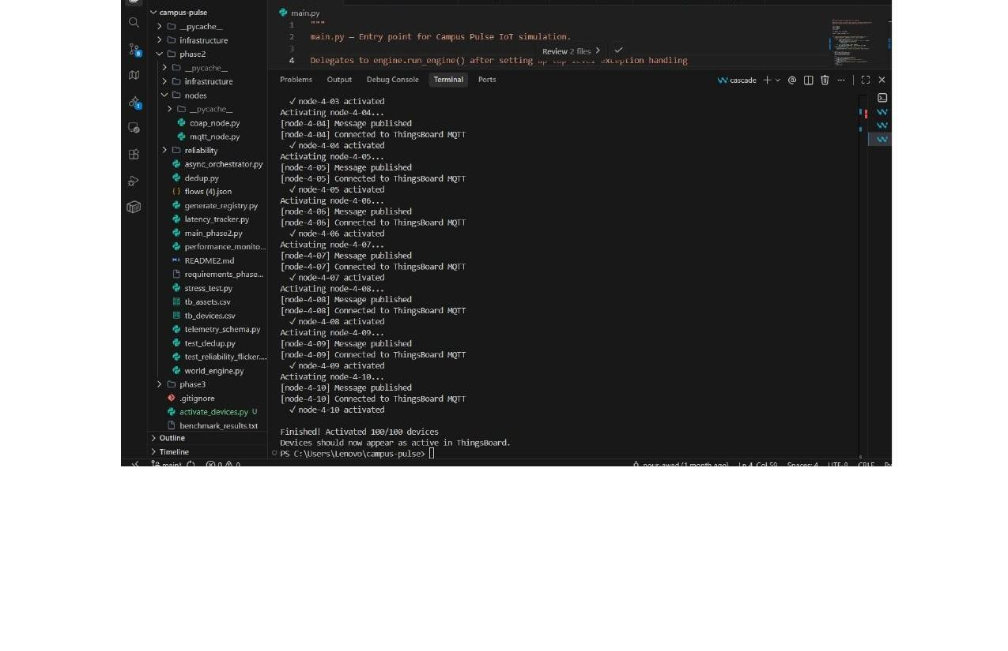
Figure 6 — VS Code — activate_devices.py output confirming 100/100 devices activated in ThingsBoard

