**WindowBuilder Setup Instructions**

1. Click on the Help menu on your eclipse Juno and select “Install New Software” submenu.

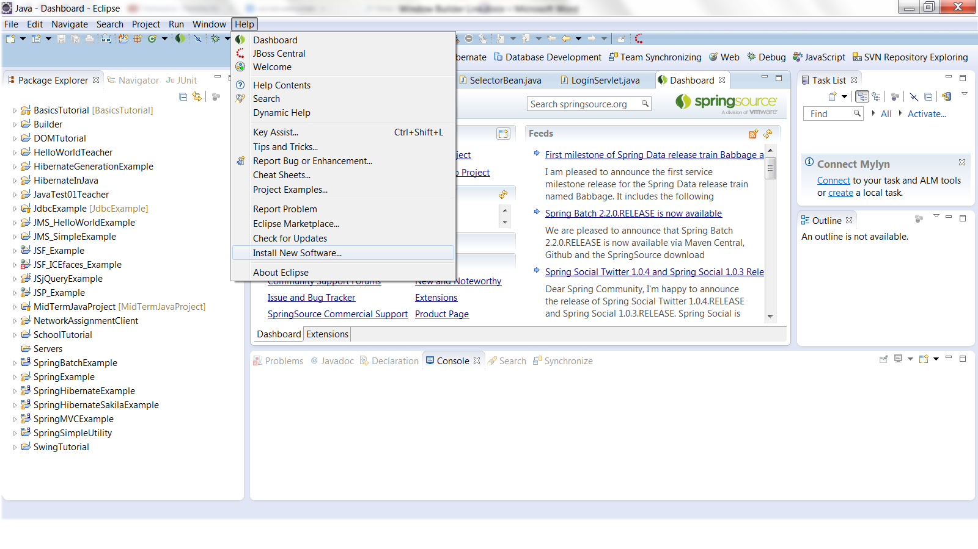

1. Click on Add button on the next screen.

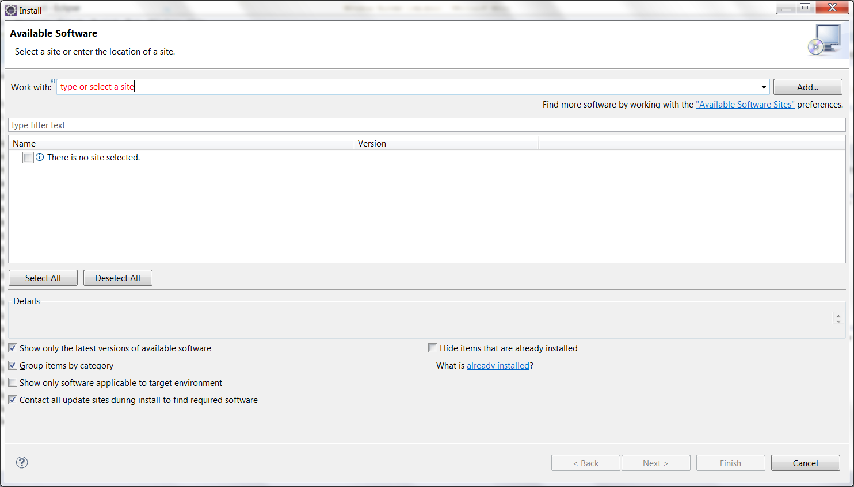

1. “Add Repository” window will pop up.

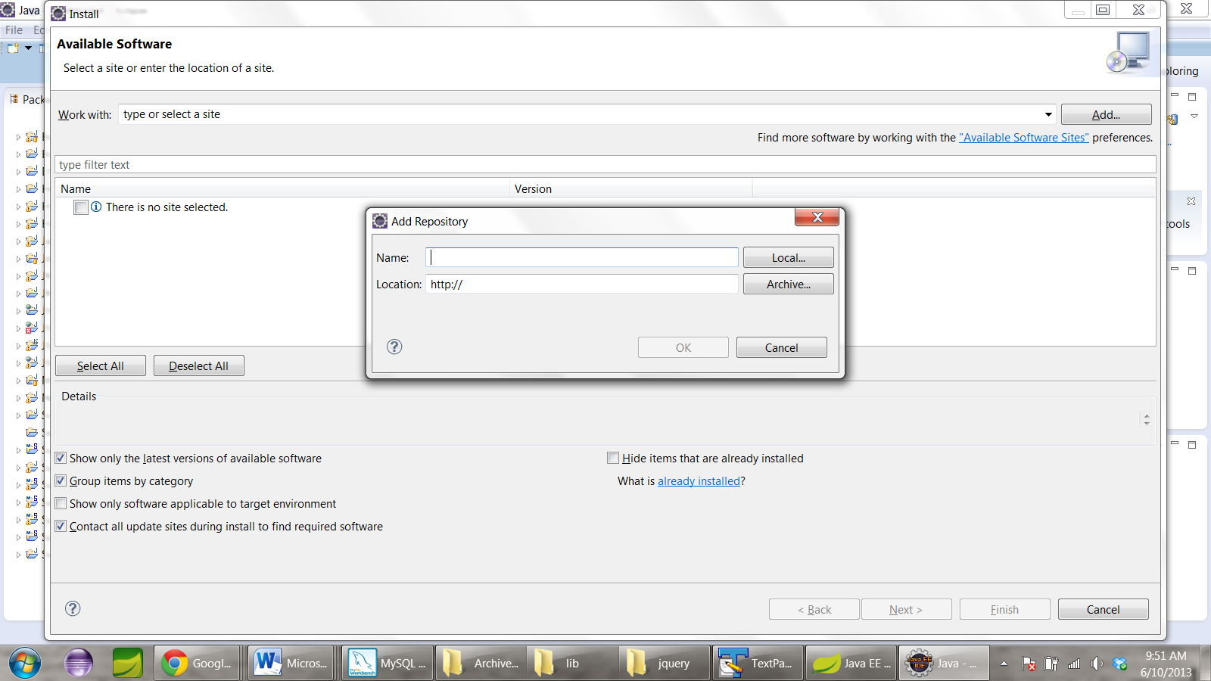

1. Type WindowBuilder in the Name field on the “Add Repository” pop up window and paste the following link in location field:

<http://download.eclipse.org/windowbuilder/WB/release/R201209281200/4.2/>

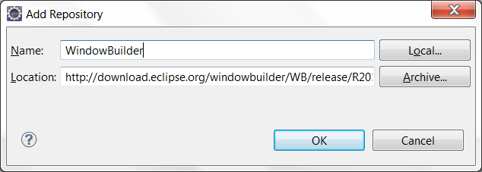

1. Click on “Select All” button and click Next button.

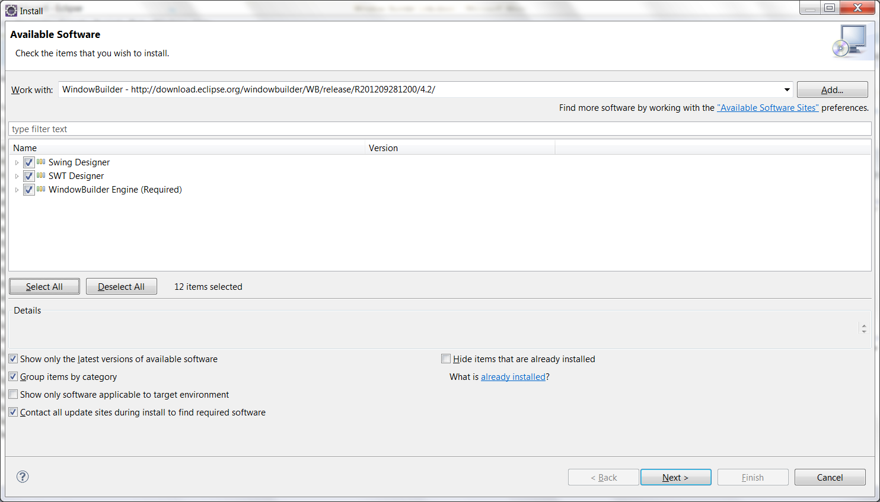

1. Click Next button and then click Finish button on the next screen when installation is finished.

**WindowBuilder Tutorials**

Window Builder Tutorial link:

<http://www.java-javafx.com/2011/01/windowbuilder-pro-hello-world-java.html>

<http://www.macs.hw.ac.uk/guidebook/>

Youtube video tutorial link:

<http://www.youtube.com/watch?v=cWbQ07ScIN8>

**Swing Tutorials**

Swing Tutorial link:

<http://www.macs.hw.ac.uk/guidebook/>

**Assignment**

Either use WindowBuilder and/or code from scratch to do this assignment.

Create a window similar to the following window:

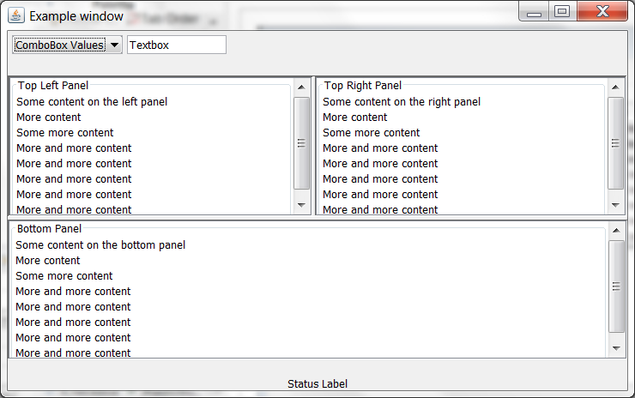

Add appropriate event listeners to the combo box and the lists so that when an item in the combo box is selected or an item in the list is double clicked the selected item will be displayed in the textbox. Also, the corresponding event should be displayed in the status label.