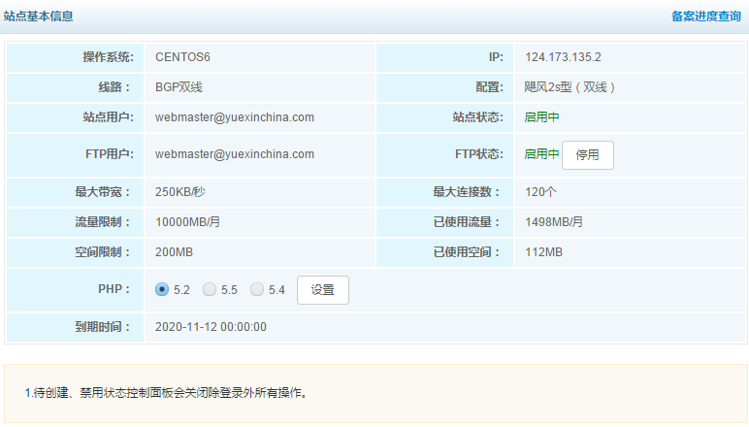

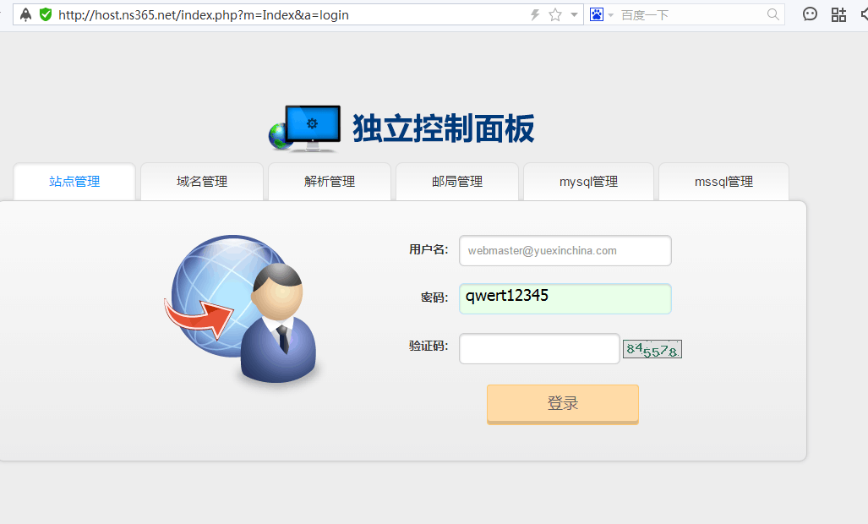

<http://host.ns365.net/index.php>

[webmaster@yuexinchina.com](mailto:webmaster@yuexinchina.com)

qwert12345

FTP

IP:124.173.135.2  
  
[webmaster@yuexinchina.com](mailto:webmaster@yuexinchina.com)  
  
密码：qwert12345

