Livo

Cross-platform streaming app for movies, series, live TV, and sports with an adaptive HLS player and bilingual AR/EN UX.
Category: Streaming App
Company / Context: Rand LLC
Tech Stack: Flutter, Dart, BLoC, Clean Architecture, GoRouter, GetIt, Retrofit, Dio, HLS

Summary
A cross-platform streaming app covering movies, series, live TV, sports, and clips — built on Clean Architecture with BLoC, phone-OTP auth, an HLS video player (fullscreen, PiP, subtitles, quality selection), and bilingual Arabic/English support.

Overview
Livo is a cross-platform streaming mobile app covering movies, series, live TV, sports, and short clips. It delivers tab-based navigation with deep-linked detail flows, explore/search across content types, and a production-grade HLS video player with fullscreen, picture-in-picture, subtitles, quality selection, and playback-speed controls.
The codebase follows Clean Architecture per feature module — data, domain, and presentation layers — with BLoC/Cubit state management, repository and use-case patterns, Either<Failure, T> error handling (dartz), and dependency injection via GetIt. REST APIs are integrated through Retrofit + Dio with auth interceptors, automatic token refresh on 401, secure storage, and centralized failure mapping.

Key Features

Streaming & Content
- Movies, series, live TV, sports, and clips with tab-based shell navigation
- Deep-linked detail flows for each content type
- Carousel banners, marquee text, and read-more descriptions
- Kids mode for family-friendly browsing
- Mock data sources alongside remote APIs for development and demos

Video Player
- HLS/network video player with adaptive streaming
- Fullscreen playback and picture-in-picture support
- Subtitles, quality selection, and playback-speed controls
- Download manager scaffold (flutter_downloader + isolate callback) for offline media

Explore & Search
- Debounced search with multi-type results
- Filter bottom sheet — tags, sort, year, and rating
- Cached network images for performant poster/thumbnail loading

Authentication & Profile
- Phone OTP authentication — register, verify, login, reset/change password
- Secure token storage with automatic refresh-token retry on 401
- Profile management with image crop and upload
- Help center, contact flows, and account deletion
- Localized form validation and password strength indicator in AR/EN

Architecture & Reliability
- Clean Architecture with feature modules, repositories, and use cases
- BLoC/Cubit state management with GetIt dependency injection
- GoRouter shell navigation with auth guards and nested library routes
- Retrofit + Dio REST layer with code generation (build_runner)
- Global error handling, remote error logging, and connectivity checks
- Responsive layouts (ScreenUtil), skeleton loaders, and asset codegen (flutter_gen)
- Environment config via .env and bilingual AR/EN localization with RTL support

Screenshots
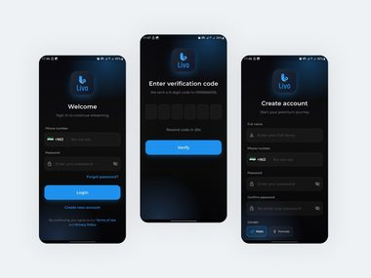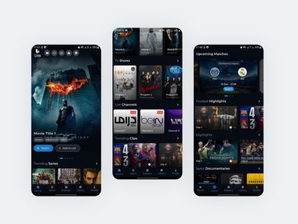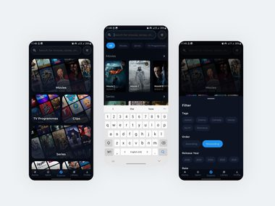

DoReMi

Cross-platform music streaming app for music, podcasts, radio, and video with offline downloads and premium subscriptions.
Category: Music Streaming
Company / Context: Rand LLC
Tech Stack: Flutter, Dart, BLoC, Clean Architecture, GoRouter, GetIt, Retrofit, just_audio, SQLite, Firebase
Links: Google Play

Summary
A cross-platform music streaming app serving music, podcasts, radio, and video — built with Clean Architecture across 15+ feature modules and 100+ domain use cases, background audio playback, offline-first SQLite downloads, deep linking, and a full subscription system that doubled the user base within six months.

Overview
DoReMi is a cross-platform music streaming app serving music, podcasts, radio, and video from a single Flutter codebase for Android and iOS. It ships bilingual (English/Arabic) support with full RTL layout, light/dark themes, and responsive UI — and doubled its user base within six months of release.
The app is engineered on Clean Architecture with 15+ feature modules and 100+ use cases separating business logic from UI, BLoC state management, dependency injection with GetIt, and functional error handling via dartz (Either/Failure pattern). The REST API layer uses Retrofit + Dio with code generation, session/auth interceptors, and environment-based configuration.

Key Features

Music & Content
- Music, podcasts, radio, and video streaming from a unified library
- GoRouter shell navigation — Home, Search, Library, and Premium tabs
- Lyrics display and rich media browsing across content types
- Cached network images and shimmer/skeleton loading states

Audio Playback
- Background audio with just_audio and audio_service
- Queue management with shuffle, repeat, and system media controls
- Mini player and continuous playback across app navigation
- Video playback via flick_video_player and video_player

Offline & Downloads
- Offline-first download system with SQLite persistence for metadata
- Background downloads for songs, videos, and podcast episodes
- Download progress tracking and offline playback when content is saved

Subscriptions & Monetization
- Premium subscription flows — bundles, trials, promo codes, and auto-renewal
- Ad-supported free tier alongside premium gating
- VPN detection for geo/licensing compliance (optional enforcement)

Deep Linking & Notifications
- Android App Links — playlists, albums, artists, and songs open directly in-app
- Cold-start deep link handling — splash → home → target content
- Firebase Cloud Messaging with push notification deep-link routing

Architecture & Engineering
- Clean Architecture — 15+ feature modules with data / domain / presentation layers
- 100+ use cases, BLoC state management, and GetIt dependency injection
- Type-safe REST API with Retrofit + Dio and build_runner code generation
- Secure storage for sensitive data + SharedPreferences for app state
- Environment-based config (.env via flutter_dotenv) and session interceptors
- Unit tests for BLoCs (bloc_test, mocktail), integration tests, and widget tests

Screenshots
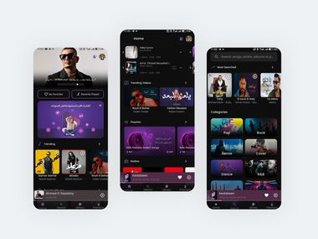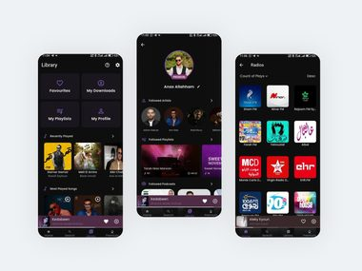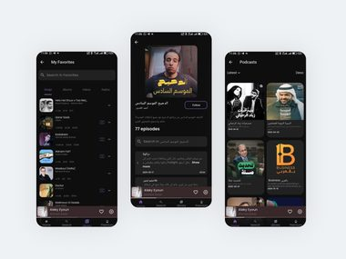

QuickSale

Full-featured classifieds marketplace with ads, stores, real-time chat, reels, and bilingual AR/EN support.
Category: Marketplace App
Company / Context: Freelance Project (Almahairi company)
Tech Stack: Flutter, GetX, Pusher, Firebase, Google Maps, Crashlytics
Links: Google Play | App Store

Summary
A full-featured classifieds marketplace app in Flutter with ads, stores, real-time Pusher chat, reels, and job/CV flows — featuring a multi-step ad creation wizard, dual user/store account modes, Firebase push notifications with deep linking, and bilingual Arabic/English RTL/LTR experience across 40+ screens.

Overview
QuickSale is a full-featured classifieds marketplace app built in Flutter, enabling users to browse and post ads, manage stores, chat in real time, share reels, and apply for jobs — all in a bilingual Arabic/English experience with full RTL/LTR support. The platform attracted 300+ listings within its launch month.
The app follows a layered architecture — presentation (UI + GetX controllers) → data (repos, DTOs, models) → core (services, config) — with repository pattern, GetX dependency injection, and Dio HTTP client with multipart uploads for images, videos, and chat attachments. It integrates Firebase (FCM push notifications, Crashlytics), Pusher for real-time messaging, and deep linking for ads, stores, users, and chat conversations.

Key Features

Marketplace & Ads
- Multi-step ad creation wizard with dynamic category filters and map-based location
- Rich ad postings — images, video, categories, pricing, and geolocation
- Dual user/store account modes with account-to-store conversion
- Reviews, follow system, blocking, and reporting for trust & safety
- Job/CV flows with document attachments
- Guest mode with login prompts when authentication is required

Real-time Chat
- Pusher-powered messaging with text, images, video, and voice messages
- In-app notification center with typed notifications
- Deep links route directly to ads, stores, users, and chat conversations

Media Handling
- Image picker, cropper, and reorderable gallery for ad listings
- Video player, thumbnail generation, trimming, and compression for reels
- Cached network images/videos and shimmer skeleton loaders
- File picker for documents (CV attachments, account files)

Maps & Location
- Google Maps integration for ad/store location selection
- Geolocator & geocoding for device location
- Hierarchical location filtering — country → city → area

Notifications & Engagement
- Firebase Cloud Messaging — foreground, background, and terminated states
- Local notifications with bilingual title/body fallback
- Deep linking via app_links for ads, stores, users, and chats

Architecture & Production
- Layered architecture with repos, DTOs, and paginated API models across 40+ screens
- GetX state management with centralized routing and navigation manager
- Dio HTTP client with logging, token auth, and structured error handling
- Local caching with GetStorage (auth, language, account mode)
- Firebase Crashlytics, Facebook App Events with iOS ATT compliance
- Environment config (.env), asset codegen (flutter_gen), and in-app update prompts

Screenshots
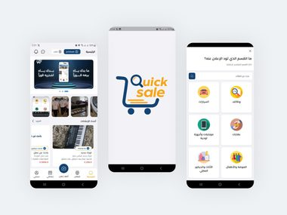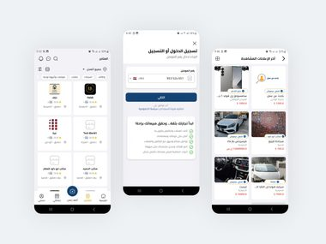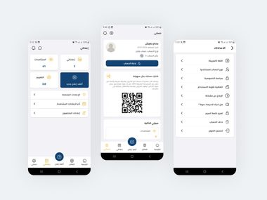

Goalatho

Sports booking app to discover nearby football pitches, check real-time slot availability, and manage reservations.
Category: Sports Booking
Company / Context: Personal Project
Tech Stack: Flutter, Dart, GetX, GetIt, Google Maps, Firebase, JWT

Summary
A Flutter sports booking app enabling users to discover nearby football pitches, check real-time slot availability, and manage reservations end-to-end — with phone OTP auth, Firebase push notifications, Google Maps venue discovery, an offline tournament bracket system, and bilingual Arabic/English support.

Overview
Goalatho is a Flutter sports booking app for iOS and Android that enables users to discover nearby football pitches, check real-time slot availability, and manage reservations end-to-end. It delivers location-aware pitch discovery using GPS, Google Maps, and backend-driven home feeds (trending, nearby, and new venues).
The app is built on a modular GetX architecture with feature modules (auth, home, search, bookings, teams, etc.), GetIt + GetX dependency injection, and a Dio API layer with pagination, filtering, sorting, and centralized error handling. It ships bilingual Arabic/English support with RTL layout, theme switching, and locale-aware API headers.

Key Features

Venue Discovery & Booking
- Discover nearby football pitches with GPS and Google Maps integration
- Real-time slot availability and end-to-end reservation management
- Backend-driven home feeds — trending, nearby, and new venues
- Debounced search, pull-to-refresh, and pagination across listings
- Booking status tracking and cancellation flows

Authentication
- Phone registration with OTP verification and password reset
- Secure JWT token storage with flutter_secure_storage
- Session-aware navigation and automatic logout on invalid tokens

Notifications
- Firebase Cloud Messaging with foreground/background handling
- Local scheduled booking reminders
- Type-based deep navigation from push notification payloads

Tournament System
- Offline tournament bracket system with knockout generation
- Team and logo management with local persistence
- Championship data stored locally for offline access

Architecture & Platform
- Feature-based modular GetX architecture with GetIt DI
- Dio API client with auth tokens, request logging, and version/language headers
- Firebase Core + Messaging with background message handlers
- SharedPreferences + secure storage for app state and credentials
- Skeleton loading, Lottie animations, and responsive design (ScreenUtil)
- Environment config via dotenv, flutter_gen assets, and app version checking

Screenshots
