Steps :

1. I downloaded a yolo version 3 weights trained on coco data set
2. extracting the model weights from the "yolov3.weights" file into a suitable format that can be used for keras.
3. For feature extraction Yolo uses Darknet-53 neural net pretrained on ImageNet. Same as ResNet, Darknet-53 has shortcut (residual) connections.
4. Doing prediction on 15 images and see the result.

Result:

You will find 2 pages for each image:

First page: contain input and output image

Second page: contains all predicted classes and their accuracy

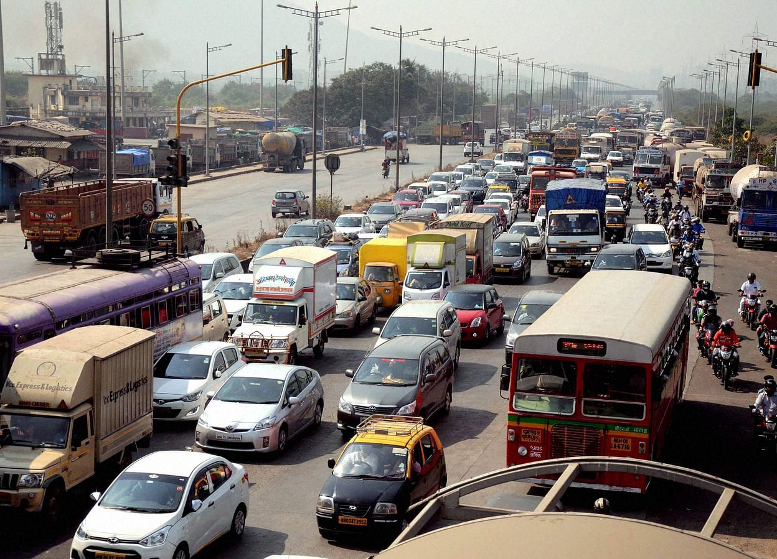

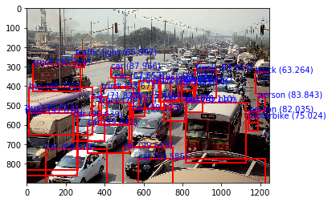

bus 86.71530485153198

bus 92.09652543067932

car 99.57752823829651

car 99.61285591125488

car 91.58490300178528

truck 90.32441973686218

truck 89.91263508796692

truck 63.26409578323364

truck 86.94174885749817

truck 78.71235013008118

truck 74.35351014137268

car 71.87543511390686

truck 93.67253184318542

car 75.4656434059143

car 99.18839931488037

truck 78.18121910095215

car 99.639493227005

car 99.12258386611938

bus 72.43264317512512

car 99.64219331741333

truck 92.07364916801453

traffic light 65.99663496017456

car 87.96579241752625

car 67.65211224555969

car 71.27220630645752

car 92.82448887825012

person 83.84329080581665

car 75.11040568351746

person 82.03539252281189

motorbike 75.02418160438538

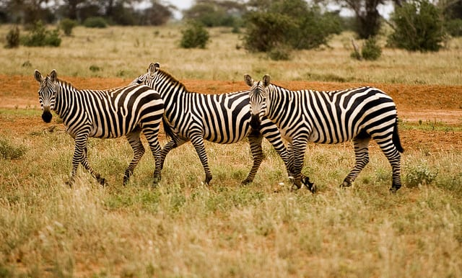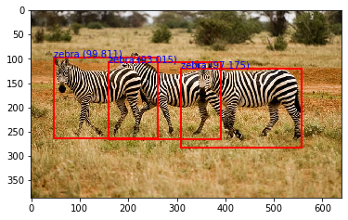

zebra 99.81138110160828

zebra 93.01466345787048

zebra 97.17503190040588



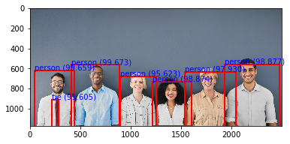

person 99.67312216758728

person 97.92967438697815

person 98.87737035751343

person 99.65869188308716

person 95.62336802482605

person 98.87438416481018

tie 91.60534739494324

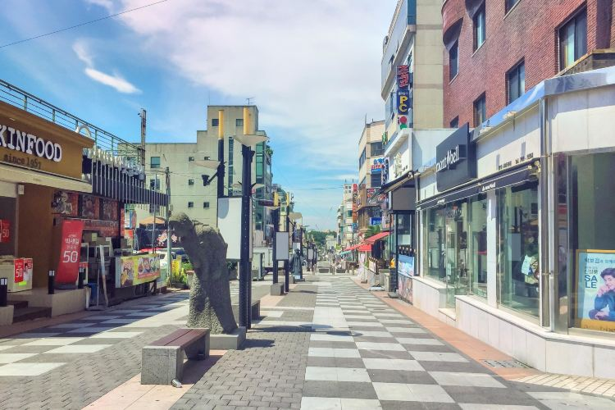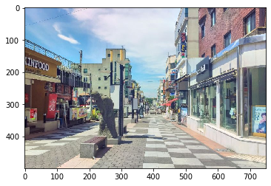

This image doesn`t contain objects from coco data set so there is no boxes here

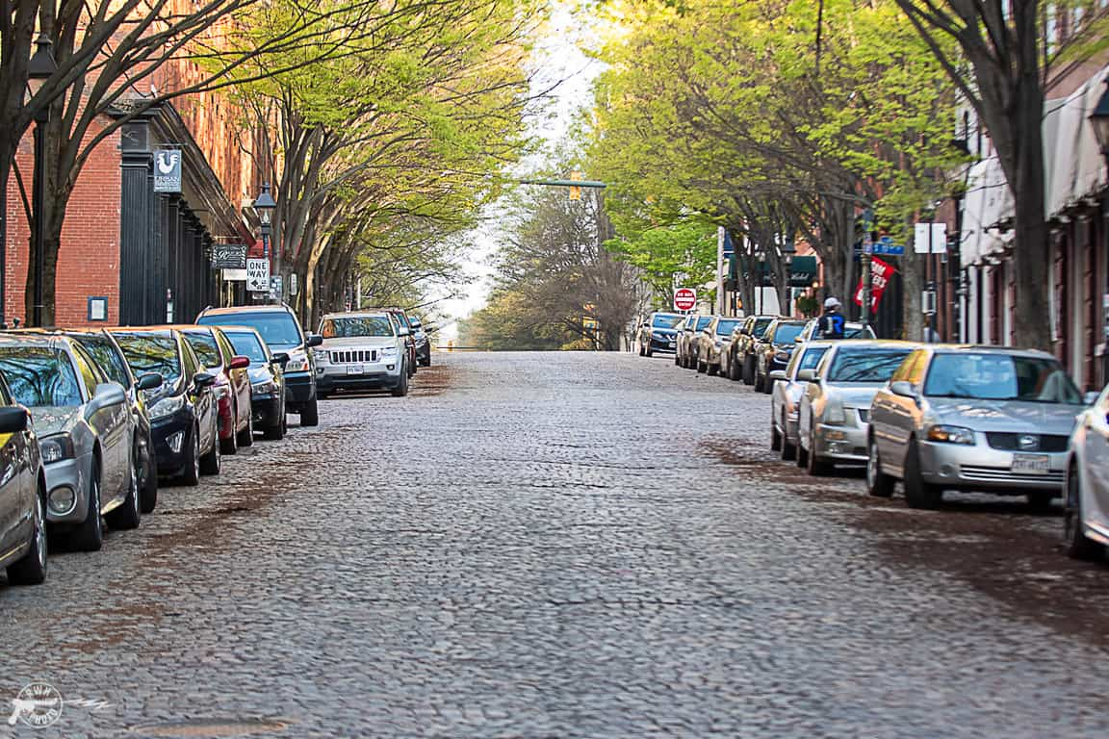

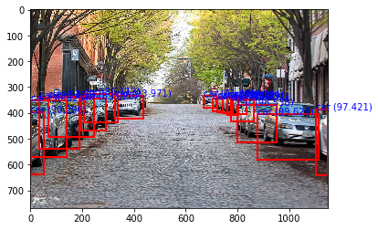

car 99.62821006774902

car 96.11257910728455

car 93.97056698799133

car 87.9069447517395

car 92.13215112686157

car 89.02607560157776

car 98.41569066047668

car 98.53810667991638

car 99.52540993690491

car 97.42095470428467

car 90.29631018638611

car 91.9814944267273

car 72.30366468429565

car 78.00403237342834

car 91.32106900215149

car 62.13405728340149

car 71.79084420204163



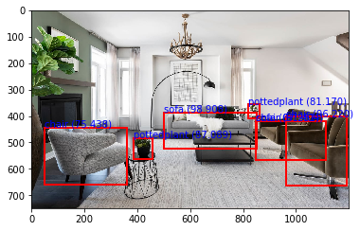

sofa 98.9078938961029

chair 91.40361547470093

sofa 67.25090742111206

chair 75.43807029724121

pottedplant 87.08899021148682

chair 96.21989727020264

pottedplant 81.16973042488098

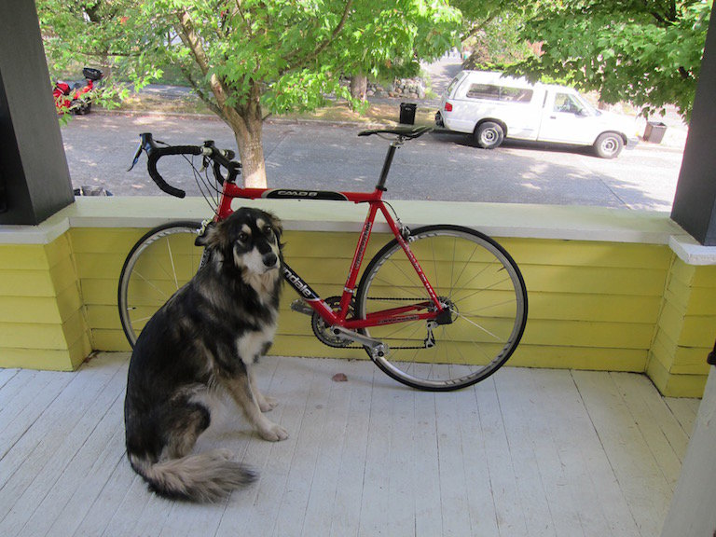

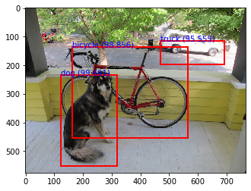

truck 95.55460214614868

bicycle 98.85594844818115

dog 99.6908962726593

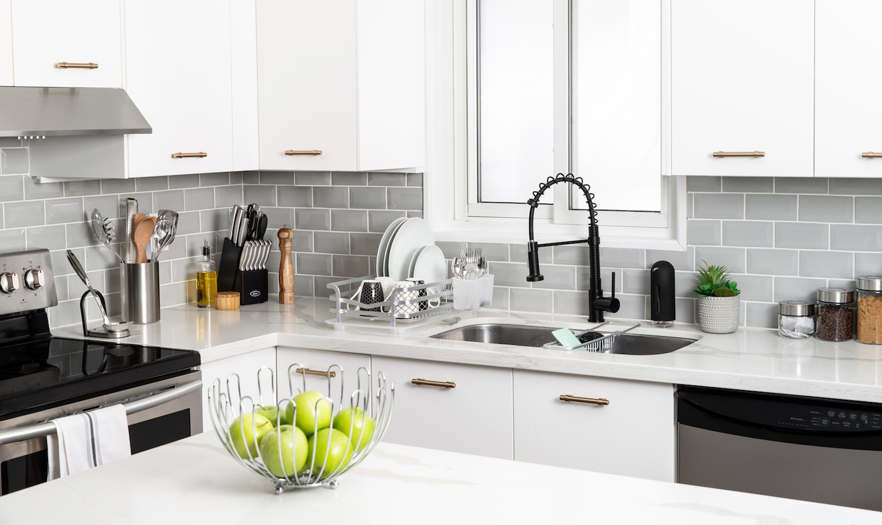

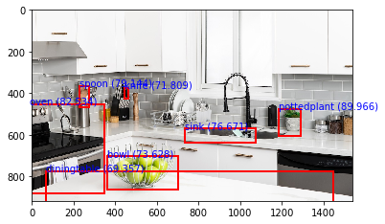

oven 82.5343132019043

bowl 73.62767457962036

diningtable 69.35704350471497

pottedplant 89.9655282497406

sink 76.67095065116882

knife 71.8088686466217

spoon 79.14352416992188

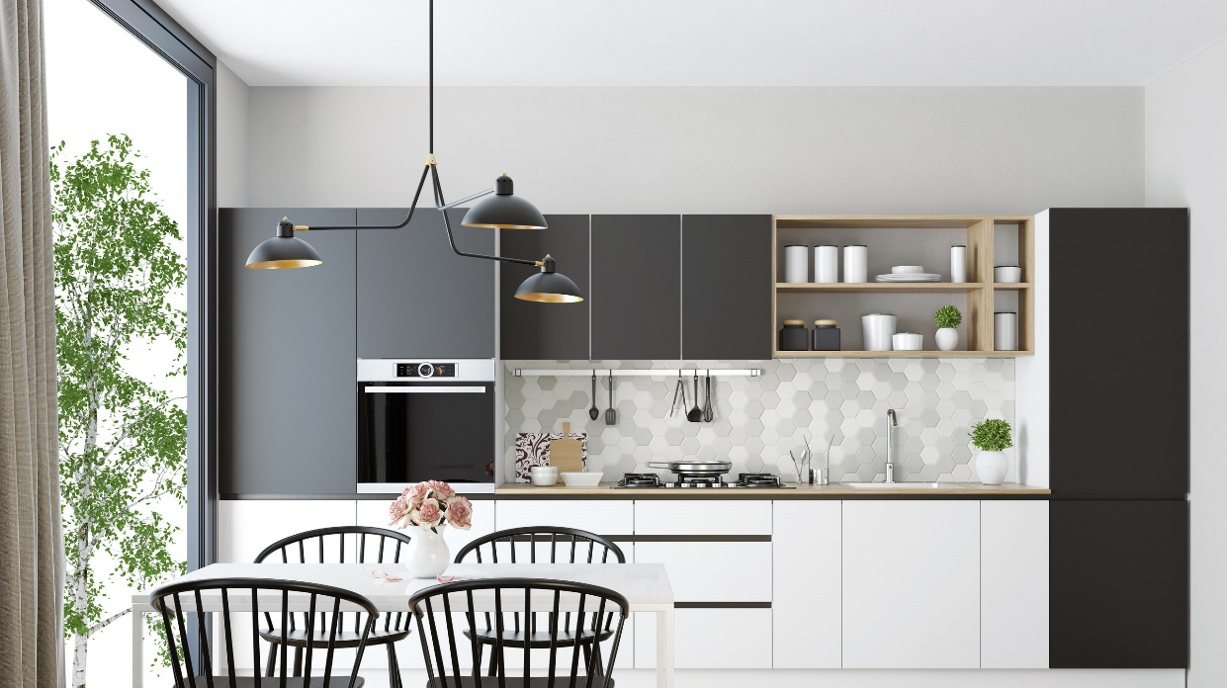

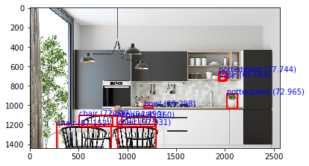

chair 97.15163111686707

chair 72.01734185218811

chair 90.36033749580383

chair 97.93116450309753

pottedplant 77.74370908737183

vase 65.06442427635193

pottedplant 72.9654848575592

bowl 89.29803371429443

vase 94.49032545089722



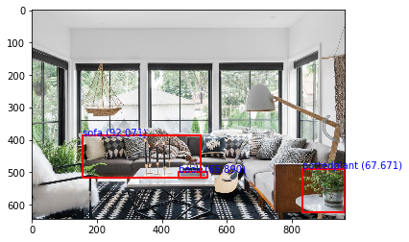

sofa 92.07144975662231

pottedplant 67.67076849937439

book 65.89049696922302



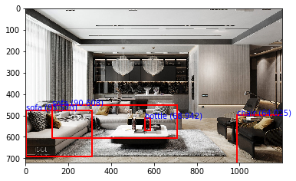

sofa 90.60773849487305

sofa 93.57001185417175

chair 64.02499079704285

bottle 68.94187331199646

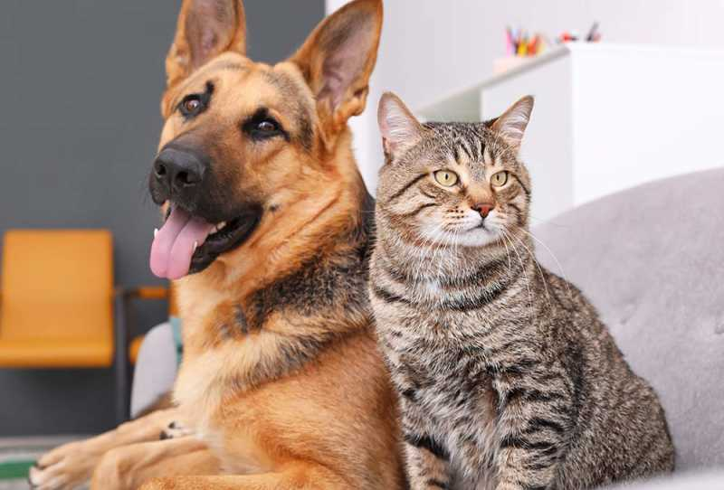

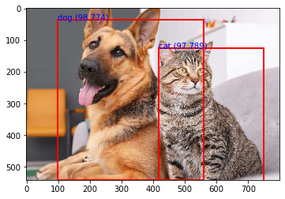

dog 98.77366423606873

cat 97.78891801834106



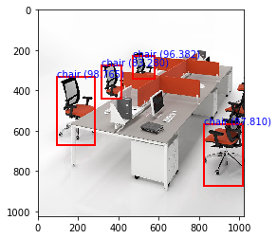

chair 96.38246893882751

chair 83.27967524528503

chair 98.76542091369629

chair 87.81033158302307

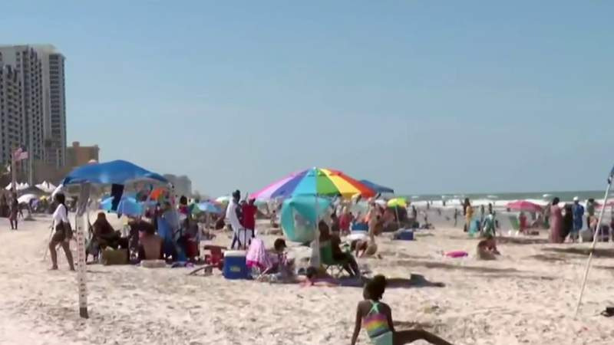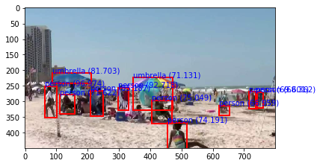

umbrella 81.70287013053894

umbrella 71.13131880760193

person 92.71802306175232

person 96.973717212677

person 71.6219425201416

person 85.18723249435425

person 75.04921555519104

person 74.19105768203735

person 69.60097551345825

person 68.36230158805847

person 66.95910692214966

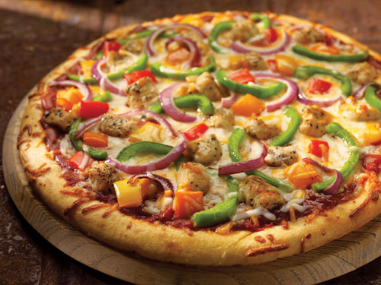

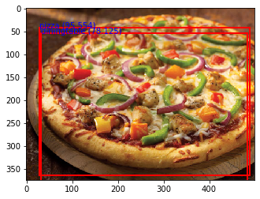

pizza 95.55433392524719

diningtable 78.12528014183044

there is a prediction for pizza with high confidence and there is a wrong prediction of diningtable here