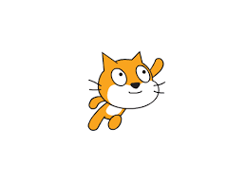

Getting Started With

**SCRATCH**

uSER MANUAL

* Mubeen Siddiqui(19K-1276)
* Bassam Tariq(19K-0152)
* Ahmed Raza(19K-0134)

# GETTING STARTED

* **SCRATCH** is a programming language that lets you create your own interactive stories, animations, games, music, and art

## 

* This guide shows you how to make a project in **SCRATCH**



To start a new project online, go to SCRATCH ONLINE and click **Create**.



If you have a SCRATCH account, sign in so your project saves.

# START MOVING

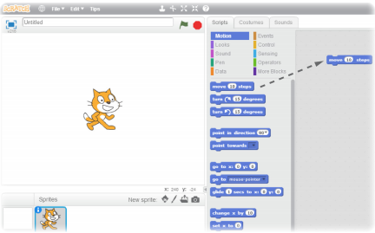

Drag a **MOVE** block into the **Scripts** area

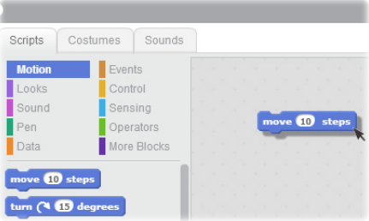

Click on the block to make the cat move.

# ADD A SOUND

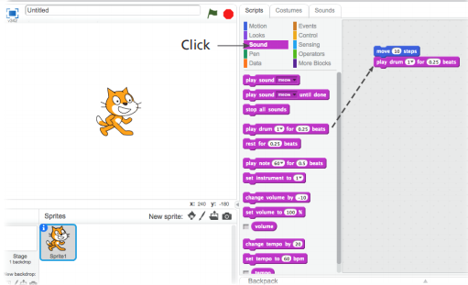

Drag out a **PLAY DRUM** and snap it onto the **MOVE** block.

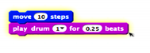

Click and listen.

*If you can’t hear it, check that the sound on your computer is on.*

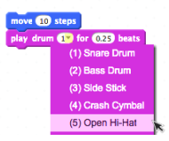

You can choose different drums from the pull-down menu.

# LOOPS (REPETITION)

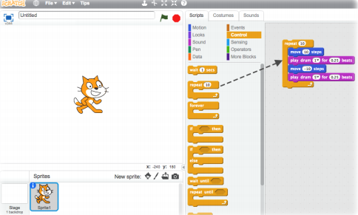

Drag out a **REPEAT** block and drop it on top of the stack.

You want the mouth of the **REPEAT** to wrap around the other blocks.

*To drag a stack, pick it up from the top block.*

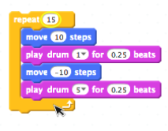

You can change how many times it repeats.

Click to run

*You can click on any block to run a stack.*

# SPEECH

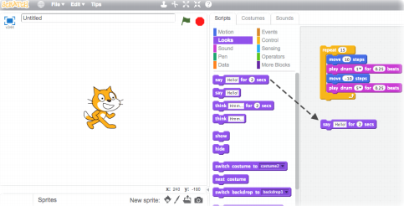

Click the **LOOKS** category and drag out a **SAY** block.

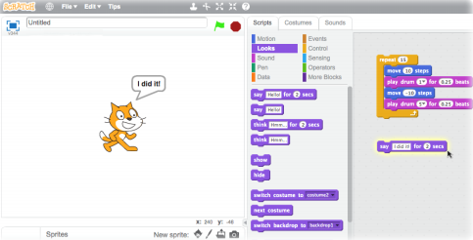

Click inside the SAY block and type to change the words.

Click to try it.

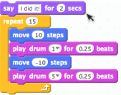 Then snap the **SAY** block on the top.

# THE GREEN FLAG

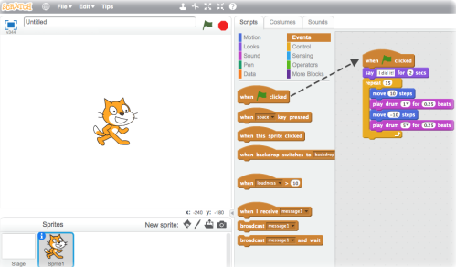

Drag out a  block and snap it on top.

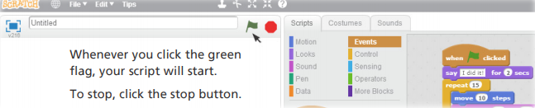

Whenever you click the green flag, your script will start.

To stop, click the **stop** button.

# KEY PRESS

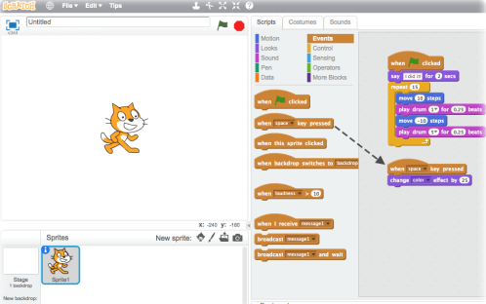

Snap on a

Now press the space bar on your keyboard.

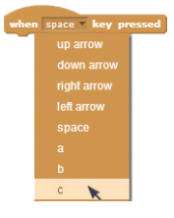

You can choose a different key from the pull-down menu.

# ADD A SPRITE

Each object in **Scratch** is called a sprite.

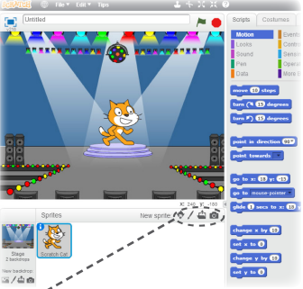

* To add a new sprite, click one of these buttons.

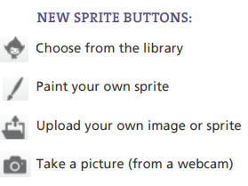

Now you can tell the sprite what to do.

# EXPLORE

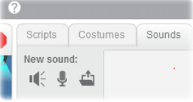

**ADD SOUND**

Click the SOUNDS tab.

You can Choose a sound, Record your own or Import a sound file.

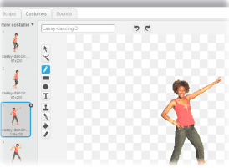

**CHANGE COSTUMES**

Each sprite can have more than one costume.

To change the current costume, click the COSTUMES tab. Then click on a different costume for the sprite.

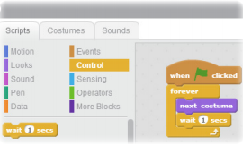**ANIMATE**

You can animate a sprite by switching between costumes.

Click the SCRIPTS tab. Create a script that switches between costumes.

* To find out more, click **HELP** or go to http://scratch.mit.edu/help