**Abstract:**

Generative Adversarial Networks (GANs) for Smart Agriculture

Smart agriculture aims to enhance agricultural productivity, minimize environmental impact, and ensure sustainable farming practices. Early detection and classification of plant diseases are crucial for reducing yield losses. Machine learning techniques, including deep learning and generative adversarial networks (GANs), have shown promise in automating image classification tasks. This study focuses on using GANs to classify plant photos into healthy and diseased categories, supporting smart agricultural practices. In farming robotics, fast and accurate image segmentation is essential for targeted treatments, distinguishing crops from weeds in real-time. Current solutions rely on visual classifiers trained on annotated datasets, which is time-consuming. This research addresses the crop/weed segmentation challenge by employing a synthetic image generation method to augment the training dataset without manual labelling. The proposed approach trains a GAN to automatically generate realistic agricultural scenes, focusing on generating instances of crops rather than entire scenes. This yields a more compact and easier-to-train generative model. The generated crop objects are integrated into real agricultural images, creating new training images. By using GANs to classify plant images and generating composite images to augment the dataset, this study is driving advances in smart agriculture by accurately and efficiently identifying healthy and diseased plants.

**Introduction:**

Plant disease identification and categorization are critical for guaranteeing sustainable and efficient agricultural practises. Farmers can apply effective steps to prevent disease transmission and crop losses if infected plants are identified in a timely manner. The use of generative adversarial networks (GANs) has shown considerable potential in automating the picture categorization process for plant health monitoring as machine learning and computer vision have advanced. We may construct intelligent systems that can quickly and reliably discern between healthy and unhealthy plants based on their visual properties by utilising the capabilities of GANs. This work seeks to investigate the use of GANs in smart agriculture for image classification, offering a promising method to improve crop management and maximise agricultural productivity.

**Principle and Architectures of Generative Adversarial Networks (GANs)**

GANs have contributed greatly to data generation for deep learning as a new class of unsupervised modelling techniques. Vanilla GAN (Goodfellow, 2014) has two learning machines (mostly neural networks) that are trained in the adversarial process, called generator (G) and discrimination (D). As shown in Figure 4, G feeds random noise (z) and generates synthetic data, while D feeds real samples (x) and needs to distinguish between real and fake G (z) samples generated by G.Simply put, G is taught to lie to D and D is taught not to lie to G.

The initial method for training a GAN model is to choose a discriminator with the best classification and a generator that confuses the discriminator the most. The following value function is optimised during the training procedure (Goodfellow, 2014):

V(D,G) = Expx [log D(x)]+Ezpz [log(1D(G(z))] (1), where px and pz represent the real and produced data distributions, respectively. The D is trained to maximise the likelihood of correctly labelling fake samples from the G as well as training samples, while the G is trained to minimise the loss log(1D(G(z))), resulting in the two-player minimax game (Goodfellow, 2014). During training, the G and D models are iteratively updated, with the parameters of one model changing while the parameters of the other remain constant. When the two models, G and D, are fully trained, the game finds a Nash equilibrium (Mirza and Osindero, 2014; Cao et al., 2018), in which D is unable to distinguish between samples and real data. When both models G and D are adequately trained, the game reaches Nash equilibrium (Mirza and Osindero, 2014; Cao et al., 2018), where D cannot distinguish between the actual data model and the distribution of the generated data. G, So always estimate 0.5 for all samples.

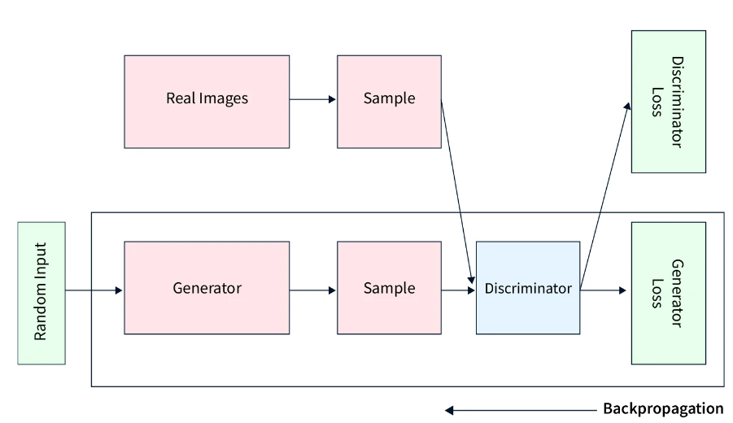

Sensor Data:

<https://drive.google.com/drive/folders/11CoI7J7rYyRr3GDk_92sf6xrh5Z-mFFk?usp=sharing>

Image Data:

<https://www.kaggle.com/datasets/arjuntejaswi/plant-village>

GAN Model:

<https://drive.google.com/drive/folders/1KBey-vO_pKv7h-eGpt6BA3mlRXAdNVxh?usp=sharing>

Classification Model:

<https://drive.google.com/drive/folders/1bIQSCDFi3qT-1an60ezgPtzGIZ6R5N9C?usp=sharing>

**References**:

* <https://pytorch.org/tutorials/beginner/dcgan_faces_tutorial.html>
* **Synthesis of IoT Sensor Telemetry Data for Smart Home Edge-IDS Evaluation**

Sasirekha GVK, Amulya Bangari, Madhav Rao, Jyotsna Bapat, Debabrata Das

* **SMOTE: Synthetic Minority Over-sampling Technique** [N. V. Chawla](https://arxiv.org/search/cs?searchtype=author&query=Chawla%2C+N+V), [K. W. Bowyer](https://arxiv.org/search/cs?searchtype=author&query=Bowyer%2C+K+W), [L. O. Hall](https://arxiv.org/search/cs?searchtype=author&query=Hall%2C+L+O), [W. P. Kegelmeyer](https://arxiv.org/search/cs?searchtype=author&query=Kegelmeyer%2C+W+P)
* **Copula Flows for Synthetic Data Generation**
* [Sanket Kamthe](https://arxiv.org/search/stat?searchtype=author&query=Kamthe%2C+S), [Samuel Assefa](https://arxiv.org/search/stat?searchtype=author&query=Assefa%2C+S), [Marc Deisenroth](https://arxiv.org/search/stat?searchtype=author&query=Deisenroth%2C+M)
* **Are GANs Created Equal? A Large-Scale Study**

Mario Lucic , Karol Kurach , Marcin Michalski ,Olivier Bousquet , Sylvain Gelly

* [Unsupervised Representation Learning With Deep Convolutional Generative Adversarial Networks](https://arxiv.org/pdf/1511.06434.pdf).