**Dr/Mahmoud Monir**

**2018/2019**

**Team Mambers :**

Bassant Hossam El-deen Section 5

Bassant Ehab Moustafa Section 5

Elaria Adham Section 5

Eriny Gerges Section 5

Shery wageh Section 5

**Introduction:**

The work environment grows in complexity, the importance of statistical skills becomes essential.

This is program is concerned with presenting his results

to “customers” who are not usually too conversant with statistics.

the program Implements all the descriptive statistics

**Project goals and direction:**

The project aims to make it easy to analyze a large amount of data.

When the user open the program he will find a menu contains all modules which he can need such as: Central Tendancy, Dispersion, Charts,.....ect.

* Central Tendancy contains : Mean, Median, Mode.
* Dispersion contains: Range, IQR, BoxPlot, Variance, Standard Deviation, Z-Score.
* Charts contains: Pie Chart, Bar Chart.
* Histogram, Dot Plot.
* Correlations contains: Scatter Plot, Pearson.

**Description:**

Firstly, A form has menu of seven choices (Central Tendency, Dispersion, Charts, graphs, Correlation, Regression & Inference).

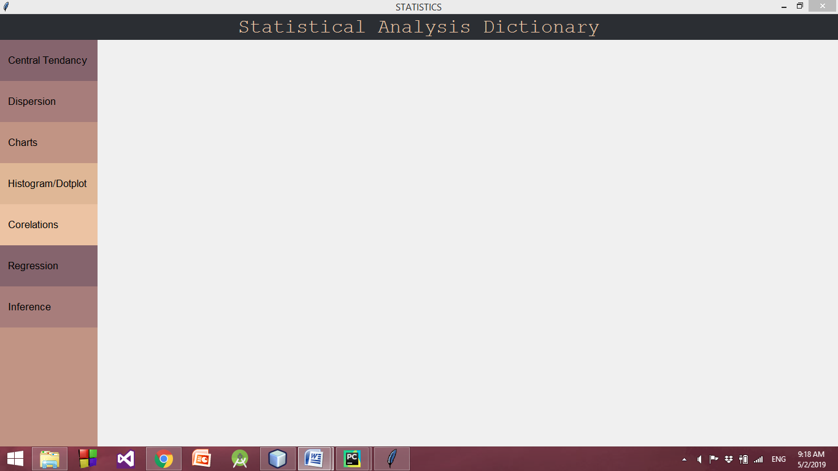

If you choose Central Tendency a new window will be opened for you to enter your values separated by "," and press done then you can calculate Mean, Median& Mode by clicking its button.

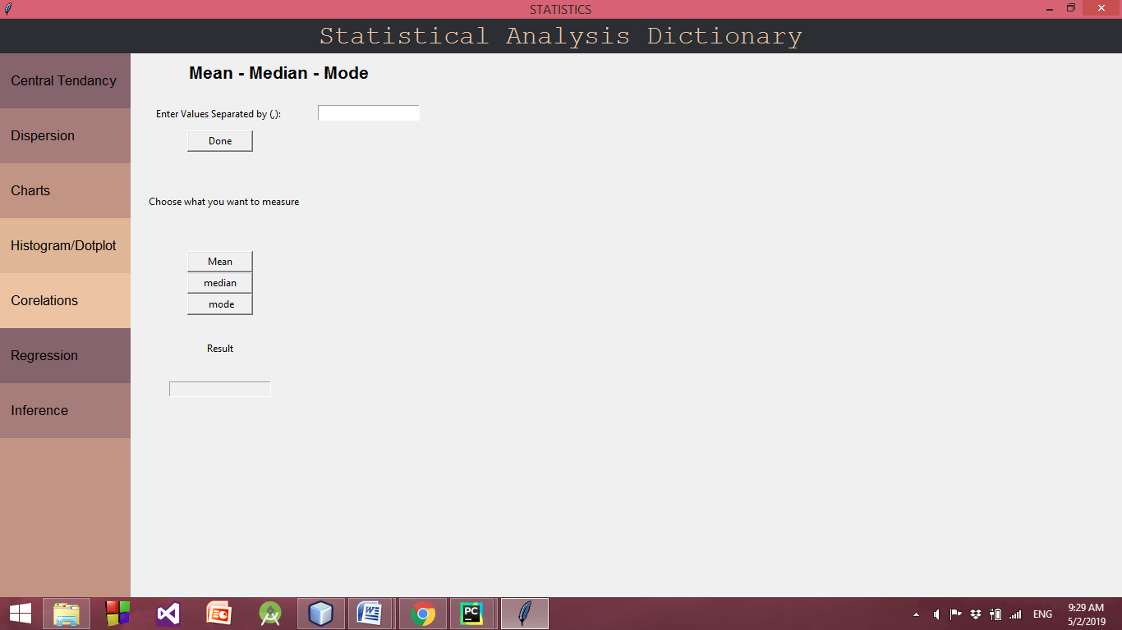

If you choose Depression a new window will be opened for you to enter your values separated by "," and then you can calculate Range, IQR, BoxPlot, Variance, Standard Deviation, Z-Score(if you want to standardize a variable) by clicking its button.

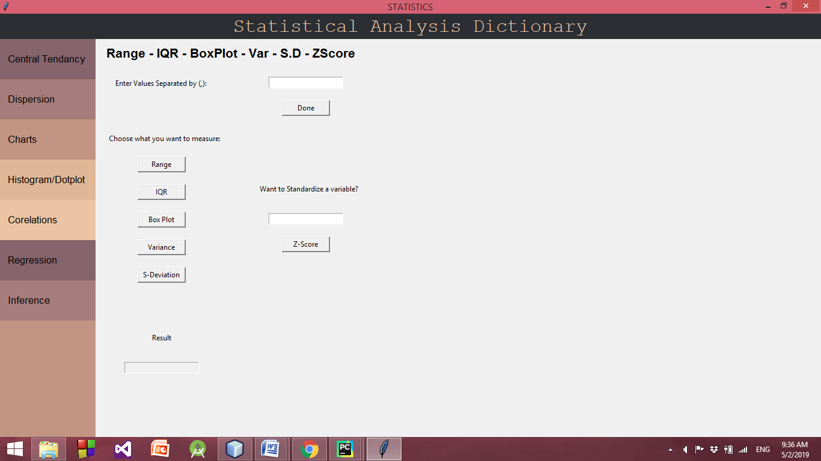

If you clicked on Box Plot button new form will open with its value

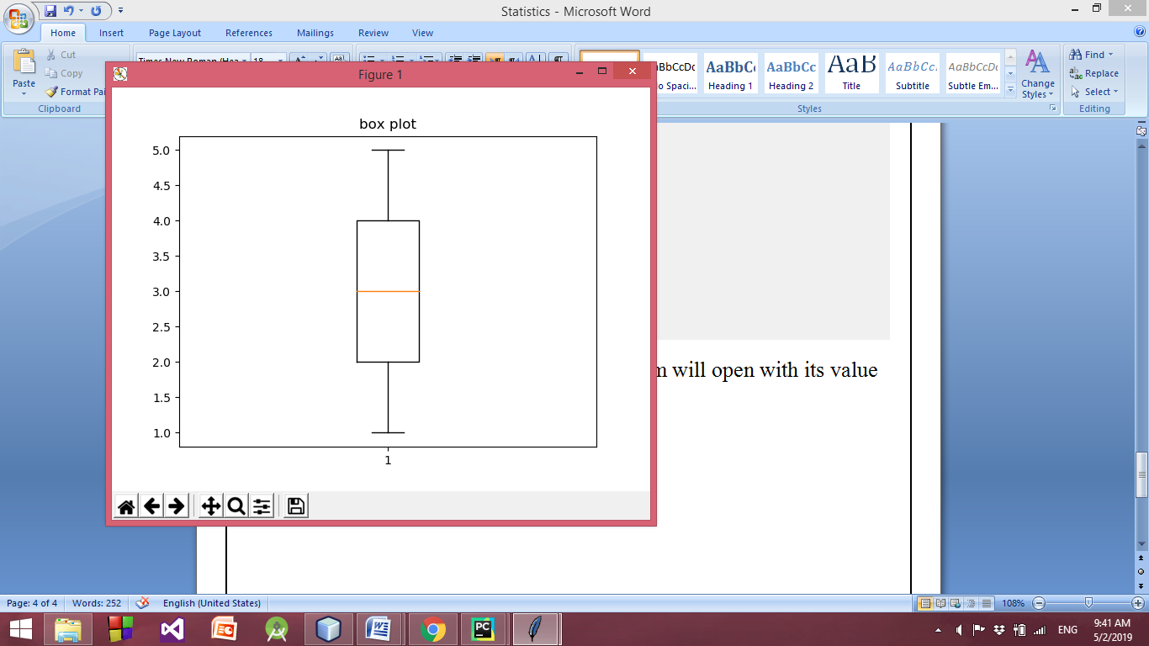

If you choose Charts a new window will be opened for you with two options Pie chart & Bar chart enter your values separated by "," and choose which one you want to calculate.

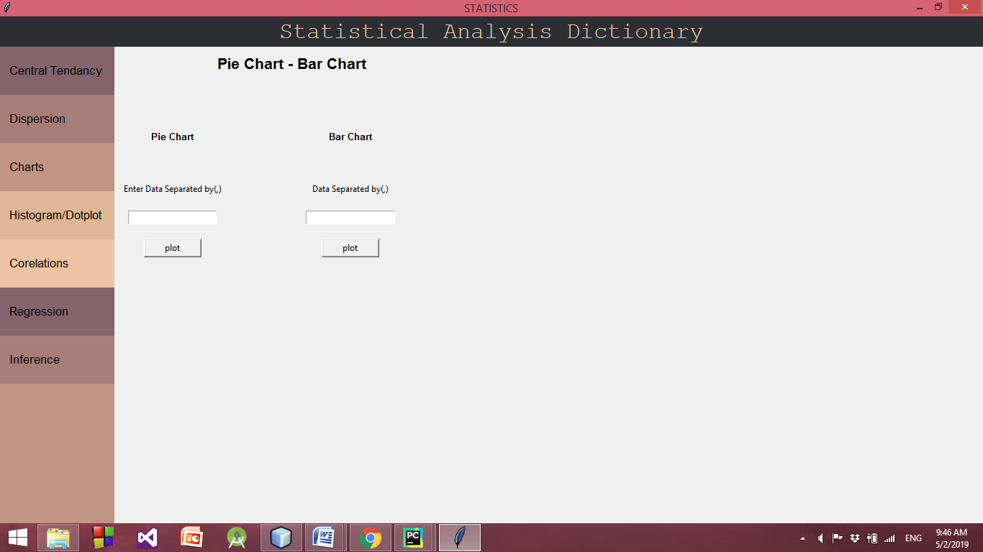

If you choose Pie Chart:

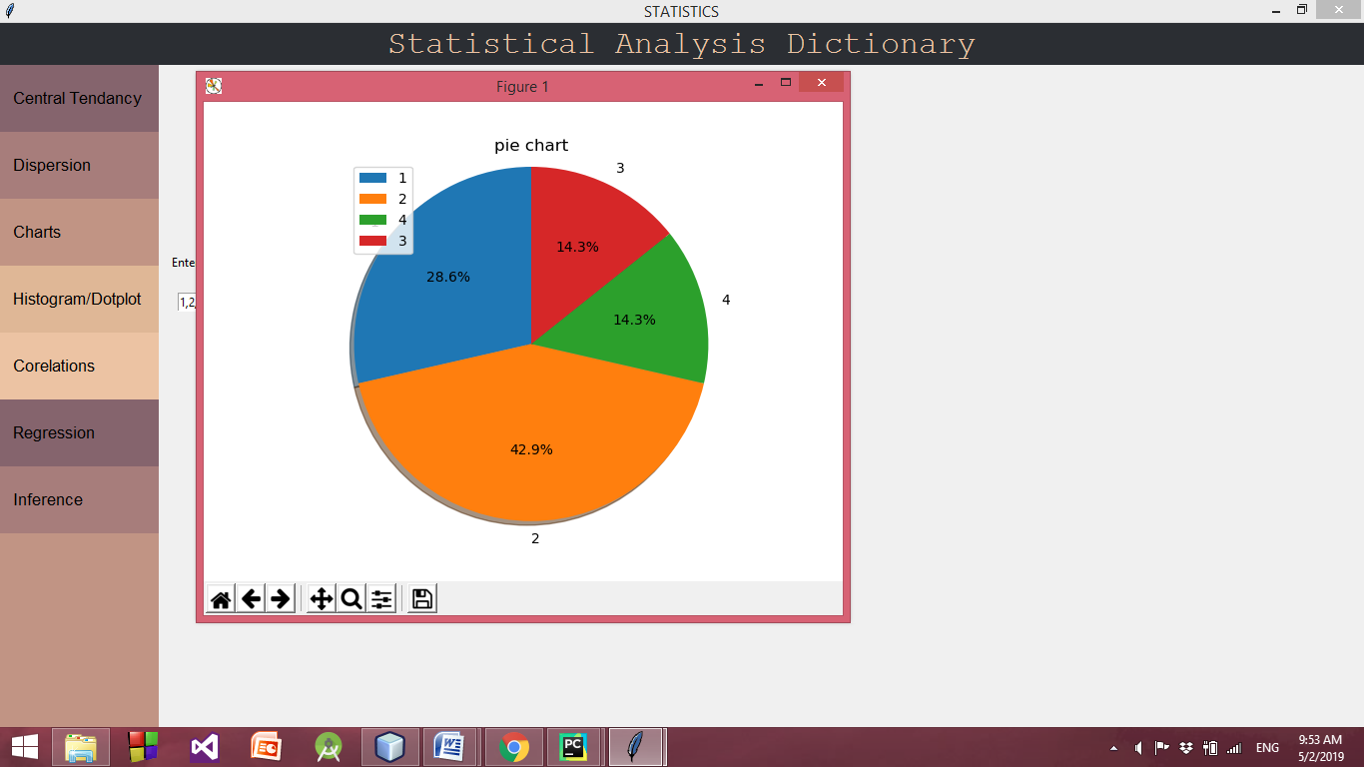

If you choose Bar Chart:

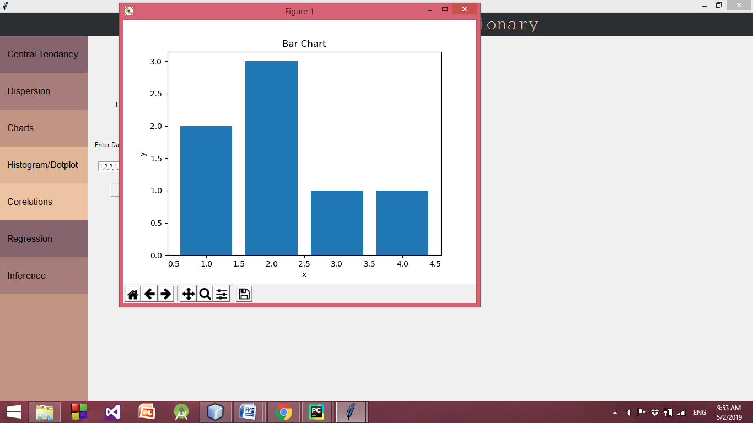

If you choose Histogram/Dot Plot a new window will be opened for you with two options Histogram & Dot Plot enter your values separated by "," and choose which one you want to calculate.

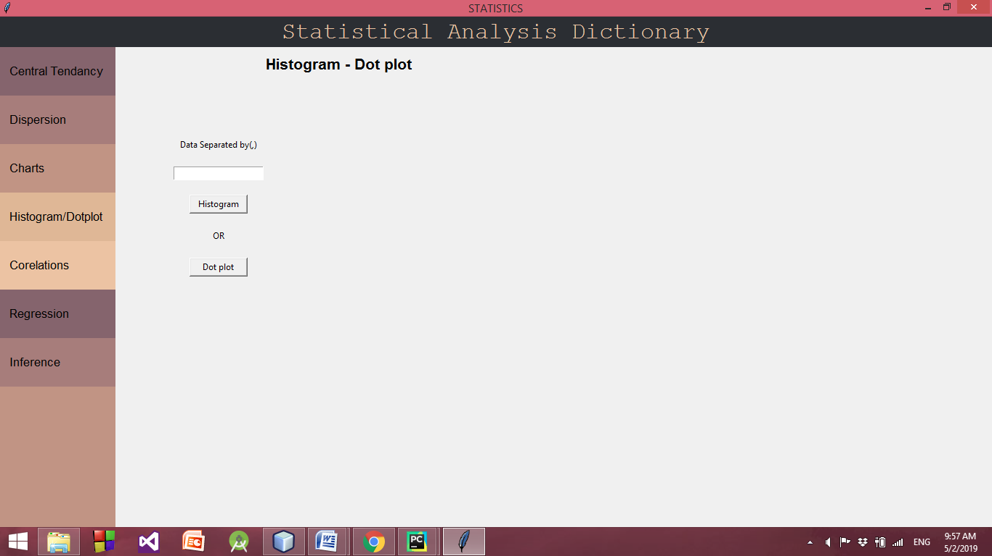

If you choose Histogram:

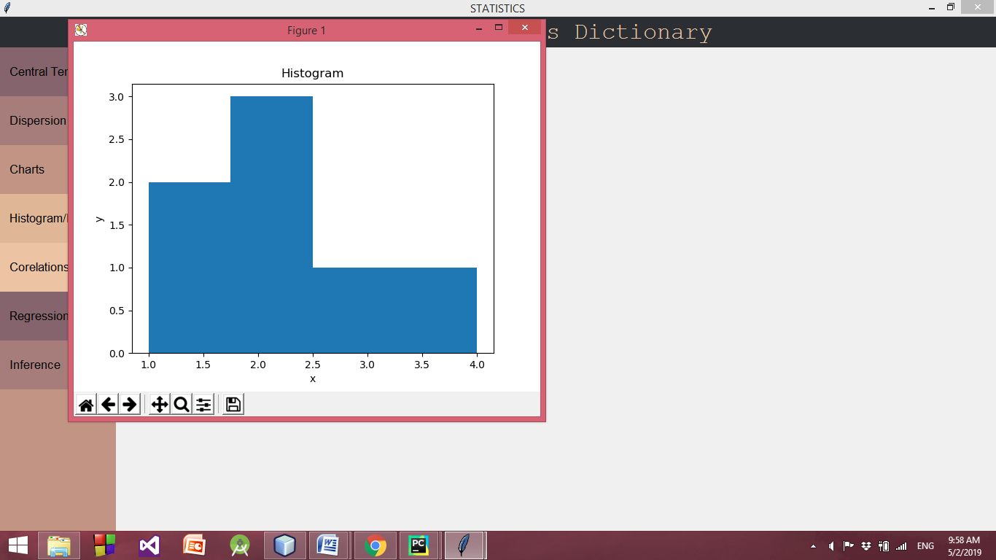

If you choose Dot Plot:

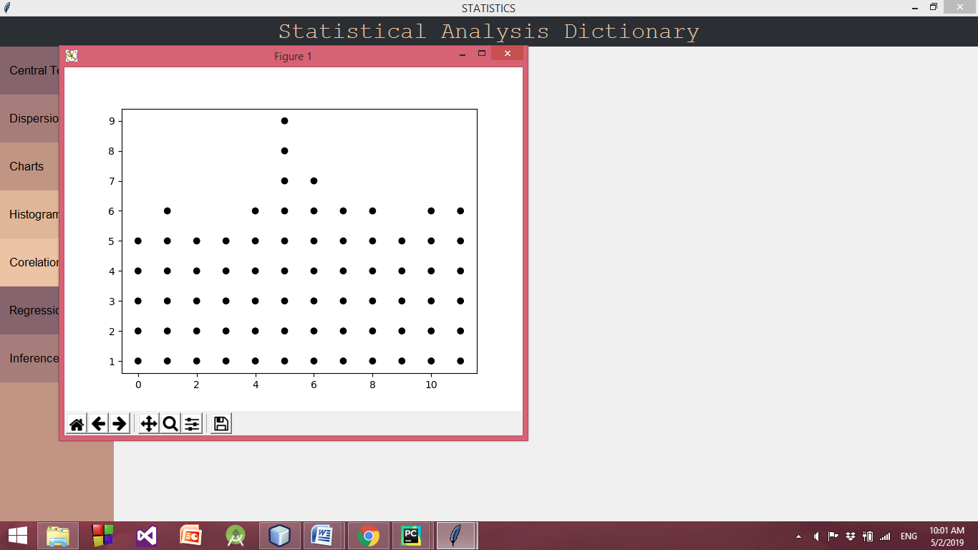

If you choose Correlation a new window will be opened for you to enter two lists separated by "," and calculate the correlation between them and you can also get a scatter plot.

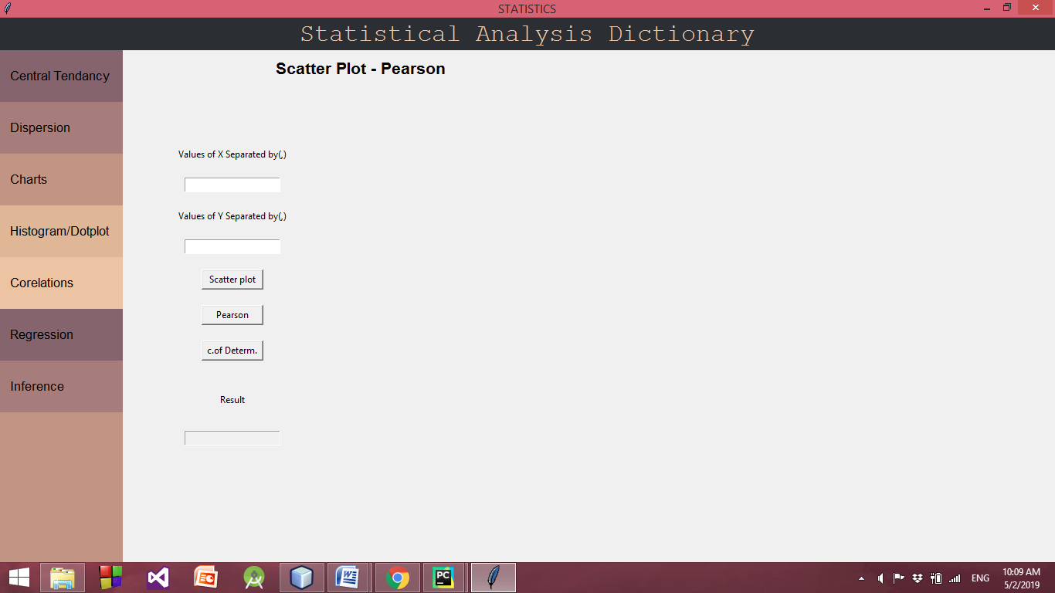

If you choose Scatter Plot:

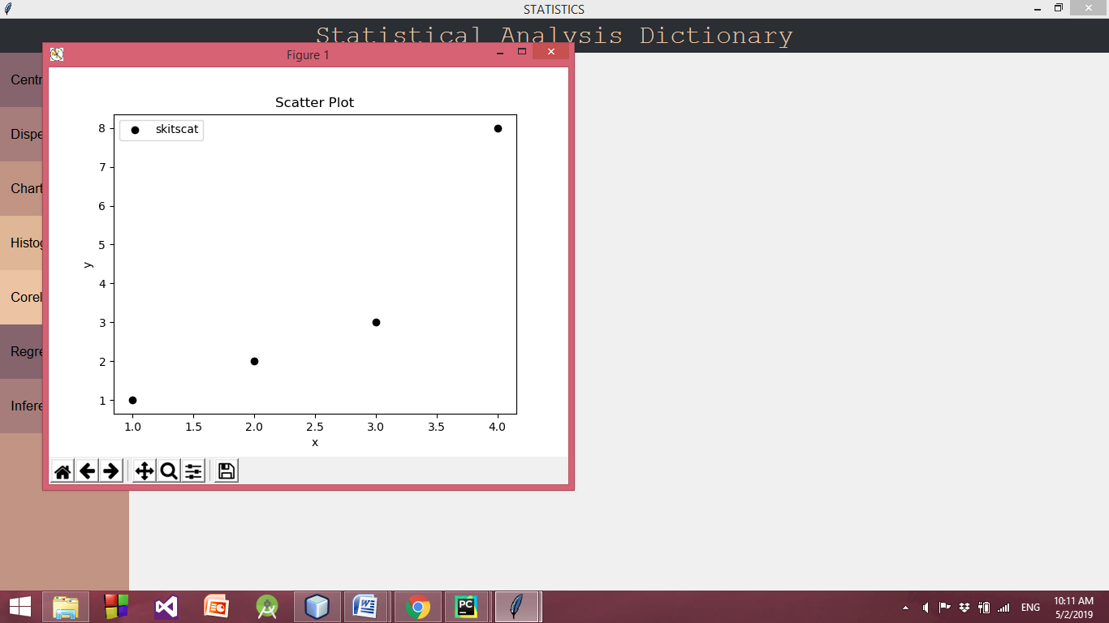

If you choose Regression a new window will be opened for you to enter two lists separated by "," and get Line Regression.

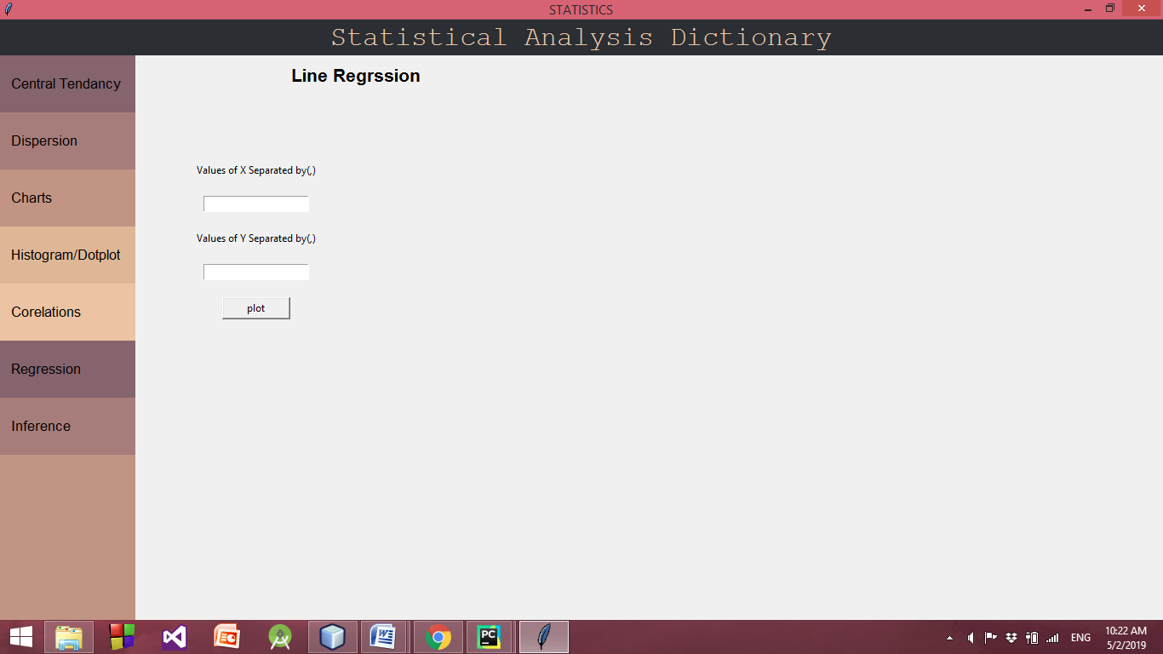

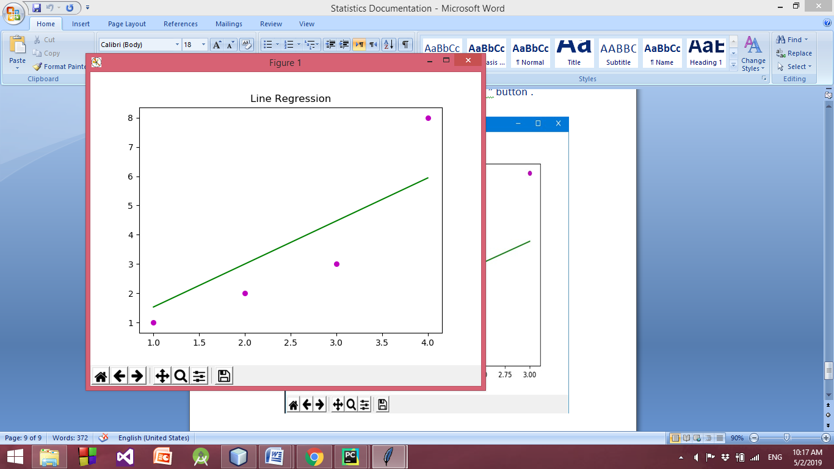

If you choose Inference a new window will be opened for you to enter Population Parameters and get Sample Statistics.

