Name: Mostafa Elsayed
ID: 20596297
Lab: 8
Task 1
docker compose ps
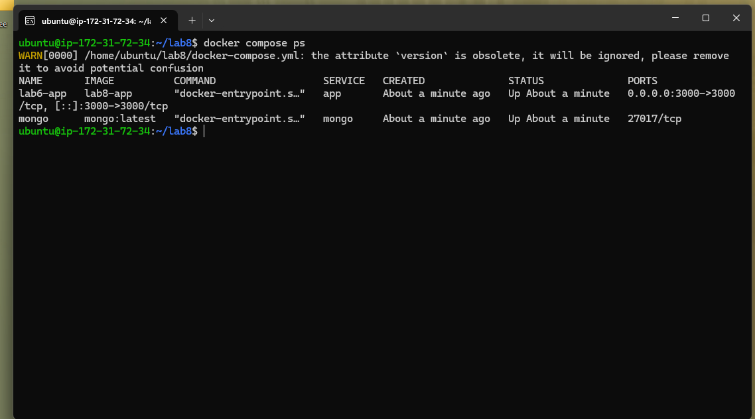
curl localhost:3000/tasks

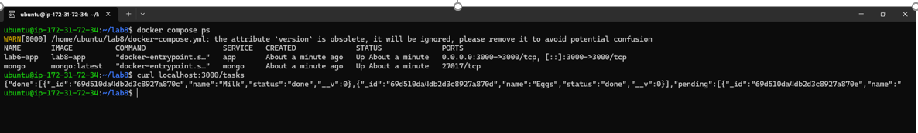
Write-up 1
The selected database is MongoDB. The host is given the service name like "mongo" instead of localhost because when using docker-compose, it will create a private network automatically where there would be DNS entries of all the containers. It makes the communication between these containers seamless by only using names, which prevents hardcoding IPs or exposing any ports.

Task 2
Screenshot of the GitHub Actions run showing all steps green
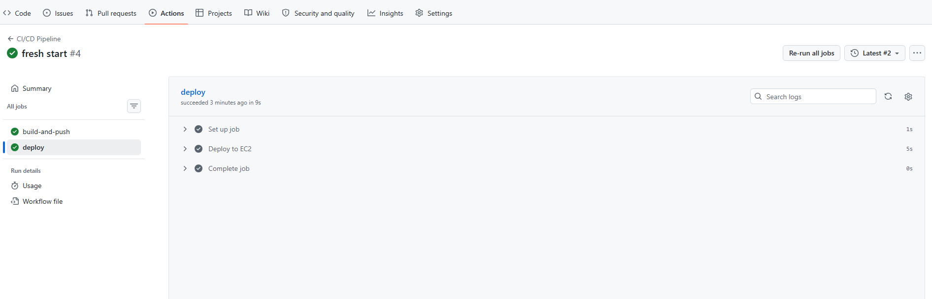

docker compose ps
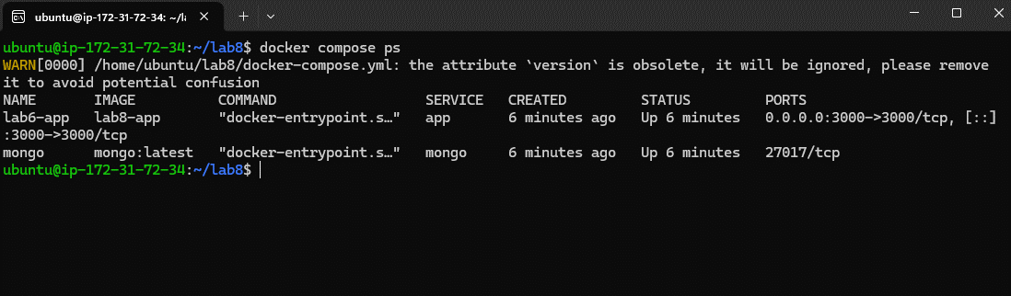

curl localhost:3000/tasks
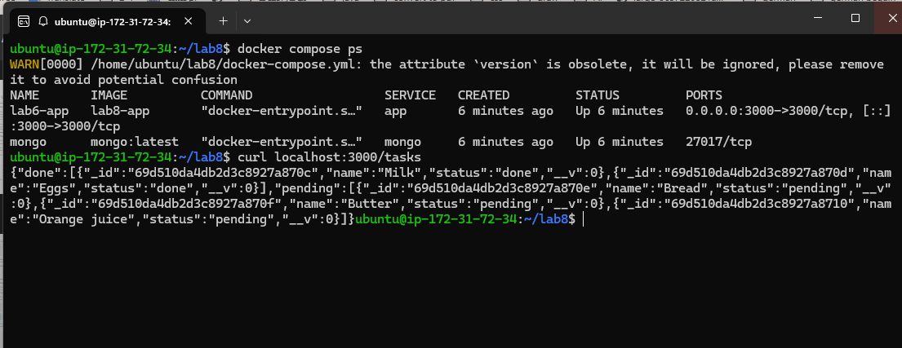

Write-up 2
ubuntu@ip-172-31-72-34:~/lab8$ docker compose ps
WARN[0000] /home/ubuntu/lab8/docker-compose.yml: the attribute `version` is obsolete, it will be ignored, please remove it to avoid potential confusion
NAME IMAGE COMMAND SERVICE CREATED STATUS PORTS
lab6-app lab8-app "docker-entrypoint.s…" app 6 minutes ago Up 6 minutes 0.0.0.0:3000->3000/tcp, [::]:3000->3000/tcp
mongo mongo:latest "docker-entrypoint.s…" mongo 6 minutes ago Up 6 minutes 27017/tcp

These two containers can interact as they belong to the same network within the Docker environment which helps the application connect to the MongoDB container through the service name mongo without exposing the MongoDB port to the Internet
Screenshot of the GitHub Actions run triggered by your commit

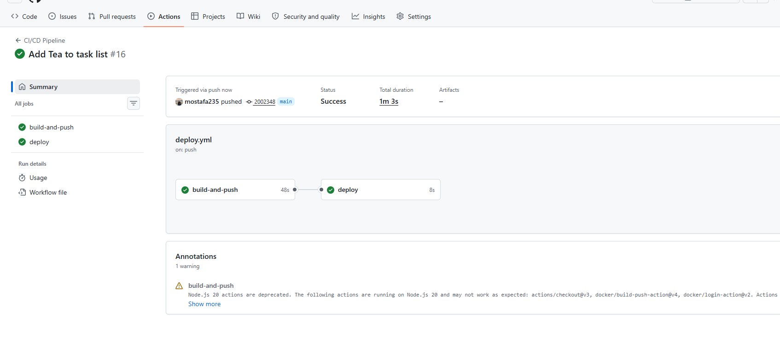

Screenshot of curl localhost:3000/tasks showing the new task in the response
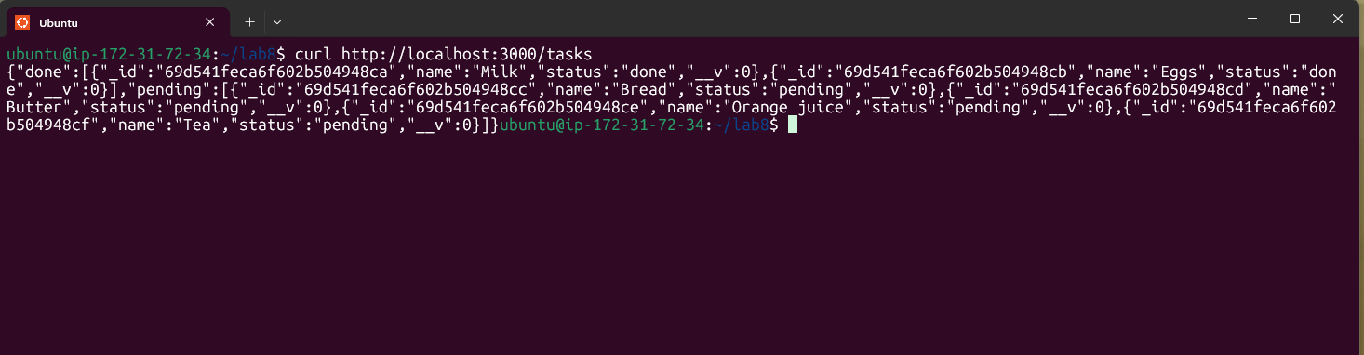
Write-up 3
Docker hub becomes the intermediary once the GitHub Actions runner creates and publishes the Docker image. It is important since, when the EC2 machine retrieves the latest Docker image from Docker hub, it doesn’t need to communicate with the GitHub Actions runner; it is possible to deploy the application even when the EC2 machine cannot reach GitHub Actions.

