Student name: Bassel Essa
ID: 20596322
CISC886 - Group 20
Lab 8

Task 1 – Add a Database Service to the Repository:
- Screenshot of docker compose ps showing both services running:
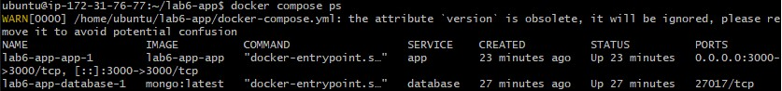

- Screenshot of curl localhost:3000/tasks returning data from the database:

- Answer to Write-up 1:
When Docker Compose brings up the stack, it places both the app and database containers on the same secure internal network. Containers on the same Docker network can communicate with each other freely across any port, so the database port (27017) does not need to be mapped to the host machine or exposed publicly for the Node app to reach it.

