PHP with Ngrok (written by CKT)

PHP (hypertext preprocessor) is especially suited to web development and is widely used by must websites (Facebook,Yahoo,Wordpress), so lets say you would like to host your own version of these popular websites and you would like your friend to try it out Ngrok is the best option with its free plan you can deploy a testing version of your website, in this tutorial, I will be teaching you how to do exactly that.

First Step:

What is Ngrok, ngrok allows you to expose a web server running on your local machine to the internet. Just tell ngrok what port your web server is listening on and that’s all you need to get started.

Sign up and download and install Ngrok by visiting ( <https://ngrok.com/> ), within ngrok dashboard you will be given instruction on how to fully configure your copy of ngrok and its an easy process

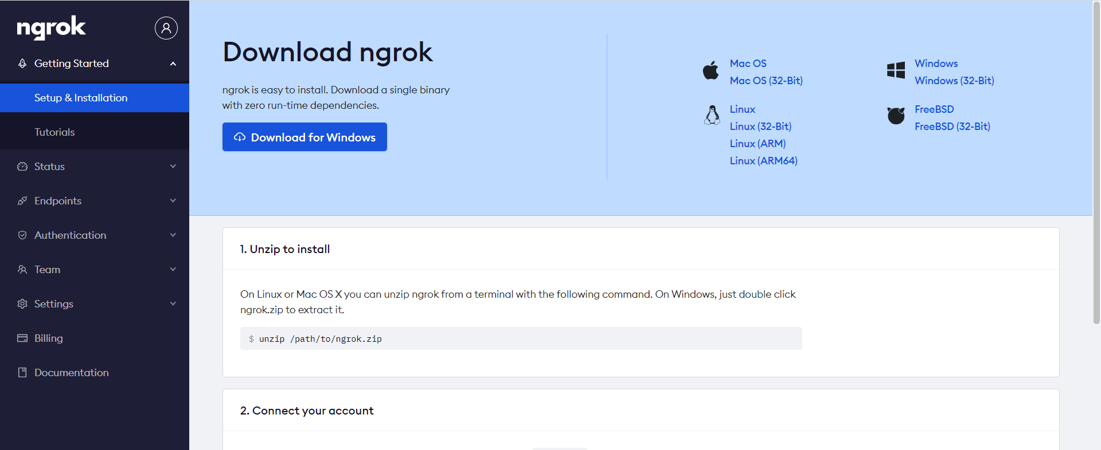

Second Step:

Once you have downloaded the zip file or copy of ngrok, you will get a ngrok.exe file which is an executable file, double click on it

Third Step:

As you are following this tutorial I assume you are comfortable with PHP, so place your project files in the htdocs directory of your xampp (server), I will be creating a simple index.php file with some content for demonstration

**In the index.php**

You can simple copy these content into the index.php file

<?php echo "This is a PHP Website running with Ngrok"; ?>

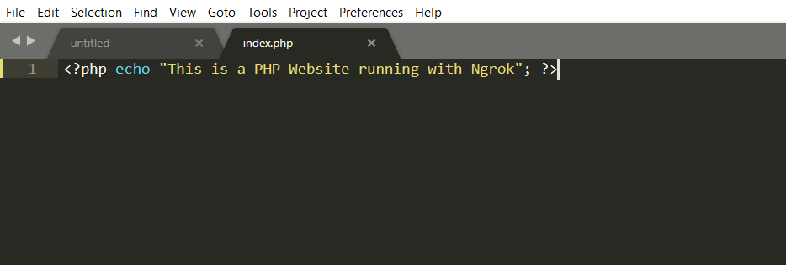

Saving file as index.php

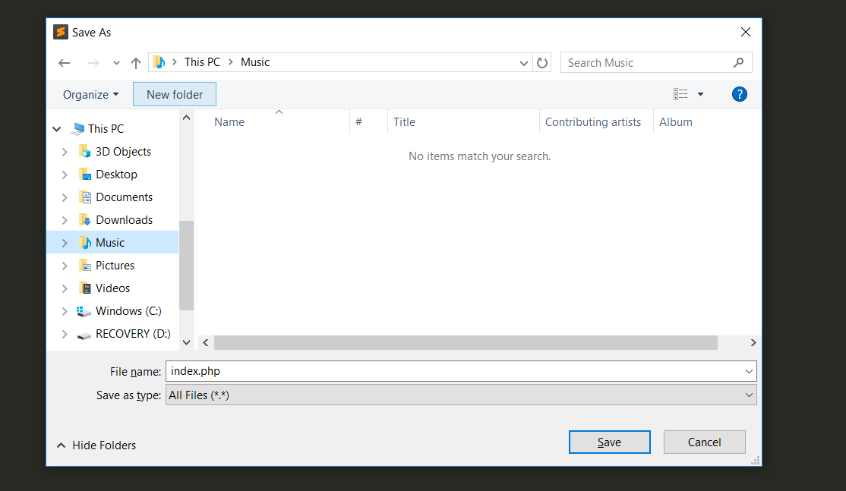

Fourth Step:

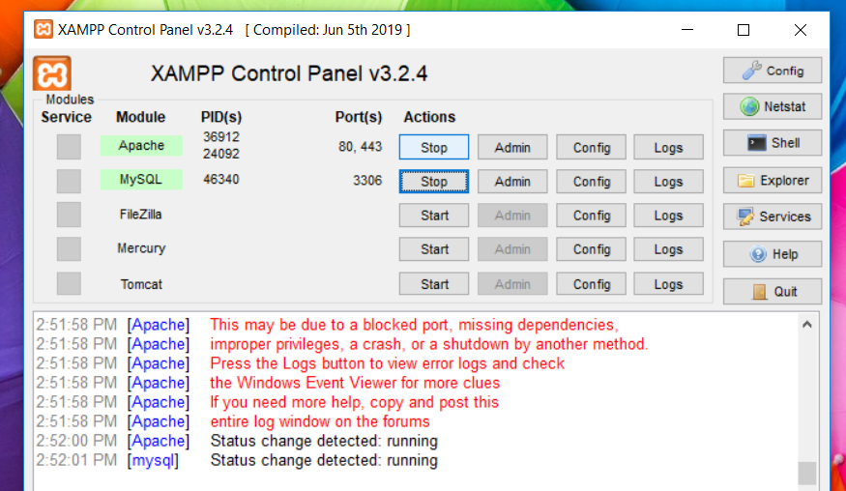

Start up your xampp: (Apache and MySQL)

Exposing your port to ngrok will help your website to be accessed by the internet, since Xampp runs on <http://127.0.0.1:80/> which is port **80,**  you will be exposing to the internet

So in the command line interface opened when you double click on ngrok.exe

Type: ngrok.exe http **80**

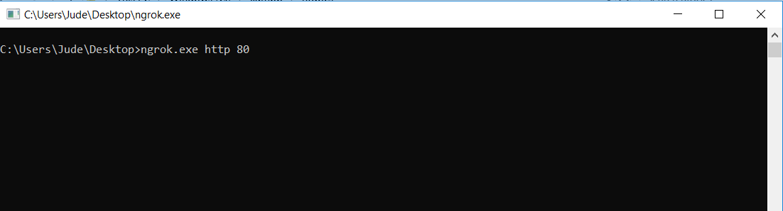

**Please make sure you are connected to the internet for this action to be successful.**

**Below is an image copy the url**

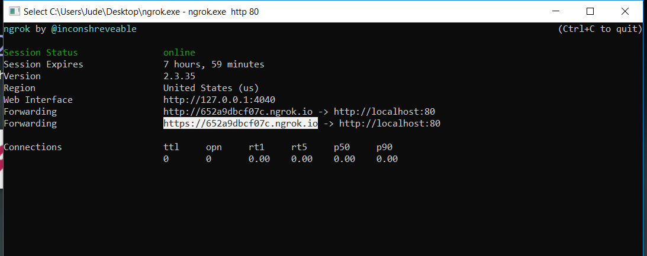

Once done, go to the the url generated by ngrok on your browser.

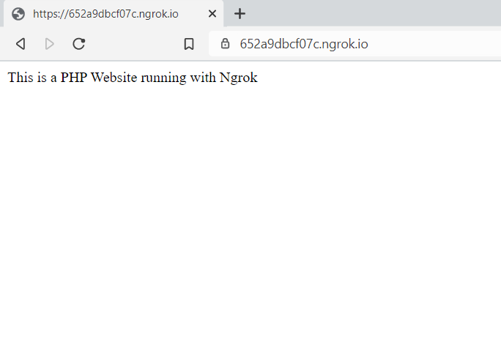

Now your website is accessible to the internet ☺

Fifth Step:

* Please make sure any private projects are removed from the htdocs folder and placed

somewhere else, as they can be accessed by anyone that has your url generated by ngrok

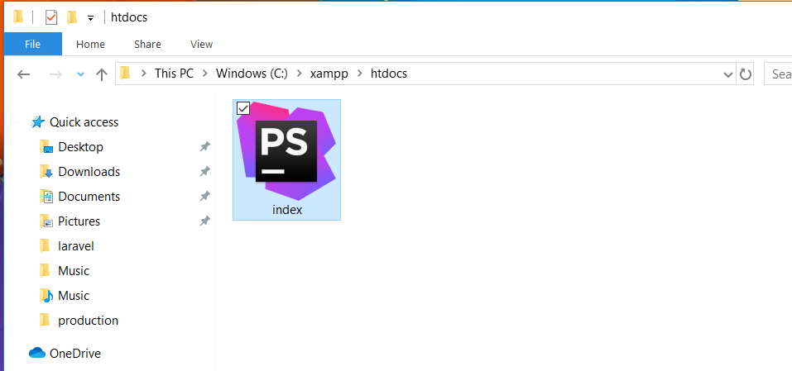

* ONLY share this url to people you trust
* Once testing is complete use CTRL+C to close tunnel or connection established by ngrok
* This session only last for some couple of hours approximately 7 hours, that’s enough time for testing (you can get premium version)
* One thing to also note is that, urls generated by ngrok are dynamic and so you will not get the same url each time you restart the session, so bare in mind that you will need to share the new url each time you reset the session.

Hope you enjoyed this tutorial

There are many thing you can do with ngrok, more