

Credit Hours system

Computer Department

Cairo University

Faculty of Engineering

CMPN/S301-Computer Architecture

**Computer Architecture Project**

Submitted to: Eng.

Submitted By:

Basim Sherief Zeenelabdeen - 1210207

Ali Mohamed Abdelghani - 1210019  
Mohamed Ashraf Mamdouh- 1210024

Mustafa Mohamed Mustafa - 1210081

1. Instruction format

1. Control Signal Table

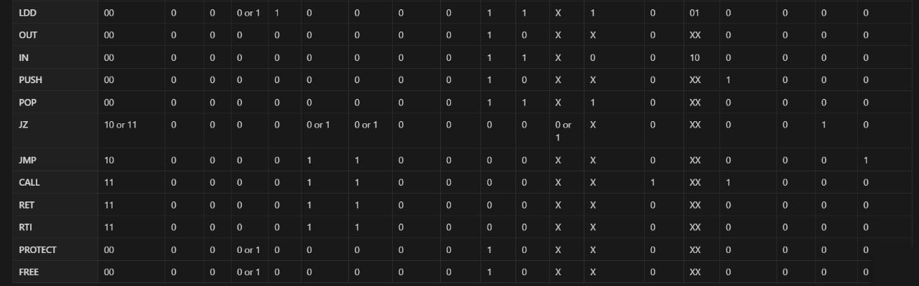

Details:

PC_INC_TYPE: choose between regular increment, Rdst from decode, Rdst from execute,output from memory

RST: resets all registers

INT: interrupt signal

IMM: does this inst have an immediate value?

FLUSH_IF_ID: flushes on branch execution,taken prediction or exceptions

FLUSH_ID_EX: flushes on branch execution or exceptions

FLUSH_EX_MEM: flushes on memory exceptions

PC_WRITE: hazard detection unit allows writing to PC?

reg_WE: enable wb to register file

Predictor: 1-bit global branch predictor

ALUorMEM: choose between ALU result or Memory result

CALL: is this a call inst?

RFC: chooses between immediate , Rsrc2, and input port

mem_WE: is the instruction allowed to write in memory?

SWAP: is this a swap inst?

JZ_Inst: is this a JZ inst?

JMP_Inst: is this an unconditional jump?

Forwarding selectors: choose between ALU forward, direct buffer value, memory forward

1. Schematic diagram

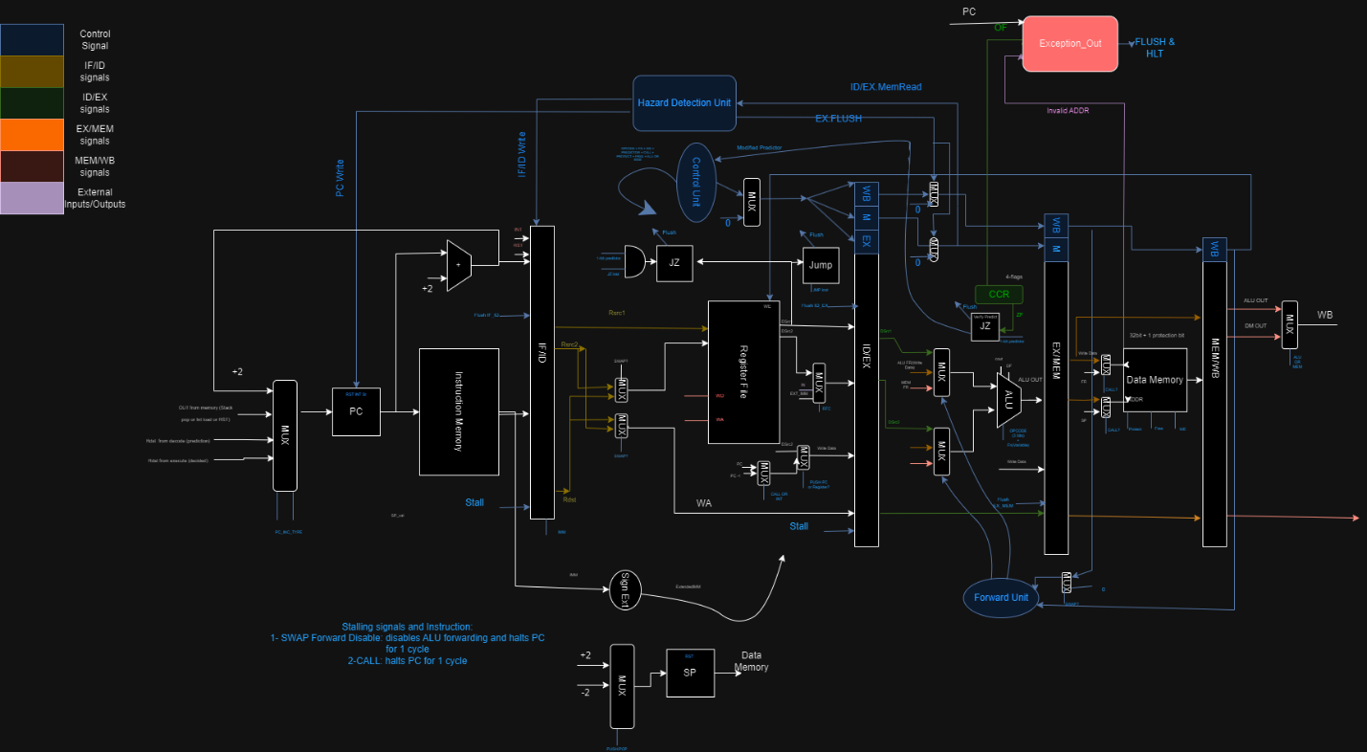

1. Pipeline stages

Fetch-Decode Buffer -> 36 bit

Decode-Execute Buffer -> 99 bit

Execute-Memory Buffer ->73 bit

Write Back Buffer->105 bit