

Cairo University

Faculty of Engineering

Spring 2025



Credit Hours System

Parallel Processing

Parallel Processing

Report

Prefix Sum

**Submitted to:** Eng Mohamed Qotb

**Submitted on:** 25/04/2025

**Submitted by:**

Basim Sherief Zeenelabdeen CCEC 1210

Compare work efficient and work inefficient implementations.

***Note for all comparisons I have used dataset of sizes 1 mil and 50 thousand elements***

|  |  |  |
| --- | --- | --- |
|  | Kernel | Cuda mem copy D2H |
| EfficientPrefixSumUlt | 2807461 | 2275038.0 |
| InefficientPrefixSumUlt | 2992744 | 1682007 |

The work efficient kernel is normally more desirable since its work efficient so its better energy efficiency and require less execution resource but

The work inefficient kernel could be better when I tested with small sizes but the requirement was to calculate accumulated sum of input array more than 1 mil

Compare work efficient But using different memories

Speedup relative to pageable memory pinned memory had 36.58x while unified memory 1.54 Zero mapped memory was the worst, I know pinned memory is much faster

|  |  |
| --- | --- |
|  | Total time from start of allocating memory executing the kernel and memcpy back to write in file **in ms** |
| Pageable memory | 419.235 |
| Pinned memory | 11.460 |
| Unified memory | 271.782 |
| Zero mapped memory | 428.450 |

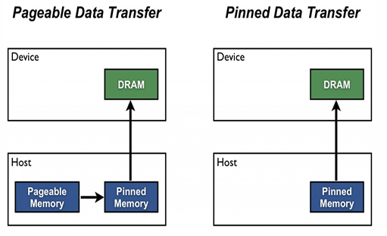 this is the expected because we remove overhead of additional copying of data instead from pageable memory to pinned we copy directly to pinned memory. When I searched there was method called prefetch that could further increase the unified memory performance but I commented it because we didn’t take it in lecture

*also note there is also memcpy in unified memory and this does not make sense but I do it because I send the same pointer to writing output function so don’t penalize me*

Compare between thread coarsening and using streams

To output correct prefix sum In case of streams I needed to add another kernel called adjustStreamValues which takes the last sum from the stream and then add it to other streams to produce correct output but its needless to do it in case of thread Coarsening

|  |  |  |  |  |
| --- | --- | --- | --- | --- |
|  | Efficient prefix sum Kernel | AdjustStreamValues | cudaStreamCreate | cudaMemcpy |
| Using Streams | 2792388 | 11809 | 626830698 | 3719053 |
| Thread Coarsening | 891531 |  |  | 4785854 |

My conclusion to the results is that we should not use streams unless there are huge amount of data at least to worth the overhead of creating streams as we see it takes ages to be created that’s why thread coarsening win against streams in that amout of data 1 mil and 50 thousands

Thank you