**NMOS**

All the reasoning and physical explanation that applies to the PMOS applies also to the NMOS so we will not repeat them in this section.

**IV characteristics of the device :**

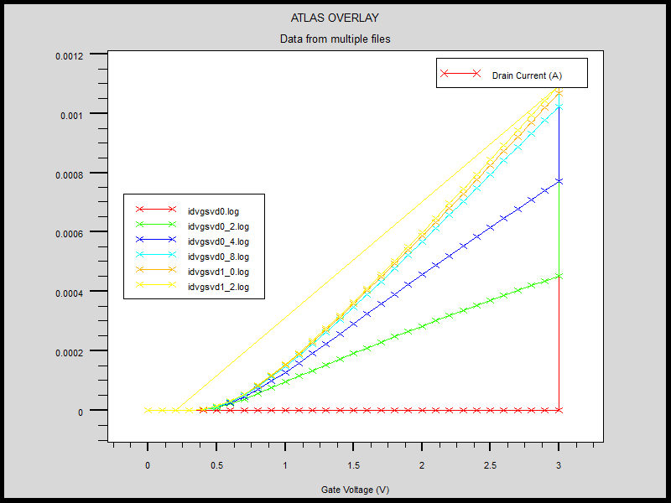

Fig.(15). Id/VGS plot at different VDS voltages

**DEVICE STRUCTURE:**

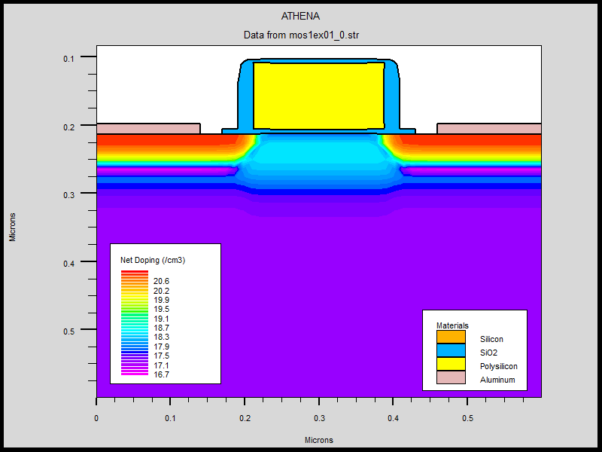

Fig(16) NMOS structure and doping profiles

**OPTIMIZATIONS:**

**Channel Doping:**

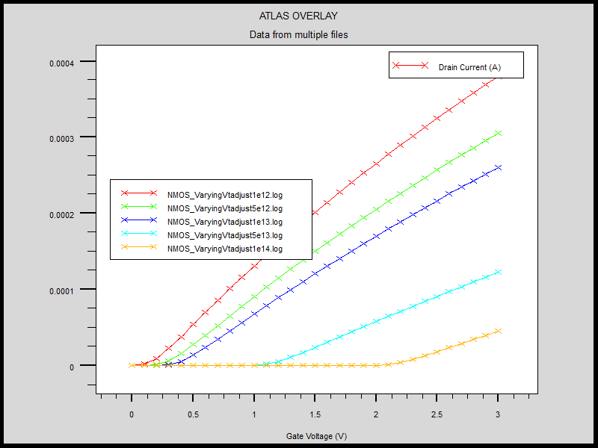

Fig(17) Id/VGS for different channel doping concentrations

**Source/Drain Doping:**

Note: Channel Concentration was varied by varying the channel doping in steps of 0.2e13

|  |  |  |
| --- | --- | --- |
| **Channel Concentration(cm-3)** | **Vth (V)** | **gm(uS/um)** |
| **7.1e17** | 0.49 | 509 |
| **6.4e17** | 0.45 | 513 |
| **5.70e17** | 0.42 | 516 |
| **5.05e17** | 0.38 | 521 |
| **4.37e17** | 0.34 | 525 |
| **3.69e17** | 0.30 | 530 |

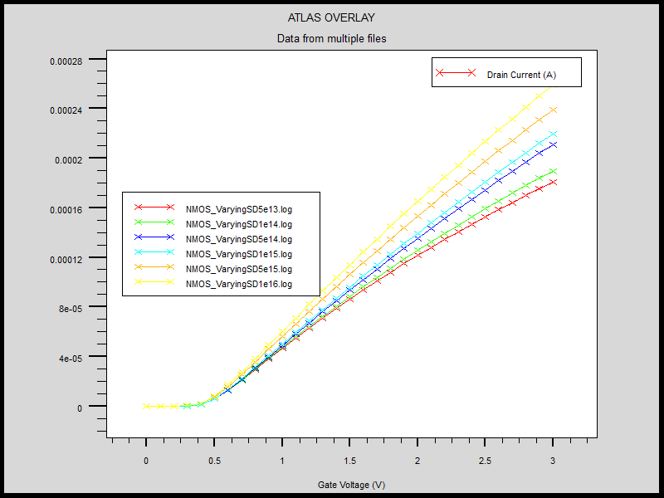

Fig(18) Id/Vgs after varying source /drain

**LDD DOPING:**

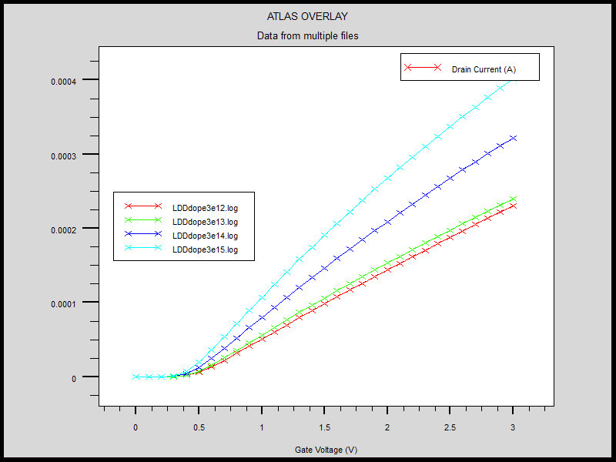

Fig(19). Id/Vgs with changing LDD doping

**Gate Oxide:**

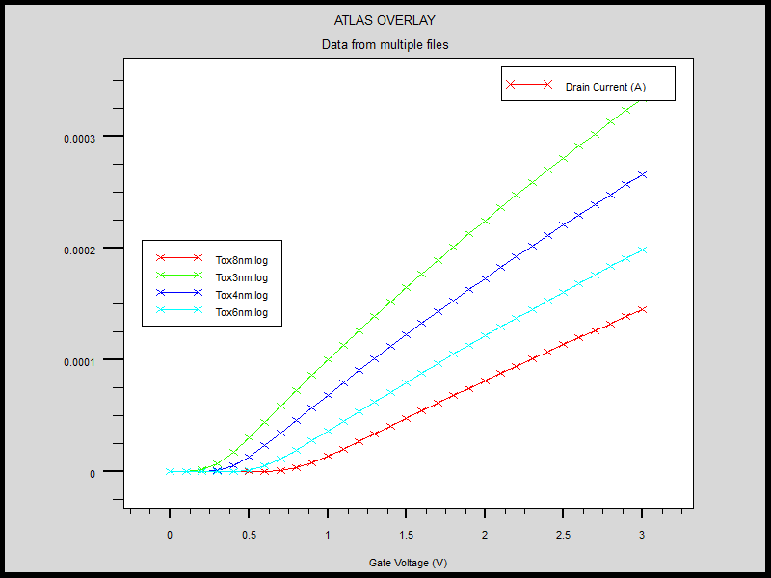

Fig(19) Id/Vgs plots with changing oxide thickness

**Process Parameters:**

|  |  |
| --- | --- |
| Gate Oxide | time=4 temp=900 dryo2 press=1.00 hcl=3 |
| P-Well doping | Boron dose=8e12 energy=100 pearson |
| LDD | Phosphorus dose=3.0e13 energy=5 pearson |
| Source/drain Doping | Arsenic dose=5.0e15 energy=12 pearson |
| Channel Doping | Phosphorus dose=1.33e13 energy=10 pearson |

**Optimized Device:**

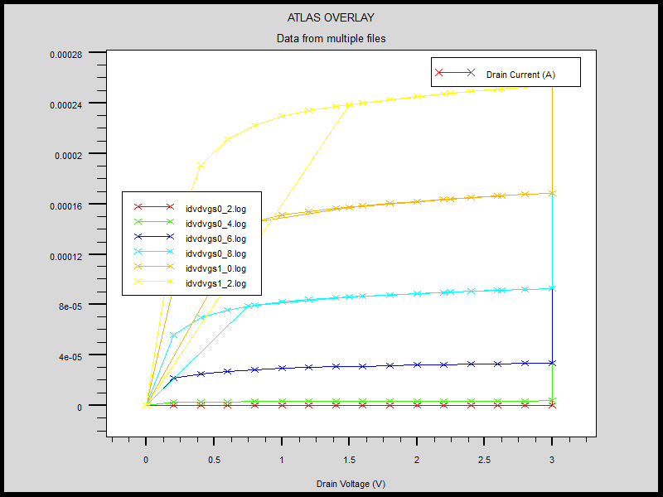

Fig(21) Id/Vds plots of optimized NMOS

**NMOS Code:**

**Process:**

**go athena**

#

line x loc=0.0 spac=0.1

line x loc=0.1 spac=0.006

line x loc=0.21 spac=0.006

line x loc=0.3 spac=0.01

#

line y loc=0.0 spac=0.002

line y loc=0.063 spac=0.002

line y loc=0.1 spac=0.005

line y loc=0.6 spac=0.015

#

init orientation=100 c.phos=1e14 space.mul=2

#pwell formation including masking off of the nwell

#

diffus time=30 temp=1000 dryo2 press=1.00 hcl=3

#

etch oxide thick=0.02

#

#P-well Implant

#

implant boron dose=8e12 energy=100 pears

#

diffus temp=950 time=100 weto2 hcl=3

#

#N-well implant not shown -

#

# welldrive starts here

diffus time=50 temp=1000 t.rate=4.000 dryo2 press=0.10 hcl=3

#

diffus time=220 temp=1200 nitro press=1

#

diffus time=90 temp=1200 t.rate=-4.444 nitro press=1

#

etch oxide all

#

#sacrificial "cleaning" oxide

diffus time=20 temp=1000 dryo2 press=1 hcl=3

#

etch oxide all

#

#gate oxide grown here:-

diffus time=4 temp=900 dryo2 press=1.00 hcl=3

#

# Extract a design parameter

extract name="gateox" thickness oxide mat.occno=1 x.val=0.05

#

#vt adjust implant

implant boron dose=1.33e13 energy=10 pearson

#

depo poly thick=0.1 divi=10

#

#from now on the situation is 2-D

#

etch poly left p1.x=0.21

#

method fermi compress

diffuse time=1 temp=900 weto2 press=1.0

#

implant phosphor dose=3.0e13 energy=5 pearson

#

depo oxide thick=0.015 divisions=8

#

etch oxide dry thick=0.015

#

implant arsenic dose=5.0e15 energy=12 pearson

#

method fermi compress

diffuse time=1 temp=900 nitro press=1.0

#

# pattern s/d contact metal

etch oxide left p1.x=0.17

deposit alumin thick=0.015 divi=2

etch alumin right p1.x=0.14

# Extract design parameters

# extract final S/D Xj

extract name="nxj" xj silicon mat.occno=1 x.val=0.1 junc.occno=1

# extract the N++ regions sheet resistance

extract name="n++ sheet rho" sheet.res material="Silicon" mat.occno=1 x.val=0.05 region.occno=1

# extract the sheet rho under the spacer, of the LDD region

extract name="ldd sheet rho" sheet.res material="Silicon" \

mat.occno=1 x.val=0.3 region.occno=1

# extract the surface conc under the channel.

extract name="chan surf conc" surf.conc impurity="Net Doping" \

material="Silicon" mat.occno=1 x.val=0.45

# extract a curve of conductance versus bias.

extract start material="Polysilicon" mat.occno=1 \

bias=0.0 bias.step=0.2 bias.stop=2 x.val=0.45

extract done name="sheet cond v bias" \

curve(bias,1dn.conduct material="Silicon" mat.occno=1 region.occno=1)\

outfile="extract.dat"

# extract the long chan Vt

extract name="n1dvt" 1dvt ntype vb=0.0 qss=1e10 x.val=0.49

structure mirror right

electrode name=gate x=0.3 y=0.1

electrode name=source x=0.1

electrode name=drain x=0.5

electrode name=substrate backside

structure outfile=mos1ex01_0.str

# plot the structure

tonyplot mos1ex01_0.str

############# Vt Test : Returns Vt, Beta and Theta ################

go atlas

# set material models

models cvt srh print

contact name=gate n.poly

interface qf=3e10

method newton

solve init

# Bias the drain

solve vdrain=0.1

log outf=idvgsvd0.log master

solve vgate=0 vstep=0.1 vfinal=3.0 name=gate

save outf=idvgsvd0.str

# plot results

tonyplot nmos1ex01_1.log

quit

**Extraction:**

**go atlas**

# extract device parameters

extract init inf="nmos1exvt.log"

extract name="nvt" (xintercept(maxslope(curve(abs(v."gate"),abs(i."drain")))) \

- abs(ave(v."drain"))/2.0)

extract init inf="nmos1exgm.log"

extract name="gm" max(deriv(v."gate",i."drain"))

#tonyplot -overlay -st idvdvgs0_2.log idvdvgs0_4.log idvdvgs0_6.log idvdvgs0_8.log idvdvgs1_0.log idvdvgs1_2.log

#tonyplot -overlay -st idvgsvd0.log idvgsvd0_2.log idvgsvd0_4.log idvgsvd0_8.log idvgsvd1_0.log idvgsvd1_2.log

**quit**