Vincent Werkle

Bassey Duke

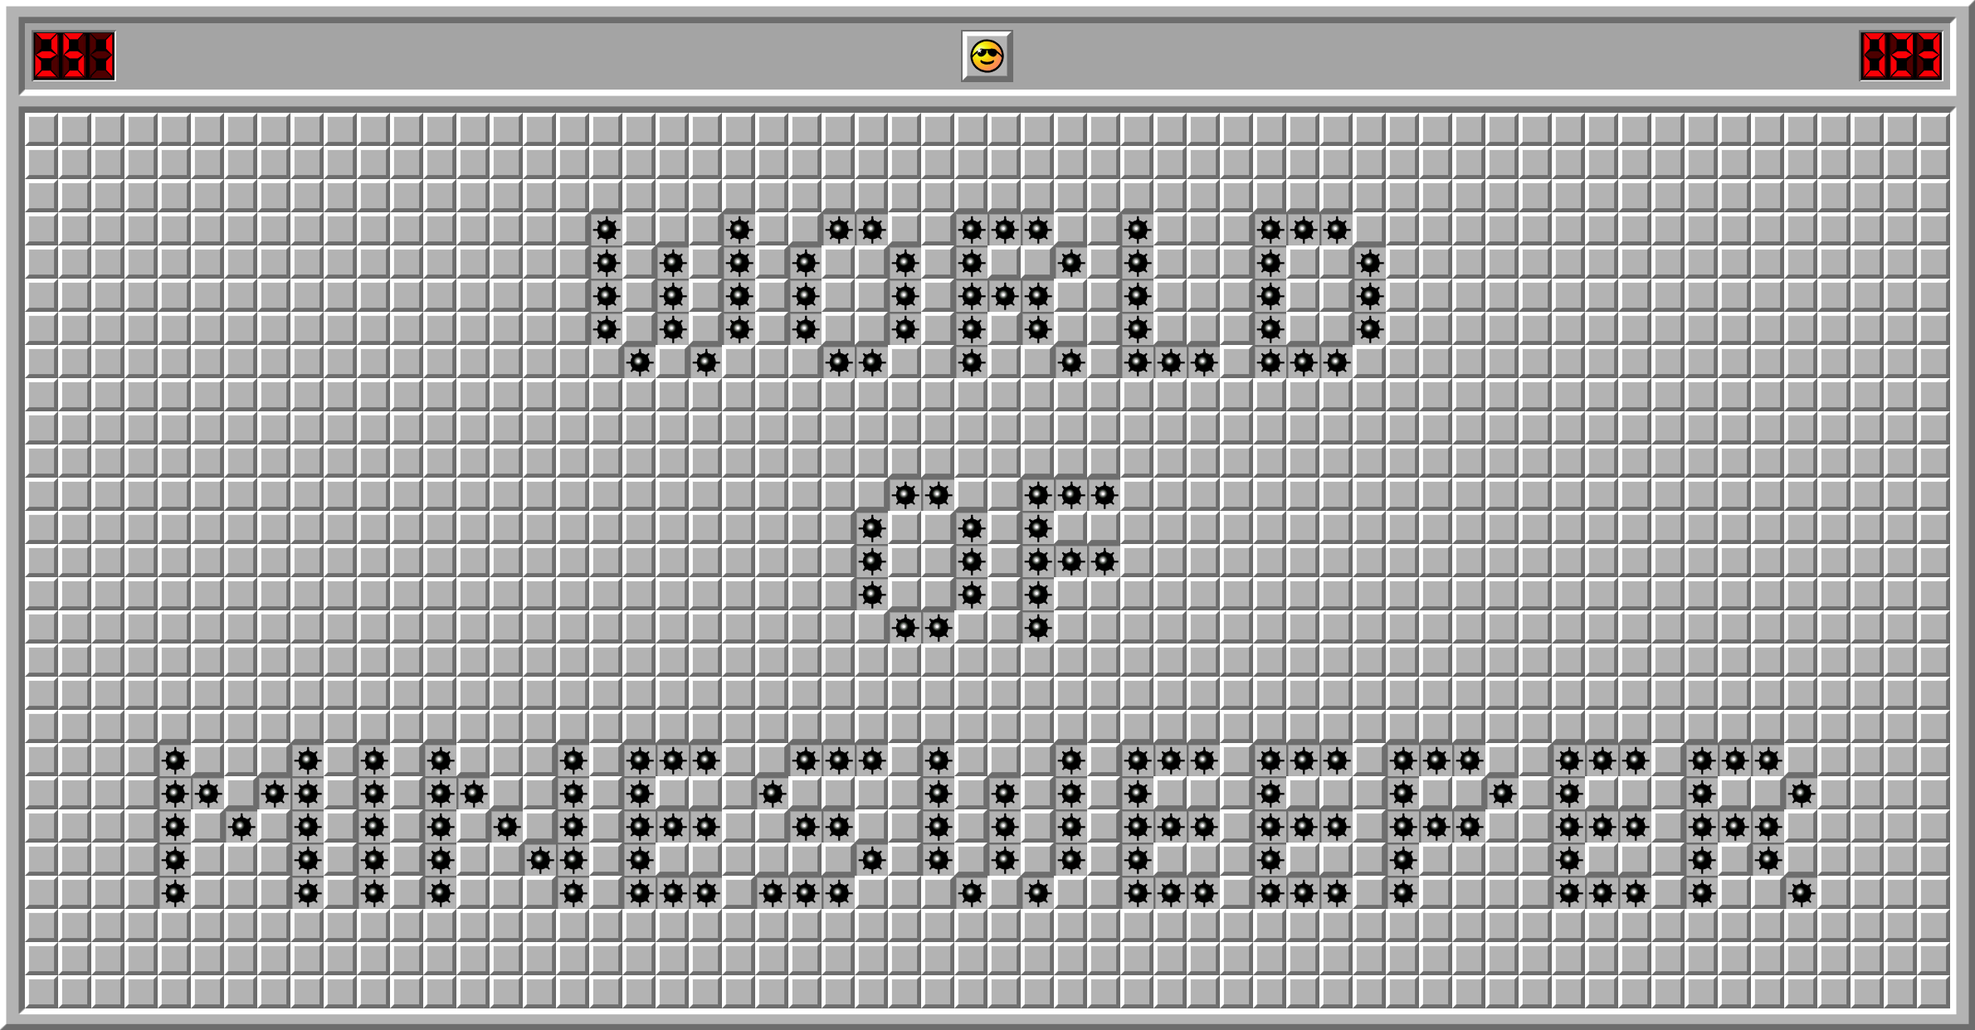

Get your copy of Minesweeper V2 today! A remake of the old classic to be able to run it on any machine. On top of that it is larger and easier to read making it more accessible to people with bad vision. Download the game and run it to start a game. Change the difficulty in the top right and restart the game by hitting the restart button. Once you click fields the numbers will indicate how many mines are touching the field. Keep clicking on fields you believe are not mines and right click on the ones you think that are mines to place a flag on them. The Mines counter in the bottom right will keep you up to date on how many mines you believe you have found and the score is equivalent to how many seconds you have been playing for. If you click on a mine it is game over!